**TITLE**

**LOGIN MONITORING SYSTEM WITH PARENTAL CONTROLS**

**INTRODUCTION OF THE PROJECT**

**This project named ‘Login Monitoring System with Parental Controls’, is for administrators of a computer system running Windows Operating System.It provides following facilities:-**

* **Login Monitoring :- Whenever an user(admin or standard users or guest) signs in to the pc ,then the details of username and login time is taken by the software and then if there is intenet connection ,then email is sent to the administrator of that pc and also get saved in the database.If there is no intenet connection, then the details are saved in the system by the software, and the software automatically test for internet connection in the background at regular specified intervals.If intenet connection is established then it sends all offline saved details to the admin via email and the details are also saved in the database.**
* **Site Blocker:- The admin can block any number of websites from opening inside any web browser in the system or pc.**
* **Program blocker:- The admin can block a number of programs from execution in the system.This prevents unwanted programs from running on the system by any user and ensures safety.**

**OBJECTIVE OF THE PROJECT**

Basically, the objective of this project is to act as a helper for administrators using Windows Operating System.It helps administrators by giving details about username who have logged in to the pc with the time at which they logged in.So, this software helps admin in system auditing.Also, if there is internet connection then email regarding the login details are sent to the admin using their registered email-id and the details are also saved in the database for further future reference.

It also provides parental control features like website blocking, program blocking.The admin can add websites to block list by using this software and those websites will be blocked from access in that system via any web browsers.This can help admin,specially parents to control what websites their children can view or not view which ensure safety for the children.Various social media sites,pronogrpahic sites can be blocked for childrens’ safety.It can also be used by various institutes like schools or colleges or universities for putting restrictions on what websites the students can browse in the organinsation’s system.This can help in ensuring good utilization of the resources available to the students in the institutions.

Using program blocking feature, admin can block any program installed in the system from running.This ensures stopping unwanted access to important and confidential programs on the system promoting security.  
  
Other features like email verification using OTP system and password authentication and security system also ensures authorized and secure use of the software by the system’s admin.Webcam feature is also there in the software which takes snapshot of the user who attempts to escalate or bypass the password authentication and security system of the software.

**PROJECT CATEGORY**

**TOOLS AND PLATFORM USED FOR DEVLOPED THIS PROJECT**

**HARDWARE ENVIRONMENT**

* **Processor:- Intel core i5 8th gen**
* **RAM:-** 8 GB
* **Storage Capacity:-** 1 TB
* **Monitor:-** 15” Color Monitor
* **Keyboard:-** Multimedia
* **Mouse:-** Optical Scroll mouse
* **Drivers:-** 52X CD Rom/DVD Ram.

**SOFTWARE ENVIROMENT**

* **Operating System:-**Windows 10
* **Back End:-** MySQL
* **Front End:-** Java
* **Database Driver:-** JDBC

**REASONS FOR CHOOSING WINDOWS 10 AS OPERATING SYSTEM**

Because without OS our computer just like metal body. So I selected windows 2000 professional/window XP as operatig system. Because its following reason, these are-

* It provides a Graphical User Interface i.e;(GUI), which has been distinguished to make your more easy.
* There is no need to remember the exact syntax of command to get your work to done.
* It is multi-user operating system which means that more then one application can be run simultaneously and smoothly.

**REASON FOR CHOOSING MySQL AS Database**

MySQL is a best example of RDBMS (Relational Database Managemnt System) which is product by oracle corporation U.S.A.

SQL i.e; structure query language, SQL command can be roughly divided in to three major categories with regard to their functionality.

* Firstly ,these are those used to create and maintain the data database structure, its name data definition language (DDL)
* The second category includes these commands that manipulate the data in such structure. Its name data manipulation language (DML).
* And thirdly these are those that control the use of the database, data control language (DCL). This facility also permits assertions to be made about data integrity.

It also provides platform independent facility, security and best protection of database.

**REASONS FOR CHOOSING JAVA AS FRONT END**

There are following reasons, so we select java as front end.

* This is the first platform independent language made available in the market by sun-micro system named java.
* The complete object oriented language java is an example of both compiler as well as interpreted bessed language.
* It provied the feature of object such as Encapculation, Data abstraction, Ploymorphism &inheritance.
* Java is also called secured language, it prevent/prohibit the host m/c i.e; requested client underlying hardware and software not to get in tuch with the source code effected and gets save, this makes sure that java is a secured language.

**PROCESS logic**

**PROBLEM DEFINITION**

**REQUIREMENT OF THE PROJECT**

***DFD (DATA FLOW DIAGRAM)***

**CONCEPT OF HOTEL**

**HOTEL**

**EMPLOYEE**

**VISITORS**

**BOOKING**

**ROOM**



**BILLING**



**MANAGEMENT**

**VISITORS**

**BILLING**



**CUSTOMER CHK_DETAILS**

Registration

Generated Report

**‘0’LEVEL DFD: OVERALL CONCEPT OF HOTEL**

**ROOM DETAILS**

**‘1’LEVEL DFD: MAINTAIN ROOM RECORD**

**ROOM**

**ROOM DETAIL**

**ROOM BILL**

Enters Data

Demands Report

View/Delete/search

Add/Update

**ROOM BOOKING**

**MANAGEMENT**

1.0

**EMPLOYEE DETAILS**

**‘1’LEVEL DFD: MAINTAIN EMPLOYEE REPORT**

**EMPLOYEE**

**EMPLOYEE DESIGNATION**

**SALARY**

**EMPLOYEE ATTENDANCE**

Enters Data

Demands Report

View/Delete/search

Add/Update

View & Print on paper

**EMPLOYEE DETAIL**

**MANAGEMENT**

2.0

**VISITORS BOOKING**

**BOOKING RECORD**

**BOOKING**

**ENQUIRY DETAIL**

**PAYMENT DETAILS**

Enters Data

Demands Report

View/Delete/search

Add/Update

View & Print on paper

**VISITORS CHK IIIIIiinDETAILS**

**MANAGEMENT**

**VISITORS HISTORY HISTORY**

3.0

**‘1’LEVEL DFD: MAINTAIN BOOKING RECORD**

**BILLING RECORD**

**‘2’LEVEL DFD: MAINTAIN BILLING RECORD**

**BILLING BILLING**

**BILLING DETAILS**

**BILL DETAILS**

**BILLING REPORT**

Enters Data

Demands Report

View/Delete/search

Add/Update

View & Print on paper

**BILLING REG.**

**MANAGEMENT**

**3.1**

**CALCULATING BILL DETAILS**

‘3’LEVEL DFD: MAINTAIN EMPLOYEE REPORT

**CACULATION OF BILL**

**BILLING DETAILS**

**FACILITY**

**ROOM CHARGE**

Enters Data

Demands Report

View/Delete/search

Add/Update

View & Print on paper

**BILLING REG.**

**MANAGEMENT**

**3.1.1**

‘2’LEVEL DFD: MAINTAIN EMPLOYEE REPORT

**TABLE OF DATABASE**

There are two databases used by this software – ‘id’ and ‘login’ .

Id database contains table named ‘id_table’. This table contains information about

the users who are authorized to use this software.

It contains following details :-

**1.TABLE NAME:- id_table**

|  |  |  |  |  |
| --- | --- | --- | --- | --- |
| **ATTRIBUTE** | **DATA TYPE** | **SIZE** | **CONSTRAINT** | **MEANING** |
| **email** | Varchar | 50 | Primary key | Admin’s Email Id |
| **password** | Varchar | 25 | Not Null | Password |
| **name** | Varchar | 50 | Not Null | Name |
| **hostName** | Varchar | 50 | Not Null | Host’s Name |

‘login’ database contains table for each authorized user. Each user has been allotted seprate table, whose name is the user’s email id(with special characters removed ).

It contains following details :-

|  |  |  |  |  |  |  |  |  |
| --- | --- | --- | --- | --- | --- | --- | --- | --- |
| **ATTRIBUTE** | | **DATA TYPE** | | **SIZE** | | **COSTRAINT** | **MEANING** | |
| **user** | Varchar | | 20 | | Not Null | | User who loged in into the system. |
| **Login_time** | Varchar | | 20 | | Not Null | | Date and time at which the user loged in into the system. |

**INPUT of the project**

**OUTPUT of the project**

**SOFTWARE TESTING**

1. Software is the verification conducted to provide stokehold with software testing. Software testing also provides and objective, independent view of the software to allow the business to appear and understand and risks at implementation of the software.It should be clear in mind that the behind testing is to find errors. There are two types of software testing.
2. Code testing: - in code testing, the system analyst develops that case to execute each instructions and path in a program.
3. Specification testing: - under specification testing the analyst examines the programs specification and then writes test data to determine how the program operates under specific section of code, usually at the function level. In an object oriented environment this is usually at the class level, and the terminal unit test includes the constructors and destructors.
4. Unit testing:-unit testing refers to tests that verify functionality of a specific section of code, usually at the function level. In an object –oriented environment this is usually at the class level, and the minimal unite tests include the constructors.
5. System testing:-The important essential part of the system development phase after designing and developing the software is the system testing. We can not say that every program or system design is perfect and because lack of communication between the user and designer some error is there in the software development.
6. Black box testing:-black box testing treats the software as a “black box” without any knowledge of internal implementation.
7. Specification- based testing:-specification –based testing aims to test the functionality of software according to the applicable requirements .thus, the tester input data into, and sees the output data from ,the test object .this level f testing usually requires through test cases to be provided to the tester.
8. White box testing: -White box testing is the tester has access to the internal data structures and algorithms including the code that implement. White box testing methods can also be used to evaluate the completeness of a test suite that was created with black box testing methods.
9. Alpha Testing: -
10. A customer conducts the alpha test at the developer’s site. Alpha tests are conducted in controlled environments.
11. The beta test is conducted at one or more customer sites by the endures of the Software. The beta test is a “live” application of the software in an environment that cannot be controlled by the developer.

**SECURITY IMPLEMENTATION**

The software manages the unique Employee Identification and thus restricts any unauthorized access to the software application.

The **Authentication** stage identifies the user using a login / ID account and verifies the ability to connect to ORACLE. If authentication is successful, the user connects to ORACLE. The user then needs **Permissions** to access databases on the server, which is done by granting access to an account in each database, mapped to the user login. The permissions validation stage controls the activities the user is allowed to perform in the ORACLE database. Here too, in addition of having a universal login to ORACLE using separate login names**,** there are two more user’s accounts. One permitting to enter the data and another permitting intermediate rights between System administrator and data entry operator.

Thus, in nutshell three security levels are as follows:

* Authentication
* Authorization
* Operator specific security

### The software checks the validation for two level entries:-

1. *Validating User.*
2. *Data Level Validation.*
3. **Validating User & Form Fields: -** Validating user covers authorize access of the software. The software restricts access by providing password facility for the validation of genuine staff members of the Dairy or employees only. All the form fields are equipped with fully implemented validation the client / user information is done at the client side only.
4. **Data Level Validation: -** It provides several level of validation, which restricts wrong type data entry to a database. This checking is done by modular process where it checks the data type before storing it into the database.

**FUTURE SCOPE & ENHANCEMENT**

In this age of fast growing technology and implementation of the latest technology there is always a scope for further improvement. Also there can be several ways to achieve the target.

The main motto is to implement the new concept in the field of development by using the tips and tricks related to the modern, primitive and advance age styles and that makes the difference. There is nothing to do without future implementation.

• In near future we can put the things in wide spread networking regarding internal operability of the feature of this software.

• Inter related table structure within the table can be implemented for the whole system providing faster retrieval, faster execution, reduction in redundancy, greater saving of space.

• All decision-making systems can also be automated to provide proper help in taking important decisions.

• The complete system can be made available Online. The user can place order, receive response, and provide his/her feedback instantly.

•This system can be enhanced to make it a complete ERP.

• Reports can be customized according to need.

**CLIENT**

**THIS PROJECT IS MADE FOR**

**THIS PROJECT IS ACCEPETED BY**

**LIMITATION OF THE PROJECT**

When this project is complete, then it is ready to install for utilization of this project. When we are going to install this software, than before installing this software we will have to check the hardware configuration of the system that is compatible or not for this software.

**HARDWARE REQUIREMENTS**

* **Processor:-** Dual Core
* **Ram:-** 1 GB Ram
* **Storage Capacity:-** 40 GB
* **Monitor:-** 15” Color Monitor
* **Keyboard:-** Multimedia
* **Mouse:-** Optical Scroll mouse
* **Drivers:-** 52X CD Rom/DVD Ram.

**SOFTWARE ENVIRONMENT**

It is not necessary we only check hardware configuration but we will also check the software of system on that we are going to install this software.

* **Operating System:-**Windows 2000 professional/Windows XP
* **Back End:-** Oracle 10(g)

**PROJECT REPORT**

**ACKNOWLEDGEMENTS**

In the completion of this project report on “Hotel Management System” I have received encouragement from various quarters, which leads to express my profound sense of gratitude to all those who have helped me in the tenure of developing this project report. It bears an imprint of many persons.

First of all I would like to owe my gratitude to the co-ordinator of our study centre Samvid Siksha Kendra MANISH KUMAR whose immense support and encouragement was a great help for us. His guidelines through out the project and updated information about the date of submission of the synopsis and project report have helped us complete our project report in time.

I would like to give my sincere thanks to our teachers RAJA RAM PANDY, UDAY KUMAR and all others whose proper and continious guidelines were a great support for us.

I would like to thank my parents for their generous support physically, mentally and financially. The cost incurred to develop this project was out of my reach, it was due to their financial and mental support that I developed this project with ease. Their physical presence whenever required was all the more encouraging.

Last but not the least I will be failing in my duty if I do not thank the almighty god with whose grace my synopsis was approved and I got the opportunity to develop this project and experience from it. I also thank god to keep me hail and hearty throughout this period because of which I was able to complete my project in time and with ease.

I may be missing some names that may have helped me in this period in some way or the other, I am thankful to them.

Lastly I would like to some up by once again thanking god for my good health and his blessings.

**PREFACE**

It is the requirement of the MCA (MASTER OF COMPUTER APPLICATION) degree that a student has to develop a project report in his/her final (i.e.; 6th semester) semester same as I have done. The topic of the project may be as per the students wish and desire. The Indira Gandhi National Open University (IGNOU) has developed this procedure to judge the ability and skills of the students on the basis of this project report by conducting viva on the regarding project of each and every student.

I have developed this project with full potential and efforts to prove my skills and ability and also to fulfil the criteria of the university (IGNOU) for the reward of the bachelor degree. It is for the first time I have taken up such a project and I feel immense pleasure to say that it was a great learning experience for me.

Through this experience I came to know how big firms manage their salary system and keep a track of their employees. For this great and wonderful experience I am thankful to my university (IGNOU) and all the people who helped me through out this project.

**INTRODUCTION OF THE PROJECT**

The hotel MAMTA HOTEL is a down town hotel, because it is locate in the heart of the city within a smart distance of the business center, shoping areas, public buildings etc. It locate at exhibition road patna in bihar.

Smt Uma Singh. The founder chairman of the hotel Garee Grand. Hotel MAMTA HOTEL, on july 10,2011 it is only locate at patna in bihar. It operating arrangement is independent hotel, it means that have no owenership or management affilication with other properties and have no relationship with other hotels with regards to policies, procedures or financial obligation.

Hotel MAMTA HOTEL welcomes you to a luxurious system and comfortable stay in the heart of the business hub of patna giving you the ultimate experience in hospitality. Hotel MAMTA HOTEL is a premium luxury hotel in patna offering you stylish, luxurious and comfortable rooms and suites refind amenities and the best in modern technology and is the landmark and address in the city.

MAMTA HOTEL and extends to every area within the hotel, making this deluxe one of the most prestigious and innovative hotels from our renowned relaxation rooms & suites to the unique cocktail concepts in bar, number of MAMTA HOTEL rooms 31.

**FACILITY OF THE HOTEL**

1. All AC
2. Own flits
3. Massage center
4. Sauna bath
5. Steam bath
6. 24 hour coffee house
7. 24 hour room service
8. Doctor on call
9. Swimming pool
10. In house travel desk
11. In house laundry
12. Fire system
13. Airport transfer
14. Exexrcise room etc…………..

**OBJECTIVE OF THE PROJECT**

Hotel MAMTA HOTEL is a largest hotel. It is provided several facility to the our visitors under one roof.just like front office its work Room allocating, Restaurant 1 (Gandhali), Restaurant 2 (Galangal), Bar (Galverch), Coffee longe and Bakery shop etc. each facility seprate counter and all counter works manualey which is complex to maintain every day truncation. It has also 110 employee, employee salary transaction and attendance rule is manualey which is also complex to maintain each and every employee daily status.

So the main work of this project is interchange all manual works in to computerized than its complixity can be reduced and save important times, which is westage in to manual working.

**TOOLS AND PLATFORM**

**HARDWARE ENVIROMENT**

* **Processor:-** Pentium-IV
* **Ram:-** 1 GB Ram
* **Storage Capacity:-** 40 GB
* **Monitor:-** 15” Color Monitor
* **Keyboard:-** Multimedia
* **Mouse:-** Optical Scroll mouse
* **Drivers:-** 52X CD Rom/DVD Ram.

**SOFTWARE ENVIROMENT**

* **Operating System:-**Windows 2000 professional/Windows XP
* **Back End:-** Oracle 10(g)
* **Front End:-** Java
* **Odbc Driver:-** Microsoft ODBC for oracle.

**REASON FOR CHOOSING WINDOWS XP AS OPERATING SYSTEM**

**W**e know that minimum one OS is required for running any computer system. Because without OS our computer just like metal body. So I am select windows 2000 professional/window XP as operatig system. Because its following reason, these are-

* Its provied a Graphical User Interface i.e;(GUI), which has been disigine to make your more easy.
* It is not need to remembering the eject syntax of command to get your work to done.
* It is single user multi-user operating system which means that more then one application can be run simultaneously and smoothly.

**REASON FOR CHOOSING ORACLE 10(G) AS BACK END**

**O**racle is a best example of ORDBMS (Object Relational Database Managemnt System) which is product by oracle corporation U.S.A. which provides following tools for database application these include SQL Plus, SQL *Plus and PL/SQL plus.

SQL i.e; structure query language, SQL command can be roughly divided in to three major categories with regard to their functionality.

* Firstly ,these are those used to create and maintain the data database structure, its name data definition language (DDL)
* The second category includes these commands that manipulate the data in such structure. Its name data manipulation language (DML).
* And thirdly these are those that control the use of the database, data control language (DCL). This facility also permits assertions to be made about data integrity.

It is also provided platform independent facility, security and best protection of database.

**REASON FOR CHOOSING JAVA AS FRONT END**

There are following reason, so we select java as front end.

* This is the first platform independent language made avilables in the market by sun-micro system named java.
* The complete object oriented language java is an example of both compiler as well as interpreted bessed language.
* It provied the feature of object such as Encapculation, Data abstraction, Ploymorphism &inheritance.
* Java is also called secured language, it prevent/prohibit the host m/c i.e; requested client underlying hardware and software not to get in tuch with the source code effected and gets save, this makes sure that java is a secured language.

**FEASIBILITY STUDY**

Not everything imaginable is feasible, not even in software, evanescent as it may appear to outsiders. Feasibility is the determination of whether or not a project is worth doing. On the contrary, software feasibility has seven solid dimensions as below: -

1. Technical feasibility.
2. Operational feasibility.
3. Economic feasibility.
4. Social feasibility.
5. Management feasibility.
6. Legal feasibility.
7. Time feasibility.

The process followed in making this determination is called a feasibility study. The type of study determines if a project can and should be taken. Once it has been determined that a project is feasible, that analyst can go ahead and prepare the project specification which finalizes project requirements. Generally, feasibility studies are undertaken within tight time constraints and normally culminate in a written and oral feasibility report. The contents and recommendation of such a study will be used as a sound basis for deciding whether to proceed, postpone or cancel the project. Thus, since the feasibility study may lead to the commitment of large resources, it becomes necessary that it should be conducted competently and that no fundamental errors of judgment are made. In other words we can say that a feasibility study is conducted to select the best system that meets performance requirement. This contains and identification description, an evaluation of candidate system and the selection of best system for the job. The system required a statement of constraints; the identification of specific system objective and a description of outputs define performance.

**3.1 Technical Feasibility**

Technical feasibility is concerned with specifying equipment and software that will successfully satisfy the user requirements. My project is fit in technical feasibility because it requires neither too much heavy configuration system for its run nor in its development.

Following hardware and software components are used in the development of proposed system.

The same configuration system is also meets all the requirements to run or for implements to run or for implementation of the system. Though I have also tested this software for that systems whose configuration is lower than the above specified

**3.2** **Economical Feasibility**

Economic analysis is the most frequently used technique for evaluation of the effectiveness of a proposed system. More commonly known as Cost/Benefit analysis, the procedure is to determine the benefits and saving that are expected from a proposed system and compare them with costs. If benefits outweigh costs, a decision is taken to design and implement the system. Other weight costs, a decision is taken to design and implement the system. Otherwise, further justification or alternative in the proposed system will have to be made if is to have a chance of being approved. This is an on going effort that improves in accuracy at each phase of the system life cycle.

Before establishing Economical Feasibility so as to justify the expenses that different organization working under this category has to bear for this Software. It is crystal clear that the user or Customer of this Software has no need to invest heavy amount for this software. As my project has been written in such a language, which is a platform Independent. It has also the feature of WORM. It means it possess the technology of Write Once & Read Many.

There is no any heavy expense on the maintenance of this Software. Also there is no need to expense a heavy amount on the set of “Very Expert Personals” because it is very easy and user-friendly software. It is fully tighten protection of Secret Password and User Name for unauthorized access of this Software.

For different types of Process or Operation, Reports or Query and Output also, there is no need of heavy expenditure.

**3.3 Operational Feasibility**

My project is also fit in Operational Feasibility Study. As I have explained before this about Technical Feasibility and Economical Feasibility, this Software is very easy and user-friendly.

I have used a very easy menu system and also used some control buttons in the easy way by which one can choose the options on his desire.

Though this is fully protected with the security by word (Password and user name), if both are matched only then one can get access of this software.

Various Reports, Forms and Queries can be generated on the fingertips for the user.

In nutshell we can say that it has following operational features:

1. It is User-Friendly.
2. It is having less paperwork.
3. Efficient tractability.
4. Query can be generated.
5. Various Reports and Forms can be generated.
6. Fully protected by Password and User Name for unauthorized access.

**SYSTEM ANALYSIS AND DESIGN**

**PROBLEM DEFINATION**

Presently all transaction in MAMTA HOTEL work on the basis of manually work. Hotel MAMTA HOTEL provides lots of facility to his visitors such as Bar, Restaurant, Coffee house etc. and it is very complex to manage all the account manual. It has also lots of employee, so it is also necessary to kept the biodata of all employee and salary transcation of all employees, presently it is also maintain manual.

Due to manual work, it is very time consuming and to operate all the work of this hotel necessary, lots of employee, which is not good for the hotel owner. In the other word we can say that, if hotel manager wants to get present status of hotel within some time that how many rooms are books and how many rooms are empty, transcation of last month of the hotel and income of the last year of the hotel, then it is not possible within some times.

**REQUIREMENT OF THE PROJECT**

The requirement of this project , interchange all manual work in to electronic system. In this hotel presently all work perform on the basis of manual technique. Due to manual system it is very complex to maintain the particular .because there are lots of work perform in a five star hotel, the reason of lots of work is generally there are lots of facility provided by a five star hotel and it has also many types of employee , so it is very important to keep all data/information in proper way.

The main work of hotel MAMTA HOTEL room allocating to his visitors when he/she check in(i.e. Arrival ) than, after arrival the visitors there are lots of process from check in (i.e. Arrival) to check out(i.e. departure). Such as to provide visitors id , Booking no , keep information visitors , keep bill details of visitors than to perform these work in manual system hotel’s manager keeps lots of ledger and lots of employee to main it , after that all information can not found at one place each information will found in particular-particular ledger and it is very complex to find any information in within few second.

In other word if all these process done by computerized system then it is very easy to keep all information of the hotel and we can also get any information of the hotel within few second.So we can say that the requirement of the project is to rid off the complexity of the manual work.

***DFD (DATA FLOW DIGRAM)***

**CONCEPT OF HOTEL**

**HOTEL**

**EMPLOYEE**

**VISITORS**

**BOOKING**

**ROOM**



**BILLING**



**MANAGEMENT**

**VISITORS**

**BILLING**



**CUSTOMER CHK_DETAILS**

Registration

Generated Report

**‘0’LEVEL DFD: OVERALL CONCEPT OF HOTEL**

**ROOM DETAILS**

**ROOM**

**ROOM DETAIL**

**ROOM BILL**

Enters Data

Demands Report

View/Delete/search

Add/Update

**ROOM BOOKING**

**MANAGEMENT**

1.0

**‘1’LEVEL DFD: MAINTAIN ROOM RECORD**

**EMPLOYEE DETAILS**

**‘1’LEVEL DFD: MAINTAIN EMPLOYEE REPORT**

**EMPLOYEE**

**EMPLOYEE DESIGNATION**

**SALARY**

**EMPLOYEE ATTENDANCE**

Enters Data

Demands Report

View/Delete/search

Add/Update

View & Print on paper

**EMPLOYEE DETAIL**

**MANAGEMENT**

2.0

**VISITORS BOOKING**

**BOOKING RECORD**

**BOOKING**

**ENQUIRY DETAIL**

**PAYMENT DETAILS**

Enters Data

Demands Report

View/Delete/search

Add/Update

View & Print on paper

**VISITORS CHK IIIIIiinDETAILS**

**MANAGEMENT**

**VISITORS HISTORY HISTORY**

3.0

**‘1’LEVEL DFD: MAINTAIN BOOKING RECORD**

**BILLING RECORD**

**‘2’LEVEL DFD: MAINTAIN BILLING RECORD**

**BILLING BILLING**

**BILLING DETAILS**

**BILL DETAILS**

**BILLING REPORT**

Enters Data

Demands Report

View/Delete/search

Add/Update

View & Print on paper

**BILLING REG.**

**MANAGEMENT**

**3.1**

**CALCULATING BILL DETAILS**

‘3’LEVEL DFD: MAINTAIN EMPLOYEE REPORT

**CACULATION OF BILL**

**BILLING DETAILS**

**FACILITY**

**ROOM CHARGE**

Enters Data

Demands Report

View/Delete/search

Add/Update

View & Print on paper

**BILLING REG.**

**MANAGEMENT**

**3.1.1**

‘2’LEVEL DFD: MAINTAIN EMPLOYEE REPORT

TABLE OF DATABASE

There are following table used in this project to kept the important database of hotel. All data kept in corresponding to their relate table and according to our need we retrieve that table for get information corresponding to our query.

**1.TABLE NAME: - ATTENDANCE TABLE:-**

|  |  |  |  |  |
| --- | --- | --- | --- | --- |
| **ATTRIBUTE** | **DATA TYPE** | **SIZE** | **CONSTRAINT** | **MEANING** |
| **Eid** | Varchar2 | 10 | Primary key | Employee Id |
| **En** | Varchar2 | 30 | Not Null | Employee Name |
| **Int** | Varchar2 | 10 | Not Null | Entry Time |
| **Out** | Varchar2 | 10 | Not Null | Out Time |
| **Date** | Date |  | Not Null | Attendance Date |

**2TABLE NAME:- ROOM BOOKING DETAILS:-**

|  |  |  |  |  |  |  |  |  |
| --- | --- | --- | --- | --- | --- | --- | --- | --- |
| **ATTRIBUTE** | | **DATA TYPE** | | **SIZE** | | **CONSTRAINT** | **MEANING** | |
| **An** | Varchar2 | | 10 | | Primary key | | Allocate Number Of Visitors |
| **Rb** | Varchar2 | | 5 | | Not Null | | Room Book |
| **Fd** | Varchar2 | | 12 | | Primary key | | For Date |
| **Nod** | Varchar2 | | 5 | | Not Null | | No Of Day |
| **Rt** | Varchar2 | | 15 | | Not Null | | Room Type |
| **Rm** | Varchar2 | | 10 | | Not Null | | Room Mode |
| **Rn** | Varchar2 | | 5 | | Not Null | | Room No. |
| **Nor** | Varchar2 | | 10 | | Not Null | | No. Of Room |
| **Cn** | Varchar2 | | 10 | | Not Null | | Contact No. |
| **Bt** | Varchar2 | | 9 | | Not Null | | Book Type |
| **Ad** | Varchar2 | | 12 | | Not Null | | Allocate Date |

**3 TABLE NAME:- MEETING ROOM BOOKING DETAILS:-**

|  |  |  |  |  |  |  |  |  |
| --- | --- | --- | --- | --- | --- | --- | --- | --- |
| **ATTRIBUTE** | | **DATA TYPE** | | **SIZE** | | **CONSTRAINT** | **MEANING** | |
| **Mrlbl** | Varchar2 | | 10 | | Primary key | | Meeting Room Book |
| **Fdlbl** | Varchar2 | | 5 | | Not Null | | For Date |
| **Flbl** | Varchar2 | | 12 | | Primary key | | From |
| **Tlbl** | Varchar2 | | 5 | | Not Null | | To |
| **Mtlbl** | Varchar2 | | 15 | | Not Null | | Meeting Room Type |
| **Noplbl** | Varchar2 | | 10 | | Not Null | | No Of Person |
| **Nodlbl** | Varchar2 | | 5 | | Not Null | | No Day |
| **Al_no** | Varchar2 | | 10 | | Not Null | | Alocate No. |
| **Cnlbl** | Varchar2 | | 10 | | Not Null | | Contact No. |
| **Btlbl** | Varchar2 | | 9 | | Not Null | | Book Type |
| **Adlbl** | Varchar2 | | 12 | | Not Null | | Allocate Date |

**4 TABLE NAME:-VISITORS DETAILS**

|  |  |  |  |  |  |
| --- | --- | --- | --- | --- | --- |
| **ATTRIBUTE** | **DATA TYPE** | **SIZE** | **CONSTRAINT** | **MEANING** | |
| **Vid** | Varchar2 | 10 | Foreign Key | Visitors Code |
| **Vn** | Varchar2 | 35 | Not Null | Name Of Visitors |
| **Va** | Varchar2 | 50 | Not Null | Address Of Visitors |
| **Vc** | Varchar2 | 15 | Not Null | City |
| **Vs** | Varchar2 | 15 | Not Null | State |
| **Vcy** | Varchar2 | 15 | Not Null | Country |
| **Vmn** | Varchar2 | 12 | Not Null | Mobile No. |
| **Vpn** | Varchar2 | 15 | Null | Phone No. |
| **Veid** | Varchar2 | 40 | Null | Email ID |
| **Vidp** | Varchar2 | 25 | Not Null | Address Proof |

**5 TABLE NAME: - VOTER ID DEATAILS**

|  |  |  |  |  |
| --- | --- | --- | --- | --- |
| **ATTRIBUTE** | **DATA TYPE** | **SIZE** | **CONSTRAINT** | **MEANING** |
| **Fn** | Varchar2 | 10 | Not Null | Name |
| **Fa** | Varchar2 | 30 | Not Null | Full Address |
| **Gd** | Varchar2 | 10 | Not Null | Gender |
| **Pn** | Varchar2 | 10 | Not Null | Pin Code |
| **Vn** | Varchar2 | 25 | Not Null | Voter Id No |
| **Vid** | Varchar2 | 10 | Foreign Key | Visitor ID |

**6 TABLE NAME: - PASSPORT DEATAILS**

|  |  |  |  |  |
| --- | --- | --- | --- | --- |
| **ATTRIBUTE** | **DATA TYPE** | **SIZE** | **CONSTRAINT** | **MEANING** |
| **Fn** | Varchar2 | 10 | Not Null | Name |
| **Fa** | Varchar2 | 30 | Not Null | Full Address |
| **Gd** | Varchar2 | 10 | Not Null | Gender |
| **Pn** | Varchar2 | 10 | Not Null | Pin Code |
| **Ps** | Varchar2 | 25 | Not Null | Passport No |
| **Vid** | Varchar2 | 10 | Foreign Key | Visitor ID |

**7 TABLE NAME: - OTHER DEATAILS**

|  |  |  |  |  |
| --- | --- | --- | --- | --- |
| **ATTRIBUTE** | **DATA TYPE** | **SIZE** | **CONSTRAINT** | **MEANING** |
| **Fn** | Varchar2 | 10 | Not Null | Name |
| **Fa** | Varchar2 | 30 | Not Null | Full Address |
| **Gd** | Varchar2 | 10 | Not Null | Gender |
| **Pn** | Varchar2 | 10 | Not Null | Pin Code |
| **Nop** | Varchar2 | 25 | Not Null | Name Of Proof |
| **Nopf** | Varchar2 | 10 | Foreign Key | Id No Of Proof |

**8 TABLE NAME:-BILL DETAILS**

|  |  |  |  |  |
| --- | --- | --- | --- | --- |
| **ATTRIBUTE** | **DATA TYPE** | **SIZE** | **COSTRAINT** | **MEANING** |
| **Vid** | Varchar2 | 10 | Primary Key | Bill No Of Visitors |
| **Vn** | Date |  | Not Null | Bill Date Of Visitors |
| **Al** | Varchar2 | 6 | Foreign Key | Allocate No Of Visitors |
| **Bn** | Varchar2 | 8 | Foreign Key | Bill No |
| **Rt** | Varchar2 | 6 | Not Null | Room Type |
| **Rc** | Number | 5 | Not Null | Room Charge |
| **Fc** | Number | 6 | Not Null | Food Charge |
| **Fyc** | Number | 6,2 | Not Null | Facility Charge |
| **Tb** | Number | 6,2 | Not Null | Totol Bill |
| **Vat** | Number | 6,2 | Not Null | Vat Amount |
| **Np** | Number | 6,2 | Not Null | Net Pay Amount |

**9 TABLE NAME:-FACILITY DETAILS**

|  |  |  |  |  |
| --- | --- | --- | --- | --- |
| **ATTRIBUTE** | **DATA TYPE** | **SIZE** | **COSTRAINT** | **MEANING** |
| **Fc** | Varchar2 | 4 | Primary Key | Code Of Facility |
| **Fn** | Varchar2 | 20 | Not Null | Name Of Facility |
| **Fch** | Number | 5 | Null | Charge Of Facility |

**10 TABLE NAME:-RESTAURANT 1(For Visitor)**

|  |  |  |  |  |
| --- | --- | --- | --- | --- |
| **ATTRIBUTE** | **DATA TYPE** | **SIZE** | **COSTRAINT** | **MEANING** |
| **Vid** | Varchar2 | 4 | Primary Key | Code Of Facility |
| **Vn** | Varchar2 | 20 | Not Null | Name Of Facility |
| **Ct** | Varchar2 | 15 | Not Null | Category |
| **Mi** | Varchar2 | 25 | Not Null | Menu Item |
| **Il** | Varchar2 | 25 | Not Null | Item List |
| **Qt** | Number | 5,0 | Not Null | Quentity |
| **Pr** | Number | 7,0 | Not Null | Price |

**11 TABLE NAME:-RESTAURANT 1(For New Coustomer)**

|  |  |  |  |  |
| --- | --- | --- | --- | --- |
| **ATTRIBUTE** | **DATA TYPE** | **SIZE** | **COSTRAINT** | **MEANING** |
| **Cid** | Varchar2 | 4 | Primary Key | Code Of Facility |
| **Cn** | Varchar2 | 20 | Not Null | Name Of Facility |
| **Ct** | Varchar2 | 15 | Not Null | Category |
| **Mi** | Varchar2 | 25 | Not Null | Menu Item |
| **Il** | Varchar2 | 25 | Not Null | Item List |
| **Qt** | Number | 5,0 | Not Null | Quentity |
| **Pr** | Number | 7,0 | Not Null | Price |

**12 TABLE NAME:-RESTAURANT 2(For Visitor)**

|  |  |  |  |  |
| --- | --- | --- | --- | --- |
| **ATTRIBUTE** | **DATA TYPE** | **SIZE** | **COSTRAINT** | **MEANING** |
| **Vid** | Varchar2 | 4 | Primary Key | Visitro Id |
| **Vn** | Varchar2 | 20 | Not Null | Visitor Name |
| **Ct** | Varchar2 | 15 | Not Null | Category |
| **Mi** | Varchar2 | 25 | Not Null | Menu Item |
| **Il** | Varchar2 | 25 | Not Null | Item List |
| **Qt** | Number | 5,0 | Not Null | Quentity |
| **Pr** | Number | 7,0 | Not Null | Price |

**13 TABLE NAME:-RESTAURANT 2(For New Coustomer)**

|  |  |  |  |  |
| --- | --- | --- | --- | --- |
| **ATTRIBUTE** | **DATA TYPE** | **SIZE** | **CONSTRAINT** | **MEANING** |
| **Cid** | Varchar2 | 4 | Primary Key | Code Of Facility |
| **Cn** | Varchar2 | 20 | Not Null | Name Of Facility |
| **Ct** | Varchar2 | 15 | Not Null | Category |
| **Mi** | Varchar2 | 25 | Not Null | Menu Item |
| **Il** | Varchar2 | 25 | Not Null | Item List |
| **Qt** | Number | 5,0 | Not Null | Quentity |
| **Pr** | Number | 7,0 | Not Null | Price |

**14 TABLE NAME:-BAKERY SHOP(For Visitor)**

|  |  |  |  |  |
| --- | --- | --- | --- | --- |
| **ATTRIBUTE** | **DATA TYPE** | **SIZE** | **CONSTRAINT** | **MEANING** |
| **Vid** | Varchar2 | 4 | Foreign Key | Visitro Id |
| **Vn** | Varchar2 | 20 | Not Null | Visitor Name |
| **Ct** | Varchar2 | 15 | Not Null | Category |
| **Ty** | Varchar2 | 25 | Not Null | Type |
| **Qt** | Number | 5,0 | Not Null | Quentity |
| **Pr** | Number | 7,0 | Not Null | Price |

**15 TABLE NAME:-BAKERY SHOP(For Customer)**

|  |  |  |  |  |
| --- | --- | --- | --- | --- |
| **ATTRIBUTE** | **DATA TYPE** | **SIZE** | **CONSTRAINT** | **MEANING** |
| **Vid** | Varchar2 | 4 | Foreign Key | Visitro Id |
| **Vn** | Varchar2 | 20 | Not Null | Visitor Name |
| **Ct** | Varchar2 | 15 | Not Null | Category |
| **Ty** | Varchar2 | 25 | Not Null | Type |
| **Qt** | Number | 5,0 | Not Null | Quentity |
| **Pr** | Number | 7,0 | Not Null | Price |

**16 TABLE NAME:-COFFEE LOUNGE(For Visitor)**

|  |  |  |  |  |
| --- | --- | --- | --- | --- |
| **ATTRIBUTE** | **DATA TYPE** | **SIZE** | **CONSTRAINT** | **MEANING** |
| **Vid** | Varchar2 | 4 | Primary Key | Visitor Id |
| **Vn** | Varchar2 | 20 | Not Null | Visitor Name |
| **Ct** | Varchar2 | 15 | Not Null | Category |
| **Qt** | Number | 5,0 | Not Null | Quentity |
| **Pr** | Number | 7,0 | Not Null | Price |

**17 TABLE NAME:-COFFEE LOUNGE(For Customer)**

|  |  |  |  |  |
| --- | --- | --- | --- | --- |
| **ATTRIBUTE** | **DATA TYPE** | **SIZE** | **CONSTRAINT** | **MEANING** |
| **Cid** | Varchar2 | 4 | Primary Key | Customer Id |
| **Cn** | Varchar2 | 20 | Not Null | Customer Name |
| **Ct** | Varchar2 | 15 | Not Null | Category |
| **Qt** | Number | 5,0 | Not Null | Quentity |
| **Pr** | Number | 7,0 | Not Null | Price |

**18 TABLE NAME:-Bar(For Visitor)**

|  |  |  |  |  |
| --- | --- | --- | --- | --- |
| **ATTRIBUTE** | **DATA TYPE** | **SIZE** | **CONSTRAINT** | **MEANING** |
| **Vid** | Varchar2 | 4 | Primary Key | Visitor Id |
| **Vn** | Varchar2 | 20 | Not Null | Visitor Name |
| **Bt** | Varchar2 | 15 | Not Null | Bar Theme |
| **Ct** | Number | 5,0 | Not Null | Category |
| **Wn** | Number | 7,0 | Not Null | Wine |
| **Qt** | Number | 5,0 | Not Null | Quentity |
| **Pr** | Number | 7,0 | Not Null | Price |

**19 TABLE NAME:-Bar(For Customer)**

|  |  |  |  |  |
| --- | --- | --- | --- | --- |
| **ATTRIBUTE** | **DATA TYPE** | **SIZE** | **CONSTRAINT** | **MEANING** |
| **Cid** | Varchar2 | 4 | Primary Key | Customer Id |
| **Cn** | Varchar2 | 20 | Not Null | Customer Name |
| **Bt** | Varchar2 | 15 | Not Null | Bar Theme |
| **Ct** | Number | 5,0 | Not Null | Category |
| **Wn** | Number | 7,0 | Not Null | Wine |
| **Qt** | Number | 5,0 | Not Null | Quentity |
| **Pr** | Number | 7,0 | Not Null | Price |

**20 TABLE NAME:-CHECK IN DETAILS**

|  |  |  |  |  |
| --- | --- | --- | --- | --- |
| **ATTRIBUTE** | **DATA TYPE** | **SIZE** | **CONSTRAINT** | **MEANING** |
| **Vid** | Varchar2 | 8 | Foreign Key | ID Of Visitors |
| **An** | Varchar2 | 10 | Foreign Key | Allocate Number |
| **Vn** | Varchar2 | 30 | Not Null | Name Of Visitors |
| **Rm** | Varchar2 | 15 | Not Null | Room Mode |
| **Rt** | Varchar2 | 10 | Not Null | Room Type |
| **Rn** | Varchar2 | 4 | Not Null | Room No Of Visitors |
| **Mr** | Number | 6,2 | Not Null | Meeting Room |
| **Cint** | Varchar2 | 8 | Not Null | Check In Time |
| **Cind** | Varchar2 | 10 | Not Null | Check In Date |

**21 TABLE NAME:-CHECK OUT DETAILS**

|  |  |  |  |  |
| --- | --- | --- | --- | --- |
| **ATTRIBUTE** | **DATA TYPE** | **SIZE** | **CONSTRAINT** | **MEANING** |
| **Vid** | Varchar2 | 8 | Foreign Key | ID Of Visitors |
| **Vn** | Varchar2 | 30 | Not Null | Name Of Visitors |
| **Rt** | Varchar2 | 10 | Not Null | Room Type |
| **Rn** | Varchar2 | 4 | Not Null | Room No Of Visitors |
| **Mr** | Number | 6,2 | Not Null | Meeting Room |
| **Coutd** | Varchar2 | 8 | Not Null | Cout Date |
| **Coutt** | Varchar2 | 10 | Not Null | Cout Time |
| **Sp** | Number | 3 | Not Null | Staying Days |
| **Bn** | Varchar2 | 10 | Not Null | Bill No. |
| **Tp** | Number | 7,2 | Not Null | Total Pay |

**22 TABLE NAME:-ROOM CANCEL DETAILS**

|  |  |  |  |  |
| --- | --- | --- | --- | --- |
| **ATTRIBUTE** | **DATA TYPE** | **SIZE** | **CONSTRAINT** | **MEANING** |
| **Allocate_no** | Varchar2 | 6 | Foreign Key | Allocate No Of Visitors |
| **Vis_id** | Varchar2 | 8 | Foreign Key | Id Of Visitors |
| **Vis_name** | Varchar2 | 30 | Not Null | Name of Visitors |
| **Cancel_date** | Date |  | Not Null | Date Of Cancel |

**23 TABLE NAME:-PAYMENT DETAILS**

|  |  |  |  |  |
| --- | --- | --- | --- | --- |
| **ATTRIBUTE** | **DATA TYPE** | **SIZE** | **CONSTRAINT** | **MEANING** |
| **Vid** | Varchar2 | 6 | Foreign Key | Visitor Id |
| **Pid** | Varchar2 | 10 | Foreign Key | Payment Id |
| **Bn** | Varchar2 | 6 | Primary Key | Bill No |
| **Amount** | Number | 7,0 | Not Null | Amount |
| **Pd** | Varchar2 | 12 | Not Null | Payment Date |
| **Pm** | Varchar2 | 10 | Not Null | Payment Mode |
| **Bn** | Varchar2 | 18 | Null | Bank Name |

**24 TABLE NAME:- EMPLOYEE DETAILS**

|  |  |  |  |  |
| --- | --- | --- | --- | --- |
| **ATTRIBUTE** | **DATA TYPE** | **SIZE** | **CONSTRAINT** | **MEANING** |
| **Eid** | Varchar2 | 10 | Foreign Key | Id Of Employee |
| **En** | Varchar2 | 30 | Not Null | Name Of Employee |
| **Edob** | Varchar2 |  | Not Null | Employee Date Of Birth |
| **Ed** | Varchar2 | 45 | Not Null | Employee Department |
| **Eb** | Varchar2 | 20 | Not Null | Employee Branch |
| **Et** | Varchar2 | 50 | Not Null | Employee Type |
| **Ep** | Varchar2 | 10 | Not Null | Employee Post |
| **Eny** | Number | 10 | Not Null | NationalLity |
| **Ea** | Number | 12 | Not Null | Address |
| **Es** | Varchar2 | 45 | Null | State |
| **Edc** | Varchar2 | 40 | Not Null | Distic |
| **Epc** | Varchar2 | 18 | Not Null | Employee Pin Code |
| **Eiid** | Varchar2 | 35 | Not Null | Employee Emil Id |
| **Ecn** | Varchar2 | 12 | Not Null | Employee Contact No |
| **Eaa** | Varchar2 | 50 | Null | Correspondance Address |
| **Ess** | Varchar2 | 15 | Null | Correspondance State |
| **Eddc** | Varchar2 | 15 | Null | Correspondance Distic |
| **Eppc** | Varchar2 | 12 | Null | Correspondance Pin |

**25 TABLE NAME:-EMPLOYEE DESIGNATION FOR OWN PAYROLL**

|  |  |  |  |  |
| --- | --- | --- | --- | --- |
| **ATTRIBUTE** | **DATA TYPE** | **SIZE** | **CONSTRAINT** | **MEANING** |
| **Eid** | Varchar2 | 10 | Foreign Key | Id Of Employee |
| **Did** | Varchar2 | 10 | Primary Key | Id Of Designation |
| **Dg** | Number | 8,2 | Not Null | Designation |
| **Bp** | Number | 4,2 | Not Null | Basic Pay |
| **Hra** | Number | 4,2 | Not Null | House Rant |
| **Da** | Number | 4,2 | Null | Dearness Allowance |
| **Ta** | Number | 4,2 | Null | Traval Allowance |
| **Pf** | Number | 4,2 | Not Null |  |
| **It** | Number | 4,2 | Not Null | Income Tax |

**26 TABLE NAME:-EMPLOYEE DESIGNATION FOR OWN CONTACTUL**

|  |  |  |  |  |
| --- | --- | --- | --- | --- |
| **ATTRIBUTE** | **DATA TYPE** | **SIZE** | **CONSTRAINT** | **MEANING** |
| **Eid** | Varchar2 | 10 | Foreign Key | Id Of Employee |
| **Did** | Varchar2 | 10 | Primary Key | Id Of Designation |
| **Amt** | Number | 8,2 | Not Null | Amount of Salary |
| **Dg** | Number | 8,2 | Not Null | Designation |
| **Ta** | Number | 4,2 | Null | Traval Allowance |
| **It** | Number | 4,2 | Not Null | Income Tax |

**27 TABLE NAME:-SALARY DETAILS OWN PAYROLL**

|  |  |  |  |  |
| --- | --- | --- | --- | --- |
| **ATTRIBUTE** | **DATA TYPE** | **SIZE** | **CONSTRAINT** | **MEANING** |
| **Eid** | Varchar2 | 10 | Foreign Key | Employee Id |
| **Did** | Varchar2 | 10 | Foreign Key | Designation Id |
| **En** | Varchar2 | 30 | Not Null | Employee Name |
| **Ti** | Number | 8 | Not Null | Employee Type |
| **Bp** | Number | 8,2 | Not Null | Basic Pay |
| **Hra** | Number | 8,2 | Not Null | House Allowance |
| **DA** | Number | 8,2 | Null | Dearness Allowance |
| **Ta** | Number | 8,2 | Not Null | Traval Allowance |
| **Pf** | Number | 8,2 | Null | Income Tax |
| **Gross** | Number | 8,2 | Not Null | Gross Salary |
| **It** | Number | 8,2 | Not Null | Income Tax |
| **Net** | Numer | 8,2 | Not Null | Net Salary |
| **Id** | Varchar2 | 12 | Not null | Issued Date |

**28 TABLE NAME:-SALARY DETAILS OWN CONTACTUAL**

|  |  |  |  |  |
| --- | --- | --- | --- | --- |
| **ATTRIBUTE** | **DATA TYPE** | **SIZE** | **CONSTRAINT** | **MEANING** |
| **Eid** | Varchar2 | 10 | Foreign Key | Employee Id |
| **Did** | Varchar2 | 10 | Foreign Key | Designation Id |
| **En** | Varchar2 | 30 | Not Null | Employee Name |
| **Ty** | Number | 8 | Not Null | Employee Type |
| **Am** | Number | 8,2 | Not Null | Amount |
| **Ta** | Number | 8,2 | Not Null | Traval Amount |
| **Gs** | Number | 8,2 | Not Null | Gross Salary |
| **It** | Number | 8,2 | Not Null | Income Tax |
| **Ns** | Numer | 8,2 | Not Null | Net Salary |
| **Id** | Varchar2 | 12 | Not null | Issued Date |

**29 TABLE NAME:- LOGIN DETAILS**

|  |  |  |  |  |
| --- | --- | --- | --- | --- |
| **ATTRIBUTE** | **DATA TYPE** | **SIZE** | **CONSTRAINT** | **MEANING** |
| **Login_name** | Varchard2 | 25 | Not Null | Name Of The Login Person |
| **Password** | Varchard2 | 20 | Primary Key | Password Of The Software |

**CODING FOR ORACLE TABLE**

**1)TABLE NAME:-**LOGIN WINDOW

Create table Loginwindow(

username varchar2(35) not null,

password varchar2(12) not nu

);

**2)TABLE NAME:-**ATTENDACE

create table Attendance(

eid varchar2(10) foreign key,

en varchar2(35) foreing key,

intt varchar2(8) not null,

outt varchar2(8) not null,

datee varchar2(12) not null

);

**3)TABLE NAME:-**EMPLYEE DETAILS

create table EmployeeDets(

eid varchar2(10) primary key,

emp varchar2(35) not null,

dob varchar2(12) not nll,

dep varchar2(25) not null,

bh varchar2(25) not null,

tp varchar2(15) not null,

dg varchar2(15) not null,

emid varchar2(35) not null,

cn varchar2(12) not null,

nl varchar2(15) not null,

pa varchar2(50) not null,

ps varchar2(15) not null,

pd varchar2(20) not null,

ppc varchar2(12) not null,

ca varchar2(50) not null,

cs varchar2(20) not null,

cd varchar2(15) not null,

cpc varchar2(12) not null

)

**4)TABLE NAME:-**EMPLYEE SALARY ON CONTACTUAL BASE

create table SalaryOnContactul(

eid varchar2(10) foreign key,

did varchar2(10) foreing key,

en varchar2(35) not null,

ty varchar2(15) not null,

am number(7,0) not null,

hra number(7,0) not null,

ta number(7,0) ,

gs number(7,0) not null,

it number(7,0) not null,

ns number(7,0) not null,

id varchar2(12) not null

);

**5)TABLE NAME:-**EMPLYEE SALARY ON PAYROLL BASE

create table SalaryOnPayroll(

eid varchar2(10) foreign key,

did varchar2(10) foreing key,

en varchar2(35) not null,

toi varchar2(15) not null,

bp number(7,0) not null,

hra number(7,0) not null,

da number(7,0) not null,

ta number(7,0) ,

pf number(7,0) not null,

gs number(7,0) not null,

it number(7,0) not null,

net number(7,0) not null,

id varchar2(12) not null

);

**6)TABLE NAME:-**EMPLYEE DESIGANATION ON CONTCATUL BASE

create table DesiganatioOnContactul(

eid varchar2(10) foreign key,

did varchar2(10) primary key,

dg varhcar2(25) not null,

bp number(7,0) not null,

pay number(7,0) not null,

ta number(7,0) not null,

it number(7,0) not null

);

**7)TABLE NAME:-**EMPLYEE DESIGANATION ON PAYROLL BASE

create table DesiganatioOnPayroll(

eid varchar2(10) foreign key,

did varchar2(10) primary key,

dg varhcar2(25) not null,

bp number(7,0) not null,

hra number(7,0) not null,

da number(7,0) not null,

ta number(7,0) not null,

pf number(7,0) not null,

it number(7,0) not null

);

**9)TABLE NAME:-**ROOM BOOK DETAILS

create table Roombook(

anlbl varchar2(10) primary key,

rblbl varchar2(5) not null,

fdlbl varchar2(12) not null,

nodlbl varchar2(5) not null,

rtlbl varchar2(20) not null,

tmlbl varchar2(20) not null,

rnlbl varchar2(5) not null,

cnlbl varchar2(12) not null,

btlbl varchar2(15) not null,

adlbl varchar2(12) not null

);

**10)TABLE NAME:-**MEETINGROOM BOOK DETAILS

create table Meetingbook(

mrlbl varchar2(5) not null,

fdlbl varchar2(12) not null,

flbl varchar2(10) not null,

tlbl varchar2(10) not null,

mrlbl varchar2(15) not null,

noplbl varchar2(10) not null,

nodlbl varchar2(5) not null,

al_no varchar2(10) primary key,

cnlbl varchar2(12) not null,

btlbl varchar2(10) not null,

adlbl varchar2(12) not null

);

**12)TABLE NAME:-**FACILITY BOOK DETAILS FOR VISITOR

create table FacilityBookDets(

vid varchar2(10) primary key,

vn varcahr2(35) not null,

ft varchar2(25) not null,

du varchar2(5) not null,

ch number(7,0) not null

);

**13)TABLE NAME:-**FACILITY BOOK DETAILS FOR CUSTOMER

create table FacilityBookDetsCus(

cid varchar2(10) not null,

cn varchar2(35) not null,

ft varchar2(25) not null,

ch number(7,2) not null

);

**14)TABLE NAME:-**VISITOR DETAILS

create table Visitorsdets(

vid varchar2(10) primary key,

vn varchar2(35) not null,

va varchar2(50) not null,

vc varchar2(15) not null,

vcy varchar2(15) not null,

vmn varchar2(12) not null,

vpn varchar2(25),

veid varchar2(35),

vidp varchar2(25) not null

);

**15)TABLE NAME:-**VOTER ID DETAILS

create table Voteriddets(

fn varchar2(35) not null,

fa varchar2(50) not null,

gd varchar2(10) not null,

pn varchar2(12) not null,

vn varchar2(25) not null,

vid varchar2(10) not null

);

**16)TABLE NAME:-**PASSPORT DETAILS

create table Passportdets(

fn varchar2(35) not null,

fa varchar2(50) not null,

gd varchar2(10) not null,

pn varchar2(12) not null,

p varchar2(25) not null

);

**16)TABLE NAME:-**OTEHER DETAILS

create table Otherdets(

fn varchar2(35) not null,

fa varchar2(50) not null,

gd varchar2(10) not null,

pn varchar2(12) not null,

nop varchar2(25) not null,

nopf varchar2(25) not null,

vid varchar2(10) not null,

);

**17)TABLE NAME:-**CHECK IN DETAILS

create table Checkindets(

vid varchar2(10) foreign key,

an varchar2(10) foreing key,

mr varchar2(15) not null,

rt varchar2(20) not null,

rm varchar2(20) not null,

rn varchar2(5) not null,

cint varchar2(10) not null,

cind varchar2(12) not null

);

**18)TABLE NAME:-**CHECK OUT DETAILS

create table Checkoutdets(

vid varchar2(10) foreign key,

vn varchar2(10) foreing key,

rt varchar2(15) not null,

rn varchar2(20) not null,

mr varchar2(20) not null,

coutd varchar2(5) not null,

coutt varchar2(10) not null,

sp varchar2(5) not null,

bn varchar2(10) foreign key,

tp number(7,0) not null

);

**19)TABLE NAME:-**BAKERY SHOP DETAILS FOR CUSTOMER

create table BakeryShopCoustmer(

cid varhchar2(10) foreign key,

cn varchar2(35) not null,

ct varchar2(15) not null,

ty varhcar2(20) not null,

qt varchar2(15) not null,

pr number(5,0) not null

);

**20)TABLE NAME:-**BAKERY SHOP DETAILS FOR VISITOR

create table BakeryShopVisitors(

vid varhchar2(10) foreign key,

vn varchar2(35) not null,

ct varchar2(15) not null,

ty varhcar2(20) not null,

qt varchar2(15) not null,

pr number(5,0) not null

);

**21)TABLE NAME:-**BAR DETAILS FOR CUSTOMER

create table BarCustomer(

cid varchar2(10) foreign key,

cn varchar2(35) not null,

bt varchar2(25) not null,

ct varhcar2(15) not null,

qt varchar2(15) not null,

pr number(5,0) not null

);

**22)TABLE NAME:-**BAR DETAILS FOR VISITOR

create table BarVisitor(

vid varchar2(10) foreign key,

vn varchar2(35) not null,

bt varchar2(25) not null,

ct varhcar2(15) not null,

qt varchar2(15) not null,

pr number(5,0) not null

);

**23)TABLE NAME:-**COFFEE LOUNGE DETAILS FOR VISITOR.

create table CoffeeLoungeVisitor(

vid varchar2(10) foreign key,

vn varchar2(35) not null,

ct varchar2(25) not null,

qt varchar2(10) not null,

pr number(3,0) not null

);

**24)TABLE NAME:-**COFFEE LOUNGE DETAILS FOR CUSTOMER.

create table CoffeeLoungeCustomer(

cid varchar2(10) foreign key,

cn varchar2(35) not null,

ct varchar2(25) not null,

qt varchar2(10) not null,

pr number(3,0) not null

);

**25)TABLE NAME:-**RESTAURANT 1 DETAILS FOR VISITOR.

create table Restaurant1visitor(

vid varchar2(10) foreign key,

vn varchar2(10) not null,

ct varchar2(15) not null,

mi varhcar2(20) not null,

il varchar2(25) not null,

qt varchar2(10) not null,

pr number(5,0) not null

);

**26)TABLE NAME:-**RESTAURANT 1 DETAILS FOR CUSTOMER.

create table Restaurant1Customer(

cid varchar2(10) foreign key,

cn varchar2(10) not null,

ct varchar2(15) not null,

mi varhcar2(20) not null,

il varchar2(25) not null,

qt varchar2(10) not null,

pr number(5,0) not null

);

**26)TABLE NAME:-**RESTAURANT 2 DETAILS FOR VISITOR.

create table Restaurant2Visitor(

vid varchar2(10) foreign key,

vn varchar2(10) not null,

ct varchar2(15) not null,

mi varhcar2(20) not null,

il varchar2(25) not null,

qt varchar2(10) not null,

pr number(5,0) not null

);

**26)TABLE NAME:-**RESTAURANT 2 DETAILS FOR CUSTOMER.

create table Restaurant2Customer(

vcid varchar2(10) foreign key,

cn varchar2(10) not null,

ct varchar2(15) not null,

mi varhcar2(20) not null,

il varchar2(25) not null,

qt varchar2(10) not null,

pr number(5,0) not null

);

**27)TABLE NAME:-**PAYMENT DETAILS.

create table Payment(

vid varchar2(10) foreign key,

pid varchar2(10) foreing key,

amount number(7,0) not null,

pd varchar2(12) not null,

pm varchar2(12) not null,

bn varchar2(25) not null

);

**28)TABLE NAME:-**BILL DETAILS

create table Billdets(

vid varchar2(10) Foreign key,

vn varchar2(35) not null,

an varchar2(10) Foreign key,

bn varchar2(10) Foreign key,

rt varchar2(15) not null,

rc number(7,0) not null,

fc number(7,0) not null,

fyc number(7,0) not null,

tb number(7,0) not null,

vat number(7,0) not null,

np number(7,0) not nul

);

###### **SYSTEM ANALYSIS**

**Identification of Need**

To identify the needfor software we use the Principles of Requirement Engineering. Requirement engineering provides the appropriate mechanism for understanding what the customer wants, analyzing need, assessing feasibility, negotiating a reasonable solution, specifying the solution unambiguously, validating the specification and managing the requirement as they are transformed into an operational system. The requirement engineering process can be described in five distinct steps: -

* Requirement elicitation.
* Requirement analysis & negotiation.
* Requirement specification.
* System Modeling.
* Requirement validation.
* Requirement Management.

In other words we can say that requirement analysis is a software task that bridges the gap between system level requirement engineering and software design. Requirement analysis allows the software engineering to refine the software allocation and build models of the data, functional and behavioral domains that will be treated by software. Requirement analysis

provides the software designer with a representation of information, function and behavior that can be translated into data, architectural, interface and component level design; finally the requirement specification provides the developer and the customer with the means to assess quality once software is built.

The most commonly used requirement elicitation technique is to conduct a meeting or interview. The first meeting between a software engineer and customer can be likened to the awkwardness of a first date between to adolescents. Neither person knows what to say or ask; Both are worried that what they do say will be misinterpreted; both are thinking about where it might lead (Both likely have radically different expectation here); Both want to get the think over with, but at the same time, both want it to be a success.

Here according to this principle the analyst starts by asking context-free-questions. That is a set of question that will lead to a basic understanding of the problem, the people who want a solution, the nature of solution that is desired, and the effectiveness of the first encounter itself. The first set of Context-free question focuses on the customer, the overall goals, and the benefits. For example, the analyst might ask:-

* Who is behind the request for this work?
* Who will use the solution?
* What will be economic benefit of a successful solution?
* Is there another source for the Solution that you need?

The next set of questions enables the software engineer to gain a better Understanding of the problem and the customer to voice his or her perceptions about a solution:-

* How would you characterize “good” output that would be generated by a successful solution?
* What problem(s) will this solution address?
* Can you show me (or describe) the environment in which the solution will be used?
* Will special performance issues or constraints affect the way the solution is approached?

The final set of question focuses on the effectiveness of the meeting:

* Are you the right person to answer these questions? Are your answers? Official”?
* Are my questions relevant to the problem that you have?
* Am I asking too many questions?
* Can anyone else provide additional information?
* Should I be asking you anything else?

According to the above concepts I went to State Bank of India and met its staffs, management, and some persons related with the organizational work, which advised me related with my project.

**Preliminary Investigation**

The first step in the system development life cycle is the preliminary investigation to determine the feasibility of the System. The purpose of the preliminary investigation is to evaluate project requests. It is not a design study nor does it includes the collection of details top describe the business system in all respect. Rather, it is collecting of information that helps committee members to evaluate the merits of the project request and make an informed judgment about the feasibility of the proposed project.

Here for the Financial System, I have worked on the preliminary investigation that accomplished the following objectives:-

* Clarify and understand the project request.
* Determine the size of the project.
* Assess costs and benefits of alternative approaches.
* Determine the technical and operational; feasibility of alternative approaches.
* Report the findings to management, with recommendation outlining the acceptances or rejection of the proposal.

Considering above criteria I also keep in mind that the requirements are clearly understandable when the clarification of project request is enquired. The data of the Financial System, which are collected by me during preliminary investigation, are through.

* Reviewing organization Documents
* Onsite observation and
* Conducting interviews.



**Figure 2: Application Feasibility Criteria**

SOFTWARE **ENGINEERING PARADIGM**

**Linear Sequential Model** has been used in carrying out this project work.The Linear Sequential Model is the oldest and the most widely used paradigm for Software Engineering. Linear Sequential Model is called sometimes the Classic Life Cycle or the Waterfall Model.

The Linear Sequential Model suggests a systematic, Sequential approach to software development that begins at the system level and progresses through Analysis, Design, Coding, Testing and Support.

Linear Sequential Model contains the following activities: -

## System / Information Engineering and Modeling

Because software is always part of a larger system (or business), work begins by establishing requirements for all system elements and then allocating some subset of these requirements to software. This system view is essential when software must interact with other elements such as hardware, people and database. System engineering and analysis encompass requirements gathering at the system level with a small amount of top-level design and analysis.

Information engineering encompasses requirements gathering at the strategic business level and at the business area level.

## Software Requirements Analysis

The requirements gathering process is intensified and focused specifically on software. To understand the nature of the program(s) to be built, the software engineer (“analyst”) must understand the information domain for the software, as well as required function, behavior, performance, and interface. Requirements for both the system and the software are documented and reviewed with the customer.

## Design

Software design is actually a multi step process that focuses on four distinct attributes of a program data structure, software architecture, interface representations, and procedural (algorithmic) detail. The design process translates requirements into a representation of the software that can be accessed for quality before coding begins. Like requirements, the design is documented and becomes part of the software configuration.

## Code Generation

The design must be translated into a machine-readable form. The code generation step performs this task. If design is

performed in a detailed manner, code generation can be accomplished mechanistically.

## Testing

Once code has been generated, program testing begins. The testing process focuses on the logical internals of the software, ensuring that all statements have been tested and on the functional externals, that is, conducting tests to uncover errors and ensure that defined input will product actual results that agree with required results.

## Support

Software will undoubtedly undergo change after it is delivered to the customer (a possible exception is embedded software). Change will occur because errors have been encountered, because the software must be adapted to accommodate change in its external environment (e.g., a change required because of a new operating system or peripheral device), or because the customer requires functional or performance enhancements. Software support/ maintenance reapplies each of the preceding phases to an existing program rather than a new one.



**Figure 3: The Linear Sequential Model**

**FORMS AND CODING FOR FRONT-END**

**LOGIN FORM**

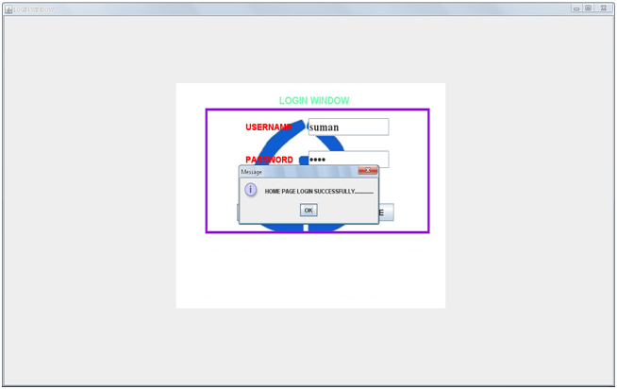

FIGURE:1: SHOWS LOGIN FORM

CODING FOR LOGIN FORM

import java.awt.*;

import javax.swing.*;

import java.awt.event.*;

class LoginWindow extends JFrame implements ActionListener

{ **//OPEN OF CLASS**

ImagePanel panel2=new ImagePanel("");

ImagePanel panel1=new ImagePanel("GG.jpg");

JLabel label=new JLabel("LOGIN WINDOW");

JLabel Ulbl=new JLabel("USERNAME");

JLabel Plbl=new JLabel("PASSWORD");

JTextField Utext=new JTextField(30);

JPasswordField Ptext=new JPasswordField(30);

JButton Sbtn=new JButton("SUBMIT");

JButton Cbtn=new JButton("CANCEL");

JButton CLbtn=new JButton("CLOSE");

LoginWindow(String st)

{

super(st);

setVisible(true);

add(panel1);

panel1.setLayout(null);

panel2.setLayout(null);

setLayout(null);

label.setFont(new Font("Arial",Font.BOLD,20));

label.setForeground(new Color(115,250,175));

Ulbl.setFont(new Font("Times Roman",Font.BOLD,18));

Utext.setFont(new Font("Times New Roman",Font.BOLD,24));

Ulbl.setForeground(Color.red);

Plbl.setFont(new Font("Times Roman",Font.BOLD,18));

Ptext.setFont(new Font("Times New Roman",Font.BOLD,24));

Plbl.setForeground(Color.red);

Sbtn.setFont(new Font("Times Roman",Font.BOLD,16));

Cbtn.setFont(new Font("Times Roman",Font.BOLD,16));

CLbtn.setFont(new Font("Timew Roman",Font.BOLD,16));

panel2.setSize(500,250);

panel1.setSize(600,500);

panel1.add(panel2);

panel1.add(label);

panel2.add(Ulbl);

panel2.add(Plbl);

panel2.add(Utext);

panel2.add(Ptext);

panel2.add(Sbtn);

panel2.add(Cbtn);

panel2.add(CLbtn);

label.setBounds(230,20,200,30);

Ulbl.setBounds(90,20,110,35);

Utext.setBounds(230,20,180,35);

Plbl.setBounds(90,85,110,35);

Ptext.setBounds(230,85,180,35);

Sbtn.setBounds(70,190,100,35);

Cbtn.setBounds(190,190,110,35);

CLbtn.setBounds(320,190,100,35);

Toolkit toolkit=getToolkit();

Dimension dim=toolkit.getScreenSize();

int w=dim.width;

int h=dim.height;

setSize(w,h);

panel1.setBounds(dim.width/2-300,dim.height/2-250,600,500);

panel2.setBounds(65,50,500,250);

panel2.setBorder(BorderFactory.createLineBorder(new Color(150,15,225),5));

setDefaultCloseOperation(EXIT_ON_CLOSE);

Sbtn.addActionListener(this);

CLbtn.addActionListener(this);

}

public void actionPerformed(ActionEvent ae)

{

if(ae.getSource()==Sbtn)

{

if(Utext.getText().equalsIgnoreCase("suman") && Ptext.getText().equals("rita"))

{

new HOMEPAGE("HOTEL MAMTA HOTEL Patna");

}

else

JOptionPane.showMessageDialog(this,"User Id or password is incorrect..............");

}

if(ae.getSource()==CLbtn)

{

dispose();

}

}

public static void main(String arsg[])

{

new LoginWindow("LOGIN WINDOW");

}

}

} **//CLOSE OF CLASS**

HOME PAGE FORM

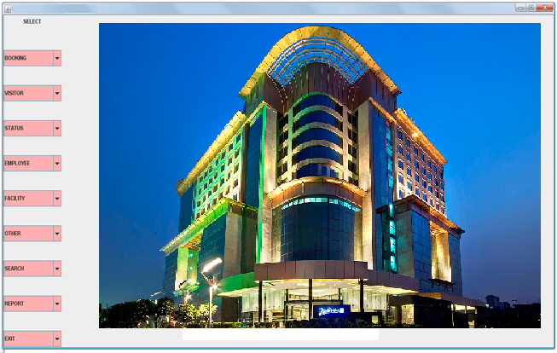

FIGURE:2: SHOWS HOME PAGE FORM

CODING FOR HOME PAGE FORM

import java.awt.*;

import javax.swing.*;

import java.awt.event.*;

public class HOMEPAGE extends JFrame implements ActionListener

{

JPanel jpanel1=new JPanel();

JPanel jpanel3=new JPanel();

ImagePanel jpanel2=new ImagePanel("5.jpg");

JLabel SELECT=new JLabel("SELECT");

JLabel lbl1=new JLabel("HOTEL");

JLabel lbl2=new JLabel("MAMTA HOTEL");

JLabel lbl3=new JLabel("exhibition road patna800 001 bihar INDIA");

JLabel lbl4=new JLabel("tel 0612 2500535/36/37/39 fax 0612 2500539");

JLabel lbl5=new JLabel("mobile +91 9771471000");

JLabel lbl6=new JLabel("info@gargeegrand.com www.gargeegrand.com");

JComboBox BOOK=new JComboBox();

JComboBox VISITOR=new JComboBox();

JComboBox STATUS=new JComboBox();

JComboBox EMPLOY=new JComboBox();

JComboBox FACILY=new JComboBox();

JComboBox SEARCH=new JComboBox();

JComboBox OTHER=new JComboBox();

JComboBox REPORT=new JComboBox();

JComboBox EXIT=new JComboBox();

HOMEPAGE(String st)

{

super(st);

JPanel p=new JPanel();

p.setLayout(new FlowLayout());

setVisible(true);

add(jpanel1,"West");

add(jpanel3);

jpanel3.setLayout(null);

jpanel3.add(jpanel2);

jpanel3.add(lbl1);

lbl1.setFont(new Font("Arial",Font.BOLD,25));

lbl1.setForeground(Color.green);

jpanel3.add(lbl2);

lbl2.setFont(new Font("Viner Hand ITC",Font.BOLD,35));

lbl2.setForeground(Color.red);

jpanel3.add(lbl3);

lbl3.setFont(new Font("Times New Roman",Font.BOLD,17));

lbl3.setFont(new Font("Times New Roman",Font.BOLD,17));

jpanel3.add(lbl4);

lbl4.setFont(new Font("Times New Roman",Font.BOLD,17));

jpanel3.add(lbl5);

lbl5.setFont(new Font("Times New Roman",Font.BOLD,17));

jpanel3.add(lbl6);

lbl6.setFont(new Font("Times New Roman",Font.BOLD,17));

lbl1.setBounds(490,525,125,30);

lbl2.setBounds(385,560,310,30);

lbl3.setBounds(390,590,400,30);

lbl4.setBounds(380,610,420,30);

lbl5.setBounds(465,630,200,30);

lbl6.setBounds(375,650,430,30);

jpanel2.setBounds(300,20,600,600);

p.add(SELECT);

jpanel1.setLayout(new GridLayout(10,1,0,40));

jpanel1.add(p);

jpanel1.add(BOOK);

jpanel1.add(VISITOR);

jpanel1.add(STATUS);

jpanel1.add(EMPLOY);

jpanel1.add(FACILY);

jpanel1.add(OTHER);

jpanel1.add(SEARCH);

jpanel1.add(REPORT);

jpanel1.add(EXIT);

BOOK.addItem("BOOKING");

BOOK.addItem("Room/Metting Room");

BOOK.addItem("Facility");

VISITOR.addItem("VISITOR");

VISITOR.addItem("Visitor Details");

VISITOR.addItem("Bill Details");

VISITOR.addItem("Check-In Details");

VISITOR.addItem("Check-Out Details");

VISITOR.addItem("Payment Details");

STATUS.addItem("STATUS");

STATUS.addItem("Room");

STATUS.addItem("Meeting Room");

EMPLOY.addItem("EMPLOYEE");

EMPLOY.addItem("Attendance");

EMPLOY.addItem("Employee Details");

EMPLOY.addItem("Desgination");

EMPLOY.addItem("Salary Details");

FACILY.addItem("FACILITY");

FACILY.addItem("Restaurant");

OTHER.addItem("OTHER");

OTHER.addItem("Facility Details");

SEARCH.addItem("SEARCH");

SEARCH.addItem("Employee Details");

SEARCH.addItem("Visitor Details");

REPORT.addItem("REPORT");

REPORT.addItem("RoomBook Report");

REPORT.addItem("Visitors Report");

REPORT.addItem("Employee Report");

EXIT.addItem("EXIT");

Toolkit toolkit=getToolkit();

Dimension dim=toolkit.getScreenSize();

int w=dim.width;

int h=dim.height;

setSize(w,h-35);

BOOK.setBackground(Color.pink);

VISITOR.setBackground(Color.pink);

STATUS.setBackground(Color.pink);

EMPLOY.setBackground(Color.pink);

SEARCH.setBackground(Color.pink);

OTHER.setBackground(Color.pink);

REPORT.setBackground(Color.pink);

EXIT.setBackground(Color.pink);

FACILY.setBackground(Color.pink);

setDefaultCloseOperation(DISPOSE_ON_CLOSE);

BOOK.addActionListener(this);

VISITOR.addActionListener(this);

STATUS.addActionListener(this);

EMPLOY.addActionListener(this);

OTHER.addActionListener(this);

FACILY.addActionListener(this);

SEARCH.addActionListener(this);

REPORT.addActionListener(this);

EXIT.addActionListener(this);

}

public void actionPerformed(ActionEvent e)

{

if(e.getSource()==BOOK)

{

if(BOOK.getSelectedItem().toString().equals("Room/Metting Room"))

{

new Bookdets("Booking Details");

BOOK.setSelectedIndex(0);

}

else if(BOOK.getSelectedItem().toString().equals("Facility"))

{

new Facility("Facility Details");

BOOK.setSelectedIndex(0);

}

}

else if(e.getSource()==VISITOR)

{

if(VISITOR.getSelectedItem().toString().equals("Visitor Details"))

{

new Visitorsdets("Visitor Details");

VISITOR.setSelectedIndex(0);

}

else if(VISITOR.getSelectedItem().toString().equals("Bill Details"))

{

new Billdets("Bill Details Windows");

VISITOR.setSelectedIndex(0);

}

else if(VISITOR.getSelectedItem().toString().equals("Check-In Details"))

{

new Checkindets("Check-In Details");

VISITOR.setSelectedIndex(0);

}

else if(VISITOR.getSelectedItem().toString().equals("Check-Out Details"))

{

new Checkoutdets("Check-Out Details");

VISITOR.setSelectedIndex(0);

}

else if(VISITOR.getSelectedItem().toString().equals("Payment Details"))

{

new Payment("Payment Details");

VISITOR.setSelectedIndex(0);

}

}

else if(e.getSource()==STATUS)

{

if(STATUS.getSelectedItem().toString().equals("Room"))

{

new Roomdets("Room Details");

STATUS.setSelectedIndex(0);

}

if(STATUS.getSelectedItem().toString().equals("Meeting Room"))

{

new MeetingRoomdets("Meeting Room Details");

STATUS.setSelectedIndex(0);

}

}

else if(e.getSource()==EMPLOY)

{

if(EMPLOY.getSelectedItem().toString().equals("Attendance"))

{

new Attendance("Attendance Details");

EMPLOY.setSelectedIndex(0);

}

if(EMPLOY.getSelectedItem().toString().equals("Employee Details"))

{

new EmployeeDets("Employee Details");

EMPLOY.setSelectedIndex(0);

}

if(EMPLOY.getSelectedItem().toString().equals("Desgination"))

{

new Designation("Designation Details");

EMPLOY.setSelectedIndex(0);

}

if(EMPLOY.getSelectedItem().toString().equals("Salary Details"))

{

new Salary("Salary Details");

EMPLOY.setSelectedIndex(0);

}

}

else if(e.getSource()==FACILY)

{

if(FACILY.getSelectedItem().toString().equals("Restaurant"))

{

new Restaurant("Facility Details");

FACILY.setSelectedIndex(0);

}

}

else if(e.getSource()==SEARCH)

{

if(SEARCH.getSelectedItem().toString().equals("Employee Details"))

{

new EmployeeSearch("Employee Details");

SEARCH.setSelectedIndex(0);

}

if(SEARCH.getSelectedItem().toString().equals("Visitor Details"))

{

new VisitorSearch("Visitor Details");

SEARCH.setSelectedIndex(0);

}

}

else if(e.getSource()==REPORT)

{

if(REPORT.getSelectedItem().toString().equals("RoomBook Report"))

{

new Report_Roombook("Room Book Report");

REPORT.setSelectedIndex(0);

}

if(REPORT.getSelectedItem().toString().equals("Visitors Report"))

{

new Report_Vistor("Visitor Report");

REPORT.setSelectedIndex(0);

}

if(REPORT.getSelectedItem().toString().equals("Employee Report"))

{

new Report_Employee("Employee Report");

REPORT.setSelectedIndex(0);

}

}

else if(e.getSource()==OTHER)

{

if(OTHER.getSelectedItem().toString().equals("Facility Details"))

{

new FacilityDets("Facility Details");

OTHER.setSelectedIndex(0);

}

}

else if(e.getSource()==EXIT)

{

if(EXIT.getSelectedItem().toString().equals("EXIT"))

dispose();

}

}

public static void main(String args[])

{

new HOMEPAGE("Hotel MAMTA HOTEL Patna");

}

}

**FORM FOR ROOM/MEETINGROOM BOOKING**

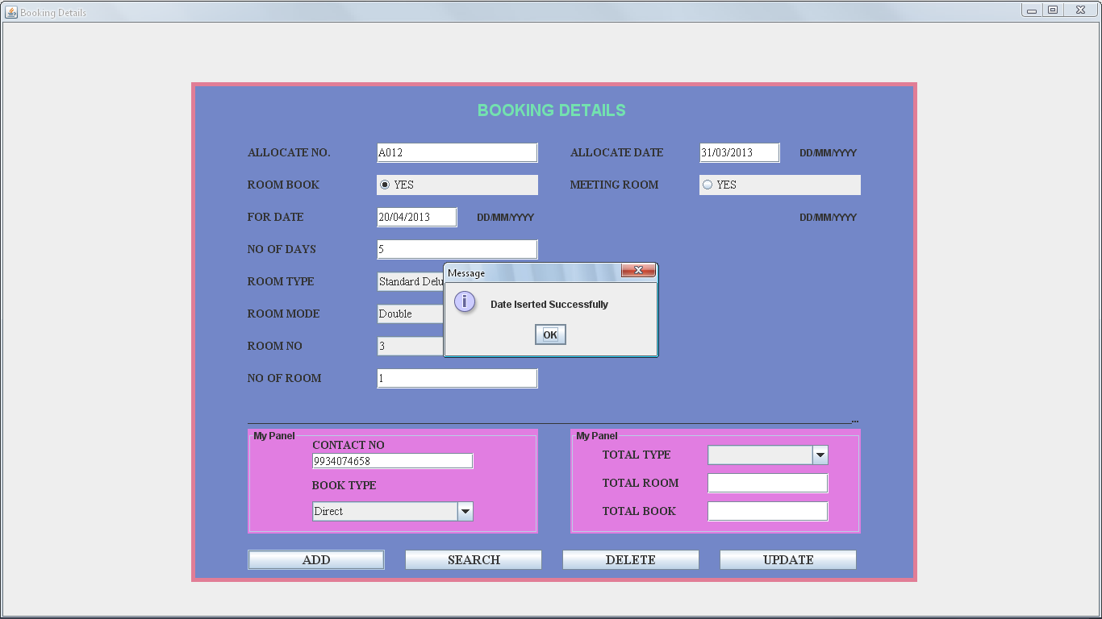

FIGURE:3: SHOWS ROOM BOOKING FORM

**CODING FOR ROOM/MEETINGROOM BOOKING FORM**

import java.awt.*;

import javax.swing.*;

import java.awt.event.*;

import java.sql.*;

class Bookdets extends JFrame implements ActionListener

{ **//OPEN OF CLASS**

JPanel jpanel1=new JPanel();

JPanel jpanel2=new JPanel();

JPanel jpanel3=new JPanel();

JPanel jpanel4=new JPanel();

JLabel jlabel=new JLabel("BOOKING DETAILS");

JLabel Rlbl=new JLabel("ROOM BOOK");

JRadioButton RB1=new JRadioButton("YES",false);

ButtonGroup BG1=new ButtonGroup();

JLabel Albl=new JLabel("ALLOCATE NO.");

static JTextField Atext=new JTextField(10);

JLabel ADlbl=new JLabel("ALLOCATE DATE");

JLabel AD=new JLabel("DD/MM/YYYY");

JTextField ADtext=new JTextField(10);

JLabel FDlbl=new JLabel("FOR DATE");

JLabel FD=new JLabel("DD/MM/YYYY");

JTextField FDtext=new JTextField(10);

JLabel NOD1lbl=new JLabel("NO OF DAYS");

JTextField NOD1text=new JTextField(2);

JLabel RTlbl=new JLabel("ROOM TYPE");

JComboBox RT=new JComboBox();

JLabel RMlbl=new JLabel("ROOM MODE");

JComboBox RM=new JComboBox();

JLabel RNlbl=new JLabel("ROOM NO");

JComboBox RN=new JComboBox();

JLabel NORlbl=new JLabel("NO OF ROOM");

JTextField NORtext=new JTextField(2);

JLabel CNlbl=new JLabel("CONTACT NO");

JTextField CNtext=new JTextField(12);

JLabel BTlbl=new JLabel("BOOK TYPE");

JComboBox BT=new JComboBox();

JLabel MRBlbl=new JLabel("MEETING ROOM");

JRadioButton MRB1=new JRadioButton("YES",false);

JLabel MFODlbl=new JLabel("FOR DATE");

JLabel MFOD=new JLabel("DD/MM/YYYY");

JTextField MFODtext=new JTextField(10);

JLabel NOD2lbl=new JLabel("NO OF DAYS");

JTextField NOD2text=new JTextField(2);

JLabel lbl=new JLabel("_________________________________________________________________________________________________________________________________");

JLabel FRlbl=new JLabel("FROM");

JTextField FRtext=new JTextField(8);

JComboBox FR=new JComboBox();

JLabel TOlbl=new JLabel("TO");

JTextField TOtext=new JTextField(8);

JComboBox TO=new JComboBox();

JLabel MRTlbl=new JLabel("MEETING ROOM TYPE");

JComboBox MRT=new JComboBox();

JLabel NOPlbl=new JLabel("NO OF PERSON");

JTextField NOPtext=new JTextField(2);

JLabel TBlbl=new JLabel("TOTAL TYPE");

JComboBox TB=new JComboBox();

JLabel TRlbl=new JLabel("TOTAL ROOM");

JTextField TRtext=new JTextField(2);

JLabel TNOBlbl=new JLabel("TOTAL BOOK");

JTextField TNOBtext=new JTextField(2);

JButton jbtn3=new JButton("ADD");

JButton jbtn4=new JButton("SEARCH");

JButton jbtn5=new JButton("DELETE");

JButton jbtn6=new JButton("UPDATE");

Bookdets(String st)

{

super(st);

setVisible(true);

add(jpanel1);

jpanel1.setLayout(null);

jpanel2.setLayout(null);

jpanel1.add(jpanel2);

jpanel2.add(jpanel3);

jpanel3.setBounds(70,430,360,130);

jpanel3.setBorder(BorderFactory.createTitledBorder("My Panel"));

jpanel3.setBackground(new Color(225,125,225));

jpanel3.setLayout(null);

jpanel2.add(jpanel4);

jpanel4.setBorder(BorderFactory.createTitledBorder("My Panel"));

jpanel4.setBackground(new Color(225,125,225));

jpanel4.setLayout(null);

jpanel4.setBounds(470,430,360,130);

jpanel2.setSize(900,620);

jpanel2.setBackground(new Color(115,135,200));

jpanel2.add(jlabel);

jlabel.setFont(new Font("ARIAL",Font.BOLD,20));

jlabel.setForeground(new Color(115,225,175));

jpanel2.add(Rlbl);

Rlbl.setFont(new Font("TIMES NEW ROMAN",Font.BOLD,14));

jpanel2.add(RB1);

RB1.setFont(new Font("TIMES NEW ROMAN",Font.PLAIN,14));

jpanel2.add(Albl);

Albl.setFont(new Font("TIMES NEW ROMAN",Font.BOLD,14));

jpanel2.add(Atext);

Atext.setFont(new Font("TIMES NEW ROMAN",Font.PLAIN,14));

jpanel2.add(ADlbl);

jpanel2.add(AD);

ADlbl.setFont(new Font("TIMES NEW ROMAN",Font.BOLD,14));

jpanel2.add(ADtext);

ADtext.setFont(new Font("TIMES NEW ROMAN",Font.PLAIN,14));

jpanel2.add(FDlbl);

jpanel2.add(FD);

FDlbl.setFont(new Font("TIMES NEW ROMAN",Font.BOLD,14));

jpanel2.add(FDtext);

FDtext.setFont(new Font("TIMES NEW ROMAN",Font.PLAIN,14));

jpanel2.add(NOD1lbl);

NOD1lbl.setFont(new Font("TIMES NEW ROMAN",Font.BOLD,14));

jpanel2.add(NOD1text);

NOD1text.setFont(new Font("TIMES NEW ROMAN",Font.PLAIN,14));

jpanel2.add(RTlbl);

RTlbl.setFont(new Font("TIMES NEW ROMAN",Font.BOLD,14));

jpanel2.add(RT);

RT.addItem("Suit Premium");

RT.addItem("Club Suite");

RT.addItem("Premium Deluxe");

RT.addItem("Club Deluxe");

RT.addItem("Standard Deluxe");

RT.setFont(new Font("TIMES NEW ROMAN",Font.PLAIN,14));

jpanel2.add(RMlbl);

RMlbl.setFont(new Font("TIMES NEW ROMAN",Font.BOLD,14));

jpanel2.add(RM);

RM.addItem("Single");

RM.addItem("Double");

RM.setFont(new Font("TIMES NEW ROMAN",Font.PLAIN,14));

jpanel2.add(RNlbl);

RNlbl.setFont(new Font("TIMES NEW ROMAN",Font.BOLD,14));

jpanel2.add(RN);

RN.addItem("1");

RN.addItem("2");

RN.addItem("3");

RN.addItem("4");

RN.addItem("5");

RN.addItem("6");

RN.addItem("7");

RN.setFont(new Font("TIMES NEW ROMAN",Font.PLAIN,14));

jpanel2.add(NORlbl);

NORlbl.setFont(new Font("TIMES NEW ROMAN",Font.BOLD,14));

jpanel2.add(NORtext);

NORtext.setFont(new Font("TIMES NEW ROMAN",Font.PLAIN,14));

jpanel3.add(CNlbl);

CNlbl.setFont(new Font("TIMES NEW ROMAN",Font.BOLD,14));

jpanel3.add(CNtext);

CNtext.setFont(new Font("TIMES NEW ROMAN",Font.PLAIN,14));

jpanel3.add(BTlbl);

BTlbl.setFont(new Font("TIMES NEW ROMAN",Font.BOLD,14));

jpanel3.add(BT);

BT.addItem("Direct");

BT.addItem("By Call");

BT.setFont(new Font("TIMES NEW ROMAN",Font.PLAIN,14));

jpanel2.add(MRBlbl);

MRBlbl.setFont(new Font("TIMES NEW ROMAN",Font.BOLD,14));

jpanel2.add(MRB1);

MRB1.setFont(new Font("TIMES NEW ROMAN",Font.PLAIN,14));

jpanel2.add(MFODlbl);

jpanel2.add(MFOD);

MFODlbl.setFont(new Font("TIMES NEW ROMAN",Font.BOLD,14));

jpanel2.add(MFODtext);

MFODtext.setFont(new Font("TIMES NEW ROMAN",Font.PLAIN,14));

jpanel2.add(NOD2lbl);

NOD2lbl.setFont(new Font("TIMES NEW ROMAN",Font.BOLD,14));

jpanel2.add(NOD2text);

NOD2text.setFont(new Font("TIMES NEW ROMAN",Font.PLAIN,14));

jpanel2.add(lbl);

jpanel2.add(FRlbl);

FRlbl.setFont(new Font("TIMES NEW ROMAN",Font.BOLD,14));

jpanel2.add(FRtext);

FRtext.setFont(new Font("TIMES NEW ROMAN",Font.PLAIN,14));

jpanel2.add(FR);

FR.addItem("AM");

FR.addItem("PM");

FR.setFont(new Font("TIMES NEW ROMAN",Font.BOLD,14));

jpanel2.add(TOlbl);

TOlbl.setFont(new Font("TIMES NEW ROMAN",Font.BOLD,14));

jpanel2.add(TOtext);

TOtext.setFont(new Font("TIMES NEW ROMAN",Font.PLAIN,14));

jpanel2.add(TO);

TO.addItem("AM");

TO.addItem("PM");

TO.setFont(new Font("TIMES NEW ROMAN",Font.BOLD,14));

jpanel2.add(MRTlbl);

MRTlbl.setFont(new Font("TIMES NEW ROMAN",Font.BOLD,14));

jpanel2.add(MRT);

MRT.addItem("Galaxy");

MRT.addItem("Ganga");

MRT.addItem("Gautam");

MRT.addItem("Gaur");

MRT.addItem("Gosthi");

MRT.setFont(new Font("TIMES NEW ROMAN",Font.PLAIN,14));

jpanel2.add(NOPlbl);

NOPlbl.setFont(new Font("TIMES NEW ROMAN",Font.BOLD,14));

jpanel2.add(NOPtext);

NOPtext.setFont(new Font("TIMES NEW ROMAN",Font.PLAIN,14));

jpanel4.add(TBlbl);

TBlbl.setFont(new Font("TIMES NEW ROMAN",Font.BOLD,14));

jpanel4.add(TB);

TB.setFont(new Font("TIMES NEW ROMAN",Font.PLAIN,14));

jpanel4.add(TRlbl);

TRlbl.setFont(new Font("TIMES NEW ROMAN",Font.BOLD,14));

jpanel4.add(TRtext);

TRtext.setFont(new Font("TIMES NEW ROMAN",Font.PLAIN,14));

jpanel4.add(TNOBlbl);

TNOBlbl.setFont(new Font("TIMES NEW ROMAN",Font.BOLD,14));

jpanel4.add(TNOBtext);

TNOBtext.setFont(new Font("TIMES NEW ROMAN",Font.PLAIN,14));

jpanel2.add(jbtn3);

jbtn3.setFont(new Font("TIMES NEW ROMAN",Font.BOLD,16));

jpanel2.add(jbtn4);

jbtn4.setFont(new Font("TIMES NEW ROMAN",Font.BOLD,16));

jpanel2.add(jbtn5);

jbtn5.setFont(new Font("TIMES NEW ROMAN",Font.BOLD,16));

jpanel2.add(jbtn6);

jbtn6.setFont(new Font("TIMES NEW ROMAN",Font.BOLD,16));

jlabel.setBounds(355,20,200,30);

Rlbl.setBounds(70,115,130,25);

RB1.setBounds(230,115,200,25);

Albl.setBounds(70,75,130,25);

Atext.setBounds(230,75,200,25);

ADlbl.setBounds(470,75,130,25);

ADtext.setBounds(630,75,100,25);

AD.setBounds(755,75,100,25);

FDlbl.setBounds(70,155,130,25);

FDtext.setBounds(230,155,100,25);

FD.setBounds(355,155,100,25);

NOD1lbl.setBounds(70,195,130,25);

NOD1text.setBounds(230,195,200,25);

RTlbl.setBounds(70,235,130,25);

RT.setBounds(230,235,200,25);

RMlbl.setBounds(70,275,130,25);

RM.setBounds(230,275,200,25);

RNlbl.setBounds(70,315,130,25);

RN.setBounds(230,315,200,25);

NORlbl.setBounds(70,355,130,25);

NORtext.setBounds(230,355,200,25);

CNlbl.setBounds(80,10,200,20);

CNtext.setBounds(80,30,200,20);

BTlbl.setBounds(80,60,200,20);

BT.setBounds(80,90,200,25);

MRBlbl.setBounds(470,115,130,25);

MRB1.setBounds(630,115,200,25);

MFODlbl.setBounds(470,155,130,25);

MFODtext.setBounds(630,155,100,25);

MFOD.setBounds(755,155,100,25);

NOD2lbl.setBounds(470,355,130,25);

NOD2text.setBounds(630,355,200,25);

lbl.setBounds(70,405,760,25);

FRlbl.setBounds(470,195,130,25);

FRtext.setBounds(630,195,100,25);

FR.setBounds(730,195,100,25);

TOlbl.setBounds(470,235,130,25);

TOtext.setBounds(630,235,100,25);

TO.setBounds(730,235,100,25);

MRTlbl.setBounds(470,275,150,25);

MRT.setBounds(630,275,200,25);

NOPlbl.setBounds(470,315,130,25);

NOPtext.setBounds(630,315,200,25);

TBlbl.setBounds(40,20,130,25);

TB.setBounds(170,20,150,25);

TRlbl.setBounds(40,55,130,25);

TRtext.setBounds(170,55,150,25);

TNOBlbl.setBounds(40,90,130,25);

TNOBtext.setBounds(170,90,150,25);

jbtn3.setBounds(70,580,170,25);

jbtn4.setBounds(265,580,170,25);

jbtn5.setBounds(460,580,170,25);

jbtn6.setBounds(655,580,170,25);

Toolkit toolkit=getToolkit();

Dimension dim=toolkit.getScreenSize();

int h=dim.height;

int w=dim.width;

setSize(w,h);

jpanel2.setBounds(dim.width/2-450,dim.height/2-310,900,620);

jpanel2.setBorder(BorderFactory.createLineBorder(new Color(225,125,150),5));

BG1.add(RB1);

BG1.add(MRB1);

//set visibility false

FDlbl.setVisible(false);

FDtext.setVisible(false);

NOD1lbl.setVisible(false);

NOD1text.setVisible(false);

RTlbl.setVisible(false);

RT.setVisible(false);

RMlbl.setVisible(false);

RM.setVisible(false);

RNlbl.setVisible(false);

RN.setVisible(false);

NORlbl.setVisible(false);

NORtext.setVisible(false);

CNlbl.setVisible(true);

CNtext.setVisible(true);

BTlbl.setVisible(true);

BT.setVisible(true);

MFODlbl.setVisible(false);

MFODtext.setVisible(false);

NOD2lbl.setVisible(false);

NOD2text.setVisible(false);

FRlbl.setVisible(false);

FRtext.setVisible(false);

FR.setVisible(false);

TOlbl.setVisible(false);

TOtext.setVisible(false);

TO.setVisible(false);

MRTlbl.setVisible(false);

MRT.setVisible(false);

NOPlbl.setVisible(false);

NOPtext.setVisible(false);

TBlbl.setVisible(true);

TB.setVisible(true);

TRlbl.setVisible(true);

TRtext.setVisible(true);

TNOBlbl.setVisible(true);

TNOBtext.setVisible(true);

// Registration of RadioButton with ActionListener

RB1.addActionListener(this);

MRB1.addActionListener(this);

jbtn3.addActionListener(this);

jbtn4.addActionListener(this);

jbtn5.addActionListener(this);

jbtn6.addActionListener(this);

}

public static void main(String args[])

{

new Bookdets("Booking Details");

}

public void actionPerformed(ActionEvent e)

{

if(e.getSource()==RB1)

{

FDlbl.setVisible(true);

FDtext.setVisible(true);

NORlbl.setVisible(true);

NORtext.setVisible(true);

CNtext.setVisible(true);

BTlbl.setVisible(true);

MFODlbl.setVisible(false);

MFODtext.setVisible(false);

NOD2lbl.setVisible(false);

NOD2text.setVisible(false);

FRlbl.setVisible(false);

FRtext.setVisible(false);

FR.setVisible(false);

TOlbl.setVisible(false);

TOtext.setVisible(false);

TO.setVisible(false);

MRTlbl.setVisible(false);

MRT.setVisible(false);

NOPlbl.setVisible(false);

NOPtext.setVisible(false);

TBlbl.setVisible(true);

TB.setVisible(true);

TRlbl.setVisible(true);

TRtext.setVisible(true);

TNOBlbl.setVisible(true);

TNOBtext.setVisible(true);

FD.setVisible(true);

}

else if(e.getSource()==MRB1)

{

FDlbl.setVisible(false);

FDtext.setVisible(false);

NOD1lbl.setVisible(false);

NOD1text.setVisible(false);

RTlbl.setVisible(false);

RT.setVisible(false);

RMlbl.setVisible(false);

RM.setVisible(false);

RNlbl.setVisible(false);

RN.setVisible(false);

NORlbl.setVisible(false);

NORtext.setVisible(false);

CNtext.setVisible(false);

BTlbl.setVisible(false);

MFODlbl.setVisible(true);

MFODtext.setVisible(true);

NOD2lbl.setVisible(true);

NOD2text.setVisible(true);

FRlbl.setVisible(true);

FRtext.setVisible(true);

FR.setVisible(true);

TOlbl.setVisible(true);

TOtext.setVisible(true);

TO.setVisible(true);

MRTlbl.setVisible(true);

MRT.setVisible(true);

NOPlbl.setVisible(true);

NOPtext.setVisible(true);

TBlbl.setVisible(true);

TB.setVisible(true);

TRlbl.setVisible(true);

TRtext.setVisible(true);

TNOBlbl.setVisible(true);

TNOBtext.setVisible(true);

MFOD.setVisible(true);

}

else if(e.getSource()==jbtn3)

{

if(RB1.isSelected())

{

try

{

Class.forName("sun.jdbc.odbc.JdbcOdbcDriver");

Connection con=DriverManager.getConnection("Jdbc:Odbc:myname","system",

"oracle");

PreparedStatement ps=con.prepareStatement("insert into Roombook values(?,?,?,?,?,?,?,?,?,?,?)");

ps.setString(1,Atext.getText());

ps.setString(2,"Yes");

ps.setString(3,FDtext.getText());

ps.setString(4,NOD1text.getText());

ps.setString(5,RT.getSelectedItem().toString());

ps.setString(6,RM.getSelectedItem().toString());

ps.setString(7,RN.getSelectedItem().toString());

ps.setString(8,NORtext.getText());

ps.setString(9,CNtext.getText());

ps.setString(10,BT.getSelectedItem().toString());

ps.setString(11,ADtext.getText());

int R=ps.executeUpdate();

if(R>0)

{

JOptionPane.showMessageDialog(this,"Date Iserted Successfully");

RB1.setSelected(false);

FDtext.setText("");

NOD1text.setText("");

RT.setSelectedIndex(0);

RM.setSelectedIndex(0);

RN.setSelectedIndex(0);

NORtext.setText("");

}

else

{

JOptionPane.showMessageDialog(this,"Date Not Inserted...");

}

}

catch(Exception S)

{

System.out.println(S);

}

}

else if(MRB1.isSelected())

{

try

{

Class.forName("sun.jdbc.odbc.JdbcOdbcDriver");

Connection con=DriverManager.getConnection("Jdbc:Odbc:myname","system",

"oracle");

PreparedStatement ps=con.prepareStatement("insert into Meetingbook values(?,?,?,?,?,?,?,?,?,?,?)");

ps.setString(1,"Yes");

ps.setString(2,MFODtext.getText());

ps.setString(3,(FRtext.getText()+" "+FR.getSelectedItem().toString()));

ps.setString(4,(TOtext.getText()+" "+TO.getSelectedItem().toString()));

ps.setString(5,MRT.getSelectedItem().toString());

ps.setString(6,NOPtext.getText());

ps.setString(7,NOD2text.getText());

ps.setString(8,Atext.getText());

ps.setString(9,CNtext.getText());

ps.setString(10,BT.getSelectedItem().toString());

ps.setString(11,ADtext.getText());

int R=ps.executeUpdate();

if(R>0)

{

JOptionPane.showMessageDialog(this,"Data Iserted Successfully");

MRB1.setSelected(false);

MFODtext.setText("");

FRtext.setText("");

FR.setSelectedIndex(0);

TOtext.setText("");

TO.setSelectedIndex(0);

MRT.setSelectedIndex(0);

NOPtext.setText("");

NOD2text.setText("");

}

Else

{

JOptionPane.showMessageDialog(this,"Data Not Inserted...");

}

}

catch(Exception S)

{

System.out.println(S);

}

}

}else if(e.getSource()==jbtn4) /*Data Searching Coding......*/

{

if(RB1.isSelected())

{

try

{

Class.forName("sun.jdbc.odbc.JdbcOdbcDriver");

Connection con=DriverManager.getConnection("Jdbc:Odbc:myname","system",

"oracle");

PreparedStatement ps=con.prepareStatement("Select * from Roombook where anlbl=?");

ps.setString(1,Atext.getText());

ResultSet rs=ps.executeQuery();

if(rs.next())

{

JOptionPane.showMessageDialog(this,"Data found...");

FDtext.setText(rs.getString(3));

NOD1text.setText(rs.getString(4));

RT.setSelectedItem(rs.getString(5));

RM.setSelectedItem(rs.getString(6));

RN.setSelectedItem(rs.getString(7));

NORtext.setText(rs.getString(8));

CNtext.setText(rs.getString(9));

BT.setSelectedItem(rs.getString(10));

ADtext.setText(rs.getString(11));

}

else

{

JOptionPane.showMessageDialog(this,"Data Not found...");

}

}

catch(Exception S)

{

System.out.println(S);

}

}

else if(MRB1.isSelected())

{

try

{

Class.forName("sun.jdbc.odbc.JdbcOdbcDriver");

Connection con=DriverManager.getConnection("Jdbc:Odbc:myname","system",

"oracle");

PreparedStatement ps=con.prepareStatement("Select * from meetingbook where anlbl=?");

ps.setString(1,Atext.getText());

ResultSet rs=ps.executeQuery();

if(rs.next())

{

JOptionPane.showMessageDialog(this,"Data found...");

MFODtext.setText(rs.getString(3));

String dt=rs.getString(4);

FRtext.setText(dt.substring(0,dt.length()2));

FR.setSelectedItem(dt.substring(dt.length()-2));

dt=rs.getString(5);

TOtext.setText(dt.substring(0,dt.length()2));

TO.setSelectedItem(dt.substring(dt.length()-2));

MRT.setSelectedItem(rs.getString(6));

NOPtext.setText(rs.getString(7));

NOD2text.setText(rs.getString(8));

CNtext.setText(rs.getString(9));

BT.setSelectedItem(rs.getString(10));

ADtext.setText(rs.getString(11));

}

else

{

JOptionPane.showMessageDialog(this,"Data Not found...");

}

}

catch(Exception S)

{

System.out.println(S);

}

}

}

else if(e.getSource()==jbtn6) /*Updating Coding.......*/

{

if(RB1.isSelected())

{

try

{

Class.forName("sun.jdbc.odbc.JdbcOdbcDriver");

Connection con=DriverManager.getConnection("Jdbc:Odbc:myname","system",

"oracle");

PreparedStatement ps=con.prepareStatement("update roombook set anlbl=?,rblbl=?,FDlbl=?,NODlbl=?,RTlbl=?,RMlbl=?,RNlbl=?,NORlbl=?,CNlbl=?,BTlbl=?,ADlbl=? where anlbl=?");

ps.setString(1,Atext.getText());

ps.setString(2,"yes");

ps.setString(3,FDtext.getText());

ps.setString(4,NOD1text.getText());

ps.setString(5,RT.getSelectedItem().toString());

ps.setString(6,RM.getSelectedItem().toString());

ps.setString(7,RN.getSelectedItem().toString());

ps.setString(8,NORtext.getText());

ps.setString(9,CNtext.getText());

ps.setString(10,BT.getSelectedItem().toString());

ps.setString(11,ADtext.getText());

ps.setString(12,Atext.getText());

int R=ps.executeUpdate();

if(R>0)

{

JOptionPane.showMessageDialog(this,"Data updated Successfully");

RB1.setSelected(false);

FDtext.setText("");

NOD1text.setText("");

RT.setSelectedIndex(0);

RM.setSelectedIndex(0);

RN.setSelectedIndex(0);

NORtext.setText("");

}

else

{

JOptionPane.showMessageDialog(this,"Data Not Updated...");

}

}

catch(Exception S)

{

System.out.println(S);

}

}

else if(MRB1.isSelected())

{

try

{

Class.forName("sun.jdbc.odbc.JdbcOdbcDriver");

Connection con=DriverManager.getConnection("Jdbc:Odbc:myname","system",

"oracle");

PreparedStatement ps=con.prepareStatement("update meetingbook set MRlbl=?,FDlbl=?,Flbl=?,Tlbl=?,MRTlbl=?,NOPlbl=?,NODlbl=?,ANLBL=?,CNlbl=?,BTlbl=?,ADlbl=? where ANLBL=?");

ps.setString(1,"Yes");

ps.setString(2,MFODtext.getText());

ps.setString(3,(FRtext.getText()+" "+FR.getSelectedItem().toString()));

ps.setString(4,(TOtext.getText()+" "+TO.getSelectedItem().toString()));

ps.setString(5,MRT.getSelectedItem().toString());

ps.setString(6,NOPtext.getText());

ps.setString(7,NOD2text.getText());

ps.setString(8,Atext.getText());

ps.setString(9,CNtext.getText());

ps.setString(10,BT.getSelectedItem().toString());

ps.setString(11,ADtext.getText());

ps.setString(12,Atext.getText());

int R=ps.executeUpdate();

if(R>0)

{

JOptionPane.showMessageDialog(this,"Updated Successfully");

MRB1.setSelected(false);

MFODtext.setText("");

FRtext.setText("");

FR.setSelectedIndex(0);

TOtext.setText("");

TO.setSelectedIndex(0);

MRT.setSelectedIndex(0);

NOPtext.setText("");

NOD2text.setText("");

}

else

{

JOptionPane.showMessageDialog(this,"Updated Not Successfully...");

}

}

catch(Exception S)

{

System.out.println(S);

}

}

}

else if(e.getSource()==jbtn5) /*Delete Coding.......*/

{

if(RB1.isSelected())

{

try

{

System.out.println("Deleted");

Class.forName("sun.jdbc.odbc.JdbcOdbcDriver");

Connection con=DriverManager.getConnection("Jdbc:Odbc:myname","system",

"oracle");

PreparedStatement ps=con.prepareStatement("delete from roombook where anlbl=?");

ps.setString(1,Atext.getText());

int R=ps.executeUpdate();

if(R>0)

{

JOptionPane.showMessageDialog(this,"Data Deleted Successfully");

}

else

{

JOptionPane.showMessageDialog(this,"Data not Deleted...");

}

}

catch(Exception S)

{

System.out.println(S);

}

}

else if(MRB1.isSelected())

{

try

{

Class.forName("sun.jdbc.odbc.JdbcOdbcDriver");

Connection con=DriverManager.getConnection("Jdbc:Odbc:myname",

"system","oracle");

PreparedStatement ps=con.prepareStatement("delete from meetingbook where AL_NO=?");

ps.setString(1,Atext.getText());

int R=ps.executeUpdate();

if(R>0)

{

JOptionPane.showMessageDialog(this,"Data Deleted Successfully");

}

else

{

JOptionPane.showMessageDialog(this,"Data Not Deleted Successfully...");

}

}

catch(Exception S)

{

System.out.println(S);

}

}

}

}

}**//CLOSE OF CLASS**

**FORM FOR SELECT CUSTOMER FOR BOOK FACILITY**

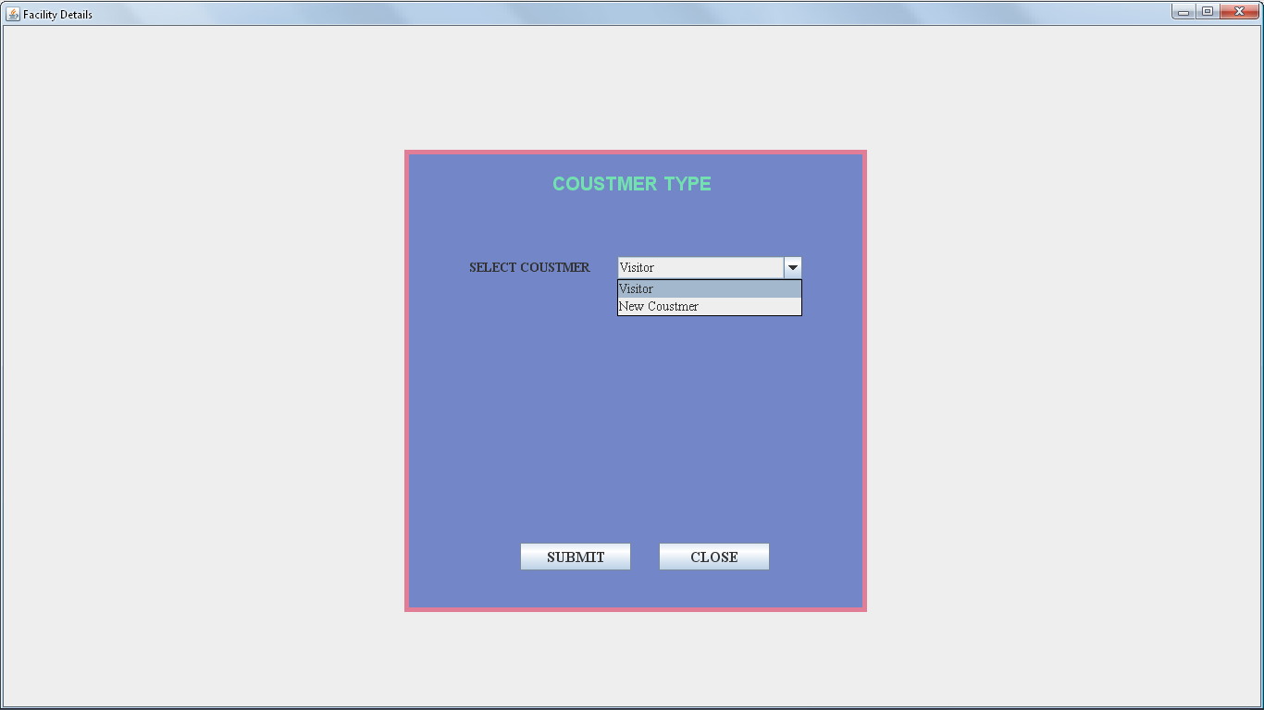

FIGURE:4: SHOWS SELECT CUSTOMER FORM

**CODING FOR SELECT CUSTOMER FOR BOOK FACILITY**

import java.awt.*;

import javax.swing.*;

import java.awt.event.*;

class Facility extends JFrame implements ActionListener

{

JPanel jpanel1=new JPanel();

JPanel jpanel2=new JPanel();

JLabel jlabel=new JLabel("COUSTMER TYPE");

JLabel SClbl=new JLabel("SELECT COUSTMER");

JComboBox SC=new JComboBox();

JButton jbtn1=new JButton("SUBMIT");

JButton jbtn2=new JButton("CLOSE");

Facility(String st)

{

super (st);

setVisible(true);

add(jpanel1);

jpanel1.setLayout(null);

jpanel2.setLayout(null);

jpanel1.add(jpanel2);

jpanel2.setSize(500,500);

jpanel2.setBackground(new Color(115,135,200));

jpanel2.add(jlabel);

jlabel.setFont(new Font("ARIAL",Font.BOLD,20));

jlabel.setForeground(new Color(115,225,175));

jpanel2.add(SClbl);

SClbl.setFont(new Font("TIMES NEW ROMAN",Font.BOLD,14));

jpanel2.add(SC);

SC.addItem("Visitor");

SC.addItem("New Coustmer");

SC.setFont(new Font("TIMES NEW ROMAN",Font.PLAIN,14));

jpanel2.add(jbtn1);

jbtn1.setFont(new Font("TIMES NEW ROMAN",Font.BOLD,16));

jpanel2.add(jbtn2);

jbtn2.setFont(new Font("TIMES NEW ROMAN",Font.BOLD,16));

jlabel.setBounds(160,20,250,35);

SClbl.setBounds(70,115,160,25);

SC.setBounds(230,115,200,25);

jbtn1.setBounds(125,425,120,30);

jbtn2.setBounds(275,425,120,30);

Toolkit toolkit=getToolkit();

Dimension dim=toolkit.getScreenSize();

int w=dim.width;

int h=dim.height;

setSize(w,h);

jpanel2.setBounds(dim.width/2-250,dim.height/2-250,500,500);

jpanel2.setBorder(BorderFactory.createLineBorder(new Color(225,125,150),5));

jbtn1.addActionListener(this);

jbtn2.addActionListener(this);

}

public void actionPerformed(ActionEvent e)

{

if(e.getSource()==jbtn1)

{

if(SC.getSelectedItem().toString().equals("Visitor"))

{

new FacilityBookDets("Visitor Facility Book Details");

}

else if(SC.getSelectedItem().toString().equals("New Coustmer"))

{

new FacilityBookDetsCus("Coustumer Facility Book Details");

}

}

else if(e.getSource()==jbtn2)

{

dispose();

}

}

public static void main(String args[])

{

new Facility("Facility Booking Windows");

}

}

**FORM BOOK FACILITY for visitor**

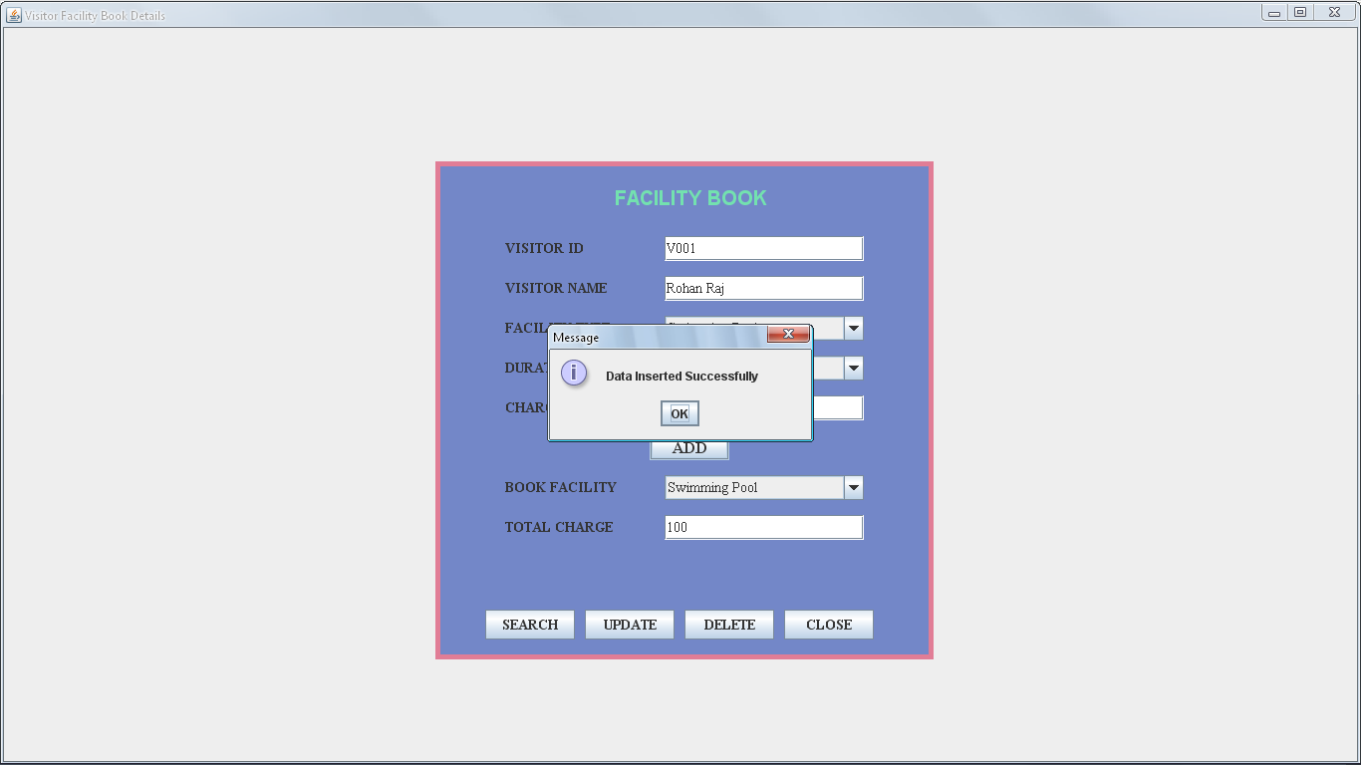

FIGURE:5: SHOWS BOOK FACILITY VISITOR FORM

**CODING BOOK FACILITY for visitor**

import java.awt.*;

import javax.swing.*;

import java.awt.event.*;

import java.sql.*;

class FacilityBookDets extends JFrame implements ActionListener

{

static String st="";

JPanel jpanel1=new JPanel();

JPanel jpanel2=new JPanel();

JLabel jlabel=new JLabel("FACILITY BOOK");

JLabel VIlbl=new JLabel("VISITOR ID");

JTextField VItext=new JTextField(10);

JLabel VNlbl=new JLabel("VISITOR NAME");

JTextField VNtext=new JTextField(25);

JLabel FClbl=new JLabel("FACILITY TYPE");

JComboBox FC=new JComboBox();

JLabel DUlbl=new JLabel("DURATION");

JComboBox DU=new JComboBox();

JLabel CHlbl=new JLabel("CHARGE");

JTextField CHtext=new JTextField("0",5);

JButton jbtn1=new JButton("ADD");

JLabel TBFlbl=new JLabel("BOOK FACILITY");

JComboBox TBF=new JComboBox();

JLabel TClbl=new JLabel("TOTAL CHARGE");

JTextField TCtext=new JTextField("0",6);

JButton jbtn2=new JButton("SEARCH");

JButton jbtn3=new JButton("UPDATE");

JButton jbtn4=new JButton("DELETE");

JButton jbtn5=new JButton("CLOSE");

FacilityBookDets(String st)

{

super (st);

setVisible(true);

add(jpanel1);

jpanel1.setLayout(null);

jpanel2.setLayout(null);

jpanel1.add(jpanel2);

jpanel2.setSize(500,500);

jpanel2.setBackground(new Color(115,135,200));

jpanel2.add(jlabel);

jlabel.setFont(new Font("ARIAl",Font.BOLD,20));

jlabel.setForeground(new Color(115,225,175));

jpanel2.add(VIlbl);

VIlbl.setFont(new Font("TIMES NEW ROMAN",Font.BOLD,14));

jpanel2.add(VItext);

VItext.setFont(new Font("TIMES NEW ROMAN",Font.PLAIN,14));

jpanel2.add(VNlbl);

VNlbl.setFont(new Font("TIMES NEW ROMAN",Font.BOLD,14));

jpanel2.add(VNtext);

VNtext.setFont(new Font("TIMES NEW ROMAN",Font.PLAIN,14));

jpanel2.add(FClbl);

FClbl.setFont(new Font("TIMES NEW ROMAN",Font.BOLD,14));

jpanel2.add(FC);

FC.addItem("Select");

FC.addItem("Swimming Pool");

FC.addItem("Steam Bath");

FC.addItem("Sauna Bath");

FC.setFont(new Font("TIMES NEW ROMAN",Font.PLAIN,14));

jpanel2.add(DUlbl);

DUlbl.setFont(new Font("TIMES NEW ROMAN",Font.BOLD,14));

jpanel2.add(DU);

DU.addItem("Select");

DU.addItem("1 Hours");

DU.addItem("2 Hours");

DU.addItem("3 Hours");

DU.setFont(new Font("TIMES NEW ROMAN",Font.PLAIN,14));

jpanel2.add(CHlbl);

CHlbl.setFont(new Font("TIMES NEW ROMAN",Font.BOLD,14));

jpanel2.add(CHtext);

CHtext.setFont(new Font("TIMES NEW ROMAN",Font.PLAIN,14));

jpanel2.add(TBFlbl);

TBFlbl.setFont(new Font("TIMES NEW ROMAN",Font.BOLD,14));

jpanel2.add(TBF);

TBF.setFont(new Font("TIMES NEW ROMAN",Font.PLAIN,14));

jpanel2.add(TClbl);

TClbl.setFont(new Font("TIMES NEW ROMAN",Font.BOLD,14));

jpanel2.add(TCtext);

TCtext.setFont(new Font("TIMES NEW ROMAN",Font.PLAIN,14));

jpanel2.add(jbtn1);

jbtn1.setFont(new Font("TIMES NEW ROMAN",Font.BOLD,16));

jpanel2.add(jbtn2);

jbtn2.setFont(new Font("TIMES NEW ROMAN",Font.BOLD,14));

jpanel2.add(jbtn3);

jbtn3.setFont(new Font("TIMES NEW ROMAN",Font.BOLD,14));

jpanel2.add(jbtn4);

jbtn4.setFont(new Font("TIMES NEW ROMAN",Font.BOLD,14));

jpanel2.add(jbtn5);

jbtn5.setFont(new Font("TIMES NEW ROMAN",Font.BOLD,14));

jlabel.setBounds(180,20,160,35);

VIlbl.setBounds(70,75,130,25);

VItext.setBounds(230,75,200,25);

VNlbl.setBounds(70,115,130,25);

VNtext.setBounds(230,115,200,25);

FClbl.setBounds(70,155,130,25);

FC.setBounds(230,155,200,25);

DUlbl.setBounds(70,195,130,25);

DU.setBounds(230,195,200,25);

CHlbl.setBounds(70,235,130,25);

CHtext.setBounds(230,235,200,25);

jbtn1.setBounds(215,275,80,25);

TBFlbl.setBounds(70,315,130,25);

TBF.setBounds(230,315,200,25);

TClbl.setBounds(70,355,130,25);

TCtext.setBounds(230,355,200,25);

jbtn2.setBounds(50,450,90,30);

jbtn3.setBounds(150,450,90,30);

jbtn4.setBounds(250,450,90,30);

jbtn5.setBounds(350,450,90,30);

Toolkit toolkit=getToolkit();

Dimension dim=toolkit.getScreenSize();

int w=dim.width;

int h=dim.height;

setSize(w,h);

jpanel2.setBounds(dim.width/2-250,dim.height/2-250,500,500);

jpanel2.setBorder(BorderFactory.createLineBorder(new Color(225,125,150),5));

jbtn1.addActionListener(this);

jbtn2.addActionListener(this);

jbtn3.addActionListener(this);

jbtn4.addActionListener(this);

jbtn5.addActionListener(this);

FC.addActionListener(this);

DU.addActionListener(this);

}

public void actionPerformed(ActionEvent e)

{

if(e.getSource()==jbtn1)

{

if(st.equals(VItext.getText()))

{

System.out.println("Old");

TBF.addItem(FC.getSelectedItem().toString());

TCtext.setText(""+(Integer.parseInt(CHtext.getText())+Integer.parseInt(TCtext.getText())));

}

else

{

System.out.println("New");

st=VItext.getText();

TBF.removeAllItems();

TCtext.setText("0");

TBF.addItem(FC.getSelectedItem().toString());

TCtext.setText(""+(Integer.parseInt(CHtext.getText())+Integer.parseInt(TCtext.getText())));

}

try

{ /*Insert Coding.....*/

Class.forName("sun.jdbc.odbc.JdbcOdbcDriver");

Connection con=DriverManager.getConnection("Jdbc:Odbc:myname","system","oracle");

PreparedStatement ps=con.prepareStatement("insert into FacilityBookDets values(?,?,?,?,?)");

ps.setString(1,VItext.getText());

ps.setString(2,VNtext.getText());

ps.setString(3,FC.getSelectedItem().toString());

ps.setString(4,DU.getSelectedItem().toString());

ps.setString(5,CHtext.getText());

int R=ps.executeUpdate();

if(R>0)

{

JOptionPane.showMessageDialog(this,"Data Inserted Successfully");

}

else

{

JOptionPane.showMessageDialog(this,"Data Not Inserted Successfully");

}

}

catch(Exception S)

{

System.out.println(S);

}

}

else if(e.getSource()==jbtn2) /*Searching Coding...*/

{

try

{

Class.forName("sun.jdbc.odbc.JdbcOdbcDriver");

Connection con=DriverManager.getConnection("Jdbc:Odbc:myname","system","oracle");

PreparedStatement ps=con.prepareStatement("Select *from FacilityBookDets where vid=?");

ps.setString(1,VItext.getText());

ResultSet rs=ps.executeQuery();

if(rs.next())

{

JOptionPane.showMessageDialog(this,"Data found...");

VNtext.setText(rs.getString(2));

FC.setSelectedItem(rs.getString(3));

DU.setSelectedItem(rs.getString(4));

CHtext.setText(rs.getString(5));

}

else

{

JOptionPane.showMessageDialog(this,"Data Not Search Successfully");

}

}

catch(Exception S)

{

System.out.println(S);

}

}

else if(e.getSource()==jbtn3) /*Updating Coding...*/

{

try

{

Class.forName("sun.jdbc.odbc.JdbcOdbcDriver");

Connection con=DriverManager.getConnection("Jdbc:Odbc:myname","system","oracle");

PreparedStatement ps=con.prepareStatement("update FacilityBookDets set vid=?,vn=?,ft=?,du=?,ch=? where vid=?");

ps.setString(1,VItext.getText());

ps.setString(2,VNtext.getText());

ps.setString(3,FC.getSelectedItem().toString());

ps.setString(4,DU.getSelectedItem().toString());

ps.setString(5,CHtext.getText());

ps.setString(6,VItext.getText());

int R=ps.executeUpdate();

if(R>0)

{

JOptionPane.showMessageDialog(this,"Data Update Successfully");

}

else

{

JOptionPane.showMessageDialog(this,"Data Not Update Successfully");

}

}

catch(Exception S)

{

System.out.println(S);

}

}

else if(e.getSource()==jbtn4) /*Deleting Coding...*/

{

try

{

Class.forName("sun.jdbc.odbc.JdbcOdbcDriver");

Connection con=DriverManager.getConnection("Jdbc:Odbc:myname","system","oracle");

PreparedStatement ps=con.prepareStatement("delete from FacilityBookDets where vid=?");

ps.setString(1,VItext.getText());

int R=ps.executeUpdate();

if(R>0)

{

JOptionPane.showMessageDialog(this,"Data Deleted Successfully");

}

else

{

JOptionPane.showMessageDialog(this,"Data Not Deleted Successfully");

}

}

catch(Exception S)

{

System.out.println(S);

}

}

else if(e.getSource()==jbtn5)

{

dispose();

}

else if(e.getSource()==FC || e.getSource()==DU)

{

if(FC.getSelectedItem().equals("Swimming Pool") && DU.getSelectedItem().equals("1 Hours"))

{

CHtext.setText("100");

}

else if(FC.getSelectedItem().equals("Swimming Pool") && DU.getSelectedItem().equals("2Hours"))

{

CHtext.setText("200");

}

else if(FC.getSelectedItem().equals("Swimming Pool") && DU.getSelectedItem().equals("3Hours"))

{

CHtext.setText("300");

}

else if(FC.getSelectedItem().equals("Steam Bath") && DU.getSelectedItem().equals("1Hours"))

{

CHtext.setText("400");

}

else if(FC.getSelectedItem().equals("Steam Bath") && DU.getSelectedItem().equals("2 Hours"))

{

CHtext.setText("500");

}

else if(FC.getSelectedItem().equals("Steam Bath") && DU.getSelectedItem().equals("3 Hours"))

{

CHtext.setText("600");

}

else if(FC.getSelectedItem().equals("Sauna Bath") && DU.getSelectedItem().equals("1 Hours"))

{

CHtext.setText("100");

}

else if(FC.getSelectedItem().equals("Sauna Bath") && DU.getSelectedItem().equals("1 Hours"))

{

CHtext.setText("700");

}

else if(FC.getSelectedItem().equals("Sauna Bath") && DU.getSelectedItem().equals("2 Hours"))

{

CHtext.setText("800");

}

else if(FC.getSelectedItem().equals("Sauna Bath") && DU.getSelectedItem().equals("3 Hours"))

{

CHtext.setText("900");

}

}

}

public static void main(String args[])

{

new FacilityBookDets("Facility Booking Windows For Visitors");

}

}

**FORM BOOK FACILITY for customer**

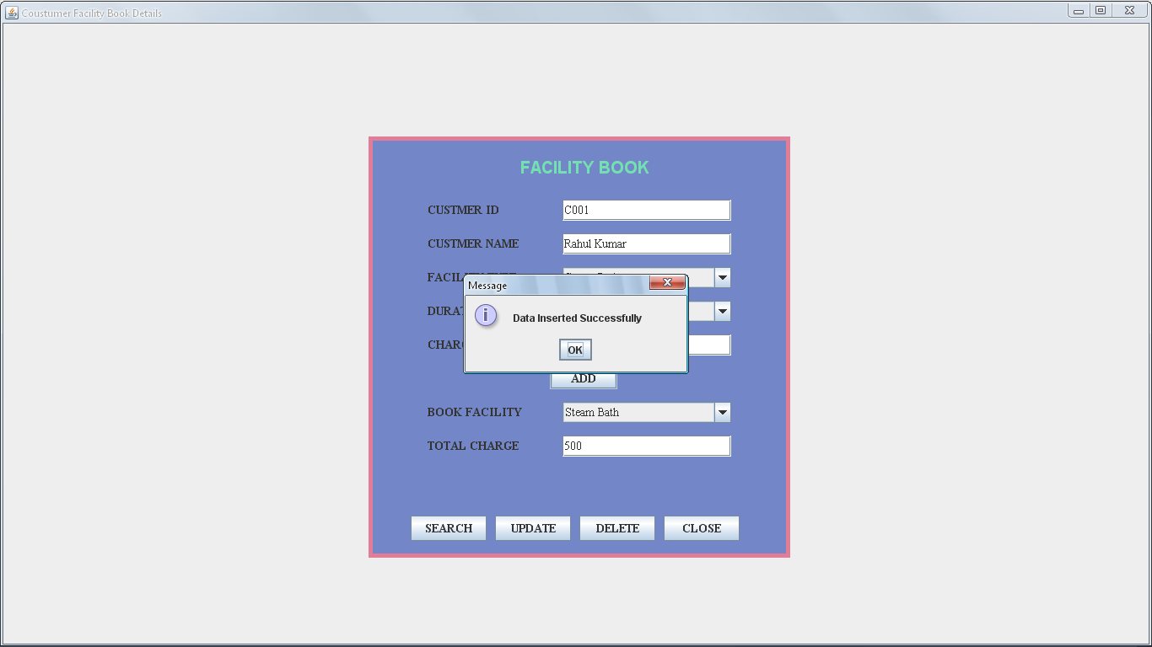

FIGURE:6: SHOWS BOOK FACILITY CUSTOMERS FORM

**CODING BOOK FACILITY for customer**

import java.awt.*;

import javax.swing.*;

import java.awt.event.*;

import java.sql.*;

class FacilityBookDetsCus extends JFrame implements ActionListener

{

static String st="";

JPanel jpanel1=new JPanel();

JPanel jpanel2=new JPanel();

JLabel jlabel=new JLabel("FACILITY BOOK");

JLabel VIlbl=new JLabel("CUSTMER ID");

JTextField VItext=new JTextField(10);

JLabel VNlbl=new JLabel("CUSTMER NAME");

JTextField VNtext=new JTextField(25);

JLabel FClbl=new JLabel("FACILITY TYPE");

JComboBox FC=new JComboBox();

JLabel DUlbl=new JLabel("DURATION");

JComboBox DU=new JComboBox();

JLabel CHlbl=new JLabel("CHARGE");

JTextField CHtext=new JTextField("0",5);

JButton jbtn1=new JButton("ADD");

JLabel TBFlbl=new JLabel("BOOK FACILITY");

JComboBox TBF=new JComboBox();

JLabel TClbl=new JLabel("TOTAL CHARGE");

JTextField TCtext=new JTextField("0",6);

JButton jbtn2=new JButton("SEARCH");

JButton jbtn3=new JButton("UPDATE");

JButton jbtn4=new JButton("DELETE");

JButton jbtn5=new JButton("CLOSE");

FacilityBookDetsCus(String st)

{

super (st);

setVisible(true);

add(jpanel1);

jpanel1.setLayout(null);

jpanel2.setLayout(null);

jpanel1.add(jpanel2);

jpanel2.setSize(500,500);

jpanel2.setBackground(new Color(115,135,200));

jpanel2.add(jlabel);

jlabel.setFont(new Font("ARIAl",Font.BOLD,20));

jlabel.setForeground(new Color(115,225,175));

jpanel2.add(VIlbl);

VIlbl.setFont(new Font("TIMES NEW ROMAN",Font.BOLD,14));

jpanel2.add(VItext);

VItext.setFont(new Font("TIMES NEW ROMAN",Font.PLAIN,14));

jpanel2.add(VNlbl);

VNlbl.setFont(new Font("TIMES NEW ROMAN",Font.BOLD,14));

jpanel2.add(VNtext);

VNtext.setFont(new Font("TIMES NEW ROMAN",Font.PLAIN,14));

jpanel2.add(FClbl);

FClbl.setFont(new Font("TIMES NEW ROMAN",Font.BOLD,14));

jpanel2.add(FC);

FC.addItem("Select");

FC.addItem("Swimming Pool");

FC.addItem("Steam Bath");

FC.addItem("Sauna Bath");

FC.setFont(new Font("TIMES NEW ROMAN",Font.PLAIN,14));

jpanel2.add(DUlbl);

DUlbl.setFont(new Font("TIMES NEW ROMAN",Font.BOLD,14));

jpanel2.add(DU);

DU.addItem("Select");

DU.addItem("1 Hours");

DU.addItem("2 Hours");

DU.addItem("3 Hours");

DU.setFont(new Font("TIMES NEW ROMAN",Font.PLAIN,14));

jpanel2.add(CHlbl);

CHlbl.setFont(new Font("TIMES NEW ROMAN",Font.BOLD,14));

jpanel2.add(CHtext);

CHtext.setFont(new Font("TIMES NEW ROMAN",Font.PLAIN,14));

jpanel2.add(TBFlbl);

TBFlbl.setFont(new Font("TIMES NEW ROMAN",Font.BOLD,14));

jpanel2.add(TBF);

TBF.setFont(new Font("TIMES NEW ROMAN",Font.PLAIN,14));

jpanel2.add(TClbl);

TClbl.setFont(new Font("TIMES NEW ROMAN",Font.BOLD,14));

jpanel2.add(TCtext);

TCtext.setFont(new Font("TIMES NEW ROMAN",Font.PLAIN,14));

jpanel2.add(jbtn1);

jbtn1.setFont(new Font("TIMES NEW ROMAN",Font.BOLD,14));

jpanel2.add(jbtn2);

jbtn2.setFont(new Font("TIMES NEW ROMAN",Font.BOLD,14));

jpanel2.add(jbtn3);

jbtn3.setFont(new Font("TIMES NEW ROMAN",Font.BOLD,14));

jpanel2.add(jbtn4);

jbtn4.setFont(new Font("TIMES NEW ROMAN",Font.BOLD,14));

jpanel2.add(jbtn5);

jbtn5.setFont(new Font("TIMES NEW ROMAN",Font.BOLD,14));

jlabel.setBounds(180,20,160,35);

VIlbl.setBounds(70,75,130,25);

VItext.setBounds(230,75,200,25);

VNlbl.setBounds(70,115,130,25);

VNtext.setBounds(230,115,200,25);

FClbl.setBounds(70,155,130,25);

FC.setBounds(230,155,200,25);

DUlbl.setBounds(70,195,130,25);

DU.setBounds(230,195,200,25);

CHlbl.setBounds(70,235,130,25);

CHtext.setBounds(230,235,200,25);

jbtn1.setBounds(215,275,80,25);

TBFlbl.setBounds(70,315,130,25);

TBF.setBounds(230,315,200,25);

TClbl.setBounds(70,355,130,25);

TCtext.setBounds(230,355,200,25);

jbtn2.setBounds(50,450,90,30);

jbtn3.setBounds(150,450,90,30);

jbtn4.setBounds(250,450,90,30);

jbtn5.setBounds(350,450,90,30);

Toolkit toolkit=getToolkit();

Dimension dim=toolkit.getScreenSize();

int w=dim.width;

int h=dim.height;

setSize(w,h);

jpanel2.setBounds(dim.width/2-250,dim.height/2-250,500,500);

jpanel2.setBorder(BorderFactory.createLineBorder(new Color(225,125,150),5));

jbtn1.addActionListener(this);

jbtn2.addActionListener(this);

jbtn3.addActionListener(this);

jbtn4.addActionListener(this);

jbtn5.addActionListener(this);

FC.addActionListener(this);

DU.addActionListener(this);

}

public void actionPerformed(ActionEvent e)

{

if(e.getSource()==jbtn1)

{

if(st.equals(VItext.getText()))

{

TBF.addItem(FC.getSelectedItem().toString());

TCtext.setText(""+(Integer.parseInt(CHtext.getText())+Integer.parseInt(TCtext.getText())));

}

else

{

System.out.println("New");

st=VItext.getText();

TBF.removeAllItems();

TCtext.setText("0");

TBF.addItem(FC.getSelectedItem().toString());

TCtext.setText(""+(Integer.parseInt(CHtext.getText())+Integer.parseInt(TCtext.getText())));

}

try

{ /*Insert Coding.....*/

Class.forName("sun.jdbc.odbc.JdbcOdbcDriver");

Connection con=DriverManager.getConnection("Jdbc:Odbc:myname","system","oracle");

PreparedStatement ps=con.prepareStatement("insert into FacilityBookDetsCus values(?,?,?,?,?)");

ps.setString(1,VItext.getText());

ps.setString(2,VNtext.getText());

ps.setString(3,FC.getSelectedItem().toString());

ps.setString(5,CHtext.getText());

ps.setString(4,DU.getSelectedItem().toString());

int R=ps.executeUpdate();

if(R>0)

{

JOptionPane.showMessageDialog(this,"Data Inserted Successfully");

}

else

{

JOptionPane.showMessageDialog(this,"Data Not Inserted Successfully");

}

}

catch(Exception S)

{

System.out.println(S);

}

else if(e.getSource()==jbtn2) /*Searching Coding...*/

{

try

{

Class.forName("sun.jdbc.odbc.JdbcOdbcDriver");

Connection con=DriverManager.getConnection("Jdbc:Odbc:myname","system","oracle");

PreparedStatement ps=con.prepareStatement("select * from FacilityBookDetsCus where cid=?");

ps.setString(1,VItext.getText());

ResultSet rs=ps.executeQuery();

if(rs.next())

{

JOptionPane.showMessageDialog(this,"Data found...");

VNtext.setText(rs.getString(2));

FC.setSelectedItem(rs.getString(3));

CHtext.setText(rs.getString(4));

DU.setSelectedItem(rs.getString(5));

}

else

{

JOptionPane.showMessageDialog(this,"Data Not Search Successfully");

}

}

catch(Exception S)

{

System.out.println(S);

}

}

else if(e.getSource()==jbtn3) /*Updating Coding...*/

{

try

{

Class.forName("sun.jdbc.odbc.JdbcOdbcDriver");

Connection con=DriverManager.getConnection("Jdbc:Odbc:myname","system","oracle");

PreparedStatement ps=con.prepareStatement("update FacilityBookDetsCus set cid=?,cn=?,ft=?,du=?,ch=? where cid=?");

ps.setString(1,VItext.getText());

ps.setString(2,VNtext.getText());

ps.setString(3,FC.getSelectedItem().toString());

ps.setString(4,DU.getSelectedItem().toString());

ps.setString(5,CHtext.getText());

ps.setString(6,VItext.getText());

int R=ps.executeUpdate();

if(R>0)

{

JOptionPane.showMessageDialog(this,"Data Update Successfully");

}

else

{

JOptionPane.showMessageDialog(this,"Data Not Update Successfully");

}

}

catch(Exception S)

{

System.out.println(S);

}

}

else if(e.getSource()==jbtn4) /*Deleting Coding...*/

{

try

{

Class.forName("sun.jdbc.odbc.JdbcOdbcDriver");

Connection con=DriverManager.getConnection("Jdbc:Odbc:myname","system","oracle");

PreparedStatement ps=con.prepareStatement("delete from FacilityBookDetsCus where cid=?");

ps.setString(1,VItext.getText());

int R=ps.executeUpdate();

if(R>0)

{

JOptionPane.showMessageDialog(this,"Data Deleted Successfully");

}

else

{

JOptionPane.showMessageDialog(this,"Data Not Deleted Successfully");

}

}

catch(Exception S)

{

System.out.println(S);

}

}

else if(e.getSource()==jbtn5)

{

dispose();

}

else if(e.getSource()==FC || e.getSource()==DU)

{

if(FC.getSelectedItem().equals("Swimming Pool") && DU.getSelectedItem().equals("1 Hours"))

{

CHtext.setText("100");

}

else if(FC.getSelectedItem().equals("Swimming Pool") && DU.getSelectedItem().equals("2Hours"))

{

CHtext.setText("200");

}

else if(FC.getSelectedItem().equals("Swimming Pool") && DU.getSelectedItem().equals("3Hours"))

{

CHtext.setText("300");

}

else if(FC.getSelectedItem().equals("Steam Bath") && DU.getSelectedItem().equals("1 Hours"))

{

CHtext.setText("400");

}

else if(FC.getSelectedItem().equals("Steam Bath") && DU.getSelectedItem().equals("2 Hours"))

{

CHtext.setText("500");

}

else if(FC.getSelectedItem().equals("Steam Bath") && DU.getSelectedItem().equals("3 Hours"))

{

CHtext.setText("600");

}

else if(FC.getSelectedItem().equals("Sauna Bath") && DU.getSelectedItem().equals("1 Hours"))

{

CHtext.setText("100");

}

else if(FC.getSelectedItem().equals("Sauna Bath") && DU.getSelectedItem().equals("1 Hours"))

{

CHtext.setText("700");

}

else if(FC.getSelectedItem().equals("Sauna Bath") && DU.getSelectedItem().equals("2 Hours"))

{

CHtext.setText("800");

}

else if(FC.getSelectedItem().equals("Sauna Bath") && DU.getSelectedItem().equals("3 Hours"))

{

CHtext.setText("900");

}

}

}

public static void main(String args[])

{

new FacilityBookDetsCus("Facility Booking Windows For Coustmer");

}

}

**VISITOR DETAILS FORM**

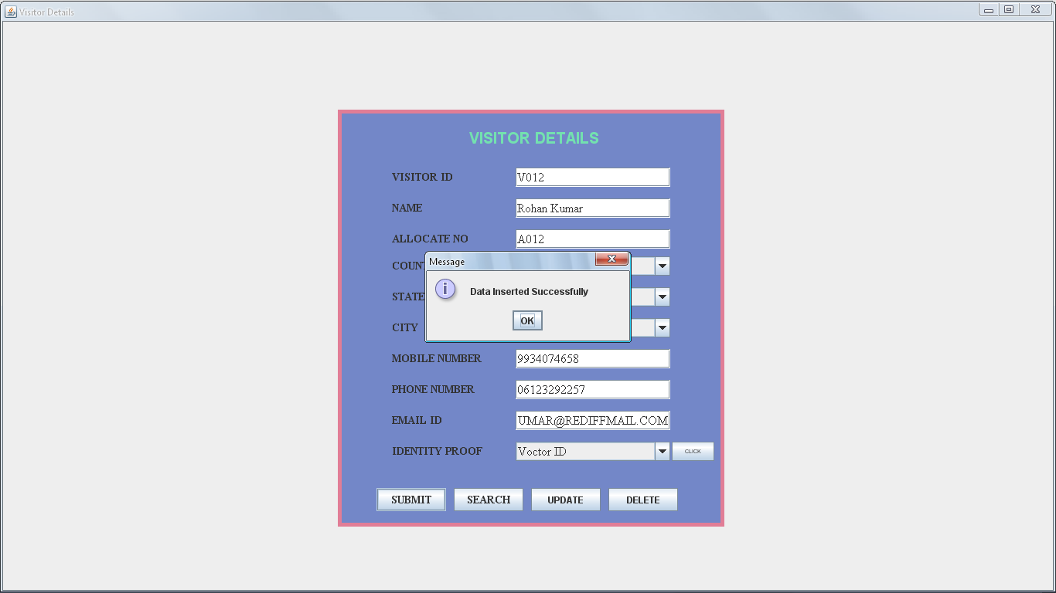

FIGURE:7: SHOWS BOOK FACILITY CUSTOMERS FORM

CODING FOR VISITOR DETAILS **FORM**

import java.awt.*;

import javax.swing.*;

import java.awt.event.*;

import java.sql.*;

class Visitorsdets extends JFrame implements ActionListener

{

JPanel jpanel1=new JPanel();

JPanel jpanel2=new JPanel();

JLabel jlabel=new JLabel("VISITOR DETAILS");

JLabel VIlbl=new JLabel("VISITOR ID");

static JTextField VItext=new JTextField(10);

JLabel VNlbl=new JLabel("NAME");

static JTextField VNtext=new JTextField(30);

JLabel VAlbl=new JLabel("ALLOCATE NO");

JTextField VAtext=new JTextField(10);

JScrollPane SC=new JScrollPane(VAtext);

JLabel VClbl=new JLabel("COUNTRY");

JComboBox VC=new JComboBox();

JLabel VSlbl=new JLabel("STATE");

JComboBox VS=new JComboBox();

JLabel VCYlbl=new JLabel("CITY");

JComboBox VCY=new JComboBox();

JLabel VMNlbl=new JLabel("MOBILE NUMBER");

JTextField VMNtext=new JTextField(12);

JLabel VPlbl=new JLabel("PHONE NUMBER");

JTextField VPtext=new JTextField(15);

JLabel VElbl=new JLabel("EMAIL ID");

JTextField VEtext=new JTextField(30);

JLabel VIPlbl=new JLabel("IDENTITY PROOF");

JComboBox VIP=new JComboBox();

JButton jbutton=new JButton("CLICK");

JButton jbutton1=new JButton("SUBMIT");

JButton jbutton2=new JButton("SEARCH");

JButton jbutton3=new JButton("UPDATE");

JButton jbutton4=new JButton("DELETE");

Visitorsdets(String st)

{

super(st);

setVisible(true);

add(jpanel1);

jpanel1.add(jpanel2);

jpanel1.setLayout(null);

jpanel2.setSize(500,540);

jpanel2.setLayout(null);

jpanel2.setBackground(new Color(115,135,200));

jpanel2.add(jlabel);

jlabel.setForeground(new Color(115,225,175));

jlabel.setFont(new Font("ARIAL",Font.BOLD,20));

jpanel2.add(VIlbl);

VIlbl.setFont(new Font("TIMES NEW ROMAN",Font.BOLD,14));

jpanel2.add(VItext);

VItext.setFont(new Font("TIMES NEW ROMAN",Font.PLAIN,16));

jpanel2.add(VNlbl);

VNlbl.setFont(new Font("TIMES NEW ROMAN",Font.BOLD,14));

jpanel2.add(VNtext);

VNtext.setFont(new Font("TIMES NEW ROMAN",Font.PLAIN,16));

jpanel2.add(VAlbl);

VAlbl.setFont(new Font("TIMES NEW ROMAN",Font.BOLD,14));

jpanel2.add(VAtext);

VAtext.setFont(new Font("TIMES NEW ROMAN",Font.PLAIN,16));

jpanel2.add(VClbl);

VClbl.setFont(new Font("TIMES NEW ROMAN",Font.BOLD,14));

jpanel2.add(VC);

VC.addItem("India");

VC.addItem("America");

VC.addItem("China");

VC.addItem("Nepal");

VC.addItem("Others");

VC.setFont(new Font("TIMES NEW ROMAN",Font.PLAIN,16));

jpanel2.add(VSlbl);

VSlbl.setFont(new Font("TIMES NEW ROMAN",Font.BOLD,14));

jpanel2.add(VS);

VS.addItem("Bihar");

VS.addItem("Jharkhand");

VS.addItem("UP");

VS.addItem("Mumbi");

VS.addItem("Timilnaddu");

VS.addItem("Urisha");

VS.addItem("MP");

VS.addItem("Others");

VS.setFont(new Font("TIMES NEW ROMAN",Font.PLAIN,16));

jpanel2.add(VCYlbl);

VCYlbl.setFont(new Font("TIMES NEW ROMAN",Font.BOLD,14));

jpanel2.add(VCY);

VCY.addItem("Patna");

VCY.addItem("Muzzaffperpur");

VCY.addItem("Supaul");

VCY.addItem("Saharsha");

VCY.addItem("Begusari");

VCY.addItem("Nalanda");

VCY.addItem("Others");

VCY.setFont(new Font("TIMES NEW ROMAN",Font.PLAIN,16));

jpanel2.add(VMNlbl);

VMNlbl.setFont(new Font("TIMES NEW ROMAN",Font.BOLD,14));

jpanel2.add(VMNtext);

VMNtext.setFont(new Font("TIMES NEW ROMAN",Font.PLAIN,16));

jpanel2.add(VPlbl);

VPlbl.setFont(new Font("TIMES NEW ROMAN",Font.BOLD,14));

jpanel2.add(VPtext);

VPtext.setFont(new Font("TIMES NEW ROMAN",Font.PLAIN,16));

jpanel2.add(VElbl);

VElbl.setFont(new Font("TIMES NEW ROMAN",Font.BOLD,14));

jpanel2.add(VEtext);

VEtext.setFont(new Font("TIMES NEW ROMAN",Font.PLAIN,16));

jpanel2.add(VIPlbl);

VIPlbl.setFont(new Font("TIMES NEW ROMAN",Font.BOLD,14));

jpanel2.add(VIP);

VIP.addItem("Voctor ID");

VIP.addItem("Passport");

VIP.addItem("Others");

VIP.setFont(new Font("TIMES NEW ROMAN",Font.PLAIN,16));

jpanel2.add(jbutton);

jbutton.setFont(new Font("TIME NEW ROMAN",Font.PLAIN,7));

jpanel2.add(jbutton1);

jbutton1.setFont(new Font("TIMES NEW ROMAN",Font.BOLD,14));

jpanel2.add(jbutton2);

jbutton2.setFont(new Font("TIMES NEW ROMAN",Font.BOLD,14));

jpanel2.add(jbutton3);

jbutton1.setFont(new Font("TIMES NEW ROMAN",Font.BOLD,14));

jpanel2.add(jbutton4);

jbutton1.setFont(new Font("TIMES NEW ROMAN",Font.BOLD,14));

jlabel.setBounds(170,20,240,35);

VIlbl.setBounds(70,75,130,25);

VItext.setBounds(230,75,200,25);

VNlbl.setBounds(70,115,130,25);

VNtext.setBounds(230,115,200,25);

VAlbl.setBounds(70,155,130,25);

VAtext.setBounds(230,155,200,25);

VClbl.setBounds(70,190,130,25);

VC.setBounds(230,190,200,25);

VSlbl.setBounds(70,230,130,25);

VS.setBounds(230,230,200,25);

VCYlbl.setBounds(70,270,130,25);

VCY.setBounds(230,270,200,25);

VMNlbl.setBounds(70,310,130,25);

VMNtext.setBounds(230,310,200,25);

VPlbl.setBounds(70,350,130,25);

VPtext.setBounds(230,350,200,25);

VElbl.setBounds(70,390,130,25);

VEtext.setBounds(230,390,200,25);

VIPlbl.setBounds(70,430,130,25);

VIP.setBounds(230,430,200,25);

jbutton.setBounds(432,430,55,25);

jbutton1.setBounds(50,490,90,30);

jbutton2.setBounds(150,490,90,30);

jbutton3.setBounds(250,490,90,30);

jbutton4.setBounds(350,490,90,30);

Toolkit toolkit=getToolkit();

Dimension dim=toolkit.getScreenSize();

int w=dim.width;

int h=dim.height;

setSize(w,h);

jpanel2.setBounds(dim.width/2-250,dim.height/2-270,500,540);

jpanel2.setBorder(BorderFactory.createLineBorder(new Color(225,125,150),5));

jpanel2.add(SC);

jbutton.addActionListener(this);

jbutton1.addActionListener(this);

jbutton2.addActionListener(this);

jbutton3.addActionListener(this);

jbutton4.addActionListener(this);

}

public void actionPerformed(ActionEvent e)

{

if(e.getSource()==jbutton)

{

if(VIP.getSelectedItem().toString().equals("Voctor ID"))

{

new Voteriddets("Voter Id Details");

}

else if(VIP.getSelectedItem().toString().equals("Passport"))

{

new Passportdets("Passport Details");

}

else if(VIP.getSelectedItem().toString().equals("Others"))

{

new Otherdets("Others Details");

}

}

else if(e.getSource()==jbutton1) /*Insert Coding...*/

{

try

{

Class.forName("sun.jdbc.odbc.JdbcOdbcDriver");

Connection con=DriverManager.getConnection("Jdbc:Odbc:myname","system","oracle");

PreparedStatement ps=con.prepareStatement("insert into Visitorsdets values(?,?,?,?,?,?,?,?,?,?)");

ps.setString(1,VItext.getText());

ps.setString(2,VNtext.getText());

ps.setString(3,VAtext.getText());

ps.setString(4,VC.getSelectedItem().toString());

ps.setString(5,VS.getSelectedItem().toString());

ps.setString(6,VCY.getSelectedItem().toString());

ps.setString(7,VMNtext.getText());

ps.setString(8,VPtext.getText());

ps.setString(9,VEtext.getText());

ps.setString(10,VIP.getSelectedItem().toString());

int R=ps.executeUpdate();

if(R>0)

{

JOptionPane.showMessageDialog(this,"Data Inserted Successfully");

}

else

{

JOptionPane.showMessageDialog(this,"Data Not Inserted Successfully");

}

}

catch(Exception S)

{

System.out.println(S);

}

}

else if(e.getSource()==jbutton2) /*Searching Coding...*/

{

try

{

Class.forName("sun.jdbc.odbc.JdbcOdbcDriver");

Connection con=DriverManager.getConnection("Jdbc:Odbc:myname","system","oracle");

PreparedStatement ps=con.prepareStatement("Select *from Visitorsdets where vid=?");

ps.setString(1,VItext.getText());

ResultSet rs=ps.executeQuery();

if(rs.next())

{

JOptionPane.showMessageDialog(this,"Data found...");

VNtext.setText(rs.getString(2));

VAtext.setText(rs.getString(3));

VC.setSelectedItem(rs.getString(4));

VS.setSelectedItem(rs.getString(5));

VCY.setSelectedItem(rs.getString(6));

VMNtext.setText(rs.getString(7));

VPtext.setText(rs.getString(8));

VEtext.setText(rs.getString(9));

VIP.setSelectedItem(rs.getString(10));

}

else

{

JOptionPane.showMessageDialog(this,"Data Not Search Successfully");

}

}

catch(Exception S)

{

System.out.println(S);

}

}

else if(e.getSource()==jbutton3) /*Updating Coding...*/

{

try

{

Class.forName("sun.jdbc.odbc.JdbcOdbcDriver");

Connection con=DriverManager.getConnection("Jdbc:Odbc:myname","system","oracle");

PreparedStatement ps=con.prepareStatement("update Visitorsdets set vid=?,vn=?,va=?,vc=?,vs=?,vcy=?,vmn=?,vpn=?,veid=?,vidp=? where vid=?");

ps.setString(1,VItext.getText());

ps.setString(2,VNtext.getText());

ps.setString(3,VAtext.getText());

ps.setString(4,VC.getSelectedItem().toString());

ps.setString(5,VS.getSelectedItem().toString());

ps.setString(6,VCY.getSelectedItem().toString());

ps.setString(7,VMNtext.getText());

ps.setString(8,VPtext.getText());

ps.setString(9,VEtext.getText());

ps.setString(10,VIP.getSelectedItem().toString());

ps.setString(11,VItext.getText());

int R=ps.executeUpdate();

if(R>0)

{

JOptionPane.showMessageDialog(this,"Data Update Successfully");

}

else

{

JOptionPane.showMessageDialog(this,"Data Not Update Successfully");

}

}

catch(Exception S)

{

System.out.println(S);

}

}

else if(e.getSource()==jbutton4) /*Deleting Coding...*/

{

try

{

Class.forName("sun.jdbc.odbc.JdbcOdbcDriver");

Connection con=DriverManager.getConnection("Jdbc:Odbc:myname","system","oracle");

PreparedStatement ps=con.prepareStatement("delete from Visitorsdets where vid=?");

ps.setString(1,VItext.getText());

int R=ps.executeUpdate();

if(R>0)

{

JOptionPane.showMessageDialog(this,"Data Deleted Successfully");

}

else

{

JOptionPane.showMessageDialog(this,"Data Not Deleted Successfully");

}

}

catch(Exception S)

{

System.out.println(S);

}

}

}

public static void main(String args[])

{

new Visitorsdets("Visitors Details Windows");

}

}

VOTER ID DETAILS FORM

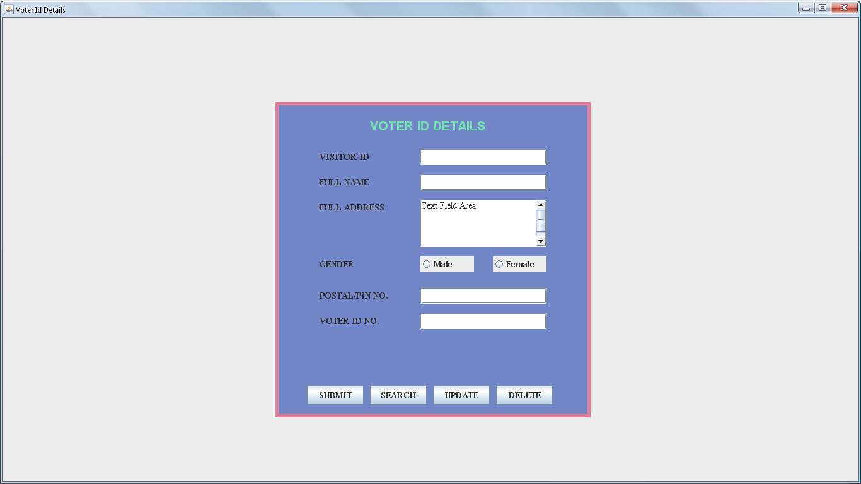

FIGURE:8: SHOWS VOTER ID DETAILS FORM

CODING FOR VOTER ID DETAILS FORM

import java.awt.*;

import javax.swing.*;

import java.awt.event.*;

import java.sql.*;

class Voteriddets extends JFrame implements ActionListener

{

JPanel jpanel1=new JPanel();

JPanel jpanel2=new JPanel();

JLabel jlabel=new JLabel("VOTER ID DETAILS");

JLabel VIlbl=new JLabel("VISITOR ID");

JTextField VItext=new JTextField(Visitorsdets.VItext.getText());

JLabel Nlbl=new JLabel("FULL NAME");

JTextField Ntext=new JTextField(Visitorsdets.VNtext.getText());

JLabel Albl=new JLabel("FULL ADDRESS");

JTextArea Atext=new JTextArea("Text Field Area",5,10);

JLabel RBlbl=new JLabel("GENDER");

JRadioButton RB1=new JRadioButton("Male",false);

JRadioButton RB2=new JRadioButton("Female",false);

ButtonGroup BG=new ButtonGroup();

JScrollPane SC=new JScrollPane(Atext);

JLabel Plbl=new JLabel("POSTAL/PIN NO.");

JTextField Ptext=new JTextField(10);

JLabel PNlbl=new JLabel("VOTER ID NO.");

JTextField PNtext=new JTextField(15);

JButton jbtn1=new JButton("SUBMIT");

JButton jbtn2=new JButton("SEARCH");

JButton jbtn3=new JButton("UPDATE");

JButton jbtn4=new JButton("DELETE");

Voteriddets(String st)

{

super(st);

setVisible(true);

add(jpanel1);

jpanel1.add(jpanel2);

jpanel1.setLayout(null);

jpanel2.setLayout(null);

jpanel2.setSize(500,500);

jpanel2.setBackground(new Color(115,135,200));

jpanel2.add(jlabel);

jlabel.setFont(new Font("ARIL",Font.BOLD,20));

jlabel.setForeground(new Color(115,225,175));

jpanel2.add(VIlbl);

VIlbl.setFont(new Font("TIMES NEW ROMAN",Font.BOLD,14));

jpanel2.add(VItext);

VItext.setFont(new Font("TIMES NEW ROMAN",Font.PLAIN,14));

jpanel2.add(Nlbl);

Nlbl.setFont(new Font("TIMES NEW ROMAN",Font.BOLD,14));

jpanel2.add(Ntext);

Ntext.setFont(new Font("TIMES NEW ROMAN",Font.PLAIN,14));

jpanel2.add(Albl);

Albl.setFont(new Font("TIMES NEW ROMAN",Font.BOLD,14));

jpanel2.add(SC);

Atext.setLineWrap(true);

Atext.setLineWrap(false);

Atext.setFont(new Font("TIMES NEW ROMAN",Font.PLAIN,14));

jpanel2.add(RBlbl);

RBlbl.setFont(new Font("TIMES NEW ROMAN",Font.BOLD,14));

jpanel2.add(RB1);

jpanel2.add(RB2);

BG.add(RB1);

RB1.setFont(new Font("TIMES NEW ROMAN",Font.BOLD,14));

BG.add(RB2);

RB2.setFont(new Font("TIMES NEW ROMAN",Font.BOLD,14));

jpanel2.add(Plbl);

Plbl.setFont(new Font("TIMES NEW ROMAN",Font.BOLD,14));

jpanel2.add(Ptext);

Ptext.setFont(new Font("TIMES NEW ROMAN",Font.PLAIN,14));

jpanel2.add(PNlbl);

PNlbl.setFont(new Font("TIMES NEW ROMAN",Font.BOLD,14));

jpanel2.add(PNtext);

PNtext.setFont(new Font("TIMES NEW ROMAN",Font.PLAIN,14));

jpanel2.add(jbtn1);

jbtn1.setFont(new Font("TIMES NEW ROMAN",Font.BOLD,14));

jpanel2.add(jbtn2);

jbtn2.setFont(new Font("TIMES NEW ROMAN",Font.BOLD,14));

jpanel2.add(jbtn3);

jbtn3.setFont(new Font("TIMES NEW ROMAN",Font.BOLD,14));

jpanel2.add(jbtn4);

jbtn4.setFont(new Font("TIMES NEW ROMAN",Font.BOLD,14));

jlabel.setBounds(150,20,200,35);

VIlbl.setBounds(70,75,130,25);

VItext.setBounds(230,75,200,25);

Nlbl.setBounds(70,115,130,25);

Ntext.setBounds(230,115,200,25);

Albl.setBounds(70,155,130,25);

SC.setBounds(230,155,200,75);

RBlbl.setBounds(70,245,130,25);

RB1.setBounds(230,245,85,25);

RB2.setBounds(345,245,85,25);

Plbl.setBounds(70,295,130,25);

Ptext.setBounds(230,295,200,25);

PNlbl.setBounds(70,335,130,25);

PNtext.setBounds(230,335,200,25);

jbtn1.setBounds(50,450,90,30);

jbtn2.setBounds(150,450,90,30);

jbtn3.setBounds(250,450,90,30);

jbtn4.setBounds(350,450,90,30);

Toolkit toolkit=getToolkit();

Dimension dim=toolkit.getScreenSize();

int w=dim.width;

int h=dim.height;

setSize(w,h);

jpanel2.setBounds(dim.width/2-250,dim.height/2-250,500,500);

jpanel2.setBorder(BorderFactory.createLineBorder(new Color(225,125,150),5));

jbtn1.addActionListener(this);

/*jbutton2.addActionListener(this);

jbutton3.addActionListener(this);

jbutton4.addActionListener(this);*/

}

public void actionPerformed(ActionEvent e)

{

if(e.getSource()==jbtn1)

{

String gender="";

try

{

if(RB1.isSelected())

{

gender="Male";

}

else

{

gender="Female";

}

Class.forName("sun.jdbc.odbc.JdbcOdbcDriver");

Connection con=DriverManager.getConnection("Jdbc:Odbc:myname","system","oracle");

PreparedStatement ps=con.prepareStatement("insert into Voteriddets values(?,?,?,?,?)");

ps.setString(1,Ntext.getText());

ps.setString(2,Atext.getText());

ps.setString(3,gender);

ps.setString(4,Ptext.getText());

ps.setString(5,PNtext.getText());

int R=ps.executeUpdate();

if(R>0)

{

JOptionPane.showMessageDialog(this,"Data Inserted Successfully");

}

else

{

JOptionPane.showMessageDialog(this,"Data Not Inserted Successfully");

}

}

catch(Exception S)

{

System.out.println(S);

}

}

}

public static void main(String args[])

{

new Voteriddets("Passport Details Windows");

}

}

PASSPORT DETAILS FORM

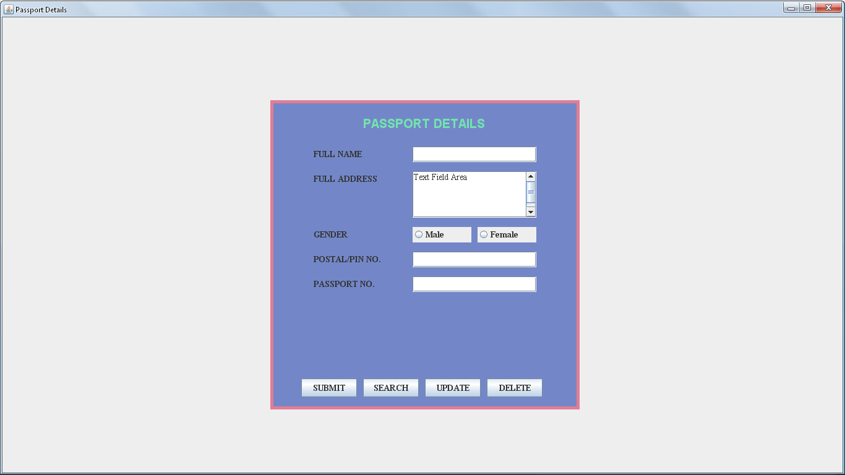

FIGURE:9: SHOWS PASSPORT DETAILS FORM

CODING FOR PASSPORT DETAILS FORM

import java.awt.*;

import javax.swing.*;

import java.awt.event.*;

import java.sql.*;

class Passportdets extends JFrame implements ActionListener

{

JPanel jpanel1=new JPanel();

JPanel jpanel2=new JPanel();

JLabel jlabel=new JLabel("PASSPORT DETAILS");

JLabel Nlbl=new JLabel("FULL NAME");

JTextField Ntext=new JTextField(30);

JLabel Albl=new JLabel("FULL ADDRESS");

JTextArea Atext=new JTextArea("Text Field Area",5,10);

JScrollPane SC=new JScrollPane(Atext);

JLabel RBlbl=new JLabel("GENDER");

JRadioButton RB1=new JRadioButton("Male",false);

JRadioButton RB2=new JRadioButton("Female",false);

ButtonGroup BG=new ButtonGroup();

JLabel Plbl=new JLabel("POSTAL/PIN NO.");

JTextField Ptext=new JTextField(10);

JLabel PNlbl=new JLabel("PASSPORT NO.");

JTextField PNtext=new JTextField(15);

JButton jbtn1=new JButton("SUBMIT");

JButton jbtn2=new JButton("SEARCH");

JButton jbtn3=new JButton("UPDATE");

JButton jbtn4=new JButton("DELETE");

Passportdets(String st)

{

super(st);

setVisible(true);

add(jpanel1);

jpanel1.add(jpanel2);

jpanel1.setLayout(null);

jpanel2.setLayout(null);

jpanel2.setSize(500,500);

jpanel2.setBackground(new Color(115,135,200));

jpanel2.add(jlabel);

jlabel.setFont(new Font("ARIL",Font.BOLD,20));

jlabel.setForeground(new Color(115,225,175));

jpanel2.add(Nlbl);

Nlbl.setFont(new Font("TIMES NEW ROMAN",Font.BOLD,14));

jpanel2.add(Ntext);

Ntext.setFont(new Font("TIMES NEW ROMAN",Font.PLAIN,14));

jpanel2.add(Albl);

Albl.setFont(new Font("TIMES NEW ROMAN",Font.BOLD,14));

jpanel2.add(SC);

Atext.setLineWrap(true);

Atext.setLineWrap(false);

Atext.setFont(new Font("TIMES NEW ROMAN",Font.PLAIN,14));

jpanel2.add(RBlbl);

RBlbl.setFont(new Font("TIMES NEW ROMAN",Font.BOLD,14));

jpanel2.add(RB1);

jpanel2.add(RB2);

BG.add(RB1);

RB1.setFont(new Font("TIMES NEW ROMAN",Font.BOLD,14));

BG.add(RB2);

RB2.setFont(new Font("TIMES NEW ROMAN",Font.BOLD,14));

jpanel2.add(Plbl);

Plbl.setFont(new Font("TIMES NEW ROMAN",Font.BOLD,14));

jpanel2.add(Ptext);

Ptext.setFont(new Font("TIMES NEW ROMAN",Font.PLAIN,14));

jpanel2.add(PNlbl);

PNlbl.setFont(new Font("TIMES NEW ROMAN",Font.BOLD,14));

jpanel2.add(PNtext);

PNtext.setFont(new Font("TIMES NEW ROMAN",Font.PLAIN,14));

jpanel2.add(jbtn1);

jbtn1.setFont(new Font("TIMES NEW ROMAN",Font.BOLD,14));

jpanel2.add(jbtn2);

jbtn2.setFont(new Font("TIMES NEW ROMAN",Font.BOLD,14));

jpanel2.add(jbtn3);

jbtn3.setFont(new Font("TIMES NEW ROMAN",Font.BOLD,14));

jpanel2.add(jbtn4);

jbtn4.setFont(new Font("TIMES NEW ROMAN",Font.BOLD,14));

jlabel.setBounds(150,20,200,35);

Nlbl.setBounds(70,75,130,25);

Ntext.setBounds(230,75,200,25);

Albl.setBounds(70,115,130,25);

SC.setBounds(230,115,200,75);

RBlbl.setBounds(70,205,130,25);

RB1.setBounds(230,205,95,25);

RB2.setBounds(335,205,95,25);

Plbl.setBounds(70,245,130,25);

Ptext.setBounds(230,245,200,25);

PNlbl.setBounds(70,285,130,25);

PNtext.setBounds(230,285,200,25);

jbtn1.setBounds(50,450,90,30);

jbtn2.setBounds(150,450,90,30);

jbtn3.setBounds(250,450,90,30);

jbtn4.setBounds(350,450,90,30);

Toolkit toolkit=getToolkit();

Dimension dim=toolkit.getScreenSize();

int w=dim.width;

int h=dim.height;

setSize(w,h);

jpanel2.setBounds(dim.width/2-250,dim.height/2-250,500,500);

jpanel2.setBorder(BorderFactory.createLineBorder(new Color(225,125,150),5));

jbtn1.addActionListener(this);

}

public void actionPerformed(ActionEvent e)

{

if(e.getSource()==jbtn1)

{String gender="";

try

{

if(RB1.isSelected())

{

gender="Male";

}

else

{

gender="Female";

}

Class.forName("sun.jdbc.odbc.JdbcOdbcDriver");

Connection con=DriverManager.getConnection("Jdbc:Odbc:myname","system","oracle");

PreparedStatement ps=con.prepareStatement("insert into Passportdets values(?,?,?,?,?)");

ps.setString(1,Ntext.getText());

ps.setString(2,Atext.getText());

ps.setString(3,gender);

ps.setString(4,Ptext.getText());

ps.setString(5,PNtext.getText());

int R=ps.executeUpdate();

if(R>0)

{

JOptionPane.showMessageDialog(this,"Data Inserted Successfully");

}

else

{

JOptionPane.showMessageDialog(this,"Data Not Inserted Successfully");

}

}

catch(Exception S)

{

System.out.println(S);

}

}

}

public static void main(String args[])

{

new Passportdets("Passport Details Windows");

}

}

other DETAILS FORM

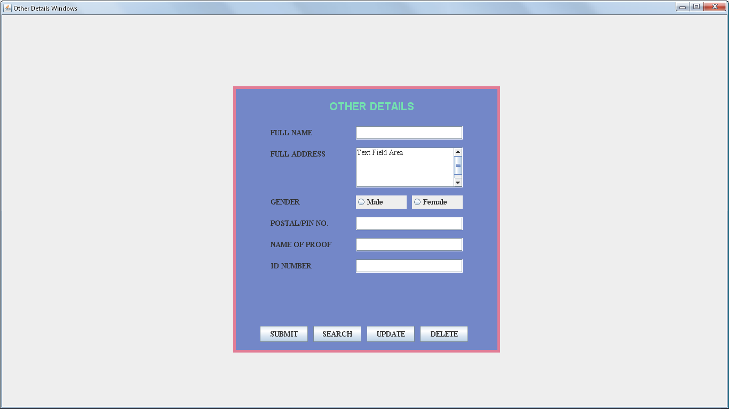FIGURE:10: SHOWS OTHER DETAILS FORM

CODING FOR other DETAILS FORM

import java.awt.*;

import javax.swing.*;

import java.awt.event.*;

import java.sql.*;

class Otherdets extends JFrame implements ActionListener

{

JPanel jpanel1=new JPanel();

JPanel jpanel2=new JPanel();

JLabel jlabel=new JLabel("OTHER DETAILS");

JLabel Nlbl=new JLabel("FULL NAME");

JTextField Ntext=new JTextField(30);

JLabel Albl=new JLabel("FULL ADDRESS");

JTextArea Atext=new JTextArea("Text Field Area",5,10);

JScrollPane SC=new JScrollPane(Atext);

JLabel RBlbl=new JLabel("GENDER");

JRadioButton RB1=new JRadioButton("Male",false);

JRadioButton RB2=new JRadioButton("Female",false);

ButtonGroup BG=new ButtonGroup();

JLabel Plbl=new JLabel("POSTAL/PIN NO.");

JTextField Ptext=new JTextField(10);

JLabel PNlbl=new JLabel("NAME OF PROOF");

JTextField PNtext=new JTextField(15);

JLabel NOPFlbl=new JLabel("ID NUMBER");

JTextField NOPFtext=new JTextField(25);

JButton jbtn1=new JButton("SUBMIT");

JButton jbtn2=new JButton("SEARCH");

JButton jbtn3=new JButton("UPDATE");

JButton jbtn4=new JButton("DELETE");

Otherdets(String st)

{

super(st);

setVisible(true);

add(jpanel1);

jpanel1.add(jpanel2);

jpanel1.setLayout(null);

jpanel2.setLayout(null);

jpanel2.setSize(500,500);

jpanel2.setBackground(new Color(115,135,200));

jpanel2.add(jlabel);

jlabel.setFont(new Font("ARIL",Font.BOLD,20));

jlabel.setForeground(new Color(115,225,175));

jpanel2.add(Nlbl);

Nlbl.setFont(new Font("TIMES NEW ROMAN",Font.BOLD,14));

jpanel2.add(Ntext);

Ntext.setFont(new Font("TIMES NEW ROMAN",Font.PLAIN,14));

jpanel2.add(Albl);

Albl.setFont(new Font("TIMES NEW ROMAN",Font.BOLD,14));

jpanel2.add(SC);

Atext.setLineWrap(true);

Atext.setLineWrap(false);

Atext.setFont(new Font("TIMES NEW ROMAN",Font.PLAIN,14));

jpanel2.add(RBlbl);

RBlbl.setFont(new Font("TIMES NEW ROMAN",Font.BOLD,14));

jpanel2.add(RB1);

jpanel2.add(RB2);

BG.add(RB1);

RB1.setFont(new Font("TIMES NEW ROMAN",Font.BOLD,14));

BG.add(RB2);

RB2.setFont(new Font("TIMES NEW ROMAN",Font.BOLD,14));

jpanel2.add(Plbl);

Plbl.setFont(new Font("TIMES NEW ROMAN",Font.BOLD,14));

jpanel2.add(Ptext);

Ptext.setFont(new Font("TIMES NEW ROMAN",Font.PLAIN,14));

jpanel2.add(PNlbl);

PNlbl.setFont(new Font("TIMES NEW ROMAN",Font.BOLD,14));

jpanel2.add(PNtext);

PNtext.setFont(new Font("TIMES NEW ROMAN",Font.PLAIN,14));

jpanel2.add(NOPFlbl);

NOPFlbl.setFont(new Font("TIMES NEW ROMAN",Font.BOLD,14));

jpanel2.add(NOPFtext);

NOPFtext.setFont(new Font("TIMES NEW ROMAN",Font.PLAIN,14));

jpanel2.add(jbtn1);

jbtn1.setFont(new Font("TIMES NEW ROMAN",Font.BOLD,14));

jpanel2.add(jbtn2);

jbtn2.setFont(new Font("TIMES NEW ROMAN",Font.BOLD,14));

jpanel2.add(jbtn3);

jbtn3.setFont(new Font("TIMES NEW ROMAN",Font.BOLD,14));

jpanel2.add(jbtn4);

jbtn4.setFont(new Font("TIMES NEW ROMAN",Font.BOLD,14));

jlabel.setBounds(180,20,200,35);

Nlbl.setBounds(70,75,130,25);

Ntext.setBounds(230,75,200,25);

Albl.setBounds(70,115,130,25);

SC.setBounds(230,115,200,75);

RBlbl.setBounds(70,205,130,25);

RB1.setBounds(230,205,95,25);

RB2.setBounds(335,205,95,25);

Plbl.setBounds(70,245,130,25);

Ptext.setBounds(230,245,200,25);

PNlbl.setBounds(70,285,130,25);

PNtext.setBounds(230,285,200,25);

NOPFlbl.setBounds(70,325,130,25);

NOPFtext.setBounds(230,325,200,25);

jbtn1.setBounds(50,450,90,30);

jbtn2.setBounds(150,450,90,30);

jbtn3.setBounds(250,450,90,30);

jbtn4.setBounds(350,450,90,30);

Toolkit toolkit=getToolkit();

Dimension dim=toolkit.getScreenSize();

int w=dim.width;

int h=dim.height;

setSize(w,h);

jpanel2.setBounds(dim.width/2-250,dim.height/2-250,500,500);

jpanel2.setBorder(BorderFactory.createLineBorder(new Color(225,125,150),5));

jbtn1.addActionListener(this);

}

public void actionPerformed(ActionEvent e)

{

if(e.getSource()==jbtn1)

{

String gender="";

try

{

if(RB1.isSelected())

{

gender="Male";

}

else

{

gender="Female";

}

Class.forName("sun.jdbc.odbc.JdbcOdbcDriver");

Connection con=DriverManager.getConnection("Jdbc:Odbc:myname","system","oracle");

PreparedStatement ps=con.prepareStatement("insert into Otherdets values(?,?,?,?,?,?)");

ps.setString(1,Ntext.getText());

ps.setString(2,Atext.getText());

ps.setString(3,gender);

ps.setString(4,Ptext.getText());

ps.setString(5,PNtext.getText());

ps.setString(6,NOPFtext.getText());

int R=ps.executeUpdate();

if(R>0)

{

JOptionPane.showMessageDialog(this,"Data Inserted Successfully");

}

else

{

JOptionPane.showMessageDialog(this,"Data Not Inserted Successfully");

}

}

catch(Exception S)

{

System.out.println(S);

}

}

}

public static void main(String args[])

{

new Otherdets("Other Details Windows");

}

}

BILL DETAILS FORM

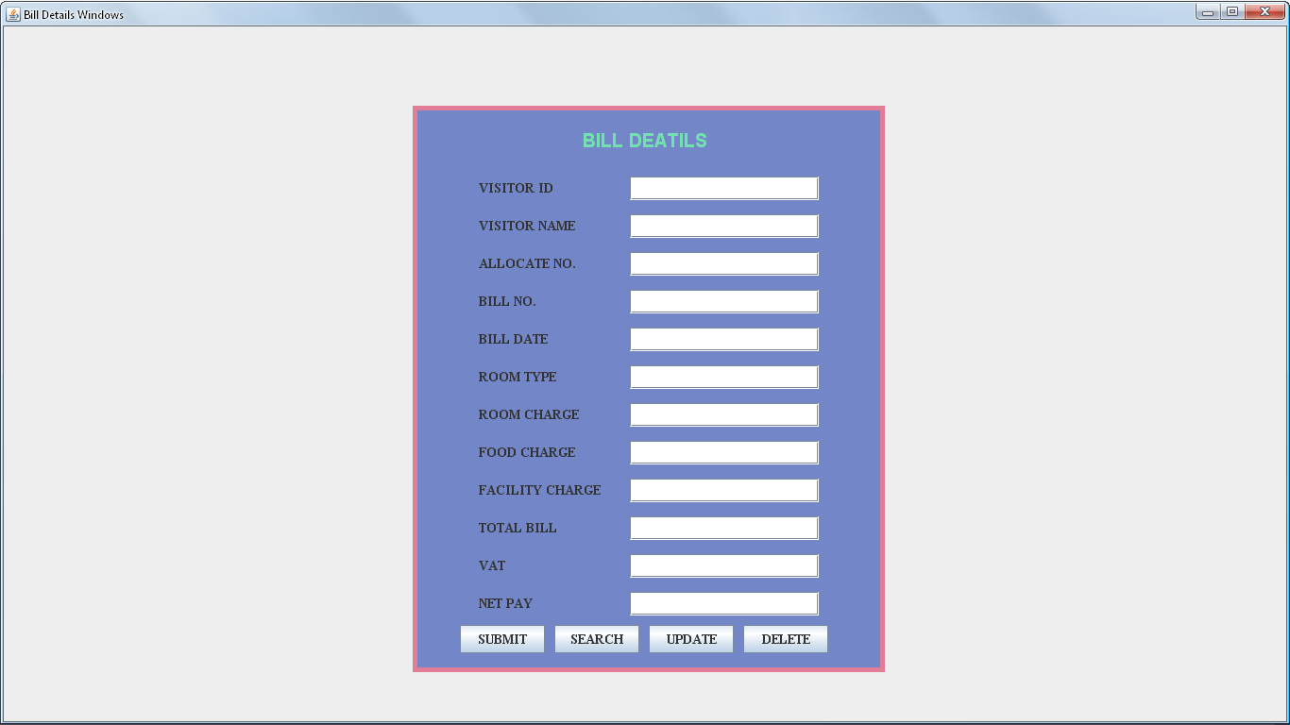FIGURE:11: SHOWS BILL DETAILS FORM

CODING FOR BILL DETAILS FORM

import java.awt.*;

import javax.swing.*;

class Billdets extends JFrame

{

JPanel jpanel1=new JPanel();

JPanel jpanel2=new JPanel();

JLabel jlabel=new JLabel("BILL DEATILS");

JLabel VIlbl=new JLabel("VISITOR ID");

JTextField VItext=new JTextField(10);

JLabel VNlbl=new JLabel("VISITOR NAME");

JTextField VNtext=new JTextField(30);

JLabel ANlbl=new JLabel("ALLOCATE NO.");

JTextField ANtext=new JTextField(10);

JLabel BNlbl=new JLabel("BILL NO.");

JTextField BNtext=new JTextField(5);

JLabel BDlbl=new JLabel("BILL DATE");

JTextField BDtext=new JTextField(10);

JLabel RTlbl=new JLabel("ROOM TYPE");

JTextField RTtext=new JTextField(10);

JLabel RClbl=new JLabel("ROOM CHARGE");

JTextField RCtext=new JTextField(5);

JLabel FClbl=new JLabel("FOOD CHARGE");

JTextField FCtext=new JTextField(5);

JLabel FCClbl=new JLabel("FACILITY CHARGE");

JTextField FCCtext=new JTextField(5);

JLabel TBlbl=new JLabel("TOTAL BILL");

JTextField TBtext=new JTextField(5);

JLabel Vlbl=new JLabel("VAT");

JTextField Vtext=new JTextField(5);

JLabel NPlbl=new JLabel("NET PAY");

JTextField NPtext=new JTextField(5);

JButton jbutton1=new JButton("SUBMIT");

JButton jbutton2=new JButton("SEARCH");

JButton jbutton3=new JButton("UPDATE");

JButton jbutton4=new JButton("DELETE");

Billdets(String st)

{

super(st);

setVisible(true);

add(jpanel1);

jpanel1.add(jpanel2);

jpanel1.setLayout(null);

jpanel2.setLayout(null);

jpanel2.setSize(500,600);

jpanel2.setBackground(new Color(115,135,200));

jpanel2.add(jlabel);

jlabel.setFont(new Font("ARIAl",Font.BOLD,20));

jlabel.setForeground(new Color(115,225,175));

jpanel2.add(VIlbl);

VIlbl.setFont(new Font("TIMES NEW ROMAN",Font.BOLD,14));

jpanel2.add(VItext);

VItext.setFont(new Font("TIMES NEW ROMAN",Font.PLAIN,16));

jpanel2.add( VNlbl);

VNlbl.setFont(new Font("TIMES NEW ROMAN",Font.BOLD,14));

jpanel2.add( VNtext);

VNtext.setFont(new Font("TIMES NEW ROMAN",Font.PLAIN,16));

jpanel2.add( ANlbl);

ANlbl.setFont(new Font("TIMES NEW ROMAN",Font.BOLD,14));

jpanel2.add( ANtext);

ANtext.setFont(new Font("TIMES NEW ROMAN",Font.PLAIN,16));

jpanel2.add(BNlbl);

BNlbl.setFont(new Font("TIMES NEW ROMAN",Font.BOLD,14));

jpanel2.add(BNtext);

BNtext.setFont(new Font("TIMES NEW ROMAN",Font.PLAIN,16));

jpanel2.add(BDlbl);

BDlbl.setFont(new Font("TIMES NEW ROMAN",Font.BOLD,14));

jpanel2.add(BDtext);

BDtext.setFont(new Font("TIMES NEW ROMAN",Font.PLAIN,16));

jpanel2.add(RTlbl);

RTlbl.setFont(new Font("TIMES NEW ROMAN",Font.BOLD,14));

jpanel2.add(RTtext);

RTtext.setFont(new Font("TIMES NEW ROMAN",Font.PLAIN,16));

jpanel2.add(RClbl);

RClbl.setFont(new Font("TIMES NEW ROMAN",Font.BOLD,14));

jpanel2.add(RCtext);

RCtext.setFont(new Font("TIMES NEW ROMAN",Font.PLAIN,16));

jpanel2.add(FClbl);

FClbl.setFont(new Font("TIMES NEW ROMAN",Font.BOLD,14));

jpanel2.add(FCtext);

FCtext.setFont(new Font("TIMES NEW ROMAN",Font.PLAIN,16));

jpanel2.add(FCClbl);

FCClbl.setFont(new Font("TIMES NEW ROMAN",Font.BOLD,14));

jpanel2.add(FCCtext);

FCCtext.setFont(new Font("TIMES NEW ROMAN",Font.PLAIN,16));

jpanel2.add(TBlbl);

TBlbl.setFont(new Font("TIMES NEW ROMAN",Font.BOLD,14));

jpanel2.add(TBtext);

TBtext.setFont(new Font("TIMES NEW ROMAN",Font.PLAIN,16));

jpanel2.add(Vlbl);

Vlbl.setFont(new Font("TIMES NEW ROMAN",Font.BOLD,14));

jpanel2.add(Vtext);

Vtext.setFont(new Font("TIMES NEW ROMAN",Font.PLAIN,16));

jpanel2.add(NPlbl);

NPlbl.setFont(new Font("TIMES NEW ROMAN",Font.BOLD,14));

jpanel2.add(NPtext);

NPtext.setFont(new Font("TIMES NEW ROMAN",Font.PLAIN,14));

jpanel2.add(jbutton1);

jbutton1.setFont(new Font("TIMES NEW ROMAN",Font.BOLD,14));

jpanel2.add(jbutton2);

jbutton2.setFont(new Font("TIMES NEW ROMAN",Font.BOLD,14));

jpanel2.add(jbutton3);

jbutton3.setFont(new Font("TIMES NEW ROMAN",Font.BOLD,14));

jpanel2.add(jbutton4);

jbutton4.setFont(new Font("TIMES NEW ROMAN",Font.BOLD,14));

jlabel.setBounds(180,20,140,35);

VIlbl.setBounds(70,75,130,25);

VItext.setBounds(230,75,200,25);

VNlbl.setBounds(70,115,130,25);

VNtext.setBounds(230,115,200,25);

ANlbl.setBounds(70,155,130,25);

ANtext.setBounds(230,155,200,25);

BNlbl.setBounds(70,195,130,25);

BNtext.setBounds(230,195,200,25);

BDlbl.setBounds(70,235,130,25);

BDtext.setBounds(230,235,200,25);

RTlbl.setBounds(70,275,130,25);

RTtext.setBounds(230,275,200,25);

RClbl.setBounds(70,315,130,25);

RCtext.setBounds(230,315,200,25);

FClbl.setBounds(70,355,130,25);

FCtext.setBounds(230,355,200,25);

FCClbl.setBounds(70,395,130,25);

FCCtext.setBounds(230,395,200,25);

TBlbl.setBounds(70,435,130,25);

TBtext.setBounds(230,435,200,25);

Vlbl.setBounds(70,475,130,25);

Vtext.setBounds(230,475,200,25);

NPlbl.setBounds(70,515,130,25);

NPtext.setBounds(230,515,200,25);

jbutton1.setBounds(50,550,90,30);

jbutton2.setBounds(150,550,90,30);

jbutton3.setBounds(250,550,90,30);

jbutton4.setBounds(350,550,90,30);

Toolkit toolkit=getToolkit();

Dimension dim=toolkit.getScreenSize();

int w=dim.width;

int h=dim.height;

setSize(w,h);

jpanel2.setBounds(dim.width/2-250,dim.height/2-300,500,600);

jpanel2.setBorder(BorderFactory.createLineBorder(new Color(225,125,150),5));

}

public static void main(String args[])

{

new Billdets("Bill Details Windows");

}

}

CHECK-IN DETAILS FORM

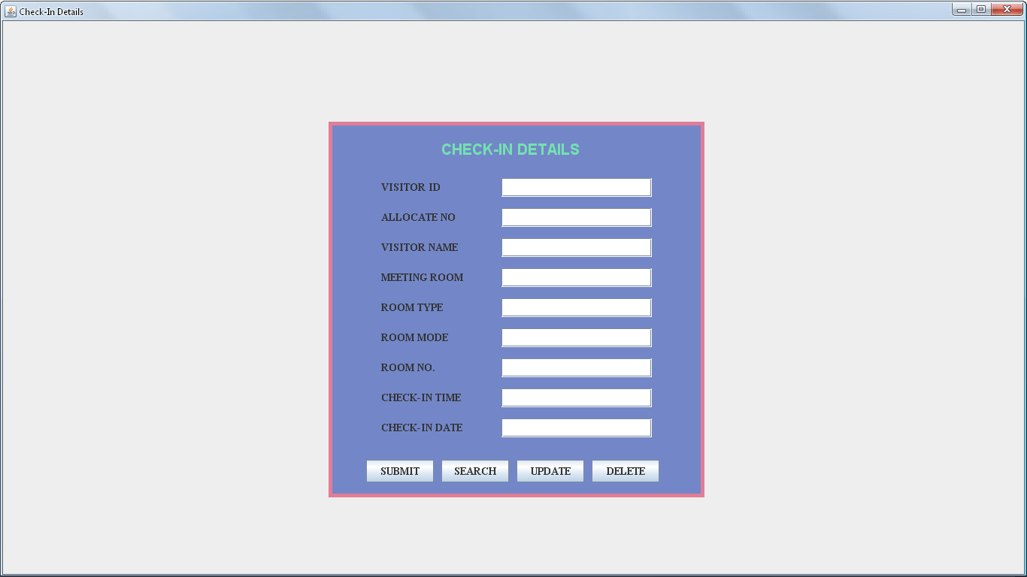

FIGURE:12: SHOWS CHECK-IN DETAILS FORM

CODING FOR CHECK-IN DETAILS FORM

import java.awt.*;

import javax.swing.*;

class Checkindets extends JFrame

{

JPanel jpanel1=new JPanel();

JPanel jpanel2=new JPanel();

JLabel jlabel=new JLabel("CHECK-IN DETAILS");

JLabel VIDlbl=new JLabel("VISITOR ID");

JTextField VIDtext=new JTextField(10);

JLabel ANlbl=new JLabel("ALLOCATE NO");

JTextField ANtext=new JTextField(10);

JLabel VINlbl=new JLabel("VISITOR NAME");

JTextField VINtext=new JTextField(30);

JLabel MRlbl=new JLabel("MEETING ROOM");

JTextField MRtext=new JTextField(10);

JLabel RMTlbl=new JLabel("ROOM TYPE");

JTextField RMTtext=new JTextField(10);

JLabel RMlbl=new JLabel("ROOM MODE");

JTextField RMtext=new JTextField(10);

JLabel RNlbl=new JLabel("ROOM NO.");

JTextField RNtext=new JTextField(10);

JLabel CINTlbl=new JLabel("CHECK-IN TIME");

JTextField CINTtext=new JTextField(6);

JLabel CIDlbl=new JLabel("CHECK-IN DATE");

JTextField CIDtext=new JTextField(10);

JButton jbutton1=new JButton("SUBMIT");

JButton jbutton2=new JButton("SEARCH");

JButton jbutton3=new JButton("UPDATE");

JButton jbutton4=new JButton("DELETE");

Checkindets(String st)

{

super(st);

setVisible(true);

add(jpanel1);

jpanel1.setLayout(null);

jpanel1.add(jpanel2);

jpanel2.setLayout(null);

jpanel2.setSize(500,500);

jpanel2.setBackground(new Color(115,135,200));

jpanel2.add(jlabel);

jlabel.setFont(new Font("ARIAL",Font.BOLD,20));

jlabel.setForeground(new Color(115,225,175));

jpanel2.add(VIDlbl);

VIDlbl.setFont(new Font("TIMES NEW ROMAN",Font.BOLD,14));

jpanel2.add(VIDtext);

VIDtext.setFont(new Font("TIMES NEW ROMAN",Font.PLAIN,16));

jpanel2.add(ANlbl);

ANlbl.setFont(new Font("TIMES NEW ROMAN",Font.BOLD,14));

jpanel2.add(ANtext);

ANtext.setFont(new Font("TIMES NEW ROMAN",Font.PLAIN,16));

jpanel2.add(VINlbl);

VINlbl.setFont(new Font("TIMES NEW ROMAN",Font.BOLD,14));

jpanel2.add(VINtext);

VINtext.setFont(new Font("TIMES NEW ROMAN",Font.PLAIN,16));

jpanel2.add(MRlbl);

MRlbl.setFont(new Font("TIMES NEW ROMAN",Font.BOLD,14));

jpanel2.add(MRtext);

MRtext.setFont(new Font("TIMES NEW ROMAN",Font.PLAIN,16));

jpanel2.add(CINTlbl);

CINTlbl.setFont(new Font("TIMES NEW ROMAN",Font.BOLD,14));

jpanel2.add(CINTtext);

CINTtext.setFont(new Font("TIMES NEW ROMAN",Font.PLAIN,16));

jpanel2.add(CIDlbl);

CIDlbl.setFont(new Font("TIMES NEW ROMAN",Font.BOLD,14));

jpanel2.add(CIDtext);

CIDtext.setFont(new Font("TIMES NEW ROMAN",Font.PLAIN,16));

jpanel2.add(RMTlbl);

RMTlbl.setFont(new Font("TIMES NEW ROMAN",Font.BOLD,14));

jpanel2.add(RMTtext);

RMTtext.setFont(new Font("TIMES NEW ROMAN",Font.PLAIN,16));

jpanel2.add(RMlbl);

RMlbl.setFont(new Font("TIMES NEW ROMAN",Font.BOLD,14));

jpanel2.add(RMtext);

RMtext.setFont(new Font("TIMES NEW ROMAN",Font.PLAIN,16));

jpanel2.add(RNlbl);

RNlbl.setFont(new Font("TIMES NEW ROMAN",Font.BOLD,14));

jpanel2.add(RNtext);

RNtext.setFont(new Font("TIMES NEW ROMAN",Font.PLAIN,16));

jpanel2.add(jbutton1);

jbutton1.setFont(new Font("TIMES NEW ROMAN",Font.BOLD,14));

jpanel2.add(jbutton2);

jbutton2.setFont(new Font("TIMES NEW ROMAN",Font.BOLD,14));

jpanel2.add(jbutton3);

jbutton3.setFont(new Font("TIMES NEW ROMAN",Font.BOLD,14));

jpanel2.add(jbutton4);

jbutton4.setFont(new Font("TIMES NEW ROMAN",Font.BOLD,14));

jlabel.setBounds(150,20,200,35);

VIDlbl.setBounds(70,75,130,25);

VIDtext.setBounds(230,75,200,25);

ANlbl.setBounds(70,115,130,25);

ANtext.setBounds(230,115,200,25);

VINlbl.setBounds(70,155,130,25);

VINtext.setBounds(230,155,200,25);

MRlbl.setBounds(70,195,130,25);

MRtext.setBounds(230,195,200,25);

RMTlbl.setBounds(70,235,130,25);

RMTtext.setBounds(230,235,200,25);

RMlbl.setBounds(70,275,130,25);

RMtext.setBounds(230,275,200,25);

RNlbl.setBounds(70,315,130,25);

RNtext.setBounds(230,315,200,25);

CINTlbl.setBounds(70,355,130,25);

CINTtext.setBounds(230,355,200,25);

CIDlbl.setBounds(70,395,130,25);

CIDtext.setBounds(230,395,200,25);

jbutton1.setBounds(50,450,90,30);

jbutton2.setBounds(150,450,90,30);

jbutton3.setBounds(250,450,90,30);

jbutton4.setBounds(350,450,90,30);

Toolkit toolkit=getToolkit();

Dimension dim=toolkit.getScreenSize();

int w=dim.width;

int h=dim.height;

setSize(w,h);

jpanel2.setBounds(dim.width/2-250,dim.height/2-250,500,500);

jpanel2.setBorder(BorderFactory.createLineBorder(new Color(225,125,150),5));

}

public static void main(String args[])

{

new Checkindets("Chenk In Details Windows");

}

}

CHECK-OUT DETAILS FORM

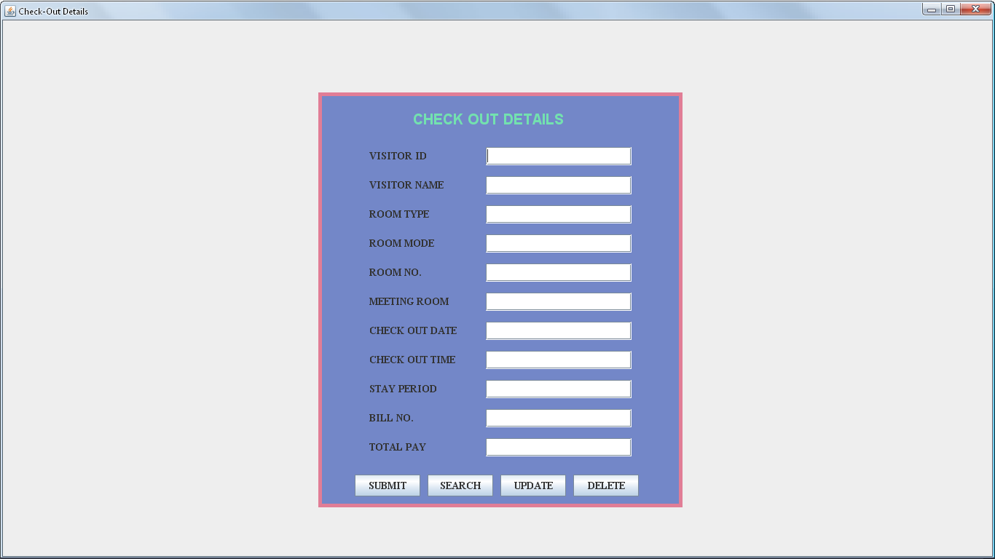

FIGURE:13: SHOWS CHECK-IN DETAILS FORM

CODING FOR CHECK-OUT DETAILS FORM

import java.awt.*;

import javax.swing.*;

class Checkoutdets extends JFrame

{

JPanel jpanel1=new JPanel();

JPanel jpanel2=new JPanel();

JLabel jlabel=new JLabel("CHECK OUT DETAILS");

JLabel VIlbl=new JLabel("VISITOR ID");

JTextField VItext=new JTextField(10);

JLabel VNlbl=new JLabel("VISITOR NAME");

JTextField VNtext=new JTextField(30);

JLabel RMTlbl=new JLabel("ROOM TYPE");

JTextField RMTtext=new JTextField(10);

JLabel RMlbl=new JLabel("ROOM MODE");

JTextField RMtext=new JTextField(10);

JLabel RNlbl=new JLabel("ROOM NO.");

JTextField RNtext=new JTextField(10);

JLabel MRTlbl=new JLabel("MEETING ROOM");

JTextField MRTtext=new JTextField(10);

JLabel CODlbl=new JLabel("CHECK OUT DATE");

JTextField CODtext=new JTextField(10);

JLabel COTlbl=new JLabel("CHECK OUT TIME");

JTextField COTtext=new JTextField(8);

JLabel SPlbl=new JLabel("STAY PERIOD");

JTextField SPtext=new JTextField(8);

JLabel BNlbl=new JLabel("BILL NO.");

JTextField BNtext=new JTextField(10);

JLabel TPlbl=new JLabel("TOTAL PAY");

JTextField TPtext=new JTextField(5);

JButton jbutton1=new JButton("SUBMIT");

JButton jbutton2=new JButton("SEARCH");

JButton jbutton3=new JButton("UPDATE");

JButton jbutton4=new JButton("DELETE");

Checkoutdets(String st)

{

super(st);

setVisible(true);

add(jpanel1);

jpanel1.setLayout(null);

jpanel1.add(jpanel2);

jpanel2.setSize(500,570);

jpanel2.setLayout(null);

jpanel2.setBackground(new Color(115,135,200));

jpanel2.add(jlabel);

jlabel.setFont(new Font("ARIAL",Font.BOLD,20));

jlabel.setForeground(new Color(115,225,175));

jpanel2.add(VIlbl);

VIlbl.setFont(new Font("TIMES NEW ROMAN",Font.BOLD,14));

jpanel2.add(VItext);

VItext.setFont(new Font("TIMES NEW ROMAN",Font.PLAIN,16));

jpanel2.add(VNlbl);

VNlbl.setFont(new Font("TIMES NEW ROMAN",Font.BOLD,14));

jpanel2.add(VNtext);

VNtext.setFont(new Font("TIMES NEW ROMAN",Font.PLAIN,16));

jpanel2.add(RMTlbl);

RMTlbl.setFont(new Font("TIMES NEW ROMAN",Font.BOLD,14));

jpanel2.add(RMTtext);

RMTtext.setFont(new Font("TIMES NEW ROMAN",Font.PLAIN,16));

jpanel2.add(RMlbl);

RMlbl.setFont(new Font("TIMES NEW ROMAN",Font.BOLD,14));

jpanel2.add(RMtext);

RMtext.setFont(new Font("TIMES NEW ROMAN",Font.PLAIN,16));

jpanel2.add(RNlbl);

RNlbl.setFont(new Font("TIMES NEW ROMAN",Font.BOLD,14));

jpanel2.add(RNtext);

RNtext.setFont(new Font("TIMES NEW ROMAN",Font.PLAIN,16));

jpanel2.add(MRTlbl);

MRTlbl.setFont(new Font("TIMES NEW ROMAN",Font.BOLD,14));

jpanel2.add(MRTtext);

MRTtext.setFont(new Font("TIMES NEW ROMAN",Font.PLAIN,16));

jpanel2.add(CODlbl);

CODlbl.setFont(new Font("TIMES NEW ROMAN",Font.BOLD,14));

jpanel2.add(CODtext);

CODtext.setFont(new Font("TIMES NEW ROMAN",Font.PLAIN,16));

jpanel2.add(COTlbl);

COTlbl.setFont(new Font("TIMES NEW ROMAN",Font.BOLD,14));

jpanel2.add(COTtext);

COTtext.setFont(new Font("TIMES NEW ROMAN",Font.PLAIN,16));

jpanel2.add(SPlbl);

SPlbl.setFont(new Font("TIMES NEW ROMAN",Font.BOLD,14));

jpanel2.add(SPtext);

SPtext.setFont(new Font("TIMES NEW ROMAN",Font.PLAIN,16));

jpanel2.add(BNlbl);

BNlbl.setFont(new Font("TIMES NEW ROMAN",Font.BOLD,14));

jpanel2.add(BNtext);

BNtext.setFont(new Font("TIMES NEW ROMAN",Font.PLAIN,16));

jpanel2.add(TPlbl);

TPlbl.setFont(new Font("TIMES NEW ROMAN",Font.BOLD,14));

jpanel2.add(TPtext);

TPtext.setFont(new Font("TIMES NEW ROMAN",Font.PLAIN,14));

jpanel2.add(jbutton1);

jbutton1.setFont(new Font("TIMES NEW ROMAN",Font.BOLD,14));

jpanel2.add(jbutton2);

jbutton2.setFont(new Font("TIMES NEW ROMAN",Font.BOLD,14));

jpanel2.add(jbutton3);

jbutton3.setFont(new Font("TIMES NEW ROMAN",Font.BOLD,14));

jpanel2.add(jbutton4);

jbutton4.setFont(new Font("TIMES NEW ROMAN",Font.BOLD,14));

jlabel.setBounds(130,20,240,35);

VIlbl.setBounds(70,75,130,25);

VItext.setBounds(230,75,200,25);

VNlbl.setBounds(70,115,130,25);

VNtext.setBounds(230,115,200,25);

RMTlbl.setBounds(70,155,130,25);

RMTtext.setBounds(230,155,200,25);

RMlbl.setBounds(70,195,130,25);

RMtext.setBounds(230,195,200,25);

RNlbl.setBounds(70,235,130,25);

RNtext.setBounds(230,235,200,25);

MRTlbl.setBounds(70,275,130,25);

MRTtext.setBounds(230,275,200,25);

CODlbl.setBounds(70,315,130,25);

CODtext.setBounds(230,315,200,25);

COTlbl.setBounds(70,355,130,25);

COTtext.setBounds(230,355,200,25);

SPlbl.setBounds(70,395,130,25);

SPtext.setBounds(230,395,200,25);

BNlbl.setBounds(70,435,130,25);

BNtext.setBounds(230,435,200,25);

TPlbl.setBounds(70,475,130,25);

TPtext.setBounds(230,475,200,25);

jbutton1.setBounds(50,525,90,30);

jbutton2.setBounds(150,525,90,30);

jbutton3.setBounds(250,525,90,30);

jbutton4.setBounds(350,525,90,30);

Toolkit toolkit=getToolkit();

Dimension dim=toolkit.getScreenSize();

int w=dim.width;

int h=dim.height;

setSize(w,h);

jpanel2.setBounds(dim.width/2-250,dim.height/2-285,500,570);

jpanel2.setBorder(BorderFactory.createLineBorder(new Color(225,125,150),5));

}

public static void main(String args[])

{

new Checkoutdets("Chenk Out Wnidows");

}

}

payment DETAILS FORM

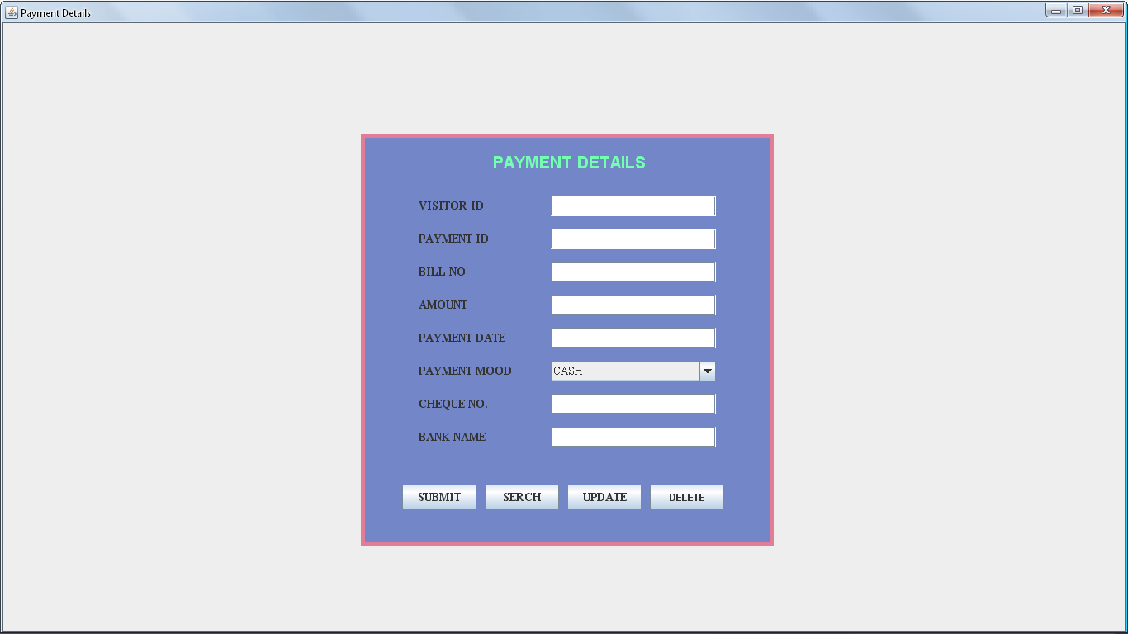

FIGURE:14: SHOWS PAYMAENT DETAILS FORM

CODING FOR payment DETAILS FORM

import java.awt.*;

import javax.swing.*;

class Payment extends JFrame

{

JPanel jpanel1=new JPanel();

JPanel jpanel2=new JPanel();

JLabel jlabel=new JLabel("PAYMENT DETAILS");

JLabel VIlbl=new JLabel("VISITOR ID");

JTextField VItext=new JTextField(10);

JLabel PIlbl=new JLabel("PAYMENT ID");

JTextField PItext=new JTextField(12);

JLabel BNlbl=new JLabel("BILL NO");

JTextField BNtext=new JTextField(8);

JLabel AMlbl=new JLabel("AMOUNT");

JTextField AMtext=new JTextField(5);

JLabel PDlbl=new JLabel("PAYMENT DATE");

JTextField PDtext=new JTextField(10);

JLabel PMlbl=new JLabel("PAYMENT MOOD");

JComboBox PM=new JComboBox();

JLabel CQlbl=new JLabel("CHEQUE NO.");

JTextField CQtext=new JTextField(10);

JLabel BKNlbl=new JLabel("BANK NAME");

JTextField BKNtext=new JTextField(25);

JButton jbtn1=new JButton("SUBMIT");

JButton jbtn2=new JButton("SERCH");

JButton jbtn3=new JButton("UPDATE");

JButton jbtn4=new JButton("DELETE");

Payment(String st)

{

super(st);

setVisible(true);

add(jpanel1);

jpanel1.add(jpanel2);

jpanel1.setLayout(null);

jpanel2.setLayout(null);

jpanel2.setSize(500,500);

jpanel2.setBackground(new Color(115,135,200));

jpanel2.add(jlabel);

jlabel.setFont(new Font("ARIAL",Font.BOLD,20));

jlabel.setForeground(new Color(115,255,175));

jpanel2.add(VIlbl);

VIlbl.setFont(new Font("TIMES NEW ROMAN",Font.BOLD,14));

jpanel2.add(VItext);

VItext.setFont(new Font("TIMES NEW ROMAN",Font.PLAIN,14));

jpanel2.add(PIlbl);

PIlbl.setFont(new Font("TIMES NEW ROMAN",Font.BOLD,14));

jpanel2.add(PItext);

PItext.setFont(new Font("TIMES NEW ROMAN",Font.PLAIN,14));

jpanel2.add(BNlbl);

BNlbl.setFont(new Font("TIMES NEW ROMAN",Font.BOLD,14));

jpanel2.add(BNtext);

BNtext.setFont(new Font("TIMES NEW ROMAN",Font.PLAIN,14));

jpanel2.add(AMlbl);

AMlbl.setFont(new Font("TIMES NEW ROMAN",Font.BOLD,14));

jpanel2.add(AMtext);

AMtext.setFont(new Font("TIMES NEW ROMAN",Font.PLAIN,14));

jpanel2.add(PDlbl);

PDlbl.setFont(new Font("TIMES NEW ROMAN",Font.BOLD,14));

jpanel2.add(PDtext);

PDtext.setFont(new Font("TIMES NEW ROMAN",Font.PLAIN,14));

jpanel2.add(PMlbl);

PMlbl.setFont(new Font("TIMES NEW ROMAN",Font.BOLD,14));

jpanel2.add(PM);

PM.addItem("CASH");

PM.addItem("CHEQUE");

PM.addItem("DEBIT CARD");

PM.setFont(new Font("TIMES NEW ROMAN",Font.PLAIN,14));

jpanel2.add(CQlbl);

CQlbl.setFont(new Font("TIMES NEW ROMAN",Font.BOLD,14));

jpanel2.add(CQtext);

CQtext.setFont(new Font("TIMES NEW ROMAN",Font.PLAIN,14));

jpanel2.add(BKNlbl);

BKNlbl.setFont(new Font("TIMES NEW ROMAN",Font.BOLD,14));

jpanel2.add(BKNtext);

BKNtext.setFont(new Font("TIMES NEW ROMAN",Font.PLAIN,14));

jpanel2.add(jbtn1);

jbtn1.setFont(new Font("TIMES NEW ROMAN",Font.BOLD,14));

jpanel2.add(jbtn2);

jbtn2.setFont(new Font("TIMES NEW ROMAN",Font.BOLD,14));

jpanel2.add(jbtn3);

jbtn3.setFont(new Font("TIMES NEW ROMAN",Font.BOLD,14));

jpanel2.add(jbtn4);

VIlbl.setFont(new Font("TIMES NEW ROMAN",Font.BOLD,14));

jlabel.setBounds(160,20,200,30);

VIlbl.setBounds(70,75,130,25);

VItext.setBounds(230,75,200,25);

PIlbl.setBounds(70,115,130,25);

PItext.setBounds(230,115,200,25);

BNlbl.setBounds(70,155,130,25);

BNtext.setBounds(230,155,200,25);

AMlbl.setBounds(70,195,130,25);

AMtext.setBounds(230,195,200,25);

PDlbl.setBounds(70,235,130,25);

PDtext.setBounds(230,235,200,25);

PMlbl.setBounds(70,275,130,25);

PM.setBounds(230,275,200,25);

CQlbl.setBounds(70,315,130,25);

CQtext.setBounds(230,315,200,25);

BKNlbl.setBounds(70,355,130,25);

BKNtext.setBounds(230,355,200,25);

jbtn1.setBounds(50,425,90,30);

jbtn2.setBounds(150,425,90,30);

jbtn3.setBounds(250,425,90,30);

jbtn4.setBounds(350,425,90,30);

Toolkit toolkit=getToolkit();

Dimension dim=toolkit.getScreenSize();

int w=dim.width;

int h=dim.height;

setSize(w,h);

jpanel2.setBounds(dim.width/2-250,dim.height/2-250,500,500);

jpanel2.setBorder(BorderFactory.createLineBorder(new Color(225,125,150),5));

}

public static void main(String args[])

{

new Payment("Payment Details Window");

}

}

Room DETAILS FORM

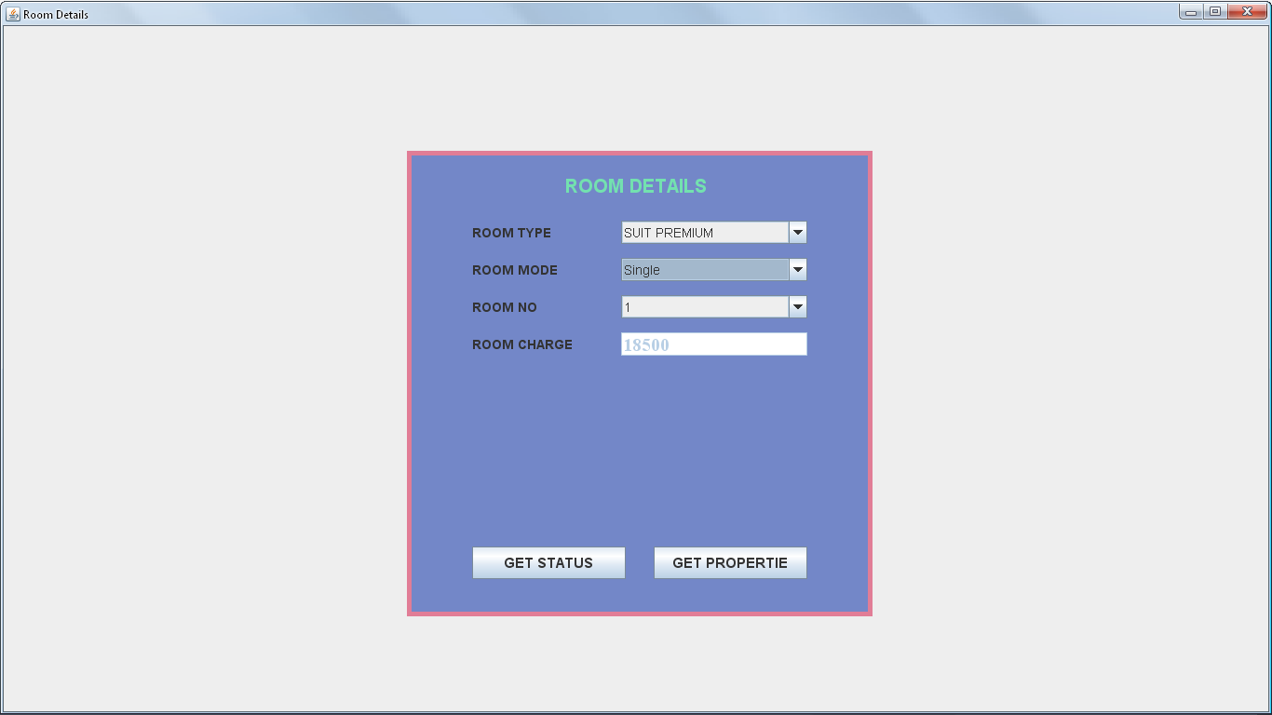

FIGURE:15: SHOWS ROOM DETAILS FORM

CODING FOR Room DETAILS FORMS

import java.awt.*;

import javax.swing.*;

import java.awt.event.*;

class Roomdets extends JFrame implements ActionListener,ItemListener

{

JPanel jpanel1=new JPanel();

JPanel jpanel2=new JPanel();

JLabel jlabel=new JLabel("ROOM DETAILS");

JLabel RTlbl=new JLabel("ROOM TYPE");

JComboBox RT=new JComboBox();

JLabel RMlbl=new JLabel("ROOM MODE");

JComboBox RM=new JComboBox();

JLabel RNlbl=new JLabel("ROOM NO");

JComboBox RN=new JComboBox();

JLabel RClbl=new JLabel("ROOM CHARGE");

JTextField RCtext=new JTextField(5);

JButton jbtn1=new JButton("GET STATUS");

JButton jbtn2=new JButton("GET PROPERTIE");

Roomdets(String st)

{

super(st);

setVisible(true);

add(jpanel1);

jpanel1.setLayout(null);

jpanel2.setLayout(null);

jpanel1.add(jpanel2);

jpanel2.setSize(500,500);

jpanel2.setBackground(new Color(115,135,200));

jpanel2.setBorder(BorderFactory.createLineBorder(new Color(225,125,150),5));

jpanel2.add(jlabel);

jlabel.setFont(new Font("ARIL",Font.BOLD,20));

jlabel.setForeground(new Color(115,225,175));

jpanel2.add(RTlbl);

RTlbl.setFont(new Font("TIME NEW ROMAN",Font.BOLD,14));

jpanel2.add(RT);

RT.addItem("SUIT PREMIUM");

RT.addItem("CLUB SUITE");

RT.addItem("PREMIUM DELUXE");

RT.addItem("CLUB DELUXE");

RT.addItem("STANDARD DELUXE");

RT.setFont(new Font("TIME NEW ROMAN",Font.PLAIN,14));

jpanel2.add(RMlbl);

RMlbl.setFont(new Font("TIME NEW ROMAN",Font.BOLD,14));

jpanel2.add(RM);

RM.addItem("Single");

RM.addItem("Double");

RM.setFont(new Font("TIME NEW ROMAN",Font.PLAIN,14));

jpanel2.add(RNlbl);

RNlbl.setFont(new Font("TIME NEW ROMAN",Font.BOLD,14));

jpanel2.add(RN);

RN.addItem("1");

RN.addItem("2");

RN.addItem("3");

RN.addItem("4");

RN.addItem("5");

RN.setFont(new Font("TIME NEW ROMAN",Font.PLAIN,14));

jpanel2.add(RClbl);

RClbl.setFont(new Font("TIME NEW ROMAN",Font.BOLD,14));

jpanel2.add(RCtext);

RCtext.setFont(new Font("TIME NEW ROMAN",Font.PLAIN,14));

jpanel2.add(jbtn1);

jbtn1.setFont(new Font("TIME NEW ROMAN",Font.BOLD,15));

jpanel2.add(jbtn2);

jbtn2.setFont(new Font("TIME NEW ROMAN",Font.BOLD,15));

jlabel.setBounds(170,20,160,35);

RTlbl.setBounds(70,75,130,25);

RT.setBounds(230,75,200,25);

RMlbl.setBounds(70,115,130,25);

RM.setBounds(230,115,200,25);

RNlbl.setBounds(70,155,130,25);

RN.setBounds(230,155,200,25);

RClbl.setBounds(70,195,130,25);

RCtext.setBounds(230,195,200,25);

jbtn1.setBounds(70,425,165,35);

jbtn2.setBounds(265,425,165,35);

Toolkit toolkit=getToolkit();

Dimension dim=toolkit.getScreenSize();

int h=dim.height;

int w=dim.width;

setSize(w,h);

jpanel2.setBounds(dim.width/2-250,dim.height/2-250,500,500);

jbtn1.addActionListener(this);

jbtn2.addActionListener(this);

RT.addItemListener(this);

RM.addItemListener(this);

RCtext.setEnabled(false);

RCtext.setFont(new Font("TimesRoman",Font.BOLD,20));

}

public void itemStateChanged(ItemEvent e)

{

if(RM.getSelectedItem().toString().equals("Single") && RT.getSelectedItem().toString().equals("SUIT PREMIUM"))

{

RCtext.setText("18500");

}

else if(RM.getSelectedItem().toString().equals("Double") && RT.getSelectedItem().toString().equals("SUIT PREMIUM"))

{

RCtext.setText("18500");

}

else if(RM.getSelectedItem().toString().equals("Single") && RT.getSelectedItem().toString().equals("CLUB SUITE"))

{

RCtext.setText("12500");

}

else if(RM.getSelectedItem().toString().equals("Double") && RT.getSelectedItem().toString().equals("CLUB SUITE"))

{

RCtext.setText("12500");

}

else if(RM.getSelectedItem().toString().equals("Double") && RT.getSelectedItem().toString().equals("PREMIUM DELUXE"))

{

RCtext.setText("9000");

}

else if(RM.getSelectedItem().toString().equals("Single") && RT.getSelectedItem().toString().equals("PREMIUM DELUXE"))

{

RCtext.setText("8000");

}

else if(RM.getSelectedItem().toString().equals("Double") && RT.getSelectedItem().toString().equals("CLUB DELUXE"))

{

RCtext.setText("8000");

}

else if(RM.getSelectedItem().toString().equals("Single") && RT.getSelectedItem().toString().equals("CLUB DELUXE"))

{

RCtext.setText("7000");

}

else if(RM.getSelectedItem().toString().equals("Single") && RT.getSelectedItem().toString().equals("STANDARD DELUXE"))

{

RCtext.setText("4500");

}

}

public void actionPerformed(ActionEvent e)

{

if(e.getSource()==jbtn1)

{

if(RT.getSelectedItem().toString().equals("SUIT PREMIUM"))

{

new SuitPremimum("Room Status Window");

}

else if(RT.getSelectedItem().toString().equals("CLUB SUITE"))

{

new ClubSuite("Room Status Window");

}

else if(RT.getSelectedItem().toString().equals("PREMIUM DELUXE"))

{

new PremimumDeluxe("Room Status Window");

}

else if(RT.getSelectedItem().toString().equals("CLUB DELUXE"))

{

new ClubDeluxe("Room Status Window");

}

else if(RT.getSelectedItem().toString().equals("STANDARD DELUXE"))

{

new StandardDeluxe("Room Status Window");

}

}

else if(e.getSource()==jbtn2)

{

if(RT.getSelectedItem().toString().equals("SUIT PREMIUM"))

{

new SuitPremimumPropt("Room Properties Window");

}

else if(RT.getSelectedItem().toString().equals("CLUB SUITE"))

{

new ClubSutiePropt("Room Properties Window");

}

else if(RT.getSelectedItem().toString().equals("PREMIUM DELUXE"))

{

new PremimumDeluxePropt("Room Properties Window");

}

else if(RT.getSelectedItem().toString().equals("CLUB DELUXE"))

{

new ClubDeluxePropt("Room Properties Window");

}

else if(RT.getSelectedItem().toString().equals("STANDARD DELUXE"))

{

new StandardDeluxePropt("Room Properties Window");

}

}

}

public static void main(String args[])

{

new Roomdets("Booking Details");

}

}

ROOM STATUS FORM OF SUIT PREMIMUM

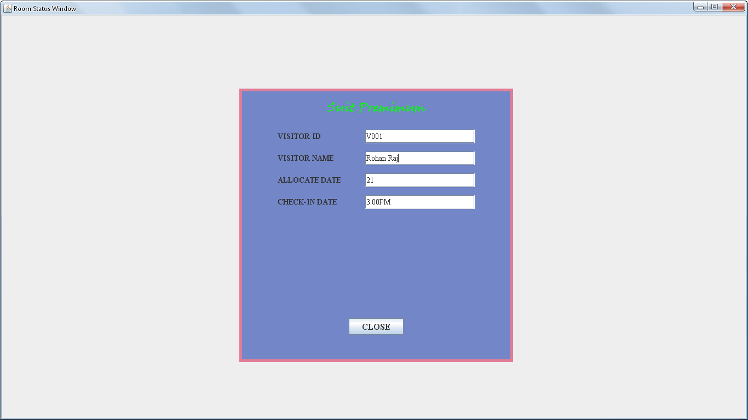

FIGURE:16: SHOWS ROOM STATUS FORM OF SUIT PREMIMUM

CODING FOR ROOM STATUS FORM OF SUIT PREMIMUM

import java.awt.*;

import javax.swing.*;

class SuitPremimum extends JFrame

{

JPanel jpanel1=new JPanel();

JPanel jpanel2=new JPanel();

JLabel jlabel=new JLabel("Suit Premimum");

JLabel VIlbl=new JLabel("VISITOR ID");

JTextField VItext=new JTextField(10);

JLabel VNlbl=new JLabel("VISITOR NAME");

JTextField VNtext=new JTextField(25);

JLabel ADlbl=new JLabel("ALLOCATE DATE");

JTextField ADtext=new JTextField(10);

JLabel CKDlbl=new JLabel("CHECK-IN DATE");

JTextField CKDtext=new JTextField(10);

JButton jbtn=new JButton("CLOSE");

SuitPremimum(String st)

{

super (st);

setVisible(true);

add(jpanel1);

jpanel1.setLayout(null);

jpanel2.setLayout(null);

jpanel1.add(jpanel2);

jpanel2.setSize(500,500);

jpanel2.setBackground(new Color(115,135,200));

jpanel2.add(jlabel);

jlabel.setFont(new Font("Viner Hand ITC",Font.BOLD,22));

jlabel.setForeground(Color.green);

jpanel2.add(VIlbl);

VIlbl.setFont(new Font("TIMES NEW ROMAN",Font.BOLD,14));

jpanel2.add(VItext);

VItext.setFont(new Font("TIMES NEW ROMAN",Font.PLAIN,14));

jpanel2.add(VNlbl);

VNlbl.setFont(new Font("TIMES NEW ROMAN",Font.BOLD,14));

jpanel2.add(VNtext);

VNtext.setFont(new Font("TIMES NEW ROMAN",Font.PLAIN,14));

jpanel2.add(ADlbl);

ADlbl.setFont(new Font("TIMES NEW ROMAN",Font.BOLD,14));

jpanel2.add(ADtext);

ADtext.setFont(new Font("TIMES NEW ROMAN",Font.PLAIN,14));

jpanel2.add(CKDlbl);

CKDlbl.setFont(new Font("TIMES NEW ROMAN",Font.BOLD,14));

jpanel2.add(CKDtext);

CKDtext.setFont(new Font("TIMES NEW ROMAN",Font.PLAIN,14));

jpanel2.add(jbtn);

jbtn.setFont(new Font("TIMES NEW ROMAN",Font.BOLD,16));

jlabel.setBounds(160,20,180,35);

VIlbl.setBounds(70,75,130,25);

VItext.setBounds(230,75,200,25);

VNlbl.setBounds(70,115,130,25);

VNtext.setBounds(230,115,200,25);

ADlbl.setBounds(70,155,130,25);

ADtext.setBounds(230,155,200,25);

CKDlbl.setBounds(70,195,130,25);

CKDtext.setBounds(230,195,200,25);

jbtn.setBounds(200,420,100,30);

Toolkit toolkit=getToolkit();

Dimension dim=toolkit.getScreenSize();

int w=dim.width;

int h=dim.height;

setSize(w,h);

jpanel2.setBounds(dim.width/2-250,dim.height/2-250,500,500);

jpanel2.setBorder(BorderFactory.createLineBorder(new Color(225,125,150),5));

setDefaultCloseOperation(DISPOSE_ON_CLOSE);

}

public static void main(String args[])

{

new SuitPremimum("Room Status Windows");

}

}

ROOM STATUS FORM OF SUIT club suite

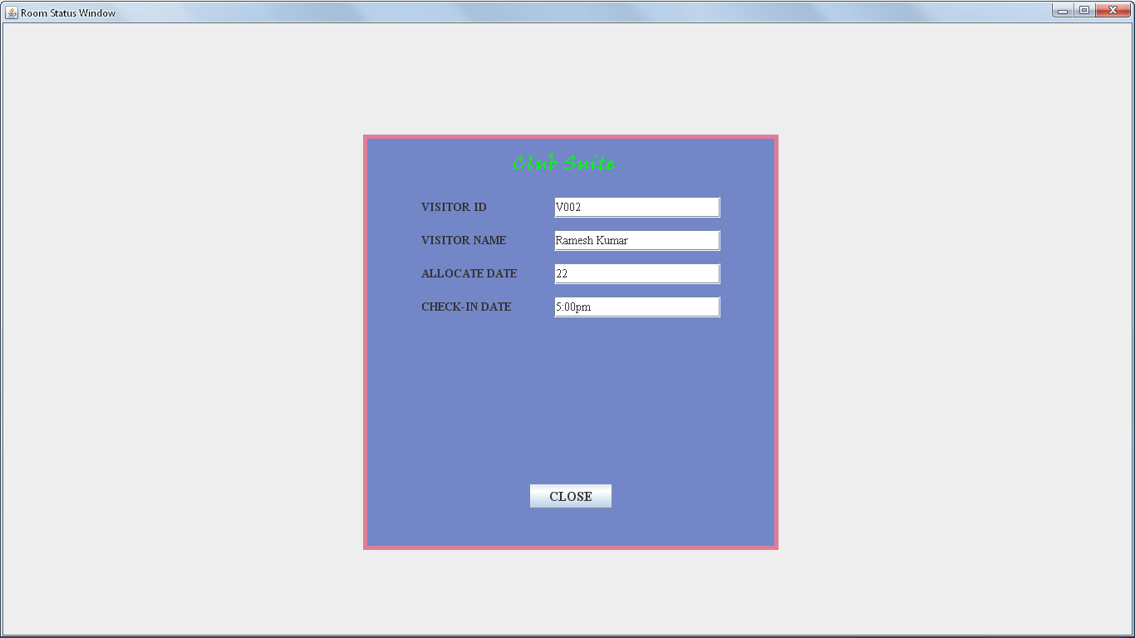

FIGURE:17: SHOWS ROOM STATUS FORM OF CLUB SUITE

CODING FOR ROOM STATUS FORM OF CLUB SUITE

import java.awt.*;

import javax.swing.*;

class ClubSuite extends JFrame

{

JPanel jpanel1=new JPanel();

JPanel jpanel2=new JPanel();

JLabel jlabel=new JLabel("Club Suite");

JLabel VIlbl=new JLabel("VISITOR ID");

JTextField VItext=new JTextField(10);

JLabel VNlbl=new JLabel("VISITOR NAME");

JTextField VNtext=new JTextField(25);

JLabel ADlbl=new JLabel("ALLOCATE DATE");

JTextField ADtext=new JTextField(10);

JLabel CKDlbl=new JLabel("CHECK-IN DATE");

JTextField CKDtext=new JTextField(10);

JButton jbtn=new JButton("CLOSE");

ClubSuite(String st)

{

super (st);

setVisible(true);

add(jpanel1);

jpanel1.setLayout(null);

jpanel2.setLayout(null);

jpanel1.add(jpanel2);

jpanel2.setSize(500,500);

jpanel2.setBackground(new Color(115,135,200));

jpanel2.add(jlabel);

jlabel.setFont(new Font("Viner Hand ITC",Font.BOLD,22));

jlabel.setForeground(Color.green);

jpanel2.add(VIlbl);

VIlbl.setFont(new Font("TIMES NEW ROMAN",Font.BOLD,14));

jpanel2.add(VItext);

VItext.setFont(new Font("TIMES NEW ROMAN",Font.PLAIN,14));

jpanel2.add(VNlbl);

VNlbl.setFont(new Font("TIMES NEW ROMAN",Font.BOLD,14));

jpanel2.add(VNtext);

VNtext.setFont(new Font("TIMES NEW ROMAN",Font.PLAIN,14));

jpanel2.add(ADlbl);

ADlbl.setFont(new Font("TIMES NEW ROMAN",Font.BOLD,14));

jpanel2.add(ADtext);

ADtext.setFont(new Font("TIMES NEW ROMAN",Font.PLAIN,14));

jpanel2.add(CKDlbl);

CKDlbl.setFont(new Font("TIMES NEW ROMAN",Font.BOLD,14));

jpanel2.add(CKDtext);

CKDtext.setFont(new Font("TIMES NEW ROMAN",Font.PLAIN,14));

jpanel2.add(jbtn);

jbtn.setFont(new Font("TIMES NEW ROMAN",Font.BOLD,16));

jlabel.setBounds(180,20,180,35);

VIlbl.setBounds(70,75,130,25);

VItext.setBounds(230,75,200,25);

VNlbl.setBounds(70,115,130,25);

VNtext.setBounds(230,115,200,25);

ADlbl.setBounds(70,155,130,25);

ADtext.setBounds(230,155,200,25);

CKDlbl.setBounds(70,195,130,25);

CKDtext.setBounds(230,195,200,25);

jbtn.setBounds(200,420,100,30);

Toolkit toolkit=getToolkit();

Dimension dim=toolkit.getScreenSize();

int w=dim.width;

int h=dim.height;

setSize(w,h);

jpanel2.setBounds(dim.width/2-250,dim.height/2-250,500,500);

jpanel2.setBorder(BorderFactory.createLineBorder(new Color(225,125,150),5));

setDefaultCloseOperation(DISPOSE_ON_CLOSE);

}

public static void main(String args[])

{

new ClubSuite("Room Status Windows");

}

}

ROOM STATUS FORM OF PREMIMUM DELUXE

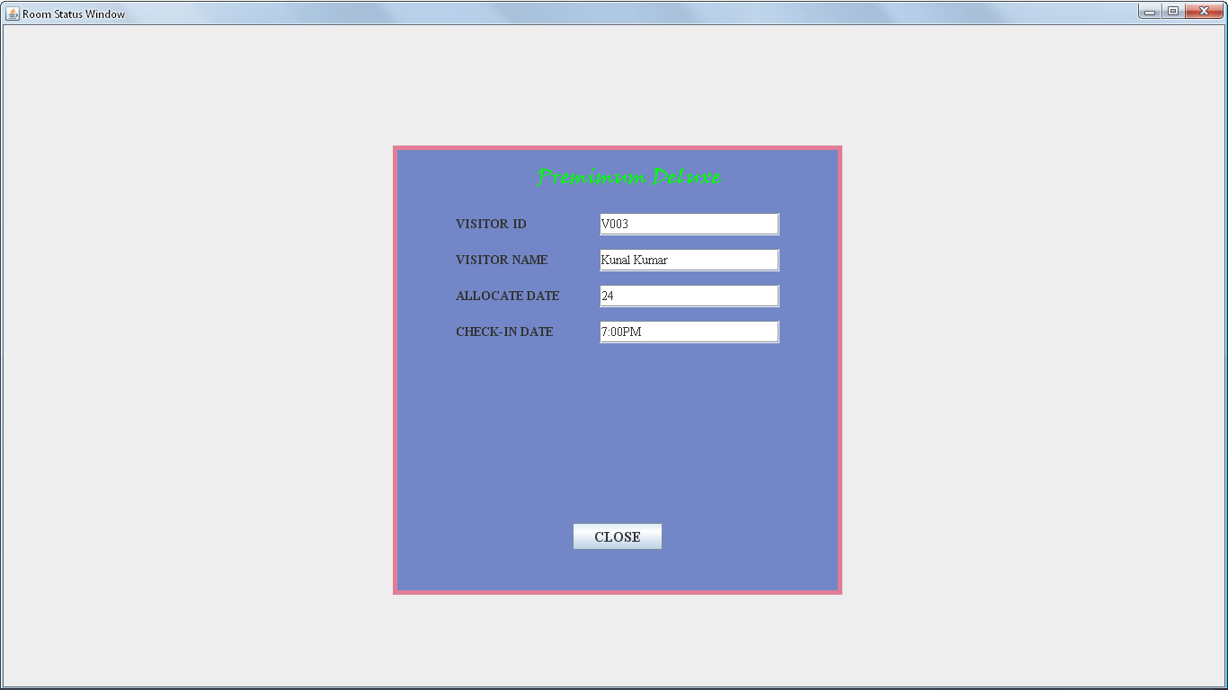

FIGURE:18: SHOWS ROOM STATUS FORM OF PREMIMUM DELUXE

CODING FOR ROOM STATUS FORM OF PREMIUM DELUXE

import java.awt.*;

import javax.swing.*;

class PremimumDeluxe extends JFrame

{

JPanel jpanel1=new JPanel();

JPanel jpanel2=new JPanel();

JLabel jlabel=new JLabel("Premimum Deluxe");

JLabel VIlbl=new JLabel("VISITOR ID");

JTextField VItext=new JTextField(10);

JLabel VNlbl=new JLabel("VISITOR NAME");

JTextField VNtext=new JTextField(25);

JLabel ADlbl=new JLabel("ALLOCATE DATE");

JTextField ADtext=new JTextField(10);

JLabel CKDlbl=new JLabel("CHECK-IN DATE");

JTextField CKDtext=new JTextField(10);

JButton jbtn=new JButton("CLOSE");

PremimumDeluxe(String st)

{

super (st);

setVisible(true);

add(jpanel1);

jpanel1.setLayout(null);

jpanel2.setLayout(null);

jpanel1.add(jpanel2);

jpanel2.setSize(500,500);

jpanel2.setBackground(new Color(115,135,200));

jpanel2.add(jlabel);

jlabel.setFont(new Font("Viner Hand ITC",Font.BOLD,22));

jlabel.setForeground(Color.green);

jpanel2.add(VIlbl);

VIlbl.setFont(new Font("TIMES NEW ROMAN",Font.BOLD,14));

jpanel2.add(VItext);

VItext.setFont(new Font("TIMES NEW ROMAN",Font.PLAIN,14));

jpanel2.add(VNlbl);

VNlbl.setFont(new Font("TIMES NEW ROMAN",Font.BOLD,14));

jpanel2.add(VNtext);

VNtext.setFont(new Font("TIMES NEW ROMAN",Font.PLAIN,14));

jpanel2.add(ADlbl);

ADlbl.setFont(new Font("TIMES NEW ROMAN",Font.BOLD,14));

jpanel2.add(ADtext);

ADtext.setFont(new Font("TIMES NEW ROMAN",Font.PLAIN,14));

jpanel2.add(CKDlbl);

CKDlbl.setFont(new Font("TIMES NEW ROMAN",Font.BOLD,14));

jpanel2.add(CKDtext);

CKDtext.setFont(new Font("TIMES NEW ROMAN",Font.PLAIN,14));

jpanel2.add(jbtn);

jbtn.setFont(new Font("TIMES NEW ROMAN",Font.BOLD,16));

jlabel.setBounds(160,20,220,35);

VIlbl.setBounds(70,75,130,25);

VItext.setBounds(230,75,200,25);

VNlbl.setBounds(70,115,130,25);

VNtext.setBounds(230,115,200,25);

ADlbl.setBounds(70,155,130,25);

ADtext.setBounds(230,155,200,25);

CKDlbl.setBounds(70,195,130,25);

CKDtext.setBounds(230,195,200,25);

jbtn.setBounds(200,420,100,30);

Toolkit toolkit=getToolkit();

Dimension dim=toolkit.getScreenSize();

int w=dim.width;

int h=dim.height;

setSize(w,h);

jpanel2.setBounds(dim.width/2-250,dim.height/2-250,500,500);

jpanel2.setBorder(BorderFactory.createLineBorder(new Color(225,125,150),5));

setDefaultCloseOperation(DISPOSE_ON_CLOSE);

}

public static void main(String args[])

{

new PremimumDeluxe("Room Status Windows");

}

}

ROOM STATUS FORM OF CLUB DELUXE

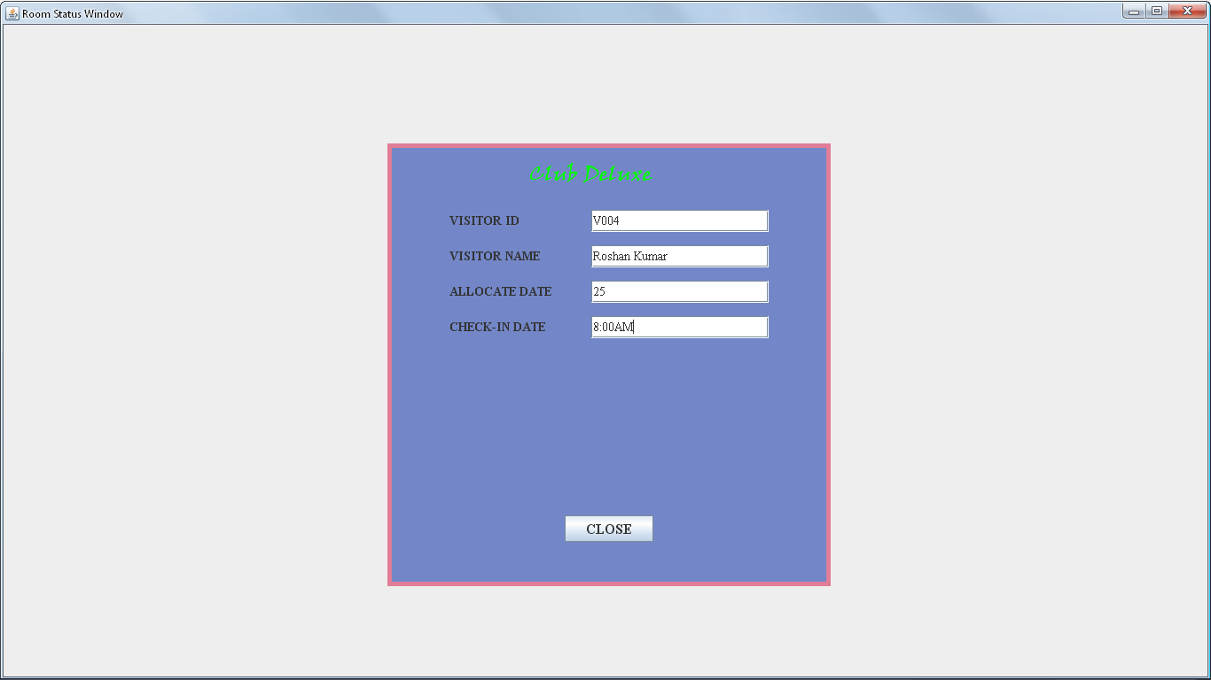

FIGURE:19: SHOWS ROOM STATUS FORM OF CLUB DELUXE

CODING FOR ROOM STATUS FORM OF CLUB DELUXE

import java.awt.*;

import javax.swing.*;

class ClubDeluxe extends JFrame

{

JPanel jpanel1=new JPanel();

JPanel jpanel2=new JPanel();

JLabel jlabel=new JLabel("Club Deluxe");

JLabel VIlbl=new JLabel("VISITOR ID");

JTextField VItext=new JTextField(10);

JLabel VNlbl=new JLabel("VISITOR NAME");

JTextField VNtext=new JTextField(25);

JLabel ADlbl=new JLabel("ALLOCATE DATE");

JTextField ADtext=new JTextField(10);

JLabel CKDlbl=new JLabel("CHECK-IN DATE");

JTextField CKDtext=new JTextField(10);

JButton jbtn=new JButton("CLOSE");

ClubDeluxe(String st)

{

super (st);

setVisible(true);

add(jpanel1);

jpanel1.setLayout(null);

jpanel2.setLayout(null);

jpanel1.add(jpanel2);

jpanel2.setSize(500,500);

jpanel2.setBackground(new Color(115,135,200));

jpanel2.add(jlabel);

jlabel.setFont(new Font("Viner Hand ITC",Font.BOLD,22));

jlabel.setForeground(Color.green);

jpanel2.add(VIlbl);

VIlbl.setFont(new Font("TIMES NEW ROMAN",Font.BOLD,14));

jpanel2.add(VItext);

VItext.setFont(new Font("TIMES NEW ROMAN",Font.PLAIN,14));

jpanel2.add(VNlbl);

VNlbl.setFont(new Font("TIMES NEW ROMAN",Font.BOLD,14));

jpanel2.add(VNtext);

VNtext.setFont(new Font("TIMES NEW ROMAN",Font.PLAIN,14));

jpanel2.add(ADlbl);

ADlbl.setFont(new Font("TIMES NEW ROMAN",Font.BOLD,14));

jpanel2.add(ADtext);

ADtext.setFont(new Font("TIMES NEW ROMAN",Font.PLAIN,14));

jpanel2.add(CKDlbl);

CKDlbl.setFont(new Font("TIMES NEW ROMAN",Font.BOLD,14));

jpanel2.add(CKDtext);

CKDtext.setFont(new Font("TIMES NEW ROMAN",Font.PLAIN,14));

jpanel2.add(jbtn);

jbtn.setFont(new Font("TIMES NEW ROMAN",Font.BOLD,16));

jlabel.setBounds(160,20,180,35);

VIlbl.setBounds(70,75,130,25);

VItext.setBounds(230,75,200,25);

VNlbl.setBounds(70,115,130,25);

VNtext.setBounds(230,115,200,25);

ADlbl.setBounds(70,155,130,25);

ADtext.setBounds(230,155,200,25);

CKDlbl.setBounds(70,195,130,25);

CKDtext.setBounds(230,195,200,25);

jbtn.setBounds(200,420,100,30);

Toolkit toolkit=getToolkit();

Dimension dim=toolkit.getScreenSize();

int w=dim.width;

int h=dim.height;

setSize(w,h);

jpanel2.setBounds(dim.width/2-250,dim.height/2-250,500,500);

jpanel2.setBorder(BorderFactory.createLineBorder(new Color(225,125,150),5));

setDefaultCloseOperation(DISPOSE_ON_CLOSE);

}

public static void main(String args[])

{

new ClubDeluxe("Room Status Windows");

}

}

ROOM STATUS FORM OF CLUB DELUXE

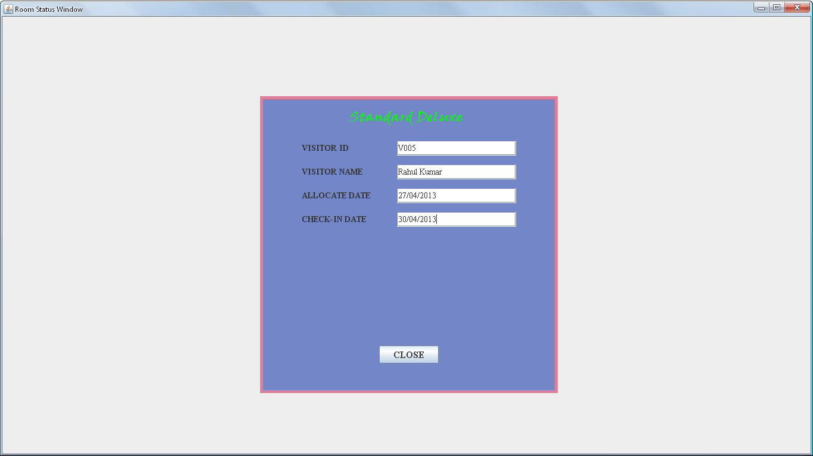FIGURE:20: SHOWS ROOM STATUS FORM OF STANDARD DELUXE

CODING FOR ROOM STATUS FORM OF STANDARD DELUXE

import java.awt.*;

import javax.swing.*;

class StandardDeluxe extends JFrame

{

JPanel jpanel1=new JPanel();

JPanel jpanel2=new JPanel();

JLabel jlabel=new JLabel("Standard Deluxe");

JLabel VIlbl=new JLabel("VISITOR ID");

JTextField VItext=new JTextField(10);

JLabel VNlbl=new JLabel("VISITOR NAME");

JTextField VNtext=new JTextField(25);

JLabel ADlbl=new JLabel("ALLOCATE DATE");

JTextField ADtext=new JTextField(10);

JLabel CKDlbl=new JLabel("CHECK-IN DATE");

JTextField CKDtext=new JTextField(10);

JButton jbtn=new JButton("CLOSE");

StandardDeluxe(String st)

{

super (st);

setVisible(true);

add(jpanel1);

jpanel1.setLayout(null);

jpanel2.setLayout(null);

jpanel1.add(jpanel2);

jpanel2.setSize(500,500);

jpanel2.setBackground(new Color(115,135,200));

jpanel2.add(jlabel);

jlabel.setFont(new Font("Viner Hand ITC",Font.BOLD,22));

jlabel.setForeground(Color.green);

jpanel2.add(VIlbl);

VIlbl.setFont(new Font("TIMES NEW ROMAN",Font.BOLD,14));

jpanel2.add(VItext);

VItext.setFont(new Font("TIMES NEW ROMAN",Font.PLAIN,14));

jpanel2.add(VNlbl);

VNlbl.setFont(new Font("TIMES NEW ROMAN",Font.BOLD,14));

jpanel2.add(VNtext);

VNtext.setFont(new Font("TIMES NEW ROMAN",Font.PLAIN,14));

jpanel2.add(ADlbl);

ADlbl.setFont(new Font("TIMES NEW ROMAN",Font.BOLD,14));

jpanel2.add(ADtext);

ADtext.setFont(new Font("TIMES NEW ROMAN",Font.PLAIN,14));

jpanel2.add(CKDlbl);

CKDlbl.setFont(new Font("TIMES NEW ROMAN",Font.BOLD,14));

jpanel2.add(CKDtext);

CKDtext.setFont(new Font("TIMES NEW ROMAN",Font.PLAIN,14));

jpanel2.add(jbtn);

jbtn.setFont(new Font("TIMES NEW ROMAN",Font.BOLD,16));

jlabel.setBounds(150,20,225,35);

VIlbl.setBounds(70,75,130,25);

VItext.setBounds(230,75,200,25);

VNlbl.setBounds(70,115,130,25);

VNtext.setBounds(230,115,200,25);

ADlbl.setBounds(70,155,130,25);

ADtext.setBounds(230,155,200,25);

CKDlbl.setBounds(70,195,130,25);

CKDtext.setBounds(230,195,200,25);

jbtn.setBounds(200,420,100,30);

Toolkit toolkit=getToolkit();

Dimension dim=toolkit.getScreenSize();

int w=dim.width;

int h=dim.height;

setSize(w,h);

jpanel2.setBounds(dim.width/2-250,dim.height/2-250,500,500);

jpanel2.setBorder(BorderFactory.createLineBorder(new Color(225,125,150),5));

setDefaultCloseOperation(DISPOSE_ON_CLOSE);

}

public static void main(String args[])

{

new StandardDeluxe("Room Status Windows");

}

MEETING ROOM DETAILS FORM

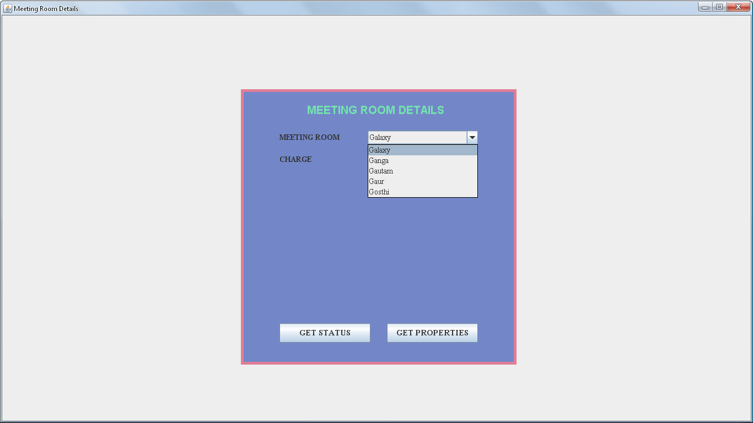

FIGURE:21: SHOWS MEETING ROOM DETAILS FORM

CODING FOR MEETING ROOM DETAILS FORM

import java.awt.*;

import javax.swing.*;

import java.awt.event.*;

class MeetingRoomdets extends JFrame implements ActionListener

{

JPanel jpanel1=new JPanel();

JPanel jpanel2=new JPanel();

JLabel jlabel=new JLabel("MEETING ROOM DETAILS");

JLabel MRTlbl=new JLabel("MEETING ROOM");

JComboBox MRT=new JComboBox();

JLabel MRClbl=new JLabel("CHARGE");

JTextField MRCtext=new JTextField(5);

JButton jbtn1=new JButton("GET STATUS");

JButton jbtn2=new JButton("GET PROPERTIES");

MeetingRoomdets(String st)

{

super(st);

setVisible(true);

add(jpanel1);

jpanel1.add(jpanel2);

jpanel1.setLayout(null);

jpanel2.setLayout(null);

jpanel2.setSize(500,500);

jpanel2.setBackground(new Color(115,135,200));

jpanel2.add(jlabel);

jlabel.setFont(new Font("ARIL",Font.BOLD,20));

jlabel.setForeground(new Color(115,225,175));

jpanel2.add(MRTlbl);

MRTlbl.setFont(new Font("TIMES NEW ROMAN",Font.BOLD,14));

jpanel2.add(MRT);

MRT.addItem("Galaxy");

MRT.addItem("Ganga");

MRT.addItem("Gautam");

MRT.addItem("Gaur");

MRT.addItem("Gosthi");

MRT.setFont(new Font("TIMES NEW ROMAN",Font.PLAIN,14));

jpanel2.add(MRClbl);

MRClbl.setFont(new Font("TIMES NEW ROMAN",Font.BOLD,14));

jpanel2.add(MRCtext);

MRCtext.setFont(new Font("TIMES NEW ROMAN",Font.PLAIN,14));

jpanel2.add(jbtn1);

jbtn1.setFont(new Font("TIMES NEW ROMAN",Font.BOLD,15));

jpanel2.add(jbtn2);

jbtn2.setFont(new Font("TIMES NEW ROMAN",Font.BOLD,15));

jlabel.setBounds(120,20,260,35);

MRTlbl.setBounds(70,75,130,25);

MRT.setBounds(230,75,200,25);

MRClbl.setBounds(70,115,130,25);

MRCtext.setBounds(230,115,200,25);

jbtn1.setBounds(70,425,165,35);

jbtn2.setBounds(265,425,165,35);

Toolkit toolkit=getToolkit();

Dimension dim=toolkit.getScreenSize();

int w=dim.width;

int h=dim.height;

setSize(w,h);

jpanel2.setBounds(dim.width/2-250,dim.height/2-250,500,500);

jpanel2.setBorder(BorderFactory.createLineBorder(new Color(225,125,150),5));

jbtn1.addActionListener(this);

jbtn2.addActionListener(this);

}

public void actionPerformed(ActionEvent e)

{

if(e.getSource()==jbtn1)

{

if(MRT.getSelectedItem().toString().equals("Galaxy"))

{

new MeetingRoom1Status("Meeting Room Status Window");

}

else if(MRT.getSelectedItem().toString().equals("Ganga"))

{

new MeetingRoom2Status("Meeting Room Status Window");

}

else if(MRT.getSelectedItem().toString().equals("Gautam"))

{

new MeetingRoom3Status("Meeting Room Status Window");

}

else if(MRT.getSelectedItem().toString().equals("Gaur"))

{

new MeetingRoom4Status("Meeting Room Status Window");

}

else if(MRT.getSelectedItem().toString().equals("Gosthi"))

{

new MeetingRoom5Status("Meeting Room Status Window");

}

}

else if(e.getSource()==jbtn2)

{

if(MRT.getSelectedItem().toString().equals("Galaxy"))

{

new MeetingRoom1("Meeting Room Status Window");

}

else if(MRT.getSelectedItem().toString().equals("Ganga"))

{

new MeetingRoom2("Meeting Room Status Window");

}

else if(MRT.getSelectedItem().toString().equals("Gautam"))

{

new MeetingRoom3("Meeting Room Status Window");

}

else if(MRT.getSelectedItem().toString().equals("Gaur"))

{

new MeetingRoom4("Meeting Room Status Window");

}

else if(MRT.getSelectedItem().toString().equals("Gosthi"))

{

new MeetingRoom5("Meeting Room Status Window");

}

}

}

public static void main(String args[])

{

new MeetingRoomdets("Meeting Room Details");

}

}

PROPERTIES OF MEETING ROOM 1 DETAILS FORM

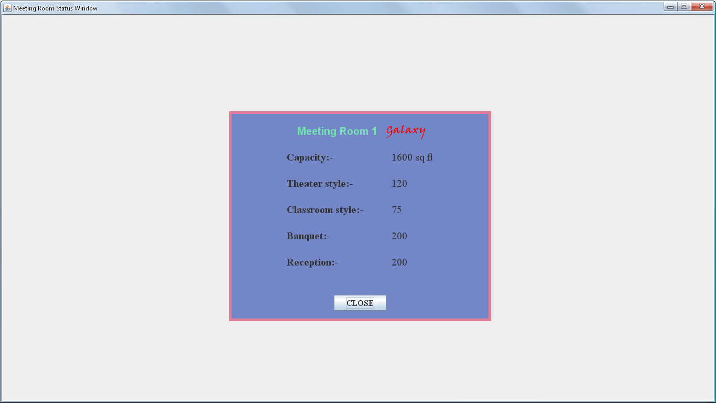

FIGURE:22: SHOWS PROPERTIES OF MEETING ROOM 1 DETAILS FORM

CODING OF MEETING ROOM 1 DETAILS FORM

import java.awt.*;

import javax.swing.*;

class MeetingRoom1 extends JFrame

{

JPanel jpanel1=new JPanel();

JPanel jpanel2=new JPanel();

JLabel jlabel=new JLabel("Meeting Room 1");

JLabel Glbl=new JLabel("Galaxy");

JLabel CAPlbl=new JLabel("Capacity:-");

JLabel caplbl=new JLabel("1600 sq ft");

JLabel THElbl=new JLabel("Theater style:-");

JLabel thelbl=new JLabel("120");

JLabel CLASSlbl=new JLabel("Classroom style:-");

JLabel classlbl=new JLabel("75");

JLabel BANlbl=new JLabel("Banquet:-");

JLabel banlbl=new JLabel("200");

JLabel REClbl=new JLabel("Reception:-");

JLabel reclbl=new JLabel("200");

JButton jbtn=new JButton("CLOSE");

MeetingRoom1(String st)

{

super(st);

setVisible(true);

jpanel1.setLayout(null);

jpanel2.setLayout(null);

add(jpanel1);

jpanel1.add(jpanel2);

jpanel2.setSize(500,400);

jpanel2.setBackground(new Color(115,135,200));

jpanel2.add(jlabel);

jlabel.setFont(new Font("ARIL",Font.BOLD,20));

jlabel.setForeground(new Color(115,225,175));

jpanel2.add(Glbl);

Glbl.setFont(new Font("Viner Hand ITC",Font.BOLD,20));

Glbl.setForeground(Color.red);

jpanel2.add(CAPlbl);

CAPlbl.setFont(new Font("TIMES NEW ROMAN",Font.BOLD,20));

jpanel2.add(caplbl);

caplbl.setFont(new Font("TIMES NEW ROMAN",Font.PLAIN,20));

jpanel2.add(THElbl);

THElbl.setFont(new Font("TIMES NEW ROMAN",Font.BOLD,20));

jpanel2.add(thelbl);

thelbl.setFont(new Font("TIMES NEW ROMAN",Font.PLAIN,20));

jpanel2.add(CLASSlbl);

CLASSlbl.setFont(new Font("TIMES NEW ROMAN",Font.BOLD,20));

jpanel2.add(classlbl);

classlbl.setFont(new Font("TIMES NEW ROMAN",Font.PLAIN,20));

jpanel2.add(BANlbl);

BANlbl.setFont(new Font("TIMES NEW ROMAN",Font.BOLD,20));

jpanel2.add(banlbl);

banlbl.setFont(new Font("TIMES NEW ROMAN",Font.PLAIN,20));

jpanel2.add(REClbl);

REClbl.setFont(new Font("TIMES NEW ROMAN",Font.BOLD,20));

jpanel2.add(reclbl);

reclbl.setFont(new Font("TIMES NEW ROMAN",Font.PLAIN,20));

jpanel2.add(jbtn);

jbtn.setFont(new Font("TIMES NEW ROMAN",Font.BOLD,16));

jlabel.setBounds(130,20,155,35);

Glbl.setBounds(300,20,90,35);

CAPlbl.setBounds(110,75,130,25);

caplbl.setBounds(310,75,130,25);

THElbl.setBounds(110,125,130,25);

thelbl.setBounds(310,125,130,25);

CLASSlbl.setBounds(110,175,150,25);

classlbl.setBounds(310,175,150,25);

BANlbl.setBounds(110,225,130,25);

banlbl.setBounds(310,225,130,25);

REClbl.setBounds(110,275,130,25);

reclbl.setBounds(310,275,130,25);

jbtn.setBounds(200,350,100,30);

Toolkit toolkit=getToolkit();

Dimension dim=toolkit.getScreenSize();

int w=dim.width;

int h=dim.height;

setSize(w,h);

jpanel2.setBounds(dim.width/2-250,dim.height/2-200,500,400);

jpanel2.setBorder(BorderFactory.createLineBorder(new Color(225,125,150),5));

setDefaultCloseOperation(DISPOSE_ON_CLOSE);

}

public static void main(String args[])

{

new MeetingRoom1("Meeting Room Details");

}

}

PROPERTIES OF MEETING ROOM 2 DETAILS FORM

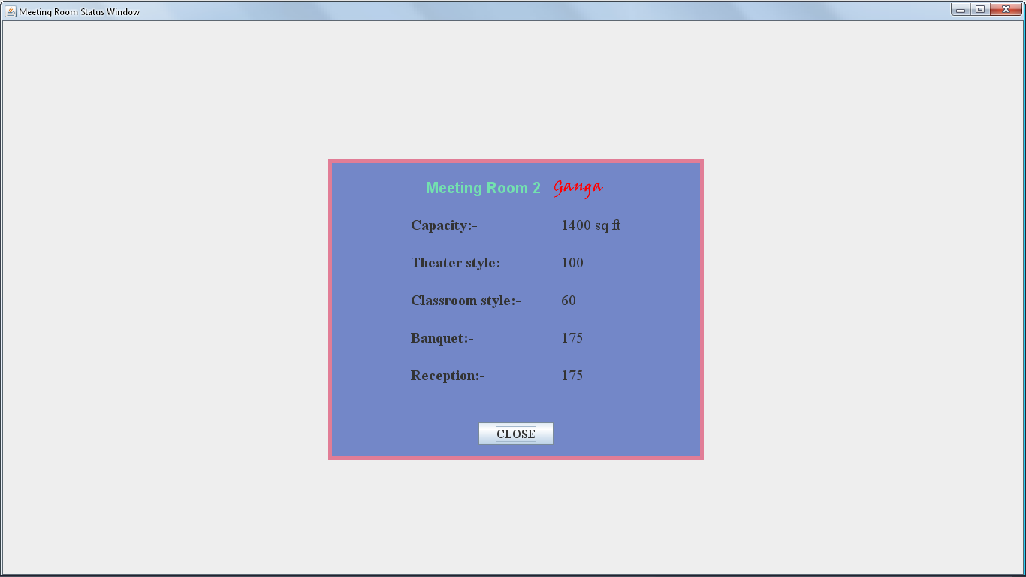

FIGURE:23: SHOWS PROPERTIES OF MEETING ROOM 2 DETAILS FORM

CODING OF MEETING ROOM 2 DETAILS FORM

import java.awt.*;

import javax.swing.*;

class MeetingRoom2 extends JFrame

{

JPanel jpanel1=new JPanel();

JPanel jpanel2=new JPanel();

JLabel jlabel=new JLabel("Meeting Room 2");

JLabel Glbl=new JLabel("Ganga");

JLabel CAPlbl=new JLabel("Capacity:-");

JLabel caplbl=new JLabel("1400 sq ft");

JLabel THElbl=new JLabel("Theater style:-");

JLabel thelbl=new JLabel("100");

JLabel CLASSlbl=new JLabel("Classroom style:-");

JLabel classlbl=new JLabel("60");

JLabel BANlbl=new JLabel("Banquet:-");

JLabel banlbl=new JLabel("175");

JLabel REClbl=new JLabel("Reception:-");

JLabel reclbl=new JLabel("175");

JButton jbtn=new JButton("CLOSE");

MeetingRoom2(String st)

{

super(st);

setVisible(true);

jpanel1.setLayout(null);

jpanel2.setLayout(null);

add(jpanel1);

jpanel1.add(jpanel2);

jpanel2.setSize(500,400);

jpanel2.setBackground(new Color(115,135,200));

jpanel2.add(jlabel);

jlabel.setFont(new Font("ARIL",Font.BOLD,20));

jlabel.setForeground(new Color(115,225,175));

jpanel2.add(Glbl);

Glbl.setFont(new Font("Viner Hand ITC",Font.BOLD,20));

Glbl.setForeground(Color.red);

jpanel2.add(CAPlbl);

CAPlbl.setFont(new Font("TIMES NEW ROMAN",Font.BOLD,20));

jpanel2.add(caplbl);

caplbl.setFont(new Font("TIMES NEW ROMAN",Font.PLAIN,20));

jpanel2.add(THElbl);

THElbl.setFont(new Font("TIMES NEW ROMAN",Font.BOLD,20));

jpanel2.add(thelbl);

thelbl.setFont(new Font("TIMES NEW ROMAN",Font.PLAIN,20));

jpanel2.add(CLASSlbl);

CLASSlbl.setFont(new Font("TIMES NEW ROMAN",Font.BOLD,20));

jpanel2.add(classlbl);

classlbl.setFont(new Font("TIMES NEW ROMAN",Font.PLAIN,20));

jpanel2.add(BANlbl);

BANlbl.setFont(new Font("TIMES NEW ROMAN",Font.BOLD,20));

jpanel2.add(banlbl);

banlbl.setFont(new Font("TIMES NEW ROMAN",Font.PLAIN,20));

jpanel2.add(REClbl);

REClbl.setFont(new Font("TIMES NEW ROMAN",Font.BOLD,20));

jpanel2.add(reclbl);

reclbl.setFont(new Font("TIMES NEW ROMAN",Font.PLAIN,20));

jpanel2.add(jbtn);

jbtn.setFont(new Font("TIMES NEW ROMAN",Font.BOLD,16));

jlabel.setBounds(130,20,155,35);

Glbl.setBounds(300,20,90,35);

CAPlbl.setBounds(110,75,130,25);

caplbl.setBounds(310,75,130,25);

THElbl.setBounds(110,125,130,25);

thelbl.setBounds(310,125,130,25);

CLASSlbl.setBounds(110,175,150,25);

classlbl.setBounds(310,175,150,25);

BANlbl.setBounds(110,225,130,25);

banlbl.setBounds(310,225,130,25);

REClbl.setBounds(110,275,130,25);

reclbl.setBounds(310,275,130,25);

jbtn.setBounds(200,350,100,30);

Toolkit toolkit=getToolkit();

Dimension dim=toolkit.getScreenSize();

int w=dim.width;

int h=dim.height;

setSize(w,h);

jpanel2.setBounds(dim.width/2-250,dim.height/2-200,500,400);

jpanel2.setBorder(BorderFactory.createLineBorder(new Color(225,125,150),5));

setDefaultCloseOperation(DISPOSE_ON_CLOSE);

}

public static void main(String args[])

{

new MeetingRoom2("Meeting Room Details2");

}

}

EMPLOYEE aatendance DETAILS FORM

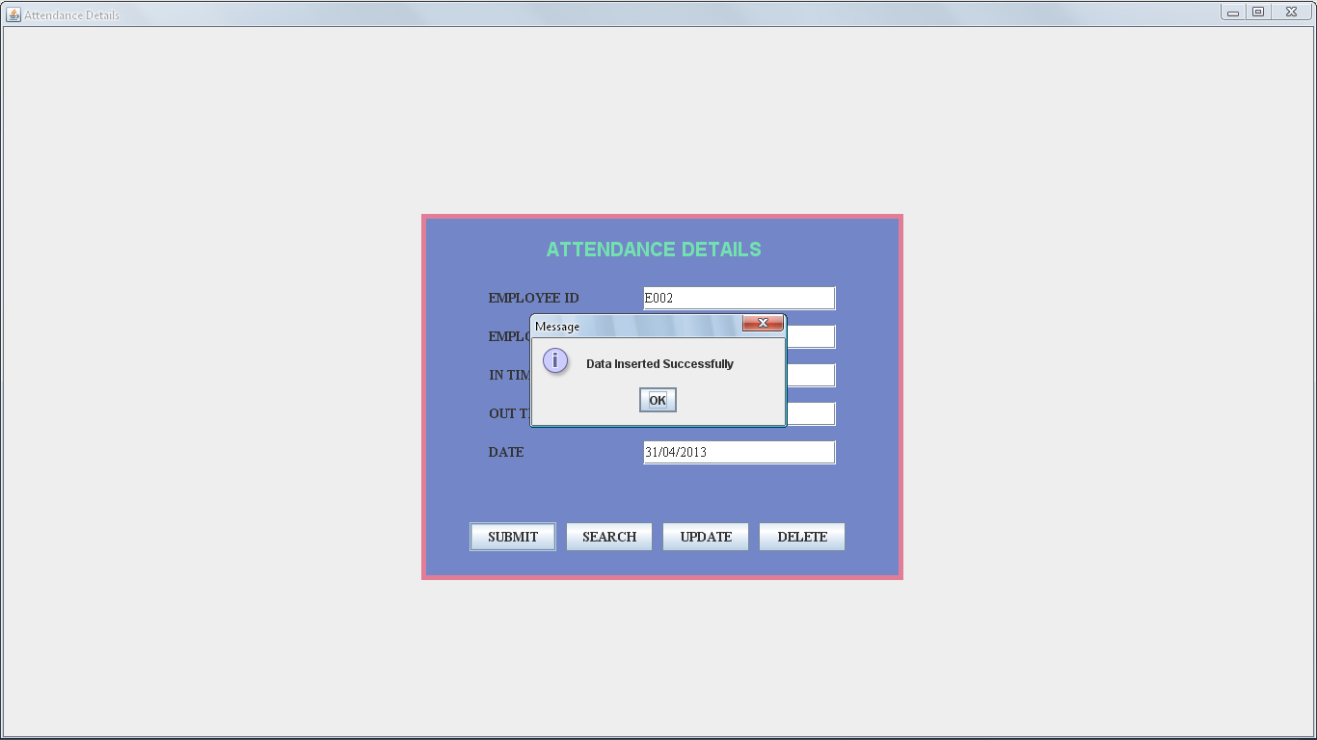

FIGURE:24: SHOWS EMPLOYEE ATTENDANCES DETAILS FORM

CODING FOR EMPLOYEE ATTENDANCE DETAILS FORM

import java.awt.*;

import javax.swing.*;

import java.awt.event.*;

import java.sql.*;

class Attendance extends JFrame implements ActionListener

{

JPanel panel1=new JPanel();

JPanel panel2=new JPanel();

JLabel jlabel=new JLabel("ATTENDANCE DETAILS");

JLabel Elbl=new JLabel("EMPLOYEE NAME");

JTextField Etext=new JTextField(30);

JLabel EIlbl=new JLabel("EMPLOYEE ID");

JTextField EItext=new JTextField(10);

JLabel Ilbl=new JLabel("IN TIME");

JTextField Itext=new JTextField(6);

JLabel Olbl=new JLabel("OUT TIME");

JTextField Otext=new JTextField(6);

JLabel Dlbl=new JLabel("DATE");

JTextField Dtext=new JTextField(10);

JButton Jbutton1=new JButton("SUBMIT");

JButton Jbutton2=new JButton("SEARCH");

JButton Jbutton3=new JButton("UPDATE");

JButton Jbutton4=new JButton("DELETE");

Attendance(String st)

{

super(st);

setVisible(true);

add(panel1);

panel1.setLayout(null);

panel2.setLayout(null);

panel1.add(panel2);

panel2.setSize(500,380);

panel2.setBackground(new Color(115,135,200));

panel2.add(jlabel);

jlabel.setFont(new Font("ARIAL",Font.BOLD,20));

jlabel.setForeground(new Color(115,225,175));

panel2.setBorder(BorderFactory.createLineBorder(new Color(225,125,150),5));

panel2.add(Elbl);

Elbl.setFont(new Font("TIMES NEW ROMAN",Font.BOLD,14));

panel2.add(Etext);

Etext.setFont(new Font("TIMES NEW ROMAN",Font.PLAIN,14));

panel2.add(EIlbl);

EIlbl.setFont(new Font("TIMES NEW ROMAN",Font.BOLD,14));

panel2.add(EItext);

EItext.setFont(new Font("TIMES NEW ROMAN",Font.PLAIN,14));

panel2.add(Ilbl);

Ilbl.setFont(new Font("TIMES NEW ROMAN",Font.BOLD,14));

panel2.add(Itext);

Itext.setFont(new Font("TIMES NEW ROMAN",Font.PLAIN,14));

panel2.add(Olbl);

Olbl.setFont(new Font("TIMES NEW ROMAN",Font.BOLD,14));

panel2.add(Otext);

Otext.setFont(new Font("TIMES NEW ROMAN",Font.PLAIN,14));

panel2.add(Dlbl);

Dlbl.setFont(new Font("TIMES NEW ROMAN",Font.BOLD,14));

panel2.add(Dtext);

Dtext.setFont(new Font("TIMES NEW ROMAN",Font.PLAIN,14));

panel2.add(Jbutton1);

Jbutton1.setFont(new Font("TIMES NEW ROMAN",Font.BOLD,14));

panel2.add(Jbutton2);

Jbutton2.setFont(new Font("TIMES NEW ROMAN",Font.BOLD,14));

panel2.add(Jbutton3);

Jbutton3.setFont(new Font("TIMES NEW ROMAN",Font.BOLD,14));

panel2.add(Jbutton4);

Jbutton4.setFont(new Font("TIMES NEW ROMAN",Font.BOLD,14));

jlabel.setBounds(130,20,240,35);

Elbl.setBounds(70,115,130,25);

Etext.setBounds(230,115,200,25);

EIlbl.setBounds(70,75,130,25);

EItext.setBounds(230,75,200,25);

Ilbl.setBounds(70,155,130,25);

Itext.setBounds(230,155,200,25);

Olbl.setBounds(70,195,130,25);

Otext.setBounds(230,195,200,25);

Dlbl.setBounds(70,235,130,25);

Dtext.setBounds(230,235,200,25);

Jbutton1.setBounds(50,320,90,30);

Jbutton2.setBounds(150,320,90,30);

Jbutton3.setBounds(250,320,90,30);

Jbutton4.setBounds(350,320,90,30);

Toolkit toolkit=getToolkit();

Dimension dim=toolkit.getScreenSize();

int w=dim.width;

int h=dim.height;

setSize(w,h);

panel2.setBounds(dim.width/2-250,dim.height/2-190,500,380);

panel2.setBorder(BorderFactory.createLineBorder(new Color(225,125,150),5));

Jbutton1.addActionListener(this);

Jbutton2.addActionListener(this);

Jbutton3.addActionListener(this);

Jbutton4.addActionListener(this);

}

public void actionPerformed(ActionEvent e)

{

if(e.getSource()==Jbutton1) /*Inset Coding...*/

{

try

{

Class.forName("sun.jdbc.odbc.JdbcOdbcDriver");

Connection con=DriverManager.getConnection("Jdbc:Odbc:myname","system","oracle");

PreparedStatement ps=con.prepareStatement("insert into Attendance values(?,?,?,?,?)");

ps.setString(1,EItext.getText());

ps.setString(2,Etext.getText());

ps.setString(3,Itext.getText());

ps.setString(4,Itext.getText());

ps.setString(5,Dtext.getText());

int R=ps.executeUpdate();

if(R>0)

{

JOptionPane.showMessageDialog(this,"Data Inserted Successfully");

}

Else

{

JOptionPane.showMessageDialog(this,"Data Not Inserted Successfully");

}

}

catch(Exception S)

{

System.out.println(S);

}

}

else if(e.getSource()==Jbutton2) /*Searching Coding...*/

{

try

{

Class.forName("sun.jdbc.odbc.JdbcOdbcDriver");

Connection con=DriverManager.getConnection("Jdbc:Odbc:myname","system","oracle");

PreparedStatement ps=con.prepareStatement("Select vid,vn from EmployeeDets where eid=?");

ps.setString(1,EItext.getText());

ResultSet rs=ps.executeQuery();

if(rs.next())

{

JOptionPane.showMessageDialog(this,"Data found...");

Etext.setText(rs.getString(2));

}

else

{

JOptionPane.showMessageDialog(this,"Data Not Search Successfully");

}

}

catch(Exception S)

{

System.out.println(S);

}

}

else if(e.getSource()==Jbutton3) /*Update Coding...*/

{

try

{

Class.forName("sun.jdbc.odbc.JdbcOdbcDriver");

Connection con=DriverManager.getConnection("Jdbc:Odbc:myname","system","oracle");

PreparedStatement ps=con.prepareStatement("update Attendance set eid=?,en=?,intt=?,outt=?,datee=? where eid=?");

ps.setString(1,EItext.getText());

ps.setString(2,Etext.getText());

ps.setString(3,Itext.getText());

ps.setString(4,Otext.getText());

ps.setString(5,Dtext.getText());

ps.setString(6,EItext.getText());

int R=ps.executeUpdate();

if(R>0)

{

JOptionPane.showMessageDialog(this,"Data Update Successfully");

}

else

{

JOptionPane.showMessageDialog(this,"Data Not Update Successfully");

}

}

catch(Exception S)

{

System.out.println(S);

}

}

else if(e.getSource()==Jbutton4)

{

try

{

Class.forName("sun.jdbc.odbc.JdbcOdbcDriver");

Connection con=DriverManager.getConnection("Jdbc:Odbc:myname","system","oracle");

PreparedStatement ps=con.prepareStatement("delete from Attendance where eid=?");

ps.setString(1,EItext.getText());

int R=ps.executeUpdate();

if(R>0)

{

JOptionPane.showMessageDialog(this,"Data Deleted Successfully");

}

else

{

JOptionPane.showMessageDialog(this,"Data Not Deleted Successfully");

}

}

catch(Exception S)

{

System.out.println(S);

}

}

}

public static void main(String args[])

{

new Attendance("ATTENDACE WINDOW");

}

}

EMPLOYEE DETAILS FORM

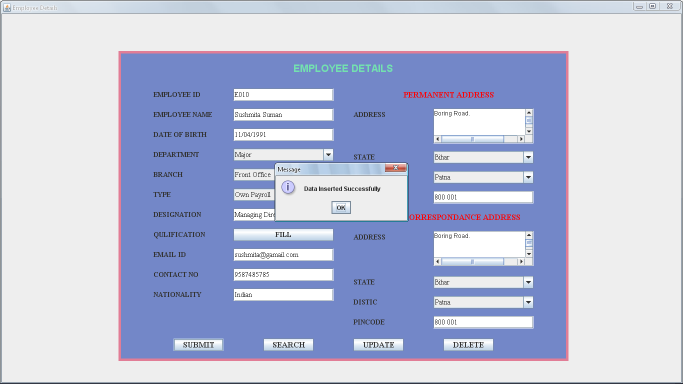

FIGURE:25: SHOWS EMPLOYEE DETAILS FORM

CODING FOR EMPLOYEE DETAILS FORM

import java.awt.*;

import javax.swing.*;

import java.awt.event.*;

import java.sql.*;

class EmployeeDets extends JFrame implements ActionListener

{

JPanel jpanel1=new JPanel();

JPanel jpanel2=new JPanel();

JLabel jlabel=new JLabel("EMPLOYEE DETAILS");

JLabel EIDlbl=new JLabel("EMPLOYEE ID");

JTextField EIDtext=new JTextField(25);

JLabel ENlbl=new JLabel("EMPLOYEE NAME");

JTextField ENtext=new JTextField(25);

JLabel EDOBlbl=new JLabel("DATE OF BIRTH");

JTextField EDOBtext=new JTextField(25);

JLabel EDlbl=new JLabel("DEPARTMENT");

JComboBox ED=new JComboBox();

JLabel EBlbl=new JLabel("BRANCH");

JComboBox EB=new JComboBox();

JLabel ETlbl=new JLabel("TYPE");

JComboBox ET=new JComboBox();

JLabel EPlbl=new JLabel("DESIGNATION");

JTextField EPtext=new JTextField(25);

JLabel EQlbl=new JLabel("QULIFICATION");

JButton FILLbtn=new JButton("FILL");

JLabel ENYlbl=new JLabel("NATIONALITY");

JTextField ENYtext=new JTextField(25);

JLabel PADlbl=new JLabel("PERMANENT ADDRESS");

JLabel EAlbl=new JLabel("ADDRESS");

JTextArea EAtext=new JTextArea("Enter Your Address",5,20);

JScrollPane EA1=new JScrollPane(EAtext);

JLabel ESlbl=new JLabel("STATE");

JComboBox ES=new JComboBox();

JLabel EDClbl=new JLabel("DISTIC");

JComboBox EDC=new JComboBox();

JLabel EPClbl=new JLabel("PINCODE");

JTextField EPCtext=new JTextField(10);

JLabel EIIDlbl=new JLabel("EMAIL ID");

JTextField EIIDtext=new JTextField(20);

JLabel ECNlbl=new JLabel("CONTACT NO");

JTextField ECNtext=new JTextField(12);

JLabel PAAlbl=new JLabel("CORRESPONDANCE ADDRESS");

JLabel EAAlbl=new JLabel("ADDRESS");

JTextArea EAAtext=new JTextArea("Enter Your Address",5,20);

JScrollPane EAA2=new JScrollPane(EAAtext);

JLabel ESSlbl=new JLabel("STATE");

JComboBox ESS=new JComboBox();

JLabel EDDClbl=new JLabel("DISTIC");

JComboBox EDDC=new JComboBox();

JLabel EPPClbl=new JLabel("PINCODE");

JTextField EPPCtext=new JTextField(10);

JButton jbtn1=new JButton("SUBMIT");

JButton jbtn2=new JButton("SEARCH");

JButton jbtn3=new JButton("UPDATE");

JButton jbtn4=new JButton("DELETE");

EmployeeDets(String st)

{

super (st);

setVisible(true);

add(jpanel1);

jpanel1.setLayout(null);

jpanel2.setLayout(null);

jpanel1.add(jpanel2);

jpanel2.setSize(900,620);

jpanel2.setBackground(new Color(115,135,200));

Toolkit toolkit=getToolkit();

Dimension dim=toolkit.getScreenSize();

int w=dim.width;

int h=dim.height;

setSize(w,h);

jpanel2.add(jlabel);

jlabel.setFont(new Font("ARIAL",Font.BOLD,20));

jlabel.setForeground(new Color(115,225,175));

jpanel2.add(EIDlbl);

EIDlbl.setFont(new Font("TIMES NEW ROMAN",Font.BOLD,14));

jpanel2.add(EIDtext);

EIDtext.setFont(new Font("TIMES NEW ROMAN",Font.PLAIN,14));

jpanel2.add(ENlbl);

ENlbl.setFont(new Font("TIMES NEW ROMAN",Font.BOLD,14));

jpanel2.add(ENtext);

ENtext.setFont(new Font("TIMES NEW ROMAN",Font.PLAIN,14));

jpanel2.add(EDOBlbl);

EDOBlbl.setFont(new Font("TIMES NEW ROMAN",Font.BOLD,14));

jpanel2.add(EDOBtext);

EDOBtext.setFont(new Font("TIMES NEW ROMAN",Font.PLAIN,14));

jpanel2.add(EDlbl);

EDlbl.setFont(new Font("TIMES NEW ROMAN",Font.BOLD,14));

jpanel2.add(ED);

ED.addItem("Major");

ED.addItem("Minor");

ED.setFont(new Font("TIMES NEW ROMAN",Font.PLAIN,14));

jpanel2.add(EBlbl);

EBlbl.setFont(new Font("TIMES NEW ROMAN",Font.BOLD,14));

jpanel2.add(EB);

EB.addItem("Front Office");

EB.addItem("Food And Bevrage Deparment");

EB.addItem("Food And Bevrage Production");

EB.addItem("House Keeping");

EB.setFont(new Font("TIMES NEW ROMAN",Font.PLAIN,14));

jpanel2.add(ETlbl);

ETlbl.setFont(new Font("TIMES NEW ROMAN",Font.BOLD,14));

jpanel2.add(ET);

ET.addItem("Own Payroll");

ET.addItem("Contectual");

ET.setFont(new Font("TIMES NEW ROMAN",Font.PLAIN,14));

jpanel2.add(EPlbl);

EPlbl.setFont(new Font("TIMES NEW ROMAN",Font.BOLD,14));

jpanel2.add(EPtext);

EPtext.setFont(new Font("TIMES NEW ROMAN",Font.PLAIN,14));

jpanel2.add(EQlbl);

EQlbl.setFont(new Font("TIMES NEW ROMAN",Font.BOLD,14));

jpanel2.add(FILLbtn);

FILLbtn.setFont(new Font("TIMES NEW ROMAN",Font.BOLD,14));

jpanel2.add(ENYlbl);

ENYlbl.setFont(new Font("TIMES NEW ROMAN",Font.BOLD,14));

jpanel2.add(ENYtext);

ENYtext.setFont(new Font("TIMES NEW ROMAN",Font.PLAIN,14));

jpanel2.add(PADlbl);

PADlbl.setFont(new Font("TIMES NEW ROMAN",Font.BOLD,16));

PADlbl.setForeground(Color.red);

jpanel2.add(EAlbl);

EAlbl.setFont(new Font("TIMES NEW ROMAN",Font.BOLD,14));

jpanel2.add(EA1);

jpanel2.add(ESlbl);

ESlbl.setFont(new Font("TIMES NEW ROMAN",Font.BOLD,14));

jpanel2.add(ES);

ES.addItem("Bihar");

ES.addItem("UP");

ES.setFont(new Font("TIMES NEW ROMAN",Font.PLAIN,14));

jpanel2.add(EDClbl);

EDClbl.setFont(new Font("TIMES NEW ROMAN",Font.BOLD,14));

jpanel2.add(EDC);

EDC.addItem("Patna");

EDC.addItem("Sharsha");

EDC.addItem("Supaul");

EDC.addItem("Gaya");

EDC.setFont(new Font("TIMES NEW ROMAN",Font.PLAIN,14));

jpanel2.add(EPClbl);

EPClbl.setFont(new Font("TIMES NEW ROMAN",Font.BOLD,14));

jpanel2.add(EPCtext);

EPCtext.setFont(new Font("TIMES NEW ROMAN",Font.PLAIN,14));

jpanel2.add(EIIDlbl);

EIIDlbl.setFont(new Font("TIMES NEW ROMAN",Font.BOLD,14));

jpanel2.add(EIIDtext);

EIIDtext.setFont(new Font("TIMES NEW ROMAN",Font.PLAIN,14));

jpanel2.add(ECNlbl);

ECNlbl.setFont(new Font("TIMES NEW ROMAN",Font.BOLD,14));

jpanel2.add(ECNtext);

ECNtext.setFont(new Font("TIMES NEW ROMAN",Font.PLAIN,14));

jpanel2.add(PAAlbl);

PAAlbl.setFont(new Font("TIMES NEW ROMAN",Font.BOLD,16));

PAAlbl.setForeground(Color.red);

jpanel2.add(EAAlbl);

EAAlbl.setFont(new Font("TIMES NEW ROMAN",Font.BOLD,14));

jpanel2.add(EAA2);

jpanel2.add(ESSlbl);

ESSlbl.setFont(new Font("TIMES NEW ROMAN",Font.BOLD,14));

jpanel2.add(ESS);

ESS.addItem("Bihar");

ESS.addItem("UP");

ESS.setFont(new Font("TIMES NEW ROMAN",Font.PLAIN,14));

jpanel2.add(EDDClbl);

EDDClbl.setFont(new Font("TIMES NEW ROMAN",Font.BOLD,14));

jpanel2.add(EDDC);

EDDC.addItem("Patna");

EDDC.addItem("Supaul");

EDDC.addItem("Sharsha");

EDDC.setFont(new Font("TIMES NEW ROMAN",Font.PLAIN,14));

jpanel2.add(EPPClbl);

EPPClbl.setFont(new Font("TIMES NEW ROMAN",Font.BOLD,14));

jpanel2.add(EPPCtext);

EPPCtext.setFont(new Font("TIMES NEW ROMAN",Font.PLAIN,14));

jpanel2.add(jbtn1);

jbtn1.setFont(new Font("TIMES NEW ROMAN",Font.BOLD,16));

jpanel2.add(jbtn2);

jbtn2.setFont(new Font("TIMES NEW ROMAN",Font.BOLD,16));

jpanel2.add(jbtn3);

jbtn3.setFont(new Font("TIMES NEW ROMAN",Font.BOLD,16));

jpanel2.add(jbtn4);

jbtn4.setFont(new Font("TIMES NEW ROMAN",Font.BOLD,16));

jlabel.setBounds(350,20,200,30);

EIDlbl.setBounds(70,75,130,25);

EIDtext.setBounds(230,75,200,25);

ENlbl.setBounds(70,115,130,25);

ENtext.setBounds(230,115,200,25);

EDOBlbl.setBounds(70,155,130,25);

EDOBtext.setBounds(230,155,200,25);

EDlbl.setBounds(70,195,130,25);

ED.setBounds(230,195,200,25);

EBlbl.setBounds(70,235,130,25);

EB.setBounds(230,235,200,25);

ETlbl.setBounds(70,275,130,25);

ET.setBounds(230,275,200,25);

EPlbl.setBounds(70,315,130,25);

EPtext.setBounds(230,315,200,25);

EQlbl.setBounds(70,355,130,25);

FILLbtn.setBounds(230,355,200,25);

EIIDlbl.setBounds(70,395,130,25);

EIIDtext.setBounds(230,395,200,25);

ECNlbl.setBounds(70,435,130,25);

ECNtext.setBounds(230,435,200,25);

ENYlbl.setBounds(70,475,130,25);

ENYtext.setBounds(230,475,200,25);

PADlbl.setBounds(570,75,200,25);

EAlbl.setBounds(470,115,130,25);

EA1.setBounds(630,115,200,70);

ESlbl.setBounds(470,200,130,25);

ES.setBounds(630,200,200,25);

EDClbl.setBounds(470,240,130,25);

EDC.setBounds(630,240,200,25);

EPClbl.setBounds(470,280,130,25);

EPCtext.setBounds(630,280,200,25);

PAAlbl.setBounds(570,320,250,25);

EAAlbl.setBounds(470,360,130,25);

EAA2.setBounds(630,360,200,70);

ESSlbl.setBounds(470,450,130,25);

ESS.setBounds(630,450,200,25);

EDDClbl.setBounds(470,490,130,25);

EDDC.setBounds(630,490,200,25);

EPPClbl.setBounds(470,530,130,25);

EPPCtext.setBounds(630,530,200,25);

jbtn1.setBounds(110,575,100,25);

jbtn2.setBounds(290,575,100,25);

jbtn3.setBounds(470,575,100,25);

jbtn4.setBounds(650,575,100,25);

jpanel2.setBounds(dim.width/2-450,dim.height/2-310,900,620);

jpanel2.setBorder(BorderFactory.createLineBorder(new Color(225,125,150),5));

FILLbtn.addActionListener(this);

jbtn1.addActionListener(this);

jbtn2.addActionListener(this);

jbtn3.addActionListener(this);

jbtn4.addActionListener(this);

}

public void actionPerformed(ActionEvent e)

{

if(e.getSource()==FILLbtn)

{

new Qulification("Qualification Details Window");

}

if(e.getSource()==jbtn1)

{

try

{ /*Insert Coding.....*/

Class.forName("sun.jdbc.odbc.JdbcOdbcDriver");

Connection con=DriverManager.getConnection("Jdbc:Odbc:myname","system","oracle");

PreparedStatement ps=con.prepareStatement("insert into EmployeeDets values(?,?,?,?,?,?,?,?,?,?,?,?,?,?,?,?,?,?)");

ps.setString(1,EIDtext.getText());

ps.setString(2,ENtext.getText());

ps.setString(3,EDOBtext.getText());

ps.setString(4,ED.getSelectedItem().toString());

ps.setString(5,EB.getSelectedItem().toString());

ps.setString(6,ET.getSelectedItem().toString());

ps.setString(7,EPtext.getText());

ps.setString(8,EIIDtext.getText());

ps.setString(9,ECNtext.getText());

ps.setString(10,ENYtext.getText());

ps.setString(11,EAtext.getText());

ps.setString(12,ES.getSelectedItem().toString());

ps.setString(13,EDC.getSelectedItem().toString());

ps.setString(14,EPCtext.getText());

ps.setString(15,EAAtext.getText());

ps.setString(16,ESS.getSelectedItem().toString());

ps.setString(17,EDDC.getSelectedItem().toString());

ps.setString(18,EPPCtext.getText());

int R=ps.executeUpdate();

if(R>0)

{

JOptionPane.showMessageDialog(this,"Data Inserted Successfully");

}

else

{

JOptionPane.showMessageDialog(this,"Data Not Inserted Successfully");

}

}

catch(Exception S)

{

System.out.println(S);

}

}

else if(e.getSource()==jbtn2) /*Searching Coding...*/

{

try

{

Class.forName("sun.jdbc.odbc.JdbcOdbcDriver");

Connection con=DriverManager.getConnection("Jdbc:Odbc:myname","system","oracle");

PreparedStatement ps=con.prepareStatement("select * from EmployeeDets where eid=?");

ps.setString(1,EIDtext.getText());

ResultSet rs=ps.executeQuery();

if(rs.next())

{

JOptionPane.showMessageDialog(this,"Data found..."); ENtext.setText(rs.getString(2));

EDOBtext.setText(rs.getString(3));

ED.setSelectedItem(rs.getString(4));

EB.setSelectedItem(rs.getString(5));

ET.setSelectedItem(rs.getString(6));

EPtext.setText(rs.getString(7));

EIIDtext.setText(rs.getString(8));

ECNtext.setText(rs.getString(9));

ENYtext.setText(rs.getString(10));

EAtext.setText(rs.getString(11));

ES.setSelectedItem(rs.getString(12));

EDC.setSelectedItem(rs.getString(13));

EPCtext.setText(rs.getString(14));

EAAtext.setText(rs.getString(15));

ESS.setSelectedItem(rs.getString(16));

EDDC.setSelectedItem(rs.getString(17));

EPPCtext.setText(rs.getString(18));

}

else

{

JOptionPane.showMessageDialog(this,"Data Not Search Successfully");

}

}

catch(Exception S)

{

System.out.println(S);

}

}

else if(e.getSource()==jbtn3) /*Updating Coding...*/

{

try

{

Class.forName("sun.jdbc.odbc.JdbcOdbcDriver");

Connection con=DriverManager.getConnection("Jdbc:Odbc:myname","system","oracle");

PreparedStatement ps=con.prepareStatement( "update EmployeeDets set eid=?,emp=?,dob=?,dep=?,bh=?,tp=?,dg=?,emid=?,cn=?,nl=?,pa=?,ps=?,pd=?,ppc=?,ca=?,cs=?,cd=?,cpc=? where eid=?");

ps.setString(1,EIDtext.getText());

ps.setString(2,ENtext.getText());

ps.setString(3,EDOBtext.getText());

ps.setString(4,ED.getSelectedItem().toString());

ps.setString(5,EB.getSelectedItem().toString());

ps.setString(6,ET.getSelectedItem().toString());

ps.setString(7,EPtext.getText());

ps.setString(8,EIIDtext.getText());

ps.setString(9,ECNtext.getText());

ps.setString(10,ENYtext.getText());

ps.setString(11,EAtext.getText());

ps.setString(12,ES.getSelectedItem().toString());

ps.setString(13,EDC.getSelectedItem().toString());

ps.setString(14,EPCtext.getText());

ps.setString(15,EAAtext.getText());

ps.setString(16,ESS.getSelectedItem().toString());

ps.setString(17,EDDC.getSelectedItem().toString());

ps.setString(18,EPPCtext.getText());

ps.setString(19,EIDtext.getText());

int R=ps.executeUpdate();

if(R>0)

{

JOptionPane.showMessageDialog(this,"Data Update Successfully");

}

else

{

JOptionPane.showMessageDialog(this,"Data Not Update Successfully");

}

}

catch(Exception S)

{

System.out.println(S);

}

}

else if(e.getSource()==jbtn4) /*Deleting Coding...*/

{

try

{

Class.forName("sun.jdbc.odbc.JdbcOdbcDriver");

Connection con=DriverManager.getConnection("Jdbc:Odbc:myname","system","oracle");

PreparedStatement ps=con.prepareStatement("delete from EmployeeDets where eid=?");

ps.setString(1,EIDtext.getText());

int R=ps.executeUpdate();

if(R>0)

{

JOptionPane.showMessageDialog(this,"Data Deleted Successfully");

}

else

{

JOptionPane.showMessageDialog(this,"Data Not Deleted Successfully");

}

}

catch(Exception S)

{

System.out.println(S);

}

}

}

public static void main(String args[])

{

new EmployeeDets("Employee Details Window");

}

}

SELECT EMPLOYEE TYPE FORM

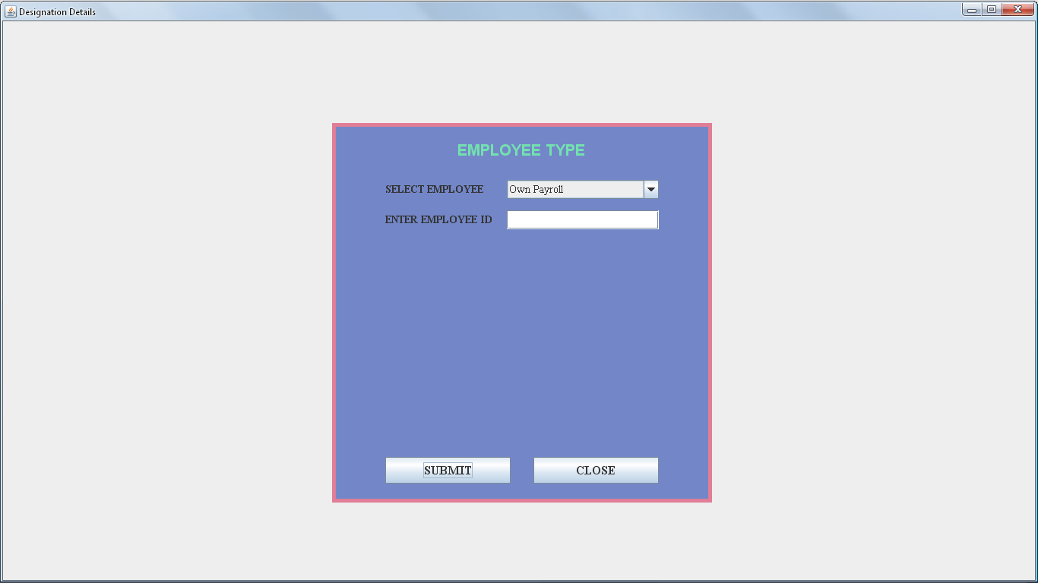

FIGURE:26: SHOWS SELECT EMPLOYEE TYPE FORM

CODING FOR SELECT EMPLOYEE TYPE FORM

import java.awt.*;

import javax.swing.*;

import java.awt.event.*;

class Designation extends JFrame implements ActionListener

{

JPanel jpanel1=new JPanel();

JPanel jpanel2=new JPanel();

JLabel jlabel=new JLabel("EMPLOYEE TYPE");

JLabel SElbl=new JLabel("SELECT EMPLOYEE");

JLabel EIDlbl=new JLabel("ENTER EMPLOYEE ID");

JTextField EIDtext=new JTextField(10);

JComboBox SE=new JComboBox();

JButton jbtn1=new JButton("SUBMIT");

JButton jbtn2=new JButton("CLOSE");

Designation(String st)

{

super(st);

setVisible(true);

add(jpanel1);

jpanel1.add(jpanel2);

jpanel1.setLayout(null);

jpanel2.setLayout(null);

jpanel2.setSize(500,500);

jpanel2.setBackground(new Color(115,135,200));

jpanel2.add(jlabel);

jlabel.setFont(new Font("ARIL",Font.BOLD,20));

jlabel.setForeground(new Color(115,225,175));

jpanel2.add(SElbl);

SElbl.setFont(new Font("TIMES NEW ROMAN",Font.BOLD,14));

jpanel2.add(SE);

SE.addItem("Own Payroll");

SE.addItem("Contectul");

SE.setFont(new Font("TIMES NEW ROMAN",Font.PLAIN,14));

jpanel2.add(EIDlbl);

EIDlbl.setFont(new Font("TIMES NEW ROMAN",Font.BOLD,14));

jpanel2.add(EIDtext);

EIDtext.setFont(new Font("TIMES NEW ROMAN",Font.BOLD,14));

jpanel2.add(jbtn1);

jbtn1.setFont(new Font("TIMES NEW ROMAN",Font.BOLD,16));

jpanel2.add(jbtn2);

jbtn2.setFont(new Font("TIMES NEW ROMAN",Font.BOLD,16));

jlabel.setBounds(165,20,180,30);

SElbl.setBounds(70,75,130,25);

SE.setBounds(230,75,200,25);

EIDlbl.setBounds(70,115,150,25);

EIDtext.setBounds(230,115,200,25);

jbtn1.setBounds(70,440,165,35);

jbtn2.setBounds(265,440,165,35);

Toolkit toolkit=getToolkit();

Dimension dim=toolkit.getScreenSize();

int w=dim.width;

int h=dim.height;

setSize(w,h);

jpanel2.setBounds(dim.width/2-250,dim.height/2-250,500,500);

jpanel2.setBorder(BorderFactory.createLineBorder(new Color(225,125,150),5));

jbtn1.addActionListener(this);

jbtn2.addActionListener(this);

}

public void actionPerformed(ActionEvent e)

{

if(e.getSource()==jbtn1)

{

if(SE.getSelectedItem().toString().equals("Own Payroll"))

{

new EmployeeDesig("Employee Desgination Window {Own Payroll}.......");

}

else if(SE.getSelectedItem().toString().equals("Contectul"))

{

new EmployeeDesig1("Employee Desgination Window {Contectul}");

}

}

public static void main(String args[])

{

new Designation("Designation Select Window");

}

}

OWN PAYROLL EMPLOYEE DETAILS FORM

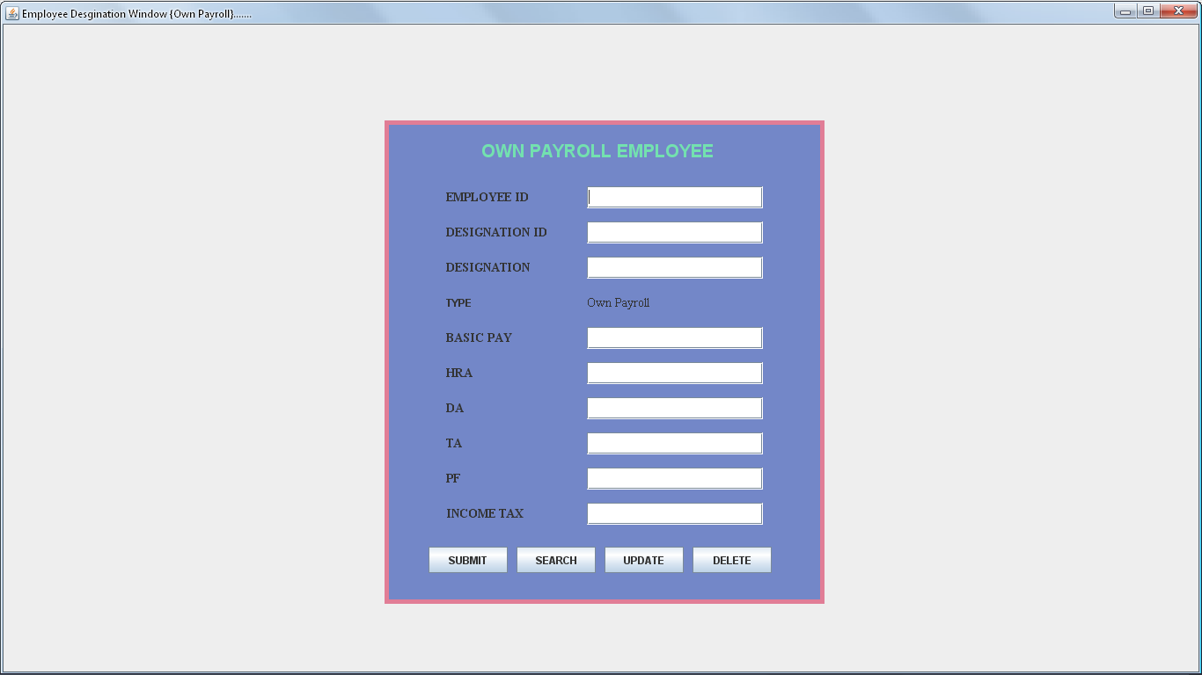

FIGURE:27: SHOWS ON PAYROLL EMPLOYEE DETAILS FORM

CODING FOROWN PAYROLL EMPLOYEE DETAILS FORM

import java.awt.*;

import javax.swing.*;

class EmployeeDesig extends JFrame

{

JPanel jpanel1=new JPanel();

JPanel jpanel2=new JPanel();

JLabel jlabel=new JLabel("OWN PAYROLL EMPLOYEE");

JLabel EIDlbl=new JLabel("EMPLOYEE ID");

JTextField EIDtext=new JTextField(10);

JLabel EDIlbl=new JLabel("DESIGNATION ID");

JTextField EDItext=new JTextField(10);

JLabel EDlbl=new JLabel("DESIGNATION");

JTextField EDtext=new JTextField(15);

JLabel ETlbl1=new JLabel("TYPE");

JLabel ETlbl=new JLabel("Own Payroll");

JLabel EBlbl=new JLabel("BASIC PAY");

JTextField EBtext=new JTextField(8);

JLabel EHRAlbl=new JLabel("HRA");

JTextField EHRAtext=new JTextField(5);

JLabel EDAlbl=new JLabel("DA");

JTextField EDAtext=new JTextField(5);

JLabel ETAlbl=new JLabel("TA");

JTextField ETAtext=new JTextField(8);

JLabel PFlbl=new JLabel("PF");

JTextField PFtext=new JTextField(5);

JLabel ITAXlbl=new JLabel("INCOME TAX");

JTextField ITAXtext=new JTextField(8);

JButton jbtn1=new JButton("SUBMIT");

JButton jbtn2=new JButton("SEARCH");

JButton jbtn3=new JButton("UPDATE");

JButton jbtn4=new JButton("DELETE");

EmployeeDesig(String st)

{

super (st);

setVisible(true);

add(jpanel1);

jpanel1.setLayout(null);

jpanel2.setLayout(null);

jpanel1.add(jpanel2);

jpanel2.setSize(500,550);

jpanel2.setBackground(new Color(115,135,200));

jpanel2.add(jlabel);

jlabel.setFont(new Font("ARIAl",Font.BOLD,20));

jlabel.setForeground(new Color(115,225,175));

jpanel2.add(EIDlbl);

EIDlbl.setFont(new Font("TIMES NEW ROMAN",Font.BOLD,14));

jpanel2.add(EIDtext);

EIDtext.setFont(new Font("TIMES NEW ROMAN",Font.PLAIN,14));

jpanel2.add(EDIlbl);

EDIlbl.setFont(new Font("TIMES NEW ROMAN",Font.BOLD,14));

jpanel2.add(EDItext);

EDItext.setFont(new Font("TIMES NEW ROMAN",Font.PLAIN,14));

jpanel2.add(EDlbl);

EDlbl.setFont(new Font("TIMES NEW ROMAN",Font.BOLD,14));

jpanel2.add(EDtext);

EDtext.setFont(new Font("TIMES NEW ROMAN",Font.PLAIN,14));

jpanel2.add(ETlbl1);

ETlbl.setFont(new Font("TIMES NEW ROMAN",Font.BOLD,14));

jpanel2.add(ETlbl);

ETlbl.setFont(new Font("TIMES NEW ROMAN",Font.PLAIN,14));

jpanel2.add(EBlbl);

EBlbl.setFont(new Font("TIMES NEW ROMAN",Font.BOLD,14));

jpanel2.add(EBtext);

EBtext.setFont(new Font("TIMES NEW ROMAN",Font.PLAIN,14));

jpanel2.add(EHRAlbl);

EHRAlbl.setFont(new Font("TIMES NEW ROMAN",Font.BOLD,14));

jpanel2.add(EHRAtext);

EHRAtext.setFont(new Font("TIMES NEW ROMAN",Font.PLAIN,14));

jpanel2.add(EDAlbl);

EDAlbl.setFont(new Font("TIMES NEW ROMAN",Font.BOLD,14));

jpanel2.add(EDAtext);

EDAtext.setFont(new Font("TIMES NEW ROMAN",Font.PLAIN,14));

jpanel2.add(ETAlbl);

ETAlbl.setFont(new Font("TIMES NEW ROMAN",Font.BOLD,14));

jpanel2.add(ETAtext);

ETAtext.setFont(new Font("TIMES NEW ROMAN",Font.PLAIN,14));

jpanel2.add(PFlbl);

PFlbl.setFont(new Font("TIMES NEW ROMAN",Font.BOLD,14));

jpanel2.add(PFtext);

PFtext.setFont(new Font("TIMES NEW ROMAN",Font.PLAIN,14));

jpanel2.add(ITAXlbl);

ITAXlbl.setFont(new Font("TIMES NEW ROMAN",Font.BOLD,14));

jpanel2.add(ITAXtext);

ITAXtext.setFont(new Font("TIMES NEW ROMAN",Font.PLAIN,14));

jpanel2.add(jbtn1);

jpanel2.add(jbtn2);

jpanel2.add(jbtn3);

jpanel2.add(jbtn4);

jlabel.setBounds(110,20,300,30);

EIDlbl.setBounds(70,75,130,25);

EIDtext.setBounds(230,75,200,25);

EDIlbl.setBounds(70,115,130,25);

EDItext.setBounds(230,115,200,25);

EDlbl.setBounds(70,155,130,25);

EDtext.setBounds(230,155,200,25);

ETlbl1.setBounds(70,195,130,25);

ETlbl.setBounds(230,195,200,25);

EBlbl.setBounds(70,235,130,25);

EBtext.setBounds(230,235,200,25);

EHRAlbl.setBounds(70,275,130,25);

EHRAtext.setBounds(230,275,200,25);

EDAlbl.setBounds(70,315,130,25);

EDAtext.setBounds(230,315,200,25);

ETAlbl.setBounds(70,355,130,25);

ETAtext.setBounds(230,355,200,25);

PFlbl.setBounds(70,395,130,25);

PFtext.setBounds(230,395,200,25);

ITAXlbl.setBounds(70,435,130,25);

ITAXtext.setBounds(230,435,200,25);

jbtn1.setBounds(50,485,90,30);

jbtn2.setBounds(150,485,90,30);

jbtn3.setBounds(250,485,90,30);

jbtn4.setBounds(350,485,90,30);

Toolkit toolkit=getToolkit();

Dimension dim=toolkit.getScreenSize();

int w=dim.width;

int h=dim.height;

setSize(w,h);

jpanel2.setBounds(dim.width/2-250,dim.height/2-275,500,550);

jpanel2.setBorder(BorderFactory.createLineBorder(new Color(225,125,150),5));

}

public static void main(String args[])

{

new EmployeeDesig("EmployeeDesignation Windows");

}

}

OWN CONTACTUAL EMPLOYEE DETAILS FORM

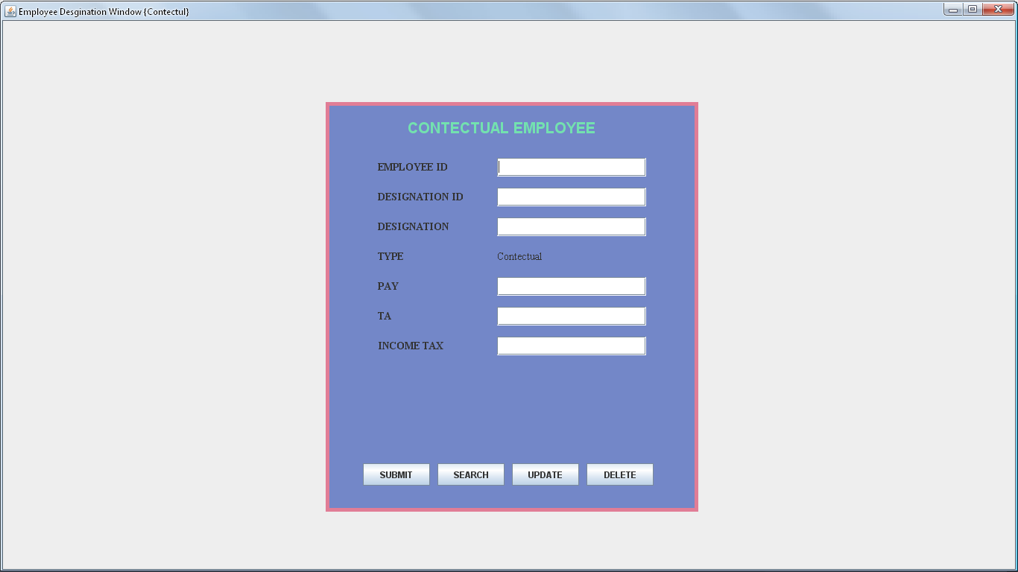

FIGURE:28: SHOWS ON CONTACTUALS EMPLOYEE DETAILS FORM

CODING FOR CONTACTUAL EMPLOYEE DETAILS FORM

import java.awt.*;

import javax.swing.*;

class EmployeeDesig1 extends JFrame

{

JPanel jpanel1=new JPanel();

JPanel jpanel2=new JPanel();

JLabel jlabel=new JLabel("CONTECTUAL EMPLOYEE");

JLabel EIDlbl=new JLabel("EMPLOYEE ID");

JTextField EIDtext=new JTextField(10);

JLabel EDIlbl=new JLabel("DESIGNATION ID");

JTextField EDItext=new JTextField(10);

JLabel EDlbl=new JLabel("DESIGNATION");

JTextField EDtext=new JTextField(15);

JLabel ETlbl1=new JLabel("TYPE");

JLabel ETlbl=new JLabel("Contectual");

JLabel EPlbl=new JLabel("PAY");

JTextField EPtext=new JTextField(8);

JLabel ETAlbl=new JLabel("TA");

JTextField ETAtext=new JTextField(5);

JLabel ITAXlbl=new JLabel("INCOME TAX");

JTextField ITAXtext=new JTextField(8);

JButton jbtn1=new JButton("SUBMIT");

JButton jbtn2=new JButton("SEARCH");

JButton jbtn3=new JButton("UPDATE");

JButton jbtn4=new JButton("DELETE");

EmployeeDesig1(String st)

{

super (st);

setVisible(true);

add(jpanel1);

jpanel1.setLayout(null);

jpanel2.setLayout(null);

jpanel1.add(jpanel2);

jpanel2.setSize(500,550);

jpanel2.setBackground(new Color(115,135,200));

jpanel2.add(jlabel);

jlabel.setFont(new Font("ARIAl",Font.BOLD,20));

jlabel.setForeground(new Color(115,225,175));

jpanel2.add(EIDlbl);

EIDlbl.setFont(new Font("TIMES NEW ROMAN",Font.BOLD,14));

jpanel2.add(EIDtext);

EIDtext.setFont(new Font("TIMES NEW ROMAN",Font.PLAIN,14));

jpanel2.add(EDIlbl);

EDIlbl.setFont(new Font("TIMES NEW ROMAN",Font.BOLD,14));

jpanel2.add(EDItext);

EDItext.setFont(new Font("TIMES NEW ROMAN",Font.PLAIN,14));

jpanel2.add(EDlbl);

EDlbl.setFont(new Font("TIMES NEW ROMAN",Font.BOLD,14));

jpanel2.add(EDtext);

EDtext.setFont(new Font("TIMES NEW ROMAN",Font.PLAIN,14));

jpanel2.add(ETlbl1);

ETlbl1.setFont(new Font("TIMES NEW ROMAN",Font.BOLD,14));

jpanel2.add(ETlbl);

ETlbl.setFont(new Font("TIMES NEW ROMAN",Font.PLAIN,14));

jpanel2.add(EPlbl);

EPlbl.setFont(new Font("TIMES NEW ROMAN",Font.BOLD,14));

jpanel2.add(EPtext);

EPtext.setFont(new Font("TIMES NEW ROMAN",Font.PLAIN,14));

jpanel2.add(ETAlbl);

ETAlbl.setFont(new Font("TIMES NEW ROMAN",Font.BOLD,14));

jpanel2.add(ETAtext);

ETAtext.setFont(new Font("TIMES NEW ROMAN",Font.PLAIN,14));

jpanel2.add(ITAXlbl);

ITAXlbl.setFont(new Font("TIMES NEW ROMAN",Font.BOLD,14));

jpanel2.add(ITAXtext);

ITAXtext.setFont(new Font("TIMES NEW ROMAN",Font.PLAIN,14));

jpanel2.add(jbtn1);

jpanel2.add(jbtn2);

jpanel2.add(jbtn3);

jpanel2.add(jbtn4);

jlabel.setBounds(110,20,300,30);

EIDlbl.setBounds(70,75,130,25);

EIDtext.setBounds(230,75,200,25);

EDIlbl.setBounds(70,115,130,25);

EDItext.setBounds(230,115,200,25);

EDlbl.setBounds(70,155,130,25);

EDtext.setBounds(230,155,200,25);

ETlbl1.setBounds(70,195,130,25);

ETlbl.setBounds(230,195,200,25);

EPlbl.setBounds(70,235,130,25);

EPtext.setBounds(230,235,200,25);

ETAlbl.setBounds(70,275,130,25);

ETAtext.setBounds(230,275,200,25);

ITAXlbl.setBounds(70,315,130,25);

ITAXtext.setBounds(230,315,200,25);

jbtn1.setBounds(50,485,90,30);

jbtn2.setBounds(150,485,90,30);

jbtn3.setBounds(250,485,90,30);

jbtn4.setBounds(350,485,90,30);

Toolkit toolkit=getToolkit();

Dimension dim=toolkit.getScreenSize();

int w=dim.width;

int h=dim.height;

setSize(w,h);

jpanel2.setBounds(dim.width/2-250,dim.height/2-275,500,550);

jpanel2.setBorder(BorderFactory.createLineBorder(new Color(225,125,150),5));

}

public static void main(String args[])

{

new EmployeeDesig1("EmployeeDesignation Windows");

}

}

SELECT EMPLOYEE TYPE FOR SALARY DETAILS FORM

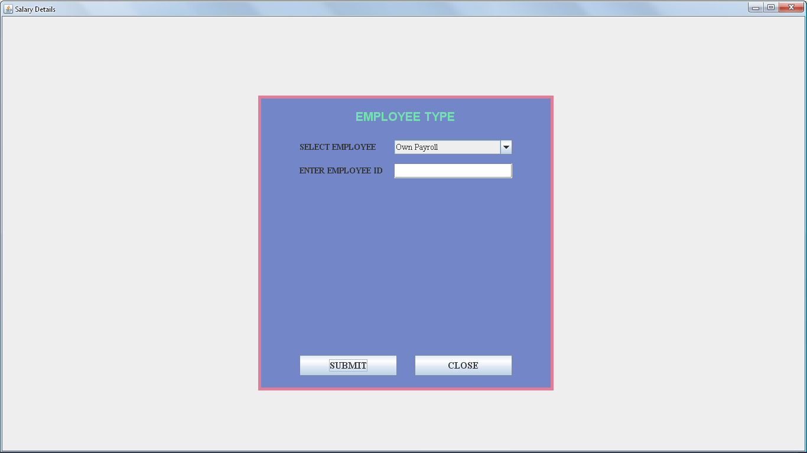

FIGURE:29: SHOWS EMPLOYEE TYPE FOR SALARY DETAILS FORM

CODING FOR SELECT EMPLOYEE TYPE FOR SALARY DETAILS FORM

import java.awt.*;

import javax.swing.*;

import java.awt.event.*;

class Salary extends JFrame implements ActionListener

{

JPanel jpanel1=new JPanel();

JPanel jpanel2=new JPanel();

JLabel jlabel=new JLabel("EMPLOYEE TYPE");

JLabel SElbl=new JLabel("SELECT EMPLOYEE");

JLabel EIDlbl=new JLabel("ENTER EMPLOYEE ID");

JTextField EIDtext=new JTextField(10);

JComboBox SE=new JComboBox();

JButton jbtn1=new JButton("SUBMIT");

JButton jbtn2=new JButton("CLOSE");

Salary(String st)

{

super(st);

setVisible(true);

add(jpanel1);

jpanel1.add(jpanel2);

jpanel1.setLayout(null);

jpanel2.setLayout(null);

jpanel2.setSize(500,500);

jpanel2.setBackground(new Color(115,135,200));

jpanel2.add(jlabel);

jlabel.setFont(new Font("ARIL",Font.BOLD,20));

jlabel.setForeground(new Color(115,225,175));

jpanel2.add(SElbl);

SElbl.setFont(new Font("TIMES NEW ROMAN",Font.BOLD,14));

jpanel2.add(SE);

SE.addItem("Own Payroll");

SE.addItem("Contectul");

SE.setFont(new Font("TIMES NEW ROMAN",Font.PLAIN,14));

jpanel2.add(EIDlbl);

EIDlbl.setFont(new Font("TIMES NEW ROMAN",Font.BOLD,14));

jpanel2.add(EIDtext);

EIDtext.setFont(new Font("TIMES NEW ROMAN",Font.BOLD,14));

jpanel2.add(jbtn1);

jbtn1.setFont(new Font("TIMES NEW ROMAN",Font.BOLD,16));

jpanel2.add(jbtn2);

jbtn2.setFont(new Font("TIMES NEW ROMAN",Font.BOLD,16));

jlabel.setBounds(165,20,180,30);

SElbl.setBounds(70,75,130,25);

SE.setBounds(230,75,200,25);

EIDlbl.setBounds(70,115,150,25);

EIDtext.setBounds(230,115,200,25);

jbtn1.setBounds(70,440,165,35);

jbtn2.setBounds(265,440,165,35);

Toolkit toolkit=getToolkit();

Dimension dim=toolkit.getScreenSize();

int w=dim.width;

int h=dim.height;

setSize(w,h);

jpanel2.setBounds(dim.width/2-250,dim.height/2-250,500,500);

jpanel2.setBorder(BorderFactory.createLineBorder(new Color(225,125,150),5));

jbtn1.addActionListener(this);

jbtn2.addActionListener(this);

}

public void actionPerformed(ActionEvent e)

{

if(e.getSource()==jbtn1)

{

if(SE.getSelectedItem().toString().equals("Own Payroll"))

{

new EmployeeSalary("Employee Salary Details Own Payroll");

}

else if(SE.getSelectedItem().toString().equals("Contectul"))

{

new EmployeeSalary1("Employee Salary Details Own Contactual");

}

}

}

public static void main(String args[])

{

new Salary("Salary Window");

}

}

Own payroll EMPLOYEE SALARY DETAILS FORM

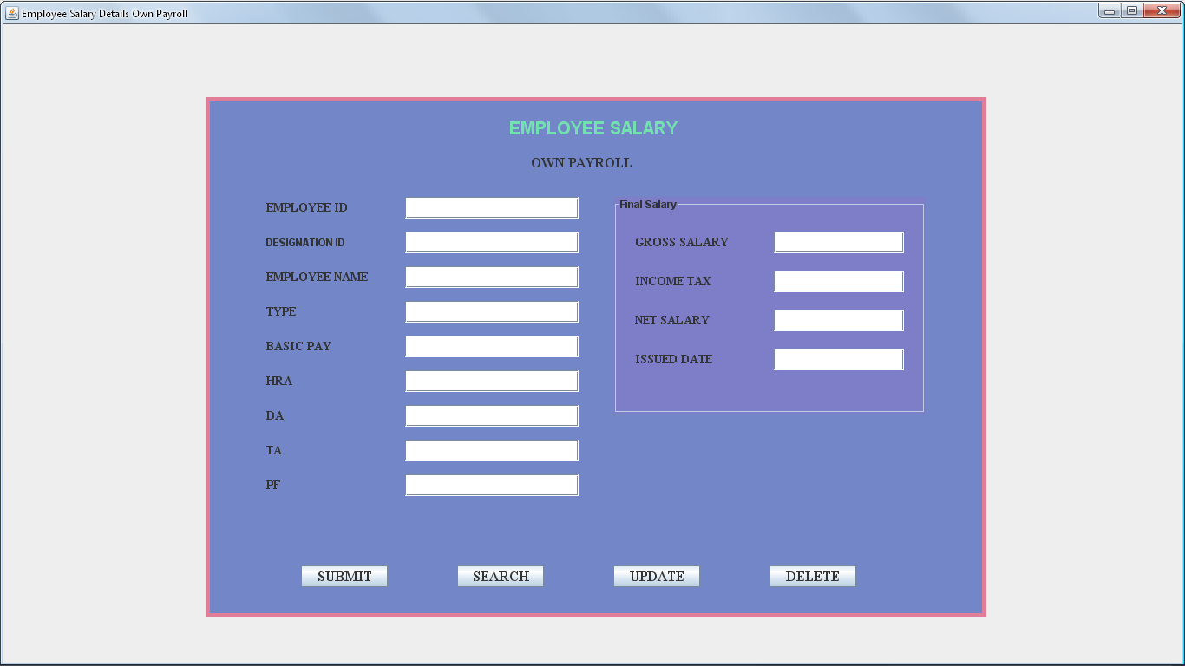

FIGURE:30: SHOWS OWN PAYROLL EMPLOYEE SALARY DETAILS FORM

CODING FOR Own payroll EMPLOYEE SALARY DETAILS FORM

import java.awt.*;

import javax.swing.*;

class EmployeeSalary extends JFrame

{

JPanel jpanel1=new JPanel();

JPanel jpanel2=new JPanel();

JPanel jpanel3=new JPanel();

JLabel jlabel1=new JLabel("EMPLOYEE SALARY");

JLabel jlabel2=new JLabel("OWN PAYROLL");

JLabel EIDlbl=new JLabel("EMPLOYEE ID");

JTextField EIDtext=new JTextField(10);

JLabel EDIlbl=new JLabel("DESIGNATION ID");

JTextField EDItext=new JTextField(10);

JLabel ENlbl=new JLabel("EMPLOYEE NAME");

JTextField ENtext=new JTextField(25);

JLabel ETlbl=new JLabel("TYPE");

JTextField ETtext=new JTextField(15);

JLabel EBPlbl=new JLabel("BASIC PAY");

JTextField EBPtext=new JTextField();

JLabel EHRAlbl=new JLabel("HRA");

JTextField EHRAtext=new JTextField(5);

JLabel EDAlbl=new JLabel("DA");

JTextField EDAtext=new JTextField(4);

JLabel ETAlbl=new JLabel("TA");

JTextField ETAtext=new JTextField(4);

JLabel EPFlbl=new JLabel("PF");

JTextField EPFtext=new JTextField(4);

JLabel EGSlbl=new JLabel("GROSS SALARY");

JTextField EGStext=new JTextField(8);

JLabel EITlbl=new JLabel("INCOME TAX");

JTextField EITtext=new JTextField(4);

JLabel ENSlbl=new JLabel("NET SALARY");

JTextField ENStext=new JTextField(8);

JLabel IDlbl=new JLabel("ISSUED DATE");

JTextField IDtext=new JTextField(10);

JButton jbtn1=new JButton("SUBMIT");

JButton jbtn2=new JButton("SEARCH");

JButton jbtn3=new JButton("UPDATE");

JButton jbtn4=new JButton("DELETE");

EmployeeSalary(String st)

{

super (st);

setVisible(true);

add(jpanel1);

jpanel1.setLayout(null);

jpanel2.setLayout(null);

jpanel1.add(jpanel2);

jpanel2.setSize(900,600);

jpanel2.setBackground(new Color(115,135,200));

jpanel2.add(jlabel1);

jlabel1.setFont(new Font("ARIL",Font.BOLD,20));

jlabel1.setForeground(new Color(115,225,175));

jpanel2.add(jlabel2);

jlabel2.setFont(new Font("TIMES NEW ROMAN",Font.BOLD,16));

jpanel2.add(EIDlbl);

EIDlbl.setFont(new Font("TIMES NEW ROMAN",Font.BOLD,14));

jpanel2.add(EIDtext);

EIDtext.setFont(new Font("TIMES NEW ROMAN",Font.PLAIN,14));

jpanel2.add(EDIlbl);

EIDlbl.setFont(new Font("TIMES NEW ROMAN",Font.BOLD,14));

jpanel2.add(EDItext);

EDItext.setFont(new Font("TIMES NEW ROMAN",Font.PLAIN,14));

jpanel2.add(ENlbl);

ENlbl.setFont(new Font("TIMES NEW ROMAN",Font.BOLD,14));

jpanel2.add(ENtext);

ENtext.setFont(new Font("TIMES NEW ROMAN",Font.PLAIN,14));

jpanel2.add(ETlbl);

ETlbl.setFont(new Font("TIMES NEW ROMAN",Font.BOLD,14));

jpanel2.add(ETtext);

ETtext.setFont(new Font("TIMES NEW ROMAN",Font.PLAIN,14));

jpanel2.add(EBPlbl);

EBPlbl.setFont(new Font("TIMES NEW ROMAN",Font.BOLD,14));

jpanel2.add(EBPtext);

EBPtext.setFont(new Font("TIMES NEW ROMAN",Font.PLAIN,14));

jpanel2.add(EHRAlbl);

EHRAlbl.setFont(new Font("TIMES NEW ROMAN",Font.BOLD,14));

jpanel2.add(EHRAtext);

EHRAtext.setFont(new Font("TIMES NEW ROMAN",Font.PLAIN,14));

jpanel2.add(EDAlbl);

EDAlbl.setFont(new Font("TIMES NEW ROMAN",Font.BOLD,14));

jpanel2.add(EDAtext);

EDAtext.setFont(new Font("TIMES NEW ROMAN",Font.PLAIN,14));

jpanel2.add(ETAlbl);

ETAlbl.setFont(new Font("TIMES NEW ROMAN",Font.BOLD,14));

jpanel2.add(ETAtext);

ETAtext.setFont(new Font("TIMES NEW ROMAN",Font.PLAIN,14));

jpanel2.add(EPFlbl);

EPFlbl.setFont(new Font("TIMES NEW ROMAN",Font.BOLD,14));

jpanel2.add(EPFtext);

EPFtext.setFont(new Font("TIMES NEW ROMAN",Font.PLAIN,14));

jpanel3.add(EGSlbl);

EGSlbl.setFont(new Font("TIMES NEW ROMAN",Font.BOLD,14));

jpanel3.add(EGStext);

EGStext.setFont(new Font("TIMES NEW ROMAN",Font.PLAIN,14));

jpanel3.add(EITlbl);

EITlbl.setFont(new Font("TIMES NEW ROMAN",Font.BOLD,14));

jpanel3.add(EITtext);

EITtext.setFont(new Font("TIMES NEW ROMAN",Font.PLAIN,14));

jpanel3.add(ENSlbl);

ENSlbl.setFont(new Font("TIMES NEW ROMAN",Font.BOLD,14));

jpanel3.add(ENStext);

ENStext.setFont(new Font("TIMES NEW ROMAN",Font.PLAIN,14));

jpanel3.add(IDlbl);

IDlbl.setFont(new Font("TIMES NEW ROMAN",Font.BOLD,14));

jpanel3.add(IDtext);

IDtext.setFont(new Font("TIMES NEW ROMAN",Font.PLAIN,14));

jpanel2.add(jbtn1);

jbtn1.setFont(new Font("TIMES NEW ROMAN",Font.BOLD,16));

jpanel2.add(jbtn2);

jbtn2.setFont(new Font("TIMES NEW ROMAN",Font.BOLD,16));

jpanel2.add(jbtn3);

jbtn3.setFont(new Font("TIMES NEW ROMAN",Font.BOLD,16));

jpanel2.add(jbtn4);

jbtn4.setFont(new Font("TIMES NEW ROMAN",Font.BOLD,16));

jlabel1.setBounds(350,20,200,30);

jlabel2.setBounds(375,60,150,30);

EIDlbl.setBounds(70,115,130,25);

EIDtext.setBounds(230,115,200,25);

EDIlbl.setBounds(70,155,130,25);

EDItext.setBounds(230,155,200,25);

ENlbl.setBounds(70,195,130,25);

ENtext.setBounds(230,195,200,25);

ETlbl.setBounds(70,235,130,25);

ETtext.setBounds(230,235,200,25);

EBPlbl.setBounds(70,275,130,25);

EBPtext.setBounds(230,275,200,25);

EHRAlbl.setBounds(70,315,130,25);

EHRAtext.setBounds(230,315,200,25);

EDAlbl.setBounds(70,355,130,25);

EDAtext.setBounds(230,355,200,25);

ETAlbl.setBounds(70,395,130,25);

ETAtext.setBounds(230,395,200,25);

EPFlbl.setBounds(70,435,130,25);

EPFtext.setBounds(230,435,200,25);

EGSlbl.setBounds(25,40,130,25);

EGStext.setBounds(185,40,150,25);

EITlbl.setBounds(25,85,130,25);

EITtext.setBounds(185,85,150,25);

ENSlbl.setBounds(25,130,130,25);

ENStext.setBounds(185,130,150,25);

IDlbl.setBounds(25,175,130,25);

IDtext.setBounds(185,175,150,25);

jbtn1.setBounds(110,540,100,25);

jbtn2.setBounds(290,540,100,25);

jbtn3.setBounds(470,540,100,25);

jbtn4.setBounds(650,540,100,25);

Toolkit toolkit=getToolkit();

Dimension dim=toolkit.getScreenSize();

int w=dim.width;

int h=dim.height;

setSize(w,h);

jpanel2.setBounds(dim.width/2-450,dim.height/2-300,900,600);

jpanel2.setBorder(BorderFactory.createLineBorder(new Color(225,125,150),5));

setDefaultCloseOperation(DISPOSE_ON_CLOSE);

jpanel2.add(jpanel3);

jpanel3.setLayout(null);

jpanel3.setSize(360,250);

jpanel3.setBounds(470,115,360,250);

jpanel3.setBackground(new Color(125,125,200));

jpanel3.setBorder(BorderFactory.createTitledBorder("Final Salary"));

}

public static void main(String args[])

{

new EmployeeSalary("Employee Salary Windows");

}

}

Own CONTACTUAL EMPLOYEE SALARY DETAILS FORM

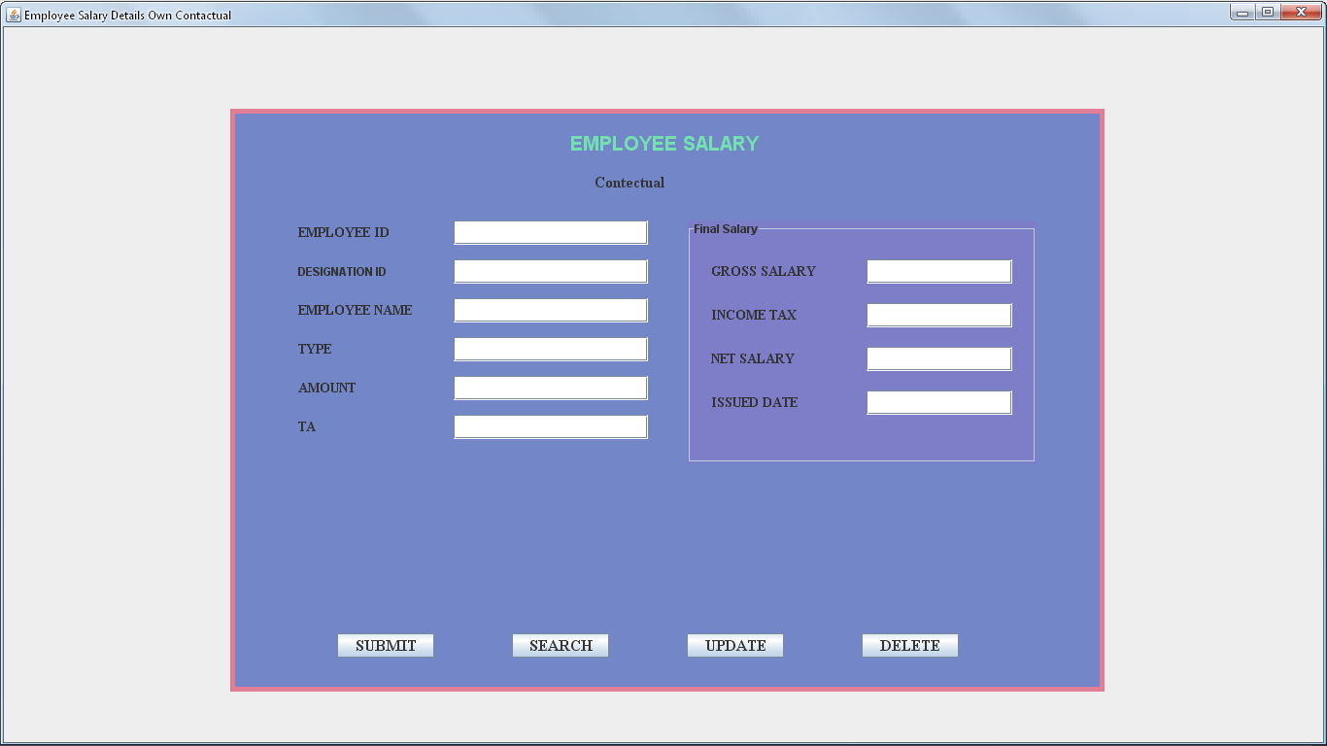

FIGURE:31: SHOWS OWN CONTACTUAL EMPLOYEE SALARY DETAILS FORM

CODING FOR Own CONTACTUAL EMPLOYEE SALARY DETAILS FORM

import java.awt.*;

import javax.swing.*;

class EmployeeSalary1 extends JFrame

{

JPanel jpanel1=new JPanel();

JPanel jpanel2=new JPanel();

JPanel jpanel3=new JPanel();

JLabel jlabel1=new JLabel("EMPLOYEE SALARY");

JLabel jlabel2=new JLabel("Contectual");

JLabel EIDlbl=new JLabel("EMPLOYEE ID");

JTextField EIDtext=new JTextField(10);

JLabel EDIlbl=new JLabel("DESIGNATION ID");

JTextField EDItext=new JTextField(10);

JLabel ENlbl=new JLabel("EMPLOYEE NAME");

JTextField ENtext=new JTextField(25);

JLabel ETlbl=new JLabel("TYPE");

JTextField ETtext=new JTextField(15);

JLabel EAMlbl=new JLabel("AMOUNT");

JTextField EAMtext=new JTextField();

JLabel ETAlbl=new JLabel("TA");

JTextField ETAtext=new JTextField(4);

JLabel EGSlbl=new JLabel("GROSS SALARY");

JTextField EGStext=new JTextField(8);

JLabel EITlbl=new JLabel("INCOME TAX");

JTextField EITtext=new JTextField(4);

JLabel ENSlbl=new JLabel("NET SALARY");

JTextField ENStext=new JTextField(8);

JLabel IDlbl=new JLabel("ISSUED DATE");

JTextField IDtext=new JTextField(10);

JButton jbtn1=new JButton("SUBMIT");

JButton jbtn2=new JButton("SEARCH");

JButton jbtn3=new JButton("UPDATE");

JButton jbtn4=new JButton("DELETE");

EmployeeSalary1(String st)

{

super (st);

setVisible(true);

add(jpanel1);

jpanel1.setLayout(null);

jpanel2.setLayout(null);

jpanel1.add(jpanel2);

jpanel2.setSize(900,600);

jpanel2.setBackground(new Color(115,135,200));

jpanel2.add(jlabel1);

jlabel1.setFont(new Font("ARIL",Font.BOLD,20));

jlabel1.setForeground(new Color(115,225,175));

jpanel2.add(jlabel2);

jlabel2.setFont(new Font("TIMES NEW ROMAN",Font.BOLD,16));

jpanel2.add(EIDlbl);

EIDlbl.setFont(new Font("TIMES NEW ROMAN",Font.BOLD,14));

jpanel2.add(EIDtext);

EIDtext.setFont(new Font("TIMES NEW ROMAN",Font.PLAIN,14));

jpanel2.add(EDIlbl);

EIDlbl.setFont(new Font("TIMES NEW ROMAN",Font.BOLD,14));

jpanel2.add(EDItext);

EDItext.setFont(new Font("TIMES NEW ROMAN",Font.PLAIN,14));

jpanel2.add(ENlbl);

ENlbl.setFont(new Font("TIMES NEW ROMAN",Font.BOLD,14));

jpanel2.add(ENtext);

ENtext.setFont(new Font("TIMES NEW ROMAN",Font.PLAIN,14));

jpanel2.add(ETlbl);

ETlbl.setFont(new Font("TIMES NEW ROMAN",Font.BOLD,14));

jpanel2.add(ETtext);

ETtext.setFont(new Font("TIMES NEW ROMAN",Font.PLAIN,14));

jpanel2.add(EAMlbl);

EAMlbl.setFont(new Font("TIMES NEW ROMAN",Font.BOLD,14));

jpanel2.add(EAMtext);

EAMtext.setFont(new Font("TIMES NEW ROMAN",Font.PLAIN,14));

jpanel2.add(ETAlbl);

ETAlbl.setFont(new Font("TIMES NEW ROMAN",Font.BOLD,14));

jpanel2.add(ETAtext);

ETAtext.setFont(new Font("TIMES NEW ROMAN",Font.PLAIN,14));

jpanel3.add(EGSlbl);

EGSlbl.setFont(new Font("TIMES NEW ROMAN",Font.BOLD,14));

jpanel3.add(EGStext);

EGStext.setFont(new Font("TIMES NEW ROMAN",Font.PLAIN,14));

jpanel3.add(EITlbl);

EITlbl.setFont(new Font("TIMES NEW ROMAN",Font.BOLD,14));

jpanel3.add(EITtext);

EITtext.setFont(new Font("TIMES NEW ROMAN",Font.PLAIN,14));

jpanel3.add(ENSlbl);

ENSlbl.setFont(new Font("TIMES NEW ROMAN",Font.BOLD,14));

jpanel3.add(ENStext);

ENStext.setFont(new Font("TIMES NEW ROMAN",Font.PLAIN,14));

jpanel3.add(IDlbl);

IDlbl.setFont(new Font("TIMES NEW ROMAN",Font.BOLD,14));

jpanel3.add(IDtext);

IDtext.setFont(new Font("TIMES NEW ROMAN",Font.PLAIN,14));

jpanel2.add(jbtn1);

jbtn1.setFont(new Font("TIMES NEW ROMAN",Font.BOLD,16));

jpanel2.add(jbtn2);

jbtn2.setFont(new Font("TIMES NEW ROMAN",Font.BOLD,16));

jpanel2.add(jbtn3);

jbtn3.setFont(new Font("TIMES NEW ROMAN",Font.BOLD,16));

jpanel2.add(jbtn4);

jbtn4.setFont(new Font("TIMES NEW ROMAN",Font.BOLD,16));

jlabel1.setBounds(350,20,200,30);

jlabel2.setBounds(375,60,150,30);

EIDlbl.setBounds(70,115,130,25);

EIDtext.setBounds(230,115,200,25);

EDIlbl.setBounds(70,155,130,25);

EDItext.setBounds(230,155,200,25);

ENlbl.setBounds(70,195,130,25);

ENtext.setBounds(230,195,200,25);

ETlbl.setBounds(70,235,130,25);

ETtext.setBounds(230,235,200,25);

EAMlbl.setBounds(70,275,130,25);

EAMtext.setBounds(230,275,200,25);

ETAlbl.setBounds(70,315,130,25);

ETAtext.setBounds(230,315,200,25);

EGSlbl.setBounds(25,40,130,25);

EGStext.setBounds(185,40,150,25);

EITlbl.setBounds(25,85,130,25);

EITtext.setBounds(185,85,150,25);

ENSlbl.setBounds(25,130,130,25);

ENStext.setBounds(185,130,150,25);

IDlbl.setBounds(25,175,130,25);

IDtext.setBounds(185,175,150,25);

jbtn1.setBounds(110,540,100,25);

jbtn2.setBounds(290,540,100,25);

jbtn3.setBounds(470,540,100,25);

jbtn4.setBounds(650,540,100,25);

Toolkit toolkit=getToolkit();

Dimension dim=toolkit.getScreenSize();

int w=dim.width;

int h=dim.height;

setSize(w,h);

jpanel2.setBounds(dim.width/2-450,dim.height/2-300,900,600);

jpanel2.setBorder(BorderFactory.createLineBorder(new Color(225,125,150),5));

setDefaultCloseOperation(DISPOSE_ON_CLOSE);

jpanel2.add(jpanel3);

jpanel3.setLayout(null);

jpanel3.setSize(360,250);

jpanel3.setBounds(470,115,360,250);

jpanel3.setBackground(new Color(125,125,200));

jpanel3.setBorder(BorderFactory.createTitledBorder("Final Salary"));

}

public static void main(String args[])

{

new EmployeeSalary1("Employee Salary Windows");

}

}

RESTAURANT 1 DETAILS FORM

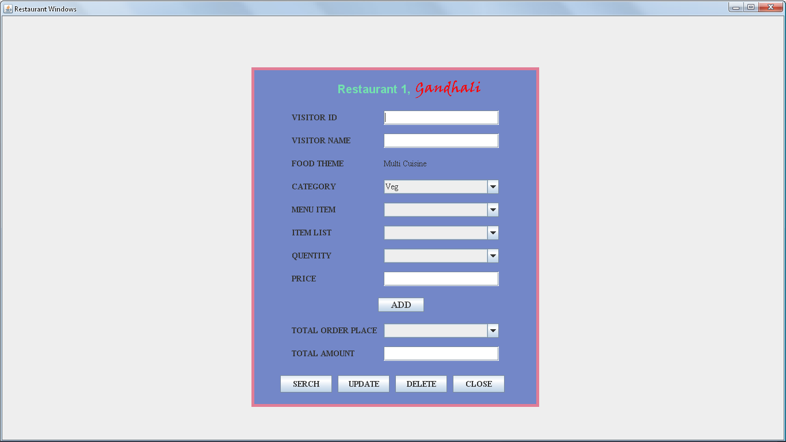

FIGURE:32: RESTAURANT 1 DETAILS FORM

CODING FOR RESTAURANT 1 DETAILS FORM

import java.awt.*;

import javax.swing.*;

class Restaurant1 extends JFrame

{

JPanel jpanel1=new JPanel();

JPanel jpanel2=new JPanel();

JLabel jlabel1=new JLabel("Restaurant 1,");

JLabel jlabel2=new JLabel("Gandhali");

JLabel VIlbl=new JLabel("VISITOR ID");

JTextField VItext=new JTextField(10);

JLabel VNlbl=new JLabel("VISITOR NAME");

JTextField VNtext=new JTextField(25);

JLabel FTlbl=new JLabel("FOOD THEME");

JLabel MClbl=new JLabel("Multi Cuisine");

JLabel CTlbl=new JLabel("CATEGORY");

JComboBox CT=new JComboBox();

JLabel MIlbl=new JLabel("MENU ITEM");

JComboBox MI=new JComboBox();

JLabel ILlbl=new JLabel("ITEM LIST");

JComboBox IL=new JComboBox();

JLabel QTlbl=new JLabel("QUENTITY");

JComboBox QT=new JComboBox();

JLabel PRlbl=new JLabel("PRICE");

JTextField PRtext=new JTextField(4);

JButton ADDbtn=new JButton("ADD");

JLabel TOPlbl=new JLabel("TOTAL ORDER PLACE");

JComboBox TOP=new JComboBox();

JLabel TAlbl=new JLabel("TOTAL AMOUNT");

JTextField TAtext=new JTextField();

JButton jbtn1=new JButton("SERCH");

JButton jbtn2=new JButton("UPDATE");

JButton jbtn3=new JButton("DELETE");

JButton jbtn4=new JButton("CLOSE");

Restaurant1(String st)

{

super(st);

setVisible(true);

add(jpanel1);

jpanel1.add(jpanel2);

jpanel1.setLayout(null);

jpanel2.setLayout(null);

jpanel2.setSize(500,590);

jpanel2.setBackground(new Color(115,135,200));

jpanel2.add(jlabel1);

jlabel1.setFont(new Font("ARIL",Font.BOLD,20));

jlabel1.setForeground(new Color(115,225,175));

jpanel2.add(jlabel2);

jlabel2.setFont(new Font("Viner Hand ITC",Font.BOLD,24));

jlabel2.setForeground(Color.red);

jpanel2.add(VIlbl);

VIlbl.setFont(new Font("TIMES NEW ROMAN",Font.BOLD,14));

jpanel2.add(VItext);

VItext.setFont(new Font("TIMES NEW ROMAN",Font.PLAIN,14));

jpanel2.add(VNlbl);

VNlbl.setFont(new Font("TIMES NEW ROMAN",Font.BOLD,14));

jpanel2.add(VNtext);

VNtext.setFont(new Font("TIMES NEW ROMAN",Font.PLAIN,14));

jpanel2.add(FTlbl);

FTlbl.setFont(new Font("TIMES NEW ROMAN",Font.BOLD,14));

jpanel2.add(MClbl);

MClbl.setFont(new Font("TIMES NEW ROMAN",Font.PLAIN,14));

jpanel2.add(CTlbl);

CTlbl.setFont(new Font("TIMES NEW ROMAN",Font.BOLD,14));

jpanel2.add(CT);

CT.addItem("Veg");

CT.addItem("Non-Veg");

CT.setFont(new Font("TIMES NEW ROMAN",Font.PLAIN,14));

jpanel2.add(MIlbl);

MIlbl.setFont(new Font("TIMES NEW ROMAN",Font.BOLD,14));

jpanel2.add(MI);

MI.setFont(new Font("TIMES NEW ROMAN",Font.PLAIN,14));

jpanel2.add(ILlbl);

ILlbl.setFont(new Font("TIMES NEW ROMAN",Font.BOLD,14));

jpanel2.add(IL);

IL.setFont(new Font("TIMES NEW ROMAN",Font.PLAIN,14));

jpanel2.add(QTlbl);

QTlbl.setFont(new Font("TIMES NEW ROMAN",Font.BOLD,14));

jpanel2.add(QT);

QT.setFont(new Font("TIMES NEW ROMAN",Font.PLAIN,14));

jpanel2.add(PRlbl);

PRlbl.setFont(new Font("TIMES NEW ROMAN",Font.BOLD,14));

jpanel2.add(PRtext);

PRtext.setFont(new Font("TIMES NEW ROMAN",Font.PLAIN,14));

jpanel2.add(ADDbtn);

ADDbtn.setFont(new Font("TIMES NEW ROMAN",Font.BOLD,16));

jpanel2.add(TOPlbl);

TOPlbl.setFont(new Font("TIMES NEW ROMAN",Font.BOLD,14));

jpanel2.add(TOP);

TOP.setFont(new Font("TIMES NEW ROMAN",Font.PLAIN,14));

jpanel2.add(TAlbl);

TAlbl.setFont(new Font("TIMES NEW ROMAN",Font.BOLD,14));

jpanel2.add(TAtext);

TAtext.setFont(new Font("TIMES NEW ROMAN",Font.PLAIN,14));

jpanel2.add(jbtn1);

jbtn1.setFont(new Font("TIMES NEW ROMAN",Font.BOLD,14));

jpanel2.add(jbtn2);

jbtn2.setFont(new Font("TIMES NEW ROMAN",Font.BOLD,14));

jpanel2.add(jbtn3);

jbtn3.setFont(new Font("TIMES NEW ROMAN",Font.BOLD,14));

jpanel2.add(jbtn4);

jbtn4.setFont(new Font("TIMES NEW ROMAN",Font.BOLD,14));

jlabel1.setBounds(150,20,130,35);

jlabel2.setBounds(285,20,120,35);

VIlbl.setBounds(70,75,130,25);

VItext.setBounds(230,75,200,25);

VNlbl.setBounds(70,115,130,25);

VNtext.setBounds(230,115,200,25);

FTlbl.setBounds(70,155,130,25);

MClbl.setBounds(230,155,200,25);

CTlbl.setBounds(70,195,130,25);

CT.setBounds(230,195,200,25);

MIlbl.setBounds(70,235,130,25);

MI.setBounds(230,235,200,25);

ILlbl.setBounds(70,275,130,25);

IL.setBounds(230,275,200,25);

QTlbl.setBounds(70,315,130,25);

QT.setBounds(230,315,200,25);

PRlbl.setBounds(70,355,130,25);

PRtext.setBounds(230,355,200,25);

ADDbtn.setBounds(220,400,80,25);

TOPlbl.setBounds(70,445,150,25);

TOP.setBounds(230,445,200,25);

TAlbl.setBounds(70,485,130,25);

TAtext.setBounds(230,485,200,25);

jbtn1.setBounds(50,535,90,30);

jbtn2.setBounds(150,535,90,30);

jbtn3.setBounds(250,535,90,30);

jbtn4.setBounds(350,535,90,30);

Toolkit toolkit=getToolkit();

Dimension dim=toolkit.getScreenSize();

int w=dim.width;

int h=dim.height;

setSize(w,h);

jpanel2.setBounds(dim.width/2-250,dim.height/2-295,500,590);

setDefaultCloseOperation(DISPOSE_ON_CLOSE);

jpanel2.setBorder(BorderFactory.createLineBorder(new Color(225,125,150),5));

}

public static void main(String args[])

{

new Restaurant1("Restaurant1 Visitor Window");

}

}

RESTAURANT 2 DETAILS FORM

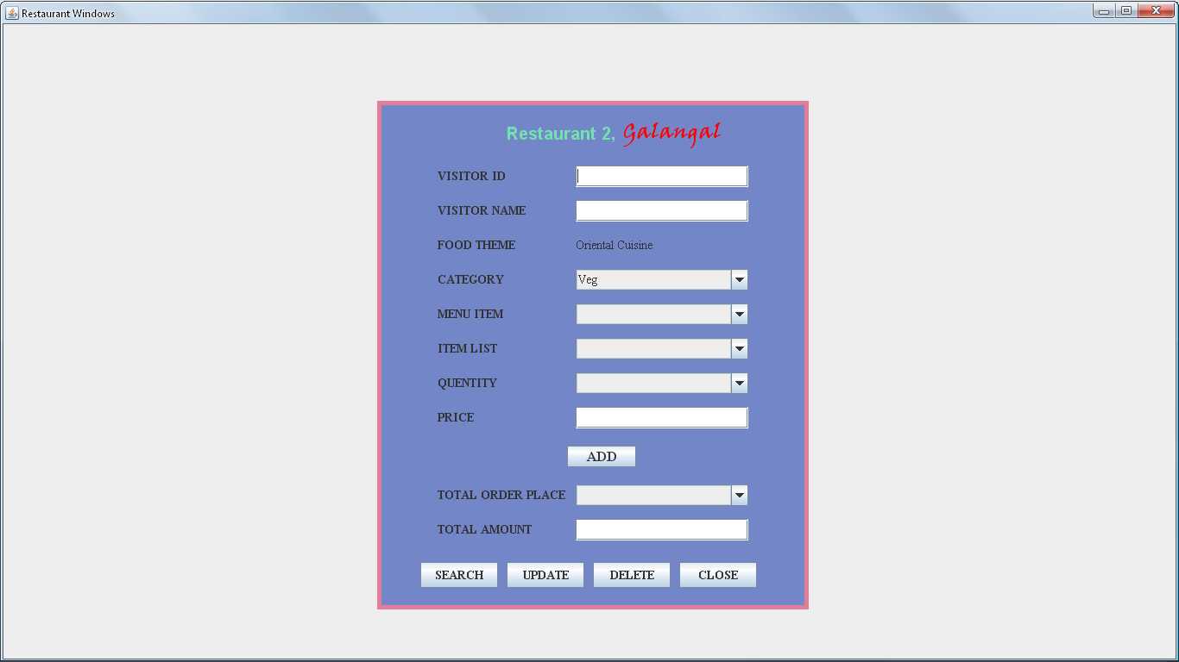

FIGURE:33: RESTAURANT 2 DETAILS FORM

CODING FOR RESTAURANT 2 DETAILS FORM

import java.awt.*;

import javax.swing.*;

class Restaurant2 extends JFrame

{

JPanel jpanel1=new JPanel();

JPanel jpanel2=new JPanel();

JLabel jlabel1=new JLabel("Restaurant 2,");

JLabel jlabel2=new JLabel("Galangal");

JLabel VIlbl=new JLabel("VISITOR ID");

JTextField VItext=new JTextField(10);

JLabel VNlbl=new JLabel("VISITOR NAME");

JTextField VNtext=new JTextField(25);

JLabel FTlbl=new JLabel("FOOD THEME");

JLabel MClbl=new JLabel("Oriental Cuisine");

JLabel CTlbl=new JLabel("CATEGORY");

JComboBox CT=new JComboBox();

JLabel MIlbl=new JLabel("MENU ITEM");

JComboBox MI=new JComboBox();

JLabel ILlbl=new JLabel("ITEM LIST");

JComboBox IL=new JComboBox();

JLabel QTlbl=new JLabel("QUENTITY");

JComboBox QT=new JComboBox();

JLabel PRlbl=new JLabel("PRICE");

JTextField PRtext=new JTextField(4);

JButton ADDbtn=new JButton("ADD");

JLabel TOPlbl=new JLabel("TOTAL ORDER PLACE");

JComboBox TOP=new JComboBox();

JLabel TAlbl=new JLabel("TOTAL AMOUNT");

JTextField TAtext=new JTextField();

JButton jbtn1=new JButton("SEARCH");

JButton jbtn2=new JButton("UPDATE");

JButton jbtn3=new JButton("DELETE");

JButton jbtn4=new JButton("CLOSE");

Restaurant2(String st)

{

super(st);

setVisible(true);

add(jpanel1);

jpanel1.add(jpanel2);

jpanel1.setLayout(null);

jpanel2.setLayout(null);

jpanel2.setSize(500,590);

jpanel2.setBackground(new Color(115,135,200));

jpanel2.add(jlabel1);

jlabel1.setFont(new Font("ARIL",Font.BOLD,20));

jlabel1.setForeground(new Color(115,225,175));

jpanel2.add(jlabel2);

jlabel2.setFont(new Font("Viner Hand ITC",Font.BOLD,24));

jlabel2.setForeground(Color.red);

jpanel2.add(VIlbl);

VIlbl.setFont(new Font("TIMES NEW ROMAN",Font.BOLD,14));

jpanel2.add(VItext);

VItext.setFont(new Font("TIMES NEW ROMAN",Font.PLAIN,14));

jpanel2.add(VNlbl);

VNlbl.setFont(new Font("TIMES NEW ROMAN",Font.BOLD,14));

jpanel2.add(VNtext);

VNtext.setFont(new Font("TIMES NEW ROMAN",Font.PLAIN,14));

jpanel2.add(FTlbl);

FTlbl.setFont(new Font("TIMES NEW ROMAN",Font.BOLD,14));

jpanel2.add(MClbl);

MClbl.setFont(new Font("TIMES NEW ROMAN",Font.PLAIN,14));

jpanel2.add(CTlbl);

CTlbl.setFont(new Font("TIMES NEW ROMAN",Font.BOLD,14));

jpanel2.add(CT);

CT.addItem("Veg");

CT.addItem("Non-Veg");

CT.setFont(new Font("TIMES NEW ROMAN",Font.PLAIN,14));

jpanel2.add(MIlbl);

MIlbl.setFont(new Font("TIMES NEW ROMAN",Font.BOLD,14));

jpanel2.add(MI);

MI.setFont(new Font("TIMES NEW ROMAN",Font.PLAIN,14));

jpanel2.add(ILlbl);

ILlbl.setFont(new Font("TIMES NEW ROMAN",Font.BOLD,14));

jpanel2.add(IL);

IL.setFont(new Font("TIMES NEW ROMAN",Font.PLAIN,14));

jpanel2.add(QTlbl);

QTlbl.setFont(new Font("TIMES NEW ROMAN",Font.BOLD,14));

jpanel2.add(QT);

QT.setFont(new Font("TIMES NEW ROMAN",Font.PLAIN,14));

jpanel2.add(PRlbl);

PRlbl.setFont(new Font("TIMES NEW ROMAN",Font.BOLD,14));

jpanel2.add(PRtext);

PRtext.setFont(new Font("TIMES NEW ROMAN",Font.PLAIN,14));

jpanel2.add(ADDbtn);

ADDbtn.setFont(new Font("TIMES NEW ROMAN",Font.BOLD,16));

jpanel2.add(TOPlbl);

TOPlbl.setFont(new Font("TIMES NEW ROMAN",Font.BOLD,14));

jpanel2.add(TOP);

TOP.setFont(new Font("TIMES NEW ROMAN",Font.PLAIN,14));

jpanel2.add(TAlbl);

TAlbl.setFont(new Font("TIMES NEW ROMAN",Font.BOLD,14));

jpanel2.add(TAtext);

TAtext.setFont(new Font("TIMES NEW ROMAN",Font.PLAIN,14));

jpanel2.add(jbtn1);

jbtn1.setFont(new Font("TIMES NEW ROMAN",Font.BOLD,14));

jpanel2.add(jbtn2);

jbtn2.setFont(new Font("TIMES NEW ROMAN",Font.BOLD,14));

jpanel2.add(jbtn3);

jbtn3.setFont(new Font("TIMES NEW ROMAN",Font.BOLD,14));

jpanel2.add(jbtn4);

jbtn4.setFont(new Font("TIMES NEW ROMAN",Font.BOLD,14));

jlabel1.setBounds(150,20,130,35);

jlabel2.setBounds(285,20,120,35);

VIlbl.setBounds(70,75,130,25);

VItext.setBounds(230,75,200,25);

VNlbl.setBounds(70,115,130,25);

VNtext.setBounds(230,115,200,25);

FTlbl.setBounds(70,155,130,25);

MClbl.setBounds(230,155,200,25);

CTlbl.setBounds(70,195,130,25);

CT.setBounds(230,195,200,25);

MIlbl.setBounds(70,235,130,25);

MI.setBounds(230,235,200,25);

ILlbl.setBounds(70,275,130,25);

IL.setBounds(230,275,200,25);

QTlbl.setBounds(70,315,130,25);

QT.setBounds(230,315,200,25);

PRlbl.setBounds(70,355,130,25);

PRtext.setBounds(230,355,200,25);

ADDbtn.setBounds(220,400,80,25);

TOPlbl.setBounds(70,445,150,25);

TOP.setBounds(230,445,200,25);

TAlbl.setBounds(70,485,130,25);

TAtext.setBounds(230,485,200,25);

jbtn1.setBounds(50,535,90,30);

jbtn2.setBounds(150,535,90,30);

jbtn3.setBounds(250,535,90,30);

jbtn4.setBounds(350,535,90,30);

Toolkit toolkit=getToolkit();

Dimension dim=toolkit.getScreenSize();

int w=dim.width;

int h=dim.height;

setSize(w,h);

jpanel2.setBounds(dim.width/2-250,dim.height/2-295,500,590);

setDefaultCloseOperation(DISPOSE_ON_CLOSE);

jpanel2.setBorder(BorderFactory.createLineBorder(new Color(225,125,150),5));

}

public static void main(String args[])

{

new Restaurant2("Restaurant2 Visitor Window");

}

}

FACILITY DETAILS FORM

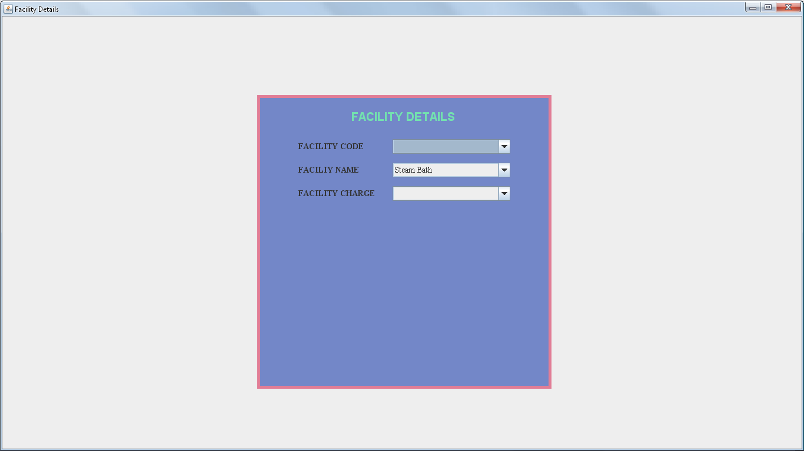

FIGURE:34: FACILITY DETAILS FORM

CIDING FOR FACILITY DETAILS FORM

import java.awt.*;

import javax.swing.*;

class FacilityDets extends JFrame

{

JPanel jpanel1=new JPanel();

JPanel jpanel2=new JPanel();

JLabel jlabel=new JLabel("FACILITY DETAILS");

JLabel FClbl=new JLabel("FACILITY CODE");

JComboBox FC=new JComboBox();

JLabel FNlbl=new JLabel("FACILIY NAME");

JComboBox FN=new JComboBox();

JLabel FCGlbl=new JLabel("FACILITY CHARGE");

JComboBox FCG=new JComboBox();

FacilityDets(String st)

{

super(st);

setVisible(true);

add(jpanel1);

jpanel1.setLayout(null);

jpanel2.setLayout(null);

jpanel1.add(jpanel2);

jpanel2.setSize(500,500);

jpanel2.setBackground(new Color(115,135,200));

jpanel2.setBorder(BorderFactory.createLineBorder(new Color(225,125,150),5));

jpanel2.add(jlabel);

jlabel.setFont(new Font("ARIAL",Font.BOLD,20));

jlabel.setForeground(new Color(115,225,175));

jpanel2.add(FClbl);

FClbl.setFont(new Font("TIMES NEW ROMAN",Font.BOLD,14));

jpanel2.add(FC);

FC.setFont(new Font("TIMES NEW ROMAN",Font.PLAIN,14));

jpanel2.add(FNlbl);

FNlbl.setFont(new Font("TIMES NEW ROMAN",Font.BOLD,14));

jpanel2.add(FN);

FN.addItem("Steam Bath");

FN.addItem("Sauna Bath");

FN.addItem("Exercise Room");

FN.addItem("Vallet Parking");

FN.addItem("Docoto Facility");

FN.addItem("Airport Transfer");

FN.setFont(new Font("TIMES NEW ROMAN",Font.PLAIN,14));

jpanel2.add(FCGlbl);

FCGlbl.setFont(new Font("TIMES NEW ROMAN",Font.BOLD,14));

jpanel2.add(FCG);

FCG.setFont(new Font("TIMES NEW ROMAN",Font.PLAIN,14));

jlabel.setBounds(160,20,180,35);

FClbl.setBounds(70,75,130,25);

FC.setBounds(230,75,200,25);

FNlbl.setBounds(70,115,130,25);

FN.setBounds(230,115,200,25);

FCGlbl.setBounds(70,155,130,25);

FCG.setBounds(230,155,200,25);

Toolkit toolkit=getToolkit();

Dimension dim=toolkit.getScreenSize();

int h=dim.height;

int w=dim.width;

setSize(w,h);

jpanel2.setBounds(dim.width/2-250,dim.height/2-250,500,500);

}

public static void main(String args[])

{

new FacilityDets("Booking Details");

}

}

EMPLOYEE SEARCH FORM

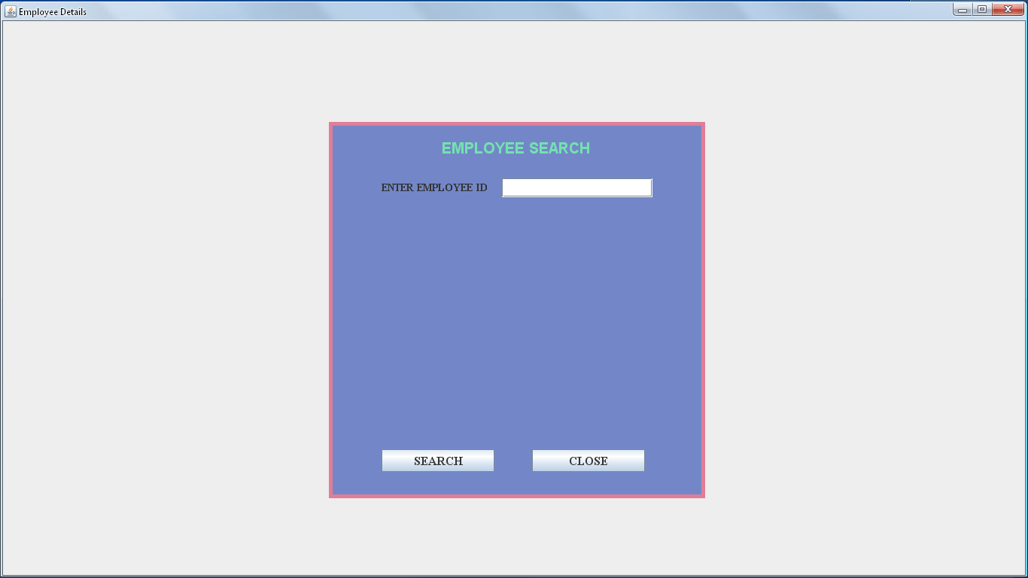

FIGURE:35: SHOWS EMPLOYEE SEARCH DETAILS FORM

CODING FOR EMPLOYEE SEARCH FORM

import java.awt.*;

import javax.swing.*;

import java.awt.event.*;

class EmployeeSearch extends JFrame implements ActionListener

{

JPanel jpanel1=new JPanel();

JPanel jpanel2=new JPanel();

JLabel jlabel=new JLabel("EMPLOYEE SEARCH");

JLabel EMPlbl=new JLabel("ENTER EMPLOYEE ID");

JTextField EMPtext=new JTextField(10);

JButton jbtn1=new JButton("SEARCH");

JButton jbtn2=new JButton("CLOSE");

EmployeeSearch(String st)

{

super(st);

setVisible(true);

add(jpanel1);

jpanel1.add(jpanel2);

jpanel1.setLayout(null);

jpanel2.setLayout(null);

jpanel2.setSize(500,500);

jpanel2.setBackground(new Color(115,135,200));

jpanel2.add(jlabel);

jlabel.setFont(new Font("ARIAL",Font.BOLD,20));

jlabel.setForeground(new Color(115,225,175));

jpanel2.add(EMPlbl);

EMPlbl.setFont(new Font("TIMES NEW ROMAN",Font.BOLD,14));

jpanel2.add(EMPtext);

EMPtext.setFont(new Font("TIMES NEW ROMAN",Font.PLAIN,14));

jpanel2.add(jbtn1);

jbtn1.setFont(new Font("TIMES NEW ROMAN",Font.BOLD,16));

jpanel2.add(jbtn2);

jbtn2.setFont(new Font("TIMES NEW ROMAN",Font.BOLD,16));

jlabel.setBounds(150,20,220,30);

EMPlbl.setBounds(70,75,150,25);

EMPtext.setBounds(230,75,200,25);

jbtn1.setBounds(70,435,150,30);

jbtn2.setBounds(270,435,150,30);

Toolkit toolkit=getToolkit();

Dimension dim=toolkit.getScreenSize();

int w=dim.width;

int h=dim.height;

setSize(w,h);

jpanel2.setBounds(dim.width/2-250,dim.height/2-250,500,500);

jpanel2.setBorder(BorderFactory.createLineBorder(new Color(225,125,150),5));

setDefaultCloseOperation(DISPOSE_ON_CLOSE);

jbtn1.addActionListener(this);

jbtn2.addActionListener(this);

}

public void actionPerformed(ActionEvent e)

{

if(e.getSource()==jbtn1)

{

if(EMPtext.getText().equals("1"))

{

new EmployeeDets("Employee Details Windows");

}

}

}

public static void main(String args[])

{

new EmployeeSearch("Employee Search Window");

}

}

VISITOR SEARCH FORM

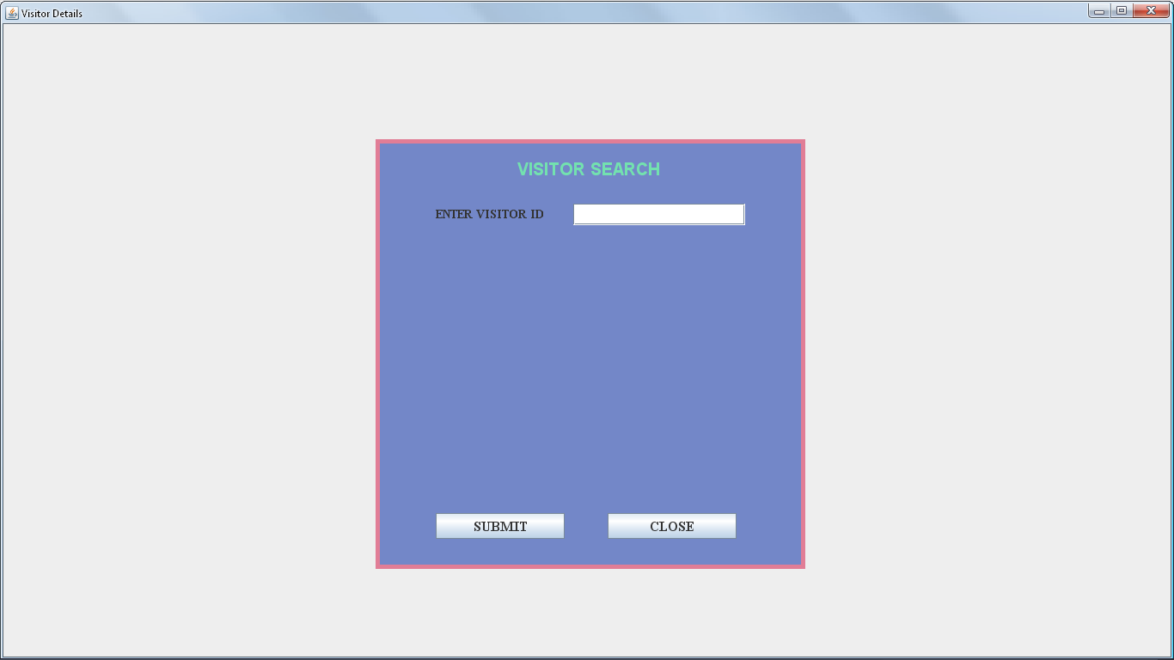

FIGURE:36: SHOWS VISITOR SEARCH DETAILS FORM

CODING FOR VISITOR SEARCH FORM

import java.awt.*;

import javax.swing.*;

import java.awt.event.*;

class VisitorSearch extends JFrame implements ActionListener

{

JPanel jpanel1=new JPanel();

JPanel jpanel2=new JPanel();

JLabel jlabel=new JLabel("VISITOR SEARCH");

JLabel EMPlbl=new JLabel("ENTER VISITOR ID");

JTextField EMPtext=new JTextField(10);

JButton jbtn1=new JButton("SUBMIT");

JButton jbtn2=new JButton("CLOSE");

VisitorSearch(String st)

{

super(st);

setVisible(true);

add(jpanel1);

jpanel1.add(jpanel2);

jpanel1.setLayout(null);

jpanel2.setLayout(null);

jpanel2.setSize(500,500);

jpanel2.setBackground(new Color(115,135,200));

jpanel2.add(jlabel);

jlabel.setFont(new Font("ARIAL",Font.BOLD,20));

jlabel.setForeground(new Color(115,225,175));

jpanel2.add(EMPlbl);

EMPlbl.setFont(new Font("TIMES NEW ROMAN",Font.BOLD,14));

jpanel2.add(EMPtext);

EMPtext.setFont(new Font("TIMES NEW ROMAN",Font.PLAIN,14));

jpanel2.add(jbtn1);

jbtn1.setFont(new Font("TIMES NEW ROMAN",Font.BOLD,16));

jpanel2.add(jbtn2);

jbtn2.setFont(new Font("TIMES NEW ROMAN",Font.BOLD,16));

jlabel.setBounds(165,20,220,30);

EMPlbl.setBounds(70,75,150,25);

EMPtext.setBounds(230,75,200,25);

jbtn1.setBounds(70,435,150,30);

jbtn2.setBounds(270,435,150,30);

Toolkit toolkit=getToolkit();

Dimension dim=toolkit.getScreenSize();

int w=dim.width;

int h=dim.height;

setSize(w,h);

jpanel2.setBounds(dim.width/2-250,dim.height/2-250,500,500);

jpanel2.setBorder(BorderFactory.createLineBorder(new Color(225,125,150),5));

jbtn1.addActionListener(this);

jbtn2.addActionListener(this);

}

public void actionPerformed(ActionEvent e)

{

if(e.getSource()==jbtn1)

{

if(EMPtext.getText().equals("1"))

{

new Visitorsdets("Visitor Search Windows");

}

}

}

public static void main(String args[])

{

new VisitorSearch("Visitor Search Window");

}

}

**REPORT DETAILS**

EMPLOYEE DETAILS REPORT FORM

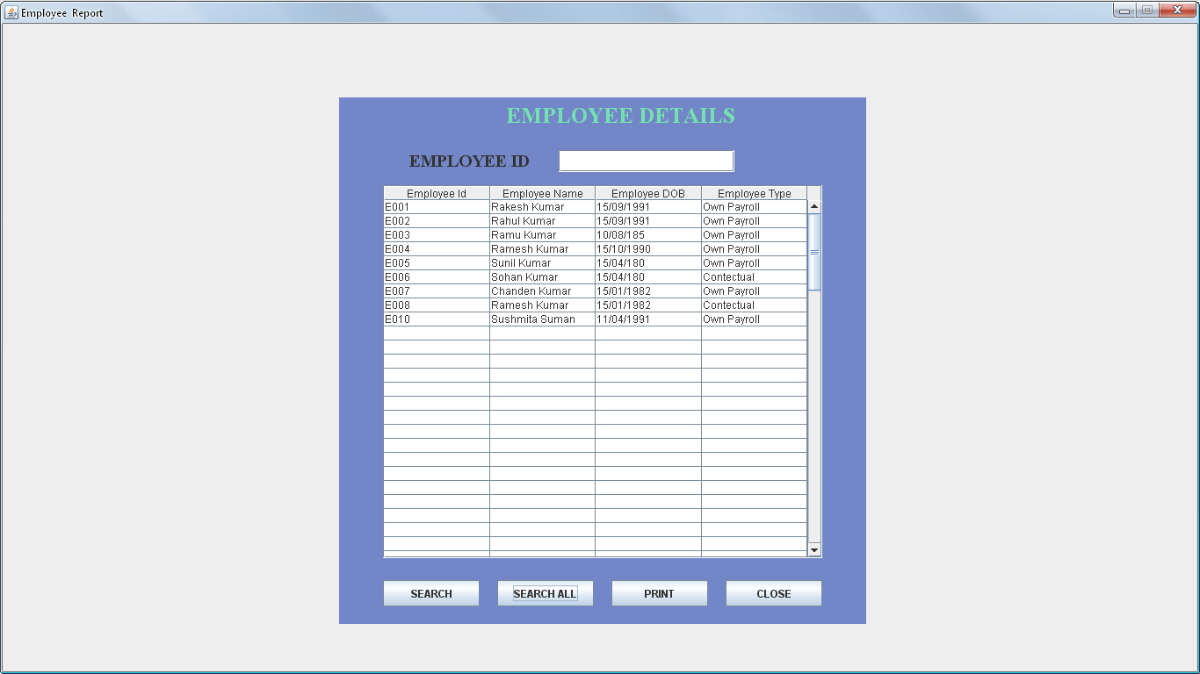

FIGURE:37: SHOWS EMPLOYEE REPORT DETAILS FORM

CODING FOR EMPLOYEE DETAILS REPORT FORM

import java.awt.*;

import javax.swing.*;

import java.util.*;

import java.awt.print.*;

import java.sql.*;

import java.awt.event.*;

class Report_Employee extends JFrame implements ActionListener

{

JTable jtable;

JScrollPane jsp;

JPanel jpanel1=new JPanel();

JLabel label=new JLabel("EMPLOYEE DETAILS");

JLabel VIlbl=new JLabel("EMPLOYEE ID");

JTextField VItext=new JTextField(12);

JButton jbtn1=new JButton("SEARCH");

JButton jbtn2=new JButton("SEARCH ALL");

JButton jbtn3=new JButton("PRINT");

JButton jbtn4=new JButton("CLOSE");

String heading[]={"Employee Id","Employee Name","Employee DOB","Employee Type"};

Object object[][]={{"","","",""},{"","","",""},{"","","",""},{"","","",""},{"","","",""},{"","","",""},{"","","",""},{"","","",""},{"","","",""},{"","","",""},{"","","",""},{"","","",""},{"","","",""},{"","","",""},{"","","",""},{"","","",""},{"","","",""},{"","","",""},{"","","",""},{"","","",""},{"","","",""},{"","","",""},{"","","",""},{"","","",""},{"","","",""},{"","","",""},{"","","",""},{"","","",""},{"","","",""},{"","","",""},{"","","",""},{"","","",""},{"","","",""},{"","","",""},{"","","",""},{"","","",""},{"","","",""},{"","","",""},{"","","",""},{"","","",""},{"","","",""},{"","","",""},{"","","",""},{"","","",""},{"","","",""},{"","","",""},{"","","",""},{"","","",""},{"","","",""},{"","","",""},{"","","",""},{"","","",""},{"","","",""},{"","","",""},{"","","",""},{"","","",""},{"","","",""},{"","","",""},{"","","",""},{"","","",""},{"","","",""},{"","","",""},{"","","",""},{"","","",""},{"","","",""},{"","","",""},{"","","",""},{"","","",""},{"","","",""},{"","","",""},{"","","",""},{"","","",""},{"","","",""},{"","","",""},{"","","",""},{"","","",""},{"","","",""},{"","","",""},{"","","",""},{"","","",""},{"","","",""},{"","","",""},{"","","",""},{"","","",""},{"","","",""},{"","","",""},{"","","",""},{"","","",""},{"","","",""},{"","","",""},{"","","",""},{"","","",""},{"","","",""},{"","","",""},{"","","",""},{"","","",""},{"","","",""},{"","","",""},{"","","",""},{"","","",""},{"","","",""},{"","","",""},{"","","",""},{"","","",""},{"","","",""},{"","","",""},{"","","",""},{"","","",""}};

Connection con;

PreparedStatement ps;

ResultSet rs;

int row=0;

Report_Employee(String st)

{

super (st);

setVisible(true);

setLayout(null);

add(jpanel1);

jpanel1.setBackground(new Color(115,135,200));

jpanel1.setLayout(null);

jpanel1.add(label);

label.setFont(new Font("TIMES NEW ROMAN",Font.BOLD,25));

label.setForeground(new Color(115,225,175));

jpanel1.add(VIlbl);

VIlbl.setFont(new Font("TIMES NEW ROMAN",Font.BOLD,20));

jpanel1.add(VItext);

VItext.setFont(new Font("TIMES NEW ROMAN",Font.PLAIN,20));

jpanel1.add(jbtn1);

jpanel1.add(jbtn2);

jpanel1.add(jbtn3);

jpanel1.add(jbtn4);

jbtn1.addActionListener(this);

jbtn2.addActionListener(this);

jbtn3.addActionListener(this);

jbtn4.addActionListener(this);

jpanel1.setSize(600,600);

jtable=new JTable(object,heading);

jsp=new JScrollPane(jtable);

jsp.setBounds(50,100,500,425);

jpanel1.add(jsp);

setVisible(true);

setResizable(false);

//searchAll();

Toolkit toolkit=getToolkit();

Dimension dim=toolkit.getScreenSize();

int w=dim.width;

int h=dim.height;

setSize(w,h);

jpanel1.setBounds(dim.width/2-300,dim.height/2-300,600,600);

label.setBounds(190,5,270,30);

VIlbl.setBounds(80,60,170,25);

VItext.setBounds(250,60,200,25);

jbtn1.setBounds(50,550,110,30);

jbtn2.setBounds(180,550,110,30);

jbtn3.setBounds(310,550,110,30);

jbtn4.setBounds(440,550,110,30);

}

public void searchAll()

{

boolean flag=true;

try

{

Class.forName("sun.jdbc.odbc.JdbcOdbcDriver");

con=DriverManager.getConnection("Jdbc:Odbc:myname","system","oracle");

ps=con.prepareStatement("select eid,emp,dob,tp from Employeedets");

rs=ps.executeQuery();

while(rs.next())

{

flag=false;

jtable.setValueAt(rs.getString(1),row,0);

jtable.setValueAt(rs.getString(2),row,1);

jtable.setValueAt(rs.getString(3),row,2);

jtable.setValueAt(rs.getString(4),row,3);

row++;

}

if(flag)

JOptionPane.showMessageDialog(this,"Data Not Found");

}

catch(Exception e){JOptionPane.showMessageDialog(this,e);}

}

public void actionPerformed(ActionEvent ae)

{

if(ae.getSource()==jbtn1)

{

try

{

int a=0;

Class.forName("sun.jdbc.odbc.JdbcOdbcDriver");

con=DriverManager.getConnection("Jdbc:Odbc:myname","system","oracle");

ps=con.prepareStatement("select eid,emp,dob,tp from Employeedets where eid=?");

ps.setString(1,VItext.getText());

rs=ps.executeQuery();

for(;row>=0;row--)

{

jtable.setValueAt("",row,0);

jtable.setValueAt("",row,1);

jtable.setValueAt("",row,2);

jtable.setValueAt("",row,3);}

row=0;

while(rs.next())

{

a=1;

jtable.setValueAt(rs.getString(1),row,0);

jtable.setValueAt(rs.getString(2),row,1);

jtable.setValueAt(rs.getString(3),row,2);

jtable.setValueAt(rs.getString(4),row,3);

row++;

}

if(a==0)

{

JOptionPane.showMessageDialog(this,"Data Not Found");

}

}

catch(Exception e)

{

JOptionPane.showMessageDialog(this,e);

}

}

else if(ae.getSource()==jbtn2)

{

try

{

int a=0;VItext.setText("");

Class.forName("sun.jdbc.odbc.JdbcOdbcDriver");

con=DriverManager.getConnection("Jdbc:Odbc:myname","system","oracle");

ps=con.prepareStatement("select eid,emp,dob,tp from Employeedets");

rs=ps.executeQuery();

for(;row>=0;row--)

{

jtable.setValueAt("",row,0);

jtable.setValueAt("",row,1);

jtable.setValueAt("",row,2);

jtable.setValueAt("",row,3);}

row=0;

while(rs.next())

{

a=1;

jtable.setValueAt(rs.getString(1),row,0);

jtable.setValueAt(rs.getString(2),row,1);

jtable.setValueAt(rs.getString(3),row,2);

jtable.setValueAt(rs.getString(4),row,3);

row++;

}

if(a==0)

{

JOptionPane.showMessageDialog(this,"Data Not Found");

}

}

catch(Exception e)

{

JOptionPane.showMessageDialog(this,e);

}

}

else if(ae.getSource()==jbtn4)

{

dispose();

}

else

{

jbtn1.setVisible(false);

jbtn2.setVisible(false);

jbtn3.setVisible(false);

VItext.setVisible(false);

VItext.setVisible(false);

PrinterJob pj = PrinterJob.getPrinterJob();

// Get and change default page format settings if necessary.

//printJob.setPrintable(this);

if (pj.printDialog())

{

try

{

pj.print();

}

catch (Exception PrintException)

{

PrintException.printStackTrace();

}

pj.cancel();

}

pj.cancel();

}

jbtn1.setVisible(true);

jbtn2.setVisible(true);

jbtn3.setVisible(true);

VIlbl.setVisible(true);

VItext.setVisible(true);

}

public int print(Graphics g, PageFormat pf, int pi) throws PrinterException

{

Graphics2D g2 = (Graphics2D) g;

g2.translate(pf.getImageableX()+5, pf.getImageableY()+5);

Font f = new Font("Monospaced",Font.PLAIN,12);

g2.setFont (f);

paint (g2);

return Printable.PAGE_EXISTS;

}

public static void main(String args[])

{

new Report_Employee("EMPLOYEE DETAILS");

}

}

VISITIRS DETAILS REPORT FORM

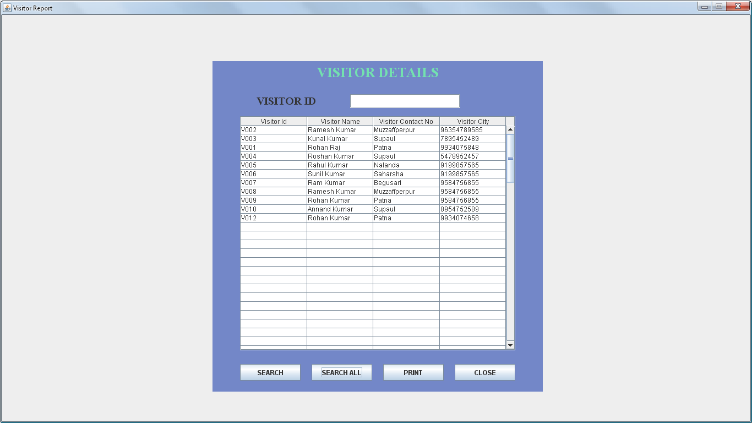

FIGURE:38: SHOWS VISITORS REPORT DETAILS FORM

CODING FOR VISITIRS DETAILS REPORT FORM

import java.awt.*;

import javax.swing.*;

import java.util.*;

import java.awt.print.*;

import java.sql.*;

import java.awt.event.*;

class Report_Vistor extends JFrame implements ActionListener

{

JTable jtable;

JScrollPane jsp;

JPanel jpanel1=new JPanel();

JLabel label=new JLabel("VISITOR DETAILS");

JLabel VIlbl=new JLabel("VISITOR ID");

JTextField VItext=new JTextField(12);

JButton jbtn1=new JButton("SEARCH");

JButton jbtn2=new JButton("SEARCH ALL");

JButton jbtn3=new JButton("PRINT");

JButton jbtn4=new JButton("CLOSE");

String heading[]={"Visitor Id","Visitor Name","Visitor Contact No","Visitor City"};

Object object[][]={{"","","",""},{"","","",""},{"","","",""},{"","","",""},{"","","",""},{"","","",""},{"","","",""},{"","","",""},{"","","",""},{"","","",""},{"","","",""},{"","","",""},{"","","",""},{"","","",""},{"","","",""},{"","","",""},{"","","",""},{"","","",""},{"","","",""},{"","","",""},{"","","",""},{"","","",""},{"","","",""},{"","","",""},{"","","",""},{"","","",""},{"","","",""},{"","","",""},{"","","",""},{"","","",""},{"","","",""},{"","","",""},{"","","",""},{"","","",""},{"","","",""},{"","","",""},{"","","",""},{"","","",""},{"","","",""},{"","","",""},{"","","",""},{"","","",""},{"","","",""},{"","","",""},{"","","",""},{"","","",""},{"","","",""},{"","","",""},{"","","",""},{"","","",""},{"","","",""},{"","","",""},{"","","",""},{"","","",""},{"","","",""},{"","","",""},{"","","",""},{"","","",""},{"","","",""},{"","","",""},{"","","",""},{"","","",""},{"","","",""},{"","","",""},{"","","",""},{"","","",""},{"","","",""},{"","","",""},{"","","",""},{"","","",""},{"","","",""},{"","","",""},{"","","",""},{"","","",""},{"","","",""},{"","","",""},{"","","",""},{"","","",""},{"","","",""},{"","","",""},{"","","",""},{"","","",""},{"","","",""},{"","","",""},{"","","",""},{"","","",""},{"","","",""},{"","","",""},{"","","",""},{"","","",""},{"","","",""},{"","","",""},{"","","",""},{"","","",""},{"","","",""},{"","","",""},{"","","",""},{"","","",""},{"","","",""},{"","","",""},{"","","",""},{"","","",""},{"","","",""},{"","","",""},{"","","",""},{"","","",""},{"","","",""},{"","","",""}};

Connection con;

PreparedStatement ps;

ResultSet rs;

int row=0;

Report_Vistor(String st)

{

super (st);

setVisible(true);

setLayout(null);

add(jpanel1);

jpanel1.setBackground(new Color(115,135,200));

jpanel1.setLayout(null);

jpanel1.add(label);

label.setFont(new Font("TIMES NEW ROMAN",Font.BOLD,25));

label.setForeground(new Color(115,225,175));

jpanel1.add(VIlbl);

VIlbl.setFont(new Font("TIMES NEW ROMAN",Font.BOLD,20));

jpanel1.add(VItext);

VItext.setFont(new Font("TIMES NEW ROMAN",Font.PLAIN,20));

jpanel1.add(jbtn1);

jpanel1.add(jbtn2);

jpanel1.add(jbtn3);

jpanel1.add(jbtn4);

jbtn1.addActionListener(this);

jbtn2.addActionListener(this);

jbtn3.addActionListener(this);

jbtn4.addActionListener(this);

jpanel1.setSize(600,600);

jtable=new JTable(object,heading);

jsp=new JScrollPane(jtable);

jsp.setBounds(50,100,500,425);

jpanel1.add(jsp);

setVisible(true);

setResizable(false);

Toolkit toolkit=getToolkit();

Dimension dim=toolkit.getScreenSize();

int w=dim.width;

int h=dim.height;

setSize(w,h);

jpanel1.setBounds(dim.width/2-300,dim.height/2-300,600,600);

label.setBounds(190,5,230,30);

VIlbl.setBounds(80,60,170,25);

VItext.setBounds(250,60,200,25);

jbtn1.setBounds(50,550,110,30);

jbtn2.setBounds(180,550,110,30);

jbtn3.setBounds(310,550,110,30);

jbtn4.setBounds(440,550,110,30);

}

public void searchAll()

{

boolean flag=true;

try

{

Class.forName("sun.jdbc.odbc.JdbcOdbcDriver");

con=DriverManager.getConnection("Jdbc:Odbc:myname","system","oracle");

ps=con.prepareStatement("select vid,vn,vc,vmn from Visitorsdets");

rs=ps.executeQuery();

while(rs.next())

{

flag=false;

jtable.setValueAt(rs.getString(1),row,0);

jtable.setValueAt(rs.getString(2),row,1);

jtable.setValueAt(rs.getString(3),row,2);

jtable.setValueAt(rs.getString(4),row,3);

row++;

}

if(flag)

JOptionPane.showMessageDialog(this,"Data Not Found");

}

catch(Exception e){JOptionPane.showMessageDialog(this,e);}

}

public void actionPerformed(ActionEvent ae)

{

if(ae.getSource()==jbtn1)

{

try

{

int a=0;

Class.forName("sun.jdbc.odbc.JdbcOdbcDriver");

con=DriverManager.getConnection("Jdbc:Odbc:myname","system","oracle");

ps=con.prepareStatement("select vid,vn,vc,vmn from Visitorsdets where Vid=?");

ps.setString(1,VItext.getText());

rs=ps.executeQuery();

for(;row>=0;row--)

{

jtable.setValueAt("",row,0);

jtable.setValueAt("",row,1);

jtable.setValueAt("",row,2);

jtable.setValueAt("",row,3);}

row=0;

while(rs.next())

{

a=1;

jtable.setValueAt(rs.getString(1),row,0);

jtable.setValueAt(rs.getString(2),row,1);

jtable.setValueAt(rs.getString(3),row,2);

jtable.setValueAt(rs.getString(4),row,3);

row++;

}

if(a==0)

{

JOptionPane.showMessageDialog(this,"Data Not Found");

}

}

catch(Exception e)

{

JOptionPane.showMessageDialog(this,e);

}

}

else if(ae.getSource()==jbtn2)

{

try

{

int a=0;VItext.setText("");

Class.forName("sun.jdbc.odbc.JdbcOdbcDriver");

con=DriverManager.getConnection("Jdbc:Odbc:myname","system","oracle");

ps=con.prepareStatement("select vid,vn,vcy,vmn from Visitorsdets");

rs=ps.executeQuery();

for(;row>=0;row--)

{

jtable.setValueAt("",row,0);

jtable.setValueAt("",row,1);

jtable.setValueAt("",row,2);

jtable.setValueAt("",row,3);}

row=0;

while(rs.next())

{

a=1;

jtable.setValueAt(rs.getString(1),row,0);

jtable.setValueAt(rs.getString(2),row,1);

jtable.setValueAt(rs.getString(3),row,2);

jtable.setValueAt(rs.getString(4),row,3);

row++;

}

if(a==0)

{

JOptionPane.showMessageDialog(this,"Data Not Found");

}

}

catch(Exception e)

{

JOptionPane.showMessageDialog(this,e);

}

}

else if(ae.getSource()==jbtn4)

{

dispose();

}

else

{

jbtn1.setVisible(false);

jbtn2.setVisible(false);

jbtn3.setVisible(false);

VItext.setVisible(false);

VItext.setVisible(false);

PrinterJob pj = PrinterJob.getPrinterJob();

if (pj.printDialog())

{

try

{

pj.print();

}

catch (Exception PrintException)

{

PrintException.printStackTrace();

}

pj.cancel();

}

pj.cancel();

}

jbtn1.setVisible(true);

jbtn2.setVisible(true);

jbtn3.setVisible(true);

VIlbl.setVisible(true);

VItext.setVisible(true);

}

public int print(Graphics g, PageFormat pf, int pi) throws PrinterException

{

Graphics2D g2 = (Graphics2D) g;

g2.translate(pf.getImageableX()+5, pf.getImageableY()+5);

Font f = new Font("Monospaced",Font.PLAIN,12);

g2.setFont (f);

paint (g2);

return Printable.PAGE_EXISTS;

}

public static void main(String args[])

{

new Report_Vistor("VISITOR DETAILS");

}

}

ROOM BOOK DETAILS REPORT FORM

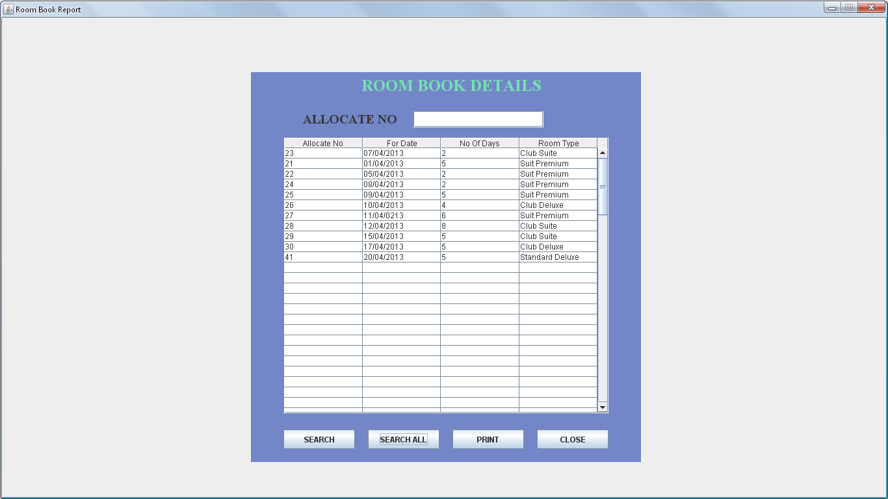

FIGURE:39: SHOWS ROOM BOOK REPORT DETAILS FORM

CODING FOR ROOM BOOK DETAILS REPORT FORM

import java.awt.*;

import javax.swing.*;

import java.util.*;

import java.awt.print.*;

import java.sql.*;

import java.awt.event.*;

class Report_Roombook extends JFrame implements ActionListener

{

JTable jtable;

JScrollPane jsp;

JPanel jpanel1=new JPanel();

JLabel label=new JLabel("ROOM BOOK DETAILS");

JLabel ALlbl=new JLabel("ALLOCATE NO");

JTextField ALtext=new JTextField(12);

JButton jbtn1=new JButton("SEARCH");

JButton jbtn2=new JButton("SEARCH ALL");

JButton jbtn3=new JButton("PRINT");

JButton jbtn4=new JButton("CLOSE");

String heading[]={"Allocate No","For Date","No Of Days","Room Type"};

Object object[][]={{"","","",""},{"","","",""},{"","","",""},{"","","",""},{"","","",""},{"","","",""},{"","","",""},{"","","",""},{"","","",""},{"","","",""},{"","","",""},{"","","",""},{"","","",""},{"","","",""},{"","","",""},{"","","",""},{"","","",""},{"","","",""},{"","","",""},{"","","",""},{"","","",""},{"","","",""},{"","","",""},{"","","",""},{"","","",""},{"","","",""},{"","","",""},{"","","",""},{"","","",""},{"","","",""},{"","","",""},{"","","",""},{"","","",""},{"","","",""},{"","","",""},{"","","",""},{"","","",""},{"","","",""},{"","","",""},{"","","",""},{"","","",""},{"","","",""},{"","","",""},{"","","",""},{"","","",""},{"","","",""},{"","","",""},{"","","",""},{"","","",""},{"","","",""},{"","","",""},{"","","",""},{"","","",""},{"","","",""},{"","","",""},{"","","",""},{"","","",""},{"","","",""},{"","","",""},{"","","",""},{"","","",""},{"","","",""},{"","","",""},{"","","",""},{"","","",""},{"","","",""},{"","","",""},{"","","",""},{"","","",""},{"","","",""},{"","","",""},{"","","",""},{"","","",""},{"","","",""},{"","","",""},{"","","",""},{"","","",""},{"","","",""},{"","","",""},{"","","",""},{"","","",""},{"","","",""},{"","","",""},{"","","",""},{"","","",""},{"","","",""},{"","","",""},{"","","",""},{"","","",""},{"","","",""},{"","","",""},{"","","",""},{"","","",""},{"","","",""},{"","","",""},{"","","",""},{"","","",""},{"","","",""},{"","","",""},{"","","",""},{"","","",""},{"","","",""},{"","","",""},{"","","",""},{"","","",""},{"","","",""},{"","","",""},{"","","",""}};

Connection con;

PreparedStatement ps;

ResultSet rs;

int row=0;

Report_Roombook(String st)

{

super (st);

setVisible(true);

setLayout(null);

add(jpanel1);

jpanel1.setBackground(new Color(115,135,200));

jpanel1.setLayout(null);

jpanel1.add(label);

label.setFont(new Font("TIMES NEW ROMAN",Font.BOLD,25));

label.setForeground(new Color(115,225,175));

jpanel1.add(ALlbl);

ALlbl.setFont(new Font("TIMES NEW ROMAN",Font.BOLD,20));

jpanel1.add(ALtext);

ALtext.setFont(new Font("TIMES NEW ROMAN",Font.PLAIN,20));

jpanel1.add(jbtn1);

jpanel1.add(jbtn2);

jpanel1.add(jbtn3);

jpanel1.add(jbtn4);

jbtn1.addActionListener(this);

jbtn2.addActionListener(this);

jbtn3.addActionListener(this);

jbtn4.addActionListener(this);

jpanel1.setSize(600,600);

jtable=new JTable(object,heading);

jsp=new JScrollPane(jtable);

jsp.setBounds(50,100,500,425);

jpanel1.add(jsp);

setVisible(true);

setResizable(false);

Toolkit toolkit=getToolkit();

Dimension dim=toolkit.getScreenSize();

int w=dim.width;

int h=dim.height;

setSize(w,h);

jpanel1.setBounds(dim.width/2-300,dim.height/2-300,600,600);

label.setBounds(170,5,300,30);

ALlbl.setBounds(80,60,170,25);

ALtext.setBounds(250,60,200,25);

jbtn1.setBounds(50,550,110,30);

jbtn2.setBounds(180,550,110,30);

jbtn3.setBounds(310,550,110,30);

jbtn4.setBounds(440,550,110,30);

}

public void searchAll()

{

boolean flag=true;

try

{

Class.forName("sun.jdbc.odbc.JdbcOdbcDriver");

con=DriverManager.getConnection("Jdbc:Odbc:myname","system","oracle");

ps=con.prepareStatement("select anlbl,fdlbl,nodlbl,rtlbl from Roombook");

rs=ps.executeQuery();

while(rs.next())

{

flag=false;

jtable.setValueAt(rs.getString(1),row,0);

jtable.setValueAt(rs.getString(2),row,1);

jtable.setValueAt(rs.getString(3),row,2);

jtable.setValueAt(rs.getString(4),row,3);

row++;

}

if(flag)

JOptionPane.showMessageDialog(this,"Data Not Found");

}

catch(Exception e){JOptionPane.showMessageDialog(this,e);}

}

public void actionPerformed(ActionEvent ae)

{

if(ae.getSource()==jbtn1)

{

try

{

int a=0;

Class.forName("sun.jdbc.odbc.JdbcOdbcDriver");

con=DriverManager.getConnection("Jdbc:Odbc:myname","system","oracle");

ps=con.prepareStatement("select anlbl,fdlbl,nodlbl,rtlbl from Roombook where anlbl=?");

ps.setString(1,ALtext.getText());

rs=ps.executeQuery();

for(;row>=0;row--)

{

jtable.setValueAt("",row,0);

jtable.setValueAt("",row,1);

jtable.setValueAt("",row,2);

jtable.setValueAt("",row,3);}

row=0;

while(rs.next())

{

a=1;

jtable.setValueAt(rs.getString(1),row,0);

jtable.setValueAt(rs.getString(2),row,1);

jtable.setValueAt(rs.getString(3),row,2);

jtable.setValueAt(rs.getString(4),row,3);

row++;

}

if(a==0)

{

JOptionPane.showMessageDialog(this,"Data Not Found");

}

}

catch(Exception e)

{

JOptionPane.showMessageDialog(this,e);

}

}

else if(ae.getSource()==jbtn2)

{

try

{

int a=0;ALtext.setText("");

Class.forName("sun.jdbc.odbc.JdbcOdbcDriver");

con=DriverManager.getConnection("Jdbc:Odbc:myname","system","oracle");

ps=con.prepareStatement("select anlbl,fdlbl,nodlbl,rtlbl from Roombook");

rs=ps.executeQuery();

for(;row>=0;row--)

{

jtable.setValueAt("",row,0);

jtable.setValueAt("",row,1);

jtable.setValueAt("",row,2);

jtable.setValueAt("",row,3);}

row=0;

while(rs.next())

{

a=1;

jtable.setValueAt(rs.getString(1),row,0);

jtable.setValueAt(rs.getString(2),row,1);

jtable.setValueAt(rs.getString(3),row,2);

jtable.setValueAt(rs.getString(4),row,3);

row++;

}

if(a==0)

{

JOptionPane.showMessageDialog(this,"Data Not Found");

}

}

catch(Exception e)

{

JOptionPane.showMessageDialog(this,e);

else if(ae.getSource()==jbtn4)

{

dispose();

}

else if(ae.getSource()==jbtn3)

{

jbtn1.setVisible(false);

jbtn2.setVisible(false);

jbtn3.setVisible(false);

ALtext.setVisible(false);

ALtext.setVisible(false);

PrinterJob pj = PrinterJob.getPrinterJob();

if (pj.printDialog())

{

try

{

pj.print();

}

catch (Exception PrintException)

{

PrintException.printStackTrace();

}

pj.cancel();

}

pj.cancel();

}

jbtn1.setVisible(true);

jbtn2.setVisible(true);

jbtn3.setVisible(true);

ALlbl.setVisible(true);

ALtext.setVisible(true);

}

public int print(Graphics g, PageFormat pf, int pi) throws PrinterException

{

Graphics2D g2 = (Graphics2D) g;

g2.translate(pf.getImageableX()+5, pf.getImageableY()+5);

Font f = new Font("Monospaced",Font.PLAIN,12);

g2.setFont (f);

paint (g2);

return Printable.PAGE_EXISTS;

}

public static void main(String args[])

{

new Report_Roombook("ROOM BOOK DETAILS");

}

}

**TESTING**

Software testing aims at eliminating program errors. Testing is a demanding and time consuming task as designers cannot confirm 100 percent accuracy. A test is said to be successful if it find errors.

**Purpose of Testing:**-The system is initially tested to see whether it generates the correct outputs. Testing includes testing of following things:-

**1)Response time:**-Online systems must have a quick response time to facilitate the user. Response time can be tested by invoking transactions on as many CRT screens as possible.

**2)Volume:-**This test is conducted to check the functioning of hardware and software. When it is handling large volume of records. The user is required to provide test data for volume testing.

**3)Stress testing**:-It aims to ensure that the candidate system operates effectively even under peak load conditions.

**4)Recovery and security:**-System failure conditions are created to test the backup and recovery procedure for file integrity. Erroneous data are entered to see the system response.

Test related to file integrity is conducted to insure whether data and programs are secure from unauthorized access.

**5)Usability Documentation And Procedure:-**The user-friendly nature of the system is assessed by the usability test. This relates to normal operating and error handling procedures. The user is asked to refer only to the documentation and procedures as a guide and no other resources to determine whether the system can be run properly.

System testing aims at identifying and correcting errors in the candidate system. The performance criteria that are used for system testing are as follows.

**1)Turnaround Time:**-It is the elapsed time between the receipt of the input and availability of output.

**2)Backup:-**It deals with the procedures to be employed when the system goes down. The software for the candidate system must be tested with a backupcomputerforcompatibility

LOGIN FORM



FIGURE:36: SHOWS LOGIN FORM FOR TESTING PURPOSE









**SOFTWARE IMPLEMENTATION**

Implementation of a tested system is done on the actual location with the actual hardware,Software and manpower platforms or limitation. To implement of this software, the followings are the necessary:

**1) Create User Data Source Name (DSN):-** User DSN will be required named as “hotel”. The type of this DSN is Micro-Soft ODBC for Oracle. One can create DSN through ODBC Manager. The ODBC manager can be activated by running “Microsoft ODBC 32 bit Manager” from control panel.

**2) Create separate user for this application: -** A user named as “system” with the password “oracle” is to be created for storing the data in a separate place. Storing data under separate user will protect the data. Oracle Navigator can be used for creating the said username and password.

**3) Create required tables:** The structure of tables required for this project (Detail given in the data base design section) is to be created in the said user. The SQL statement CREATE can be used for creating such tables.

**SOFTWARE MAINTENANCE**

Software maintenance is defined as the modification of a software product after delivery to correct faults, to improve performance or other attributes, or to adapt the product to a modified environment. The standard also addresses maintenance activities prior to delivery of the software product, but only in an information appendix of the standard.

* **Need for Maintenance**

Maintenance is needed to ensure that the software continues to satisfy user requirements. Maintenance is applicable to software developed using any software life cycle model (for example, spiral). The system changes due to corrective and non-corrective software actions. Maintenance must be performed in order to:

* Correct faults
* Improve the design
* Implement enhancements
* Interface with other systems
* Adapt programs so that different hardware, software, system features, and telecommunications facilities can be used
* Migrate legacy software
* Retire software

Maintenance is necessary to eliminate errors in the system during its working life and to tune the system to any variations in its working environment. It has been seen that there are always some errors found in the system that must be noted and corrected. It also means the review of the system from time to time. The review of the system is done for:

* knowing the full capabilities of the system
* knowing the required changes or the additional requirements
* studying the performance

If a major change to a system is needed, a new project may have to be set up to carry out the change. The new project will then proceed through all the above life cycle phases.

**CONCLUSION**

**(a)COST ESTIMATION OF THE SOFTWARE**

**(b)LIMITAION OF THE SOFTWARE**

**(c)FUTURE SCOPE OF THE SOFTWARE**

This project is designed to meet the requirements of **HOTEL MAMTA HOTEL**, Patna (An undertaking by the government of Bihar). This software is the outcome of the job that we have designed for automating the reservation system of the hotel .It has been developed by keeping in mind the specifications of the system and the organization needs. We have tried our level best to fulfill the requirements of the organization and satisfy them. For designing the system we have used simple data flow diagrams for explaining the procedure of the automated system. We have used visual basic as front-end for making the application more convenient and easy to use. Oracle is used as the back-end for creating database and storing data in a more precise way. This report briefly describes the systematic approach adopted to develop the system by efficiently using the latest facilities.

Overall the project teaches us the essential skills like:

* Using system analysis and design techniques like data flow diagram

in designing the system.

* Understanding the database handling and query processing

**COST ESTIMATION OF SOFTWARE**

Software cost estimation is the process of predicting the effort required to develop a software system. Accurate software cost estimates are critical to both developers and customers. The cost of the project depends upon the time consumed by the Software Developer to develop the system. The following Pie chart depicts the consumption of time by various phases of the System Development Life Cycle **of ROOM BOOKING SYSTEM OF HOTEL MAMTA HOTEL.**

.

**SECURITY IMPLEMENTATION**

The software manages the unique Employee Identification and thus restricts any unauthorized access to the software application.

The **Authentication** stage identifies the user using a login / ID account and verifies the ability to connect to ORACLE. If authentication is successful, the user connects to ORACLE. The user then needs **Permissions** to access databases on the server, which is done by granting access to an account in each database, mapped to the user login. The permissions validation stage controls the activities the user is allowed to perform in the ORACLE database. Here too, in addition of having as universal login to ORACLE using separate login names**,** there are two more user’s accounts. One permitting to enter the data and another permitting intermediate rights between System administrator and data entry operator.

Thus, in nutshell three security levels are as follows:

* Authentication
* Authorization
* Operator specific security

### The software checks the validation for two level entries:-

1. *Validating User.*
2. *Data Level Validation.*
3. **Validating User & Form Fields: -** Validating user covers authorize access of the software. The software restricts access by providing password facility for the validation of genuine staff members of the Dairy or employees only. All the form fields are equipped with fully implemented validation the client / user information is done at the client side only.
4. **Data Level Validation: -** It provides several level of validation, which restricts wrong type data entry to a database. This checking is done by modular process where it checks the data type before storing it into the database.

**FUTURE SCOPE & ENHANCEMENT**

In this age of fast growing technology and implementation of the latest technology there is always a scope for further improvement. Also there can be several ways to achieve the target.

The main motto is to implement the new concept in the field of development by using the tips and tricks related to the modern, primitive and advance age styles and that makes the difference. There is nothing to do without future implementation.

• In near future we can put the things in wide spread networking regarding internal operability of the feature of this software.

• Inter related table structure within the table can be implemented for the whole system providing faster retrieval, faster execution, reduction in redundancy, greater saving of space.

• All decision-making systems can also be automated to provide proper help in taking important decisions.

• The complete system can be made available Online. The user can place order, receive response, and provide his/her feedback instantly.

•This system can be enhanced to make it a complete ERP.

• Reports can be customized according to need.

**LIMITATION OF THE PROJECT**

When this project is complete, then it is ready to install for utilization of this project. When we are going to install this software, than before installing this software we will have to check the hardware configuration of the system that is compatible or not for this software.

**HARDWARE REQUIRMENT**

* **Processor:-** Dual Core
* **Ram:-** 1 GB Ram
* **Storage Capacity:-** 40 GB
* **Monitor:-** 15” Color Monitor
* **Keyboard:-** Multimedia
* **Mouse:-** Optical Scroll mouse
* **Drivers:-** 52X CD Rom/DVD Ram.

**SOFTWARE ENVIROMENT**

It is not necessary we only check hardware configuration but we will also check the software of system on that we are going to install this software.

* **Operating System:-**Windows 2000 professional/Windows XP
* **Back End:-** Oracle 10(g)

**BIBLIOGRAPHY**

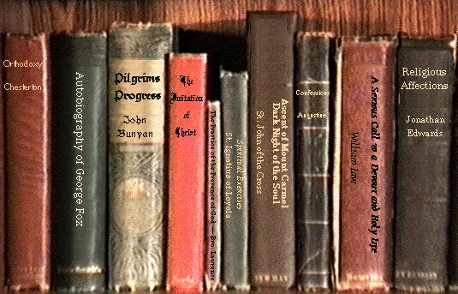

The following books and websites have been referred during the designing of this project:-

* Oracle The Complete Reference ……………………… George Koch
* Java Primer ………………………………………………E Balaguruswami
* Programming in Java …………………………………… James Gousline
* Complete Reference ……………………………………. Herbert Shield
* Google search